Multi-Omics Analysis of DNA Methylation and Gene Expression in Esophageal Squamous Cell Carcinoma (ESCC) cell and Normal Tissue
Chaeyoung kim

- Introduction
Esophageal squamous cell carcinoma (ESCC) is the sixth leading cause of cancer-related deaths worldwide, accounting for 90% of esophageal cancer cases in Asia, Eastern Europe, and Africa (Tarazi et al., 2021). Despite its prevalence, ESCC has a low survival rate of 10–30% (Conway et al., 2023). Understanding its etiology is crucial for developing prevention and treatment strategies.
DNA methylation plays a significant role in cancer development. Comparing methylation patterns between normal and tumor tissues reveals epigenetic changes in key genes, while high-throughput sequencing uncovers genomic alterations and their impact on tumorigenesis.
This study investigates differentially expressed genes between ESCC and normal tissues, integrating RNA-seq analysis to explore potential effects on gene expression.
  - Data
This report is based on data obtained from ESCC tissue and adjacent normal tissues collected from different patients.
 | Infinium Data | RNA-seq Data
Accession ID | GSE157807 | GSE194116
Number of Samples | 10 | 12
    - Infinium Data (GSE157807)
The methylation profile data was obtained from the Illumina Infinium HumanMethylation850 BeadChip platform. It includes DNA methylation data from five ESCC samples and five paired adjacent normal tissue samples, resulting in a total of 10 samples. The dataset utilizes a paired design, where each ESCC sample has a corresponding normal control sample. This can be obtained from
https://www.ncbi.nlm.nih.gov/geo/query/acc.cgi?acc=GSE157807.
Sample ID | PatientID | TissueType
GSM4775294 | ca-973 | ESCC
GSM4775295 | ca-973 | NORMAL
GSM4775296 | ca-962 | ESCC
GSM4775298 | ca-944 | ESCC
GSM4775299 | ca-944 | NORMAL
GSM4775300 | ca-942 | ESCC
GSM4775301 | ca-942 | NORMAL
GSM4775320 | ca-933 | ESCC
GSM4775303 | ca-933 | NORMAL

    - RNA-seq Data (GSE194116)
The RNA-seq data obtained by using the Illumina HiSeq 2500. It includes raw gene count data from six paired ESCC and normal tissue samples. Quality control, trimming, and mapping of the data were performed as described in the GEO metadata. This can be obtained from https://www.ncbi.nlm.nih.gov/geo/query/acc.cgi?acc=GSE194116.
 | Sample Type
GSM5828359 | ESC-1
GSM5828360 | Normal-1
GSM5828361 | ESC-2
GSM5828362 | Normal-2
GSM5828363 | ESC-2
GSM5828364 | Normal-3
GSM5828365 | ESC-2
GSM5828366 | Normal-4
GSM5828367 | ESC-2
GSM5828368 | Normal-5
GSM5828359 | ESC-2
GSM5828359 | Normal-6

- Method
  - Methylation profiling analysis
Data preprocessing, quality control, and quantile normalization were conducted using the minfi and ENmix packages. Low-quality probes, such as those with unreliable signal or high missingness, were filtered out during preprocessing. Beta values and M-values were calculated for downstream analysis.
A paired design was applied to account for patient-specific effects. Tissue type (tumor vs. normal) was modeled in the design matrix, and contrasts were defined to test differential methylation, with patient IDs included as a blocking factor in the analysis. The limma package was used to fit linear models, The intra-patient correlation was estimated using duplicateCorrelation, and the limma package was used to fit linear models. Empirical Bayes smoothing was applied to improve statistical power and identify significant CpG sites.
Checking methylation for top results was done with getM() function, interesting annotations were also added to the output. Region-level analysis was conducted using bumphunter, identifying clusters of CpG sites with consistent methylation changes. Significant CpGs and regions were annotated with genomic features, such as gene association and CpG island relation, using the IlluminaHumanMethylationEPICanno.ilm10b4.hg19 package.
Gene set enrichment analysis was performed with goana to identify enriched Gene Ontology (GO) terms, and clusterProfiler ackage was used to visualize differentially methylated Biological Process Terms.
Visualization of results included volcano and MA plots for differential methylation, as well as histograms to assess the distribution of p-values.
The results of CpG GSA, DMRs GSA, CpG Entrez IDs, and DMRs Entrez IDs were saved as "CpG_GSA_results.txt", ”bmp_GSA_results.txt","EntrezIDs_CpG_results.txt", and "EntrezIDs_bmp_results.txt", respectively (see Appendix A).
  - Expression profiling analysis
Quality control was performed on an HPC environment, while differential expression analysis was conducted on raw count data using the edgeR package. Lowly expressed genes were filtered out, and data normalization was applied using method in edgeR to account for library size differences. A design matrix was constructed to incorporate both the paired nature of the data and experimental conditions.
Differential expression analysis employed generalized linear models with a likelihood ratio test (LRT) to identify significant genes.
Gene Ontology (GO) enrichment analysis was performed using the goana and clusterProfiler package to identify differentially expressed Biological Process terms.
Results were visualized through MDS plots, Volcano plots, and MA plots.
Result of differentially expressed genes are saved as “RNAseq_results.txt”, and result of gene set analysis was saved as “RNAseq_GSA_results” (see Appendix B).
  - Integration of Data Sources
The results of the RNA-seq and CpG methylation analyses were compared, providing insight into the robustness of the findings. This comparison included both gene-level and gene set-level overlap. RNA-seq results were filtered based on an FDR threshold of 0.05, ensuring only statistically significant results were considered. Duplicated Entrez IDs and missing values were removed to ensure a unique set of genes for analysis.
A Venn diagram was created to visualize the overlap between the significant RNA-seq results and both differentially methylated regions (bumps) and CpG analysis. (see Appendix C).

- Results
  - Methylation Data Analysis
The MDS plot (Figure 1) shows distinct clustering of Tumor and ESCC samples, indicating a strong tissue type effect on methylation. Blocking for patient effect ensures that the differences observed are due to tissue type, not individual patient variability. Therefore, in the matrix design, individual variability is controlled by treating the patient effect as a blocking factor, rather than explicitly including individual as a variable. This allows the model to focus on the tissue type differences while adjusting for patient-specific variability.
A total of 35,994 CpG probes (4.18%) were significantly differentially methylated when filtered based on adj.P.Val threshold of 0.05.Figure 2 is a MA-plot of log fold changes between M-values in ESCC and normal adjacent tissue. Among 6,885 DMRs, only 3 regions were significant (FWER < 0.1). Gene set analysis on genes within or near these DMRs revealed key GO terms such as response to growth factors and regulation of cell differentiation.
For validation, individual CpG sites were analyzed. The nearest genes were identified, excluding duplicates. Top GO terms for CpG analysis included cell morphogenesis and neuron projection development (see figure 3). 6 of the top 50 gene sets overlapped between DMRs and CpG analysis. This includes regulation of cell projection organization.
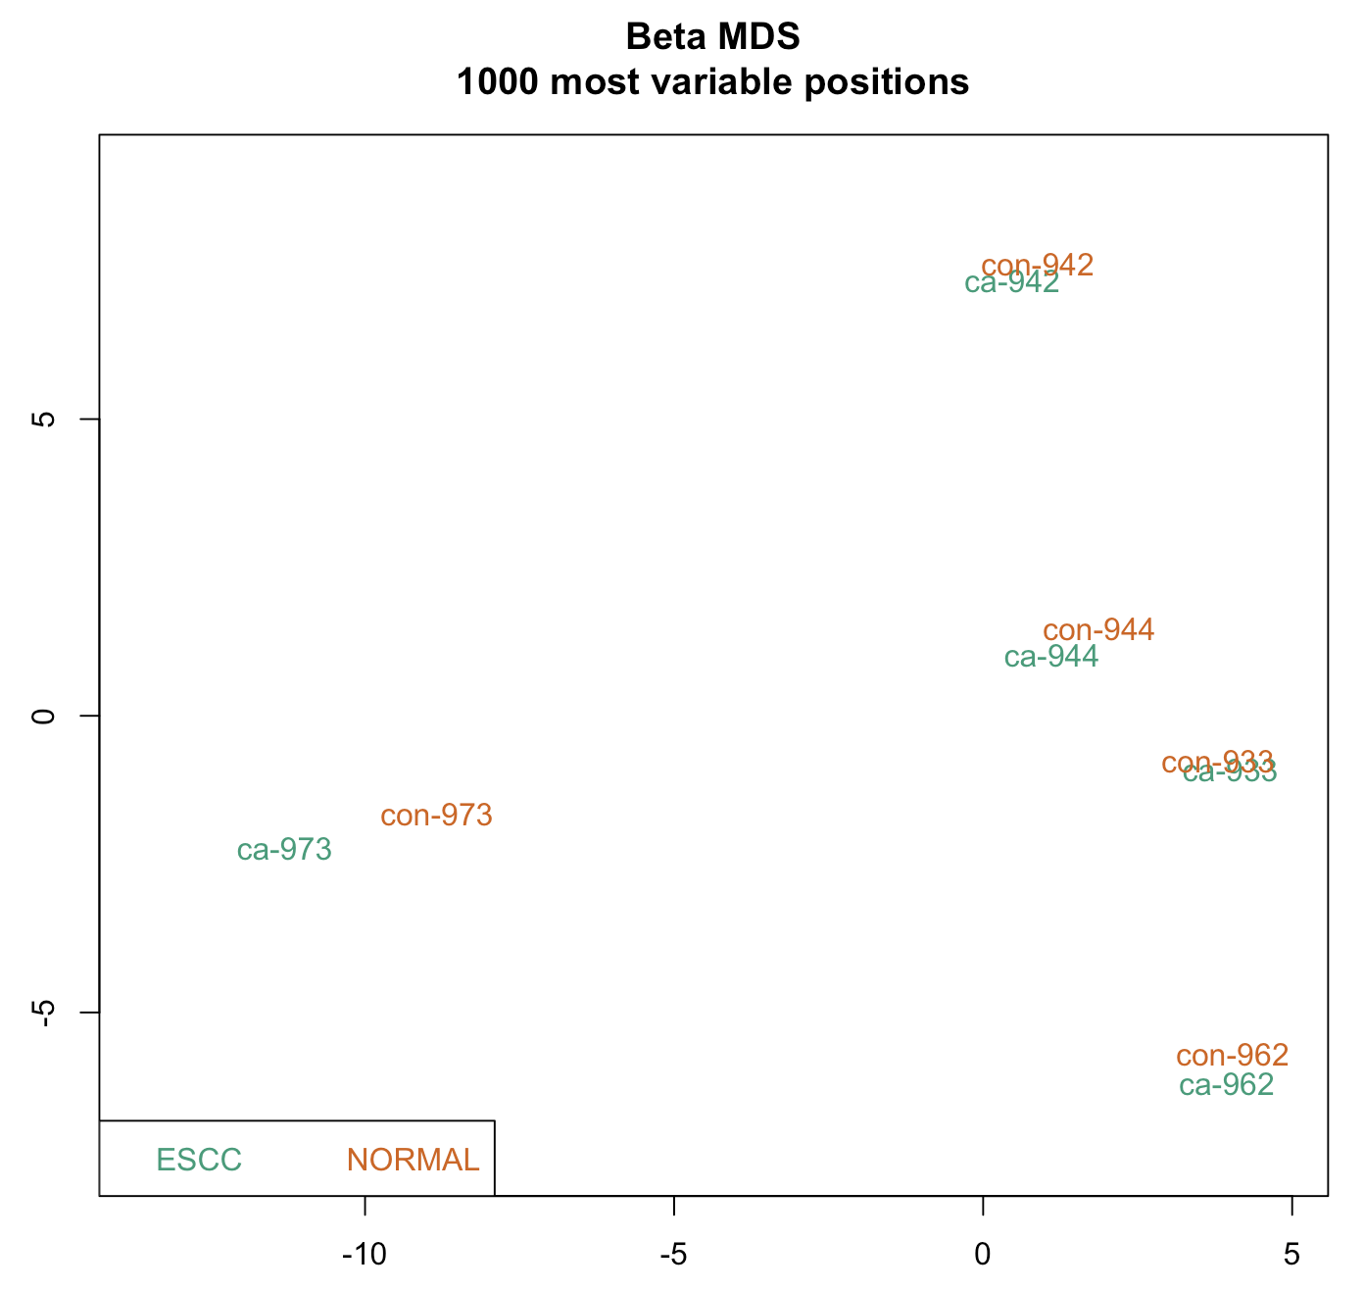
Figure 1. MDS plot of beta-values.
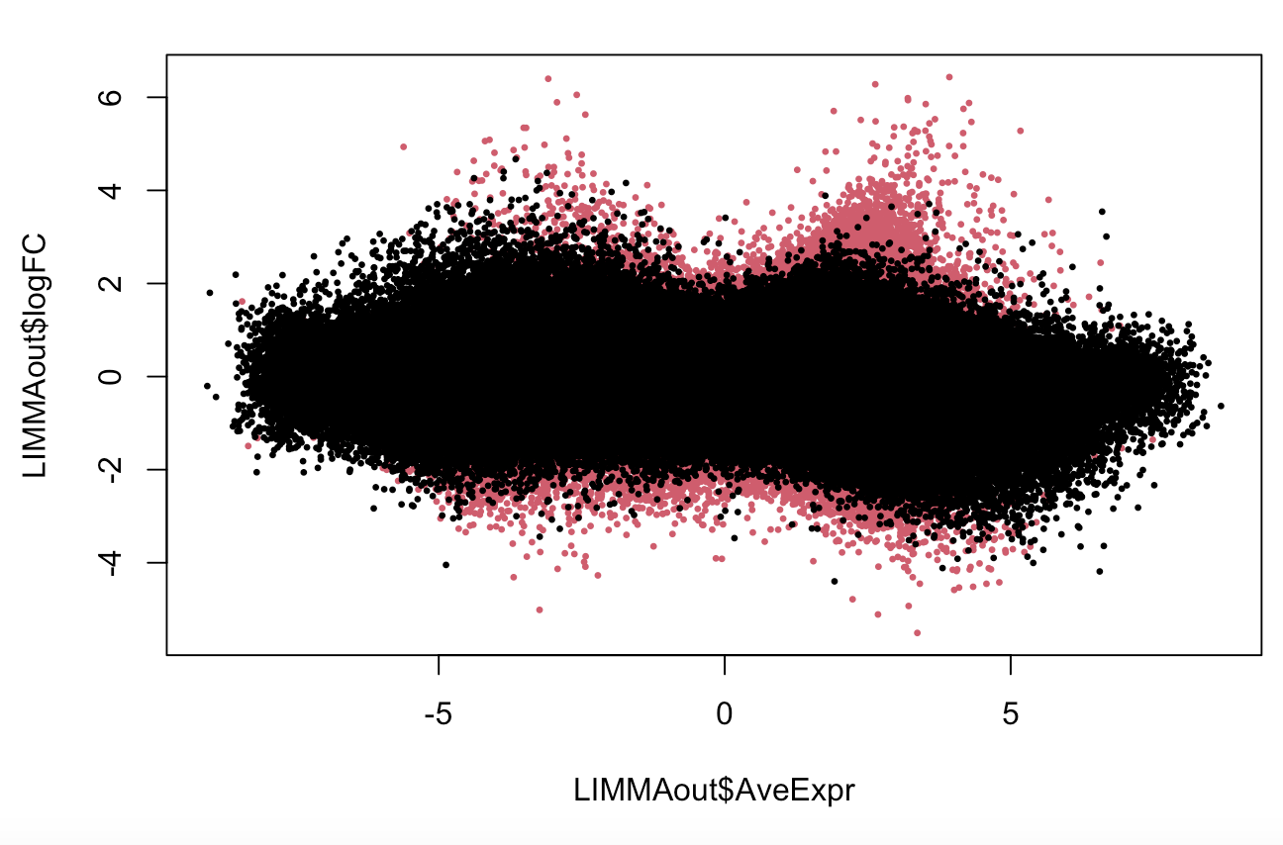
Figure 2. MA plot of log fold changes between M-values in ESCC and normal tissue.
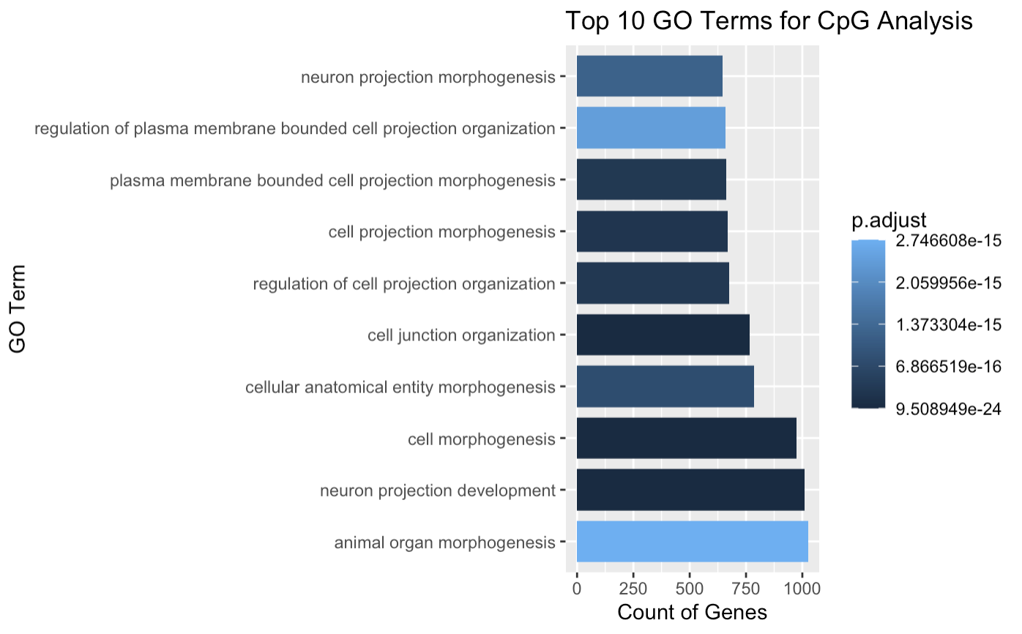
Figure 3. Top 10 GO Terms for CpG analysis.
  - RNA-seq Data Analysis
The MDS plot (Figure 4) highlights clear separation between Normal and ECA samples, suggesting a significant group effect. To account for individual variability, a patient effect was incorporated in matrix design as a factor factor in the statistical model.
Using the likelihood ratio test with the glmQLFTest() function, a total of 3,780 genes (upregulated, logFC > 0) and 3,525 genes (downregulated, logFC < 0) were identified as significantly differentially expressed among 24,315 genes, based on a FDR threshold of 0.05. The results are visualized in the MA-plot in Figure 5, and the top significant genes are listed in Table 3. Gene set analysis was performed on the significant genes using over-representation analysis of GO terms. After applying Benjamini-Hochberg FDR correction, 2,066 GO Biological Process terms were identified as significantly differentially regulated. Figure 6 shows the top 10 GO terms for CpG analysis, which include protein localization to organelle, small GTPase-mediated signal transduction, and RNA splicing.
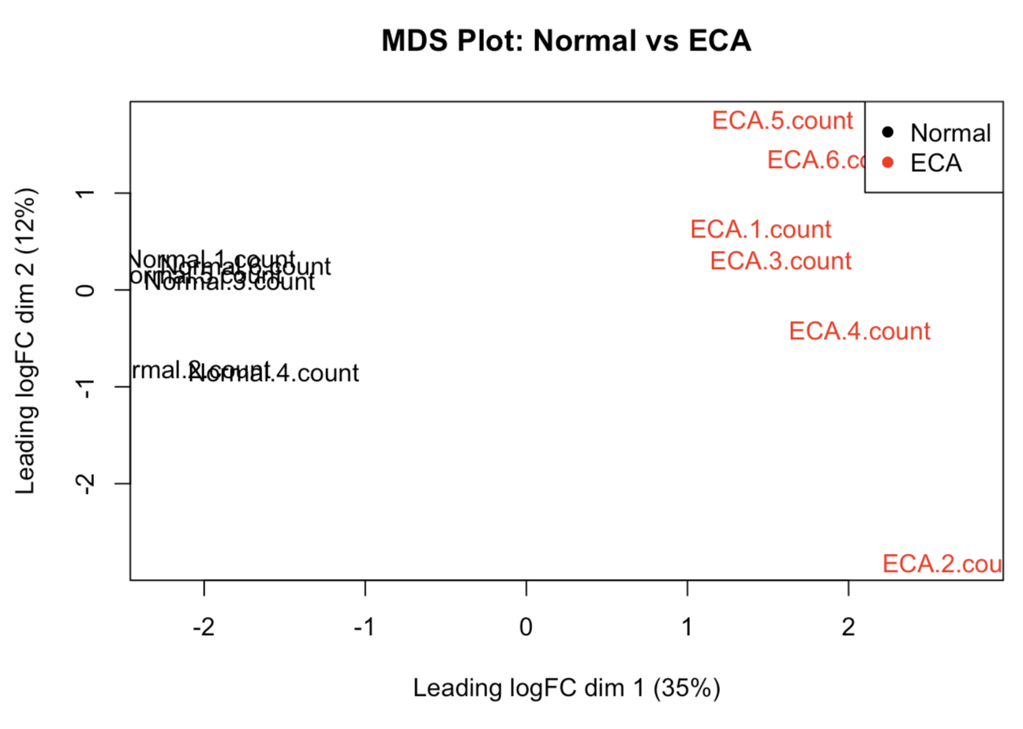
Figure 4. MDS Plot: Clustering of Normal vs ECA Samples

Gene_  name | logFC | P_value | FDR
CST1 | -9.96 | 2.97e-12 | 8.14e-08
KRT75 | -7.88 | 1.12e-11 | 1.53e-07
MMP11 | -6.49 | 4.3e-10 | 3.96e-06
P2RX2 | 6.82 | 7.18e-10 | 4.92e-06
ADIPOQ | 8.19 | 1.91e-09 | 1.05e-05
UNC13C | 4.56 | 2.31e-09 | 1.06e-05
ADAMTS20 | -5.09 | 3.76e-09 | 1.46e-05
COL10A1 | -7.56 | 4.38e-09 | 1.46e-05
MISP | -4.64 | 4.79e-09 | 1.46e-05
UPK1A | 4.60 | 6.68e-09 | 1.83e-05
Table 3. Key genes with differential expression between tumor and healthy tissues identified in the RNA-seq analysis.
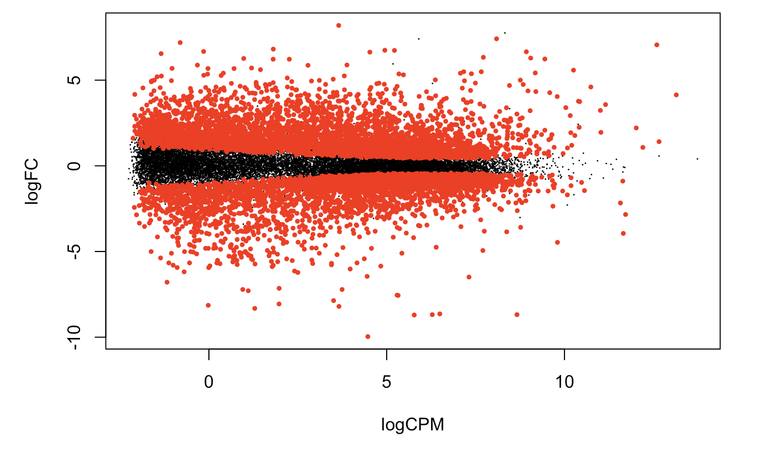
Figure 5. MA-plot of log fold changes between expression values in ESC and normal tissue.
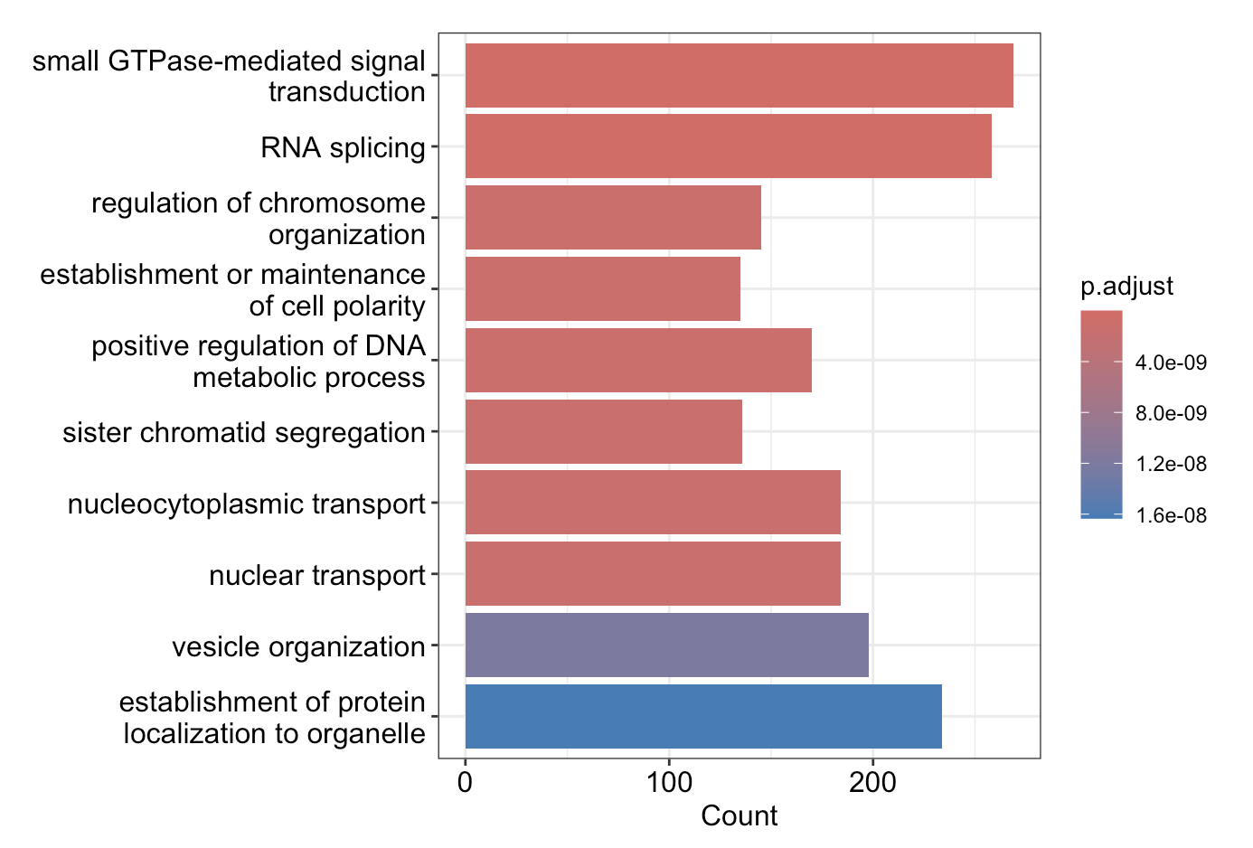Figure 6. Top 10 GO Terms for CpG analysis.
  - Comparison of Different Results
The overlap between gene expression and methylation analyses was further investigated. This included assessing the overlap of differentially methylated CpG sites and differentially methylated regions (DMRs).
A Venn diagram comparing RNA-seq and DMRs (see Figure 7) showed no overlap between the two. However, when comparing RNA-seq data with CpG methylation results, 1000 genes out of 6305 and 1194 genes exhibited overlapping results (see figure 8).
Additionally, a comparison of the top 10 GO Biological Process terms between the two analyses revealed 26 overlapping terms (see Figure 9). Some of the most significant overlapping terms include: "positive regulation of cellular component organization," "regulation of organelle organization," and "regulation of cellular processes."
Lastly, genes of interest (GOI) were selected based on common genes identified in both the RNA-seq and CpG analyses. Upregulated genes include CFLAR, KDM1A, and RBM6, while downregulated genes such as STPG1, SEMA3F, ANKIB1, HECW1, MAD1L1, and ICA1 were found to have reduced expression.
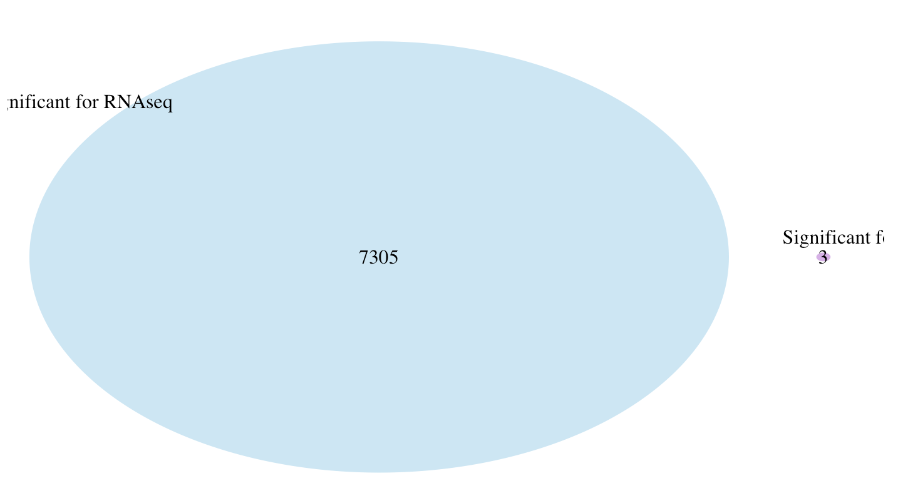
Figure 7. overlap between RNAseq results and DMRs
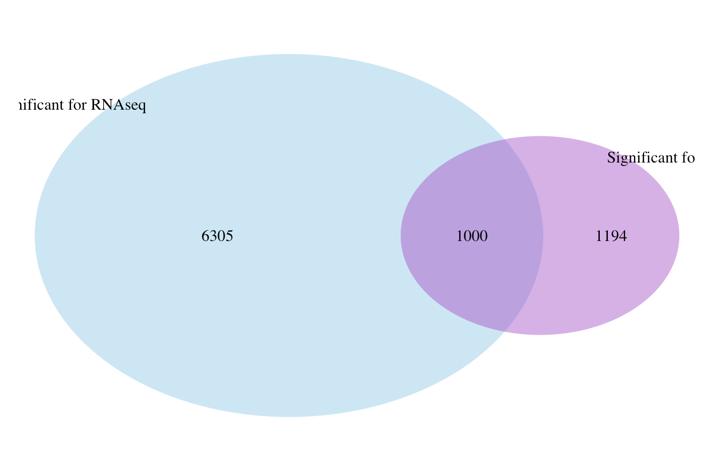
Figure 8. overlap between RNAseq results and CpG methylation results

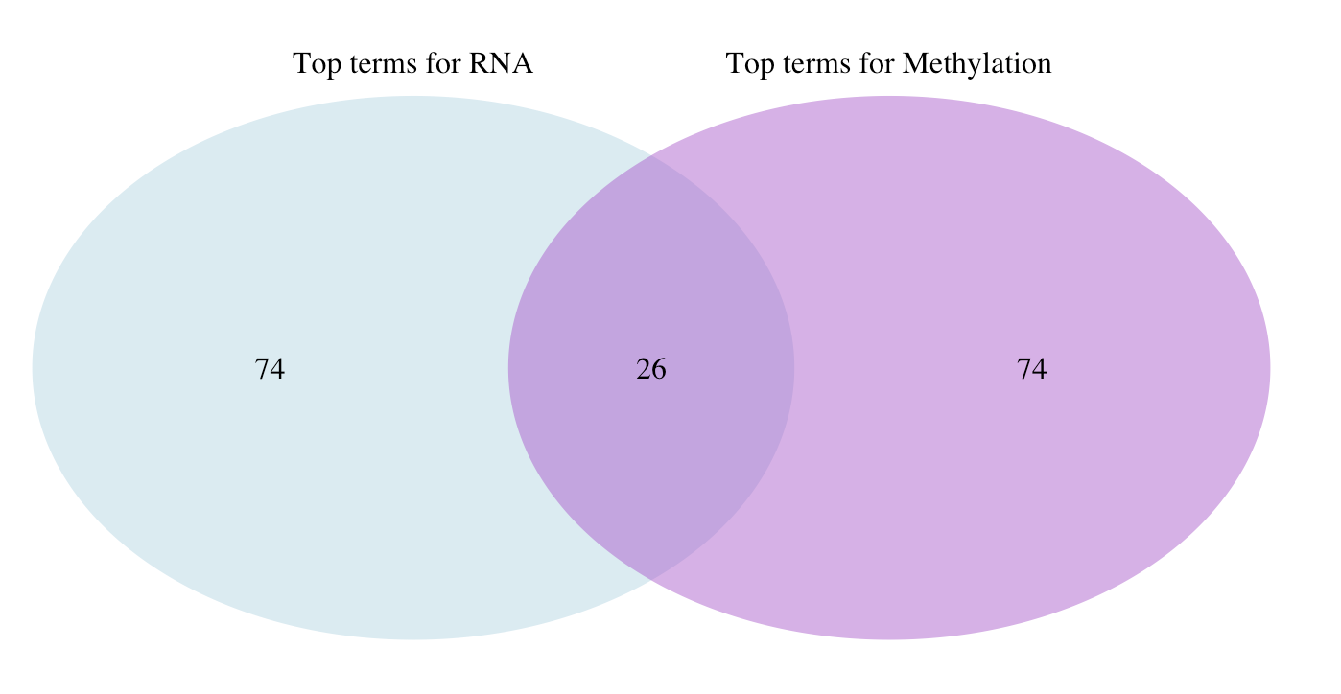
Figure 9. overlap between RNAseq results and CpG methylation results

- Discussion
Alterations in DNA methylation patterns are commonly observed in tumors, making it crucial to understand how these changes contribute to disease. The most widely used method for analyzing methylation differences between samples is the sliding window approach to identify differentially methylated regions (DMRs) (VanderKraats et al., 2013). Ideally, we would expect more overlap with DMRs than with individual CpG sites. However, in my analysis, no overlap was detected between significant RNA-seq genes and DMRs, while 1000 CpGs showed overlap. This indicates that changes in gene expression may reflect methylation changes at specific CpG sites, which are likely to play a significant role in regulating gene expression.
The possible reasons for this could be:
CpG Sensitivity: CpG sites are more responsive to methylation changes and often directly affect gene expression, particularly in promoter or regulatory regions. In contrast, DMRs require significant methylation changes across multiple CpGs, making them less sensitive to subtle changes in gene expression. Additionally, the stricter statistical criteria for identifying DMRs may exclude smaller methylation changes at individual CpGs, indicating that the lack of DMRs does not rule out their association with gene expression.
DMR Analysis Settings: The bumphunter method applied in my study used stringent parameters (cutoff = 0.25, B=500), which might limit the detection of DMRs with smaller methylation differences in CpGs.
Sample Size and Variability: With a sample size of only 10-12, there may not be enough statistical power to detect significant DMRs, even though changes in individual CpGs are more noticeable. A larger sample size would likely enhance the ability to identify subtle methylation differences.
Lastly, interesting genes, such as STPG1, SEMA3F, HECW1, MAD1L1, ICA1, CFLAR, MTMR7, KDM1A, and RBM6, which overlapped in both differential expression and CpG analyses, were found to be downregulated. Although these genes are not directly associated with esophageal squamous cell carcinoma (ESCC) or esophageal cancer, they have been linked to the progression of other cancers, including prostate cancer, lymphoma, and gastric cancer (Chen et al., 2022), (Doçi et al., 2015).
Additionally, the primary biological processes that showed overlap between differential expression and methylation analyses included GO terms related to cellular component organization and biogenesis. Structural changes in cells are a hallmark of cancer. These alterations can significantly influence processes like tumor formation, metastasis, and evasion of apoptosis. As a result, the changes in gene expression and methylation associated with these processes are essential in cancer research (Xu et al., 2021).

- Reflection and Challenges
Difference from Published Results
The most significant discrepancy was the absence of SPOCD1 as a key gene in my RNA-seq analysis, despite a related study showing it as highly differentially expressed between normal and ESCC samples. This warrants further investigation into data or methodological differences (Lin et al., 2022).
Goodness-of-Fit (GoF) Analysis:
The qq-plot of residual deviance showed deviations from normality, suggesting model misfit (see Figure 9). This may indicate issues with outliers, sample size, or model sensitivity, which could be addressed with adjustments or alternative techniques
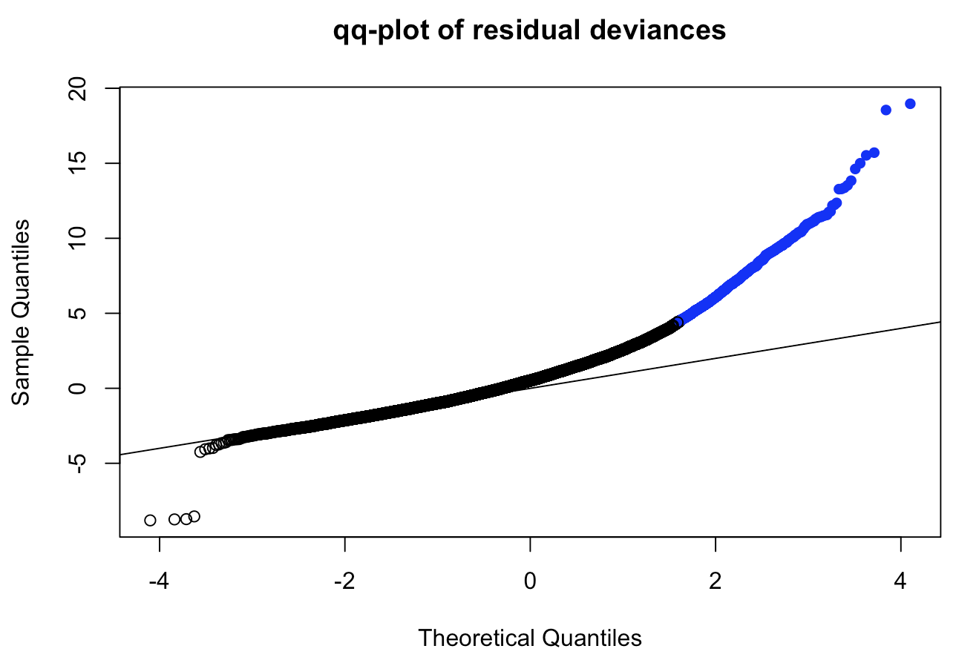
Figure 9. QQ-plot for model residuals

- Conclusion
The integration of methylation and gene expression data provides valuable insights into the molecular mechanisms of ESCC. The overlap of key genes and biological processes associated with cancer underscores the importance of considering both epigenetic and transcriptional changes in understanding cancer pathogenesis. Further research with larger sample sizes and refined analysis techniques could enhance the robustness of these findings.

References
Chen, Y., Jiang, L., Xia, L., Zhang, G., & Chen, L. (2022). Thpok inhibits the immune escape of gastric cancer cells by inducing STPG1 to inactivate the Erk pathway. BMC Immunology, 23(1). https://doi.org/10.1186/s12865-022-00485-5
Conway, E., Wu, H., & Tian, L. (2023). Overview of risk factors for esophageal squamous cell carcinoma in China. Cancers, 15(23), 5604. https://doi.org/10.3390/cancers15235604
Doçi, C. L., Mikelis, C. M., Lionakis, M. S., Molinolo, A. A., & Gutkind, J. S. (2015). Genetic identification of sema3f as an antilymphangiogenic metastasis suppressor gene in head and neck squamous carcinoma. Cancer Research, 75(14), 2937–2948. https://doi.org/10.1158/0008-5472.can-14-3121
Lin, Z., Chen, L., Wu, T., Zhang, Y., Huang, X., Chen, Y., Chen, J., & Xu, Y. (2022). Prognostic value of SPOCD1 in esophageal squamous cell carcinoma: A comprehensive study based on bioinformatics and validation. Frontiers in Genetics, 13. https://doi.org/10.3389/fgene.2022.872026
Tarazi, M., Chidambaram, S., & Markar, S. R. (2021). Risk factors of esophageal squamous cell carcinoma beyond alcohol and smoking. Cancers, 13(5), 1009. https://doi.org/10.3390/cancers13051009
VanderKraats, N. D., Hiken, J. F., Decker, K. F., & Edwards, J. R. (2013). Discovering high-resolution patterns of differential DNA methylation that correlate with gene expression changes. Nucleic Acids Research, 41(14), 6816–6827. https://doi.org/10.1093/nar/gkt482
Xu, G. B., Wang, H., Chen, S. A., & Chen, H. (2021). Epigenetic regulation in cancer metastasis. Medical Epigenetics, 471–489. https://doi.org/10.1016/b978-0-12-823928-5.00032-3

Appendix A:

Differential Methylation Analysis of Esophageal Squamous Cell Carcinoma (ESCC) and Paired Normal Tissue Samples
Chaeyoung Kim
2024-12-13
This R script performs differential methylation analysis on Illumina Infinium HumanMethylation850 BeadChip data from ESCC and paired normal tissue samples. It begins with data preprocessing and quality control using minfi and ENmix, followed by normalization of raw methylation intensities. The script then conducts differential methylation analysis using the limma package and visualizes the results with volcano and MA plots. It also annotates the differentially methylated CpGs with genomic features and performs gene-level analysis, identifying the most significant genes with methylation changes.

General info
Species: Homo Sapiens Microarray type: Illumina Infinium HumanMethylation850 BeadChip Samples: The dataset includes five ESCC samples and five matched adjacent normal tissue samples

load required packages
##load packages
library(affy)
library(arrayQualityMetrics)
library(ArrayExpress)
library(limma)
library(siggenes)
library(GEOquery)
library(ArrayExpress)
library(htmltools)
library(biomaRt)
library(tximport)
library(tximeta)
library(minfi)
library(ENmix)
library(IlluminaHumanMethylationEPICmanifest)
library(readr)
library(dplyr)
library(tidyr)
library(minfi)
library(FDb.InfiniumMethylation.hg19)
library(minfiData)
library(IlluminaHumanMethylationEPICanno.ilm10b4.hg19)
library(GenomicRanges)
library(ggplot2)

set the working directory
setwd("/Users/kimchaeyoung/Desktop/Applied_HT_analysis/Project")
dir <- "/Users/kimchaeyoung/Desktop/Applied_HT_analysis/Project/GSE157807_RAW"

1. Load the Infinium data (.idat files)
fibromethyl_RG <-read.metharray.exp(dir, extended = TRUE, force = TRUE)
pheno <- read.table("phenotype_data.txt", header = T, sep = " ")
head(pheno)
## SampleID PatientID TissueType
## 1 GSM4775294 ca-973 ESCC
## 2 GSM4775295 con-973 NORMAL
## 3 GSM4775296 ca-962 ESCC
## 4 GSM4775297 con-962 NORMAL
## 5 GSM4775298 ca-944 ESCC
## 6 GSM4775299 con-944 NORMAL

Match the samplenames to the phenotypic sample IDs
sampleNames(fibromethyl_RG) <- substr(sampleNames(fibromethyl_RG), 1, 10)
all(sampleNames(fibromethyl_RG) == pheno$SampleID)
## [1] TRUE

Add the phenotypic annotation
rownames(pheno) <- pheno$SampleID
pData(fibromethyl_RG) <- DataFrame(pheno)

Take a look at your data
fibromethyl_RG
## class: RGChannelSetExtended
## dim: 1051539 10
## metadata(0):
## assays(5): Green Red GreenSD RedSD NBeads
## rownames(1051539): 1600101 1600111 ... 99810990 99810992
## rowData names(0):
## colnames(10): GSM4775294 GSM4775295 ... GSM4775302 GSM4775303
## colData names(3): SampleID PatientID TissueType
## Annotation
## array: IlluminaHumanMethylationEPIC
## annotation: ilm10b4.hg19
head(pData(fibromethyl_RG)) # phenotypic data
## DataFrame with 6 rows and 3 columns
## SampleID PatientID TissueType
## <character> <character> <character>
## GSM4775294 GSM4775294 ca-973 ESCC
## GSM4775295 GSM4775295 con-973 NORMAL
## GSM4775296 GSM4775296 ca-962 ESCC
## GSM4775297 GSM4775297 con-962 NORMAL
## GSM4775298 GSM4775298 ca-944 ESCC
## GSM4775299 GSM4775299 con-944 NORMAL
head(getAnnotation(fibromethyl_RG)) # probe/gene annotation data
## DataFrame with 6 rows and 46 columns
## chr pos strand Name AddressA
## <character> <integer> <character> <character> <character>
## cg18478105 chr20 61847650 - cg18478105 46761277
## cg09835024 chrX 24072640 - cg09835024 16745152
## cg14361672 chr9 131463936 + cg14361672 51800947
## cg01763666 chr17 80159506 + cg01763666 37768834
## cg12950382 chr14 105176736 + cg12950382 8726444
## cg02115394 chr13 115000168 + cg02115394 68602543
## AddressB ProbeSeqA ProbeSeqB
## <character> <character> <character>
## cg18478105 86644198 AAATAAATTTCACTCTCAAA.. AAATAAATTTCGCTCTCAAA..
## cg09835024 81631976 AATAAACACCAACCCCAAAC.. AATAAACGCCGACCCCGAAC..
## cg14361672 7743487 ATCACTACCTAATCTATAAC.. ATCACTACCTAATCTATAAC..
## cg01763666 23754592 AAACAAAAATAAACAAACTC.. GAACAAAAATAAACGAACTC..
## cg12950382 76660327 ATACCAAAAAATAACAATAT.. GTACCGAAAAATAACAATAT..
## cg02115394 59659581 AAAATCACTACAACACCTCT.. AAAATCGCTACGACGCCTCT..
## Type NextBase Color Probe_rs Probe_maf
## <character> <character> <character> <character> <numeric>
## cg18478105 I C Grn NA NA
## cg09835024 I A Red NA NA
## cg14361672 I T Red NA NA
## cg01763666 I C Grn NA NA
## cg12950382 I A Red rs12882277 0.378464
## cg02115394 I A Red NA NA
## CpG_rs CpG_maf SBE_rs SBE_maf Islands_Name
## <character> <numeric> <character> <numeric> <character>
## cg18478105 NA NA NA NA chr20:61846843-61848..
## cg09835024 NA NA NA NA chrX:24072558-24073135
## cg14361672 NA NA NA NA chr9:131464843-13146..
## cg01763666 NA NA NA NA
## cg12950382 NA NA NA NA
## cg02115394 NA NA NA NA chr13:115000148-1150..
## Relation_to_Island Forward_Sequence SourceSeq
## <character> <character> <character>
## cg18478105 Island TCCCGTCTTACGGGATGGAT.. CGGTCCCCGCCCCGCCGCAC..
## cg09835024 Island AGCCCCGTCATAGGTGGGCG.. GGTGGGCGCCGACCCCGAGC..
## cg14361672 N_Shore TCACCTTCCCACCTCCTGGA.. CGCAGGATGCCAGGACGGGC..
## cg01763666 OpenSea CTGGAATGCCAGCTGCTGCT.. CGCCTGCCTCAGCTTAGCTG..
## cg12950382 OpenSea CCCTGCTGCCACCACCTCGG.. CGCCACTCGGGCACGTGCAC..
## cg02115394 Island TTCTGGGGAAAGAAGGCTCA.. GGAATCGCTGCGGCGCCTCT..
## UCSC_RefGene_Name UCSC_RefGene_Accession UCSC_RefGene_Group
## <character> <character> <character>
## cg18478105 YTHDF1 NM_017798 TSS200
## cg09835024 EIF2S3 NM_001415 TSS1500
## cg14361672 PKN3 NM_013355 TSS1500
## cg01763666 CCDC57 NM_198082 Body
## cg12950382 INF2;INF2 NM_022489;NM_001031714 Body;Body
## cg02115394 CDC16;CDC16 NM_003903;NM_001078645 TSS200;TSS200
## Phantom4_Enhancers Phantom5_Enhancers DMR X450k_Enhancer
## <character> <character> <character> <character>
## cg18478105
## cg09835024
## cg14361672
## cg01763666
## cg12950382
## cg02115394
## HMM_Island Regulatory_Feature_Name
## <character> <character>
## cg18478105 20:61317142-61318498 20:61846284-61847956
## cg09835024 X:24071907-24073667
## cg14361672
## cg01763666 17:77752688-77752973
## cg12950382 14:104247518-104247873
## cg02115394 13:114018251-114018976 13:115000009-115001429
## Regulatory_Feature_Group GencodeBasicV12_NAME
## <character> <character>
## cg18478105 Promoter_Associated YTHDF1;YTHDF1
## cg09835024 Promoter_Associated EIF2S3
## cg14361672 PKN3
## cg01763666
## cg12950382
## cg02115394 Promoter_Associated CDC16;CDC16;CDC16;CD..
## GencodeBasicV12_Accession GencodeBasicV12_Group
## <character> <character>
## cg18478105 ENST00000370334.4;EN.. TSS200;TSS200
## cg09835024 ENST00000253039.4 TSS200
## cg14361672 ENST00000291906.4 TSS1500
## cg01763666
## cg12950382
## cg02115394 ENST00000375312.3;EN.. TSS200;TSS1500;TSS15..
## GencodeCompV12_NAME GencodeCompV12_Accession
## <character> <character>
## cg18478105 YTHDF1;YTHDF1 ENST00000370334.4;EN..
## cg09835024 EIF2S3;EIF2S3;EIF2S3 ENST00000487075.1;EN..
## cg14361672 PKN3 ENST00000291906.4
## cg01763666
## cg12950382 INF2;INF2 ENST00000474229.1;EN..
## cg02115394 CDC16;CDC16;CDC16;CD.. ENST00000360383.3;EN..
## GencodeCompV12_Group DNase_Hypersensitivity_NAME
## <character> <character>
## cg18478105 TSS200;TSS200 chr20:61847520-61847..
## cg09835024 TSS1500;TSS1500;TSS200 chrX:24072600-24073395
## cg14361672 TSS1500
## cg01763666 chr17:80159145-80159..
## cg12950382 5'UTR;TSS1500
## cg02115394 TSS200;TSS1500;TSS15..
## DNase_Hypersensitivity_Evidence_Count OpenChromatin_NAME
## <character> <character>
## cg18478105 3
## cg09835024 3
## cg14361672 chr9:131463740-13146..
## cg01763666 3
## cg12950382 chr14:105171651-1051..
## cg02115394 chr13:114999804-1150..
## OpenChromatin_Evidence_Count TFBS_NAME TFBS_Evidence_Count
## <character> <character> <character>
## cg18478105
## cg09835024
## cg14361672 3
## cg01763666
## cg12950382 6
## cg02115394 6
## Methyl27_Loci Methyl450_Loci Random_Loci
## <character> <character> <character>
## cg18478105 TRUE
## cg09835024 TRUE
## cg14361672 TRUE
## cg01763666 TRUE
## cg12950382 TRUE
## cg02115394 TRUE
head(getRed(fibromethyl_RG)) # red intensities
## GSM4775294 GSM4775295 GSM4775296 GSM4775297 GSM4775298 GSM4775299
## 1600101 8583 12827 3830 9367 4954 10840
## 1600111 3453 2761 2645 2980 2439 2774
## 1600115 17883 22055 16548 18121 15096 19506
## 1600123 8856 3802 6330 4031 8918 3456
## 1600131 8768 9344 9284 9278 8703 9871
## 1600135 6165 4901 1791 2787 6313 3551
## GSM4775300 GSM4775301 GSM4775302 GSM4775303
## 1600101 5862 11990 9392 12172
## 1600111 2854 3314 5044 3472
## 1600115 18868 20872 20537 21858
## 1600123 10723 4022 4632 4070
## 1600131 9592 10419 10582 10919
## 1600135 6684 3320 3028 3217
head(getGreen(fibromethyl_RG)) # green intensities
## GSM4775294 GSM4775295 GSM4775296 GSM4775297 GSM4775298 GSM4775299
## 1600101 10460 6324 11666 9540 12510 8582
## 1600111 8063 8561 8776 7726 8740 9129
## 1600115 2273 2644 1756 2398 2162 2650
## 1600123 3899 7585 4028 6637 4704 8566
## 1600131 452 701 378 1095 725 1101
## 1600135 8546 9023 8894 9067 8439 10444
## GSM4775300 GSM4775301 GSM4775302 GSM4775303
## 1600101 12631 10981 11332 10098
## 1600111 9813 10796 8260 9675
## 1600115 2296 2969 2813 3319
## 1600123 5983 8557 9007 7526
## 1600131 838 1308 822 2712
## 1600135 9149 12027 11627 12507
head(getNBeads(fibromethyl_RG)) # number of beads on the array
## GSM4775294 GSM4775295 GSM4775296 GSM4775297 GSM4775298 GSM4775299
## 1600101 17 12 10 3 14 14
## 1600111 16 13 11 15 10 20
## 1600115 14 13 6 21 9 9
## 1600123 6 6 13 12 9 9
## 1600131 16 10 14 15 17 12
## 1600135 13 12 8 19 20 10
## GSM4775300 GSM4775301 GSM4775302 GSM4775303
## 1600101 18 15 15 12
## 1600111 11 15 11 16
## 1600115 15 14 19 11
## 1600123 11 10 12 10
## 1600131 18 12 15 14
## 1600135 6 18 16 22
Subset the data
fibromethyl_RG <- fibromethyl_RG[, pData(fibromethyl_RG)$TissueType %in% c("ESCC", "NORMAL")]
fibromethyl_RG
## class: RGChannelSetExtended
## dim: 1051539 10
## metadata(0):
## assays(5): Green Red GreenSD RedSD NBeads
## rownames(1051539): 1600101 1600111 ... 99810990 99810992
## rowData names(0):
## colnames(10): GSM4775294 GSM4775295 ... GSM4775302 GSM4775303
## colData names(3): SampleID PatientID TissueType
## Annotation
## array: IlluminaHumanMethylationEPIC
## annotation: ilm10b4.hg19
Change sample names to something more meaningful
sampleNames(fibromethyl_RG) <- paste(sampleNames(fibromethyl_RG), pData(fibromethyl_RG)$PatientID, sep = "_")

MDSplot
The MDS plot shows distinct clustering of Tumor and ESCC samples, indicating a strong tissue type effect on methylation.
mdsPlot(fibromethyl_RG, sampNames = pheno$PatientID, sampGroups = pheno$TissueType)
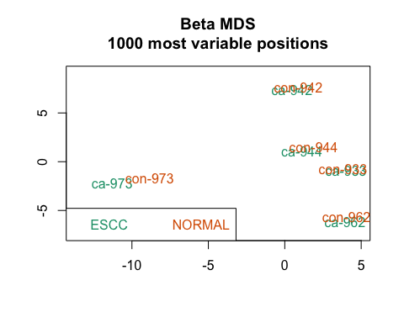

2. Convert RGChannelSetExtended to MethylSet (nopreprocessing)
fibromethyl_raw <- preprocessRaw(fibromethyl_RG)
fibromethyl_raw
## class: MethylSet
## dim: 865859 10
## metadata(0):
## assays(2): Meth Unmeth
## rownames(865859): cg18478105 cg09835024 ... cg10633746 cg12623625
## rowData names(0):
## colnames(10): GSM4775294_ca-973 GSM4775295_con-973 ...
## GSM4775302_ca-933 GSM4775303_con-933
## colData names(3): SampleID PatientID TissueType
## Annotation
## array: IlluminaHumanMethylationEPIC
## annotation: ilm10b4.hg19
## Preprocessing
## Method: Raw (no normalization or bg correction)
## minfi version: 1.50.0
## Manifest version: 0.3.0

Function to calculate M-values
getM <- function(Methylset, offset = 1){
M <- log2((getMeth(Methylset)+offset)/(getUnmeth(Methylset)+offset))
return(M)
}

Take a look at the raw M- and beta-values
head(getB(fibromethyl_raw, offset = 100)) # offset is 100 by default
## GSM4775294_ca-973 GSM4775295_con-973 GSM4775296_ca-962
## cg18478105 0.02037731 0.03109891 0.02054859
## cg09835024 0.06172306 0.06293996 0.02378288
## cg14361672 0.61400311 0.56718493 0.65933080
## cg01763666 0.82792407 0.74343134 0.83734793
## cg12950382 0.95796548 0.95489454 0.97870947
## cg02115394 0.07590685 0.09547401 0.09380235
## GSM4775297_con-962 GSM4775298_ca-944 GSM4775299_con-944
## cg18478105 0.03490071 0.02270157 0.02921835
## cg09835024 0.03853107 0.03552134 0.04718218
## cg14361672 0.60851766 0.61657085 0.62235043
## cg01763666 0.84669986 0.79726187 0.80676104
## cg12950382 0.97014384 0.96592052 0.95276292
## cg02115394 0.11122933 0.08732973 0.09858528
## GSM4775300_ca-942 GSM4775301_con-942 GSM4775302_ca-933
## cg18478105 0.04628510 0.03395232 0.02584976
## cg09835024 0.06220547 0.02824983 0.03910984
## cg14361672 0.67525773 0.65724069 0.44645227
## cg01763666 0.78959714 0.79593858 0.84665083
## cg12950382 0.97379239 0.96207481 0.95842527
## cg02115394 0.05235188 0.10389376 0.11233870
## GSM4775303_con-933
## cg18478105 0.03023432
## cg09835024 0.03624792
## cg14361672 0.64133140
## cg01763666 0.77531340
## cg12950382 0.97697621
## cg02115394 0.08184721
head(getM(fibromethyl_raw, offset = 1)) # offset is 1 by default
## GSM4775294_ca-973 GSM4775295_con-973 GSM4775296_ca-962
## cg18478105 -5.572929 -4.9498211 -5.5544487
## cg09835024 -3.907059 -3.8815180 -5.3301306
## cg14361672 0.695017 0.4072892 0.9819998
## cg01763666 2.353933 1.5770407 2.4752358
## cg12950382 5.046578 4.7951514 6.5451254
## cg02115394 -3.586201 -3.2293933 -3.2539252
## GSM4775297_con-962 GSM4775298_ca-944 GSM4775299_con-944
## cg18478105 -4.7730217 -5.4109550 -5.039479
## cg09835024 -4.6200376 -4.7373754 -4.316086
## cg14361672 0.6589631 0.7108818 0.744739
## cg01763666 2.5679166 2.0456904 2.132450
## cg12950382 5.7611918 5.4810015 4.717919
## cg02115394 -2.9813925 -3.3693331 -3.177278
## GSM4775300_ca-942 GSM4775301_con-942 GSM4775302_ca-933
## cg18478105 -4.352037 -4.8188211 -5.2214340
## cg09835024 -3.890386 -5.0823355 -4.5982407
## cg14361672 1.084901 0.9641675 -0.2968053
## cg01763666 1.979098 2.0227699 2.5564314
## cg12950382 6.173927 5.2650289 4.9940694
## cg02115394 -4.157782 -3.0928352 -2.9667276
## GSM4775303_con-933
## cg18478105 -4.991068
## cg09835024 -4.715291
## cg14361672 0.859330
## cg01763666 1.839024
## cg12950382 6.327118
## cg02115394 -3.474192

3. Quality control on raw data
The raw data plots highlight the variability and technical biases present before preprocessing. The Red & Green Intensities and Meth & Unmeth Intensities show significant differences between samples, indicating the need for normalization to reduce technical noise. Similarly, the Sum of Meth & Unmeth Intensities and Combined Meth & Unmeth Intensities reveal inconsistent distributions across samples, reflecting batch effects and other biases. The Beta-values and M-values distributions are uneven and lack clear separation, further emphasizing the importance of preprocessing to make the data suitable for downstream methylation analysis.
# Plot red and green intensities together (use RGChannelSet)
multifreqpoly(
mat = log2(getGreen(fibromethyl_RG) + 1),
col = "green",
main = "Raw Green Intensities",
xlab = "Log2 Intensity",
legend = NULL # remove legend
)
multifreqpoly(
mat = log2(getRed(fibromethyl_RG) + 1),
col = "red",
append = TRUE, # combine 2 plots
legend = NULL # no legend here
)
legend("left", legend = c("Green", "Red"), fill = c("green", "red")) # add legend manually
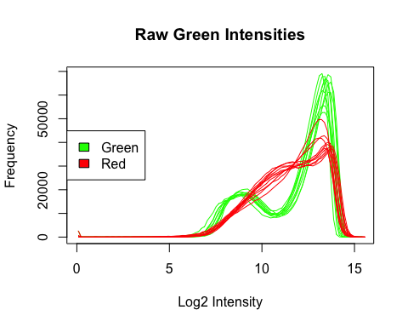
# Plot methylated and unmethylated intensities together (use MethylSet)
multifreqpoly(
mat = log2(getMeth(fibromethyl_raw) + 1),
col = "orange",
main = "Raw Methylated Intensities",
xlab = "Log2 Intensity",
legend = NULL
)
multifreqpoly(
mat = log2(getUnmeth(fibromethyl_raw) + 1),
col = "blue",
append = TRUE,
legend = NULL # no legend here
)
legend("left", legend = c("Methylated", "Unmethylated"), fill = c("orange", "blue")) # add legend manually
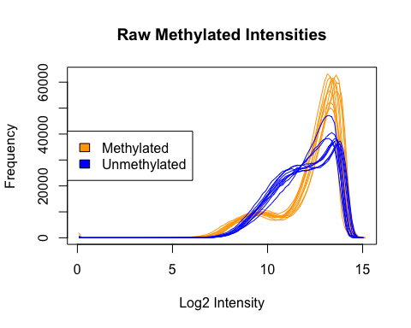
# Plot summed methylated and unmethylated intensities
multifreqpoly(
mat = log2(getMeth(fibromethyl_raw) + getUnmeth(fibromethyl_raw) + 1),
main = "Raw Sum of Meth & Unmeth Intensities",
xlab = "Log2 Intensity",
legend = list(
x = "left",
legend = colnames(fibromethyl_raw), fill = 1:ncol(fibromethyl_raw),
cex = 0.6
)
)
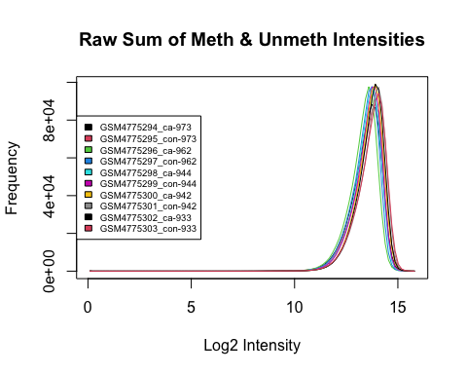
# Plot combined methylated and unmethylated intensities
multifreqpoly(
mat = log2(rbind(getMeth(fibromethyl_raw) + 1, getUnmeth(fibromethyl_raw)) + 1),
main = "Raw Combined Meth & Unmeth Intensities",
xlab = "Log2 Intensity",
legend = list(
x = "left",
legend = colnames(fibromethyl_raw),
fill = 1:ncol(fibromethyl_raw),
cex = 0.6
)
)
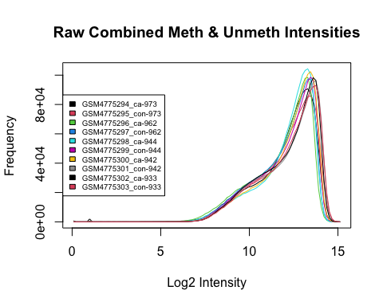
# Plot raw Beta-values
multifreqpoly(
mat = getB(fibromethyl_raw),
main = "Raw Beta-values",
xlab = "Beta-value",
legend = list(
x = "top",
legend = colnames(fibromethyl_raw),
fill = 1:ncol(fibromethyl_raw),
cex = 0.6
)
)
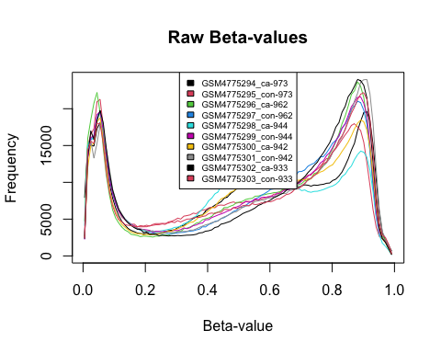
# Plot raw M-values
multifreqpoly(
mat = getM(fibromethyl_raw),
main = "Raw M-values",
xlab = "M-value",
legend = list(
x = "left",
legend = colnames(fibromethyl_raw),
fill = 1:ncol(fibromethyl_raw),
cex = 0.6
)
)
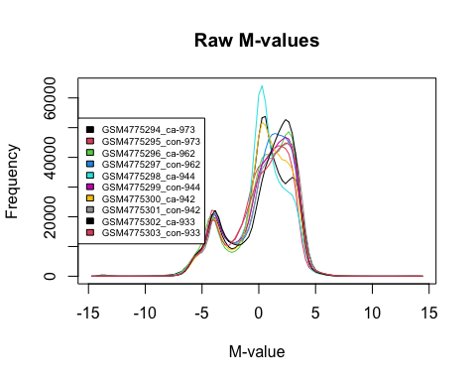

4. Filtering and Preprocessing

4.1. Quality control
- qc_CpG - A total of 5141 CpG sites were classified as low-quality, and majority of CpG sites have minimal low-quality data, supporting the dataset’s overall reliability.
- freqpolygon_beta_beforeQC & frepolygon_beta_afterGC - The graph exhibits two peaks, one near 0 (unmethylated CpGs) and another near 1 (methylated CpGs). This bimodal pattern is typical for methylation data and indicates a clear separation of methylated and unmethylated sites. Minimal changes founded to the raw distribution. This may indicate that the data was already consistent and reliable.
# Quality control function
fibromethyl_QC <- QCinfo(fibromethyl_RG)
## 0 samples with percentage of low quality CpG value greater than 0.05 or bisulfite intensity less than 11092.61
## 5141 CpGs with percentage of low quality value greater than 0.05
## Ploting qc_sample.jpg ...
## Done
## Ploting qc_CpG.jpg ...
## Done
## Identifying ourlier samples based on beta or total intensity values...
## After excluding low quality samples and CpGs
## 0 samples are outliers based on averaged total intensity value
## 0 samples are outliers in beta value distribution
## 0 outlier samples were added into badsample list
## WARNING: Sample size may be too small to correctly identify outlier samples!
## RECOMMAND: set outlier=FALSE or double check total intensity and beta value
## distribution plots to confirm
## Ploting freqpolygon_beta_beforeQC.jpg ...
## Done
## Ploting freqpolygon_beta_afterQC.jpg ...
## Done
names(fibromethyl_QC)
## [1] "detP" "nbead" "bisul" "badsample"
## [5] "badCpG" "outlier_sample"
knitr::include_graphics("qc_CpG.jpg")
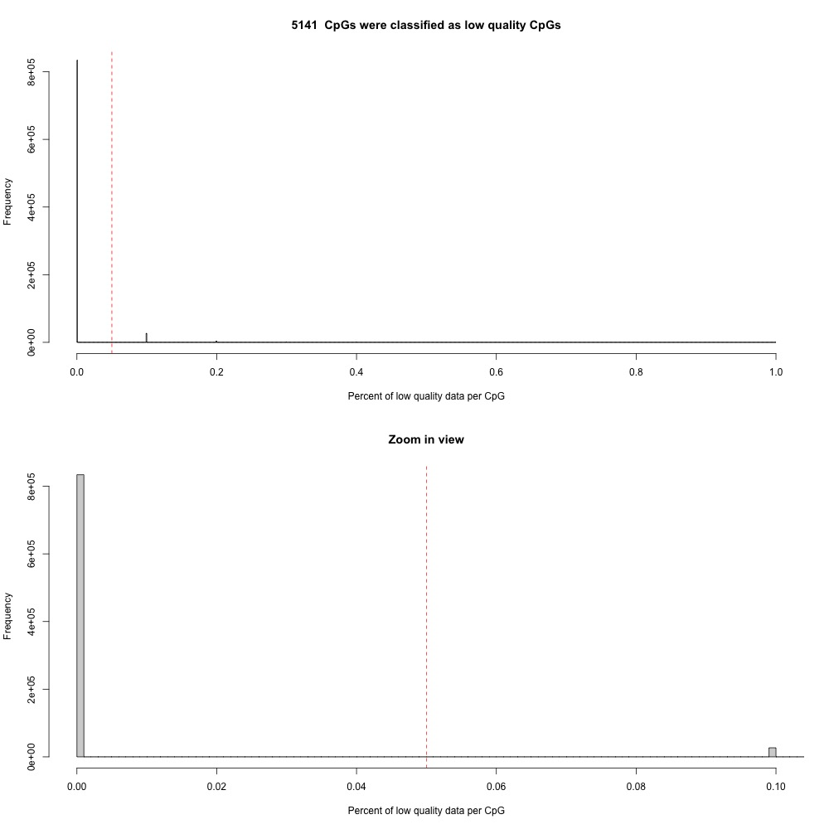
knitr::include_graphics("freqpolygon_beta_beforeQC.jpg")
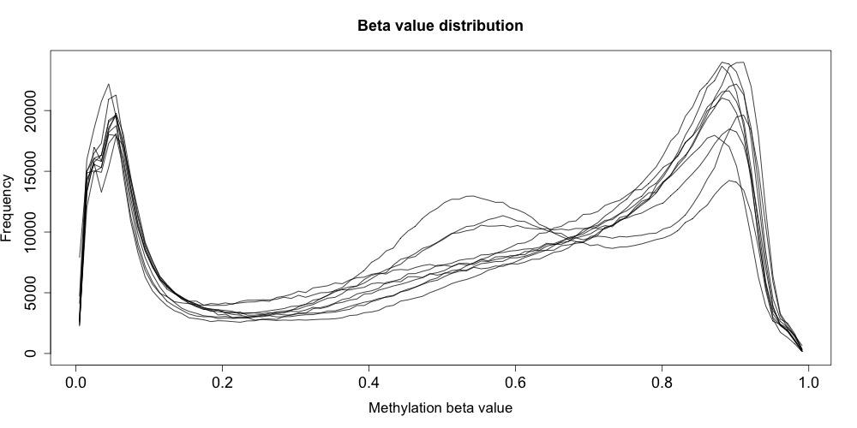
knitr::include_graphics("freqpolygon_beta_afterQC.jpg")
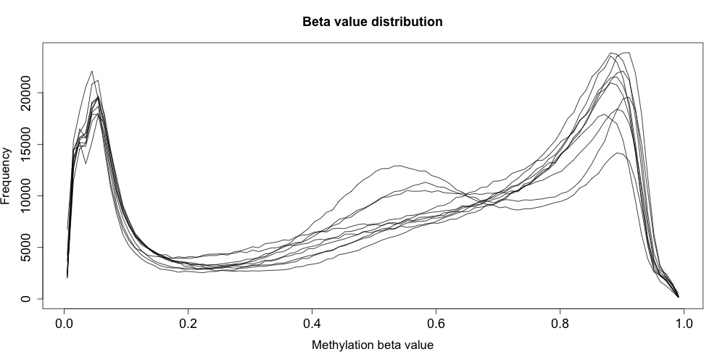
length(fibromethyl_QC$badsample) # no bad quality samples
## [1] 0
length(fibromethyl_QC$outlier_sample) #no outlier samples
## [1] 0
length(fibromethyl_QC$badCpG)
## [1] 5141

4.2. Checkout bad quality probes
# # bad quality probes
# NA probes
NA_CpGs <- is.na(rowSums(getB(fibromethyl_raw)))
sum(NA_CpGs)
## [1] 0
NA_CpGs <- names(NA_CpGs)[NA_CpGs]
NA_CpGs # no NA probes
## character(0)

4.3 preprocessing with “ENmix” package
fibromethyl_BC <- preprocessENmix(
fibromethyl_RG ,
bgParaEst = "oob",
dyeCorr = "RELIC",
QCinfo = fibromethyl_QC ,
exQCsample = TRUE , # Exclude samples that don't meet quality control criteria (set to TRUE to exclude)
exQCcpg = TRUE , # Exclude CpGs that don't meet quality control criteria (set to TRUE to exclude)
exSample = NULL , # List of additional samples to exclude (set to NULL if none)
exCpG = NA_CpGs # List of CpGs to exclude (NA_CpGs should be excluded)
)
## 5141 CpGs were excluded before ENmix correction
## Analysis is running, please wait...!
fibromethyl_BC
## class: MethylSet
## dim: 860718 10
## metadata(0):
## assays(2): Meth Unmeth
## rownames(860718): cg18478105 cg09835024 ... cg10633746 cg12623625
## rowData names(0):
## colnames(10): GSM4775294_ca-973 GSM4775295_con-973 ...
## GSM4775302_ca-933 GSM4775303_con-933
## colData names(3): SampleID PatientID TissueType
## Annotation
## array: IlluminaHumanMethylationEPIC
## annotation: ilm10b4.hg19
## Preprocessing
## Method: NA
## minfi version: NA
## Manifest version: NA

4.4. Normalization with ‘norm.quantile’ function
# 'fibromethyl_N' is the new object containing the normalized data.
# The quantile2 method adjusts the data to a common distribution across samples, making cross-sample comparisons easier.
fibromethyl_N <- norm.quantile(fibromethyl_BC , method = "quantile2")
## Analysis is running, please wait...!
fibromethyl_N
## class: MethylSet
## dim: 860718 10
## metadata(0):
## assays(2): Meth Unmeth
## rownames(860718): cg18478105 cg09835024 ... cg10633746 cg12623625
## rowData names(0):
## colnames(10): GSM4775294_ca-973 GSM4775295_con-973 ...
## GSM4775302_ca-933 GSM4775303_con-933
## colData names(3): SampleID PatientID TissueType
## Annotation
## array: IlluminaHumanMethylationEPIC
## annotation: ilm10b4.hg19
## Preprocessing
## Method: Backgroud_corr: ENmix,oob
## minfi version: dyeBiasCorrection: RELIC
## Manifest version: Normalization: quantile2

5. Quality Control on preprocessed data
- The Red & Green Intensities now overlap, indicating balanced signal intensities, and the Meth & Unmeth Intensities show clear separation, reflecting proper adjustment. The Sum of Meth & Unmeth Intensities and Combined Meth & Unmeth Intensities have consistent distributions across samples, reducing technical variability. Finally, the Beta-values display a bimodal distribution, while the M-values are more clearly defined, ensuring that the data is ready for robust methylation analysis and comparison between conditions.
# Which probes are green and red and TII
color <- getAnnotation(fibromethyl_N)$Color
green <- color == "Grn"
red <- color == "Red"
t2 <- color == ""
# Plot red and green intensities together
multifreqpoly(
mat = log2(rbind(
getMeth(fibromethyl_N)[(red | t2), ] + 1,
getUnmeth(fibromethyl_N)[red, ] + 1 )),
col = "red",
main = "Preprocessed Red & Green Intensities",
xlab = "Log2 Intensity",
legend = NULL # remove legend
)
multifreqpoly(
mat = log2(rbind(
getMeth(fibromethyl_N)[green, ] + 1,
getUnmeth(fibromethyl_N)[(green | t2), ] + 1
)),
col = "green",
append = TRUE, # use append to combine 2 plots
legend = list(
x = "left", # change legend position
legend = c("Green", "Red"), # change legend values
fill = c("green", "red") # change legend color
)
)
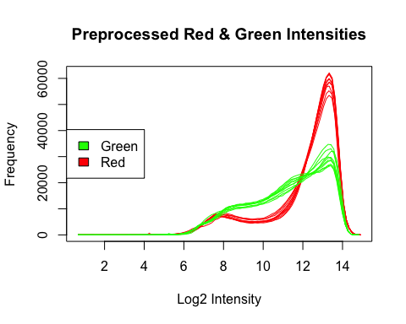
# Plot methylated and unmethylated intensities together (use MethylSet)
multifreqpoly(
mat = log2(getMeth(fibromethyl_N) + 1),
col = "orange",
main = "Preprocessed Meth & Unmeth Intensities",
xlab = "Log2 Intensity",
legend = NULL
)
multifreqpoly(
mat = log2(getUnmeth(fibromethyl_N) + 1),
col = "blue",
append = TRUE ,
legend = list(
x = "left",
legend = c("Methylated", "Unmethylated"),
fill = c("orange", "blue"),
cex = 0.6
)
)
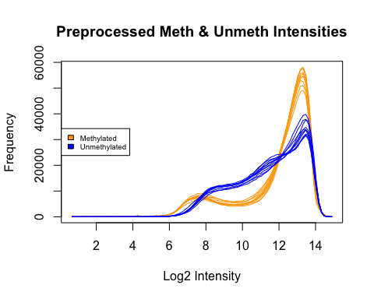
# Plot summed meth and unmeth intensities
multifreqpoly(
mat = log2(getMeth(fibromethyl_N) + getUnmeth(fibromethyl_N) + 1),
main = "Preprocessed Sum of Meth & Unmeth Intensities",
xlab = "Log2 Intensity",
legend = list(
x = "left",
legend = colnames(fibromethyl_N),
fill = 1:ncol(fibromethyl_N),
cex = 0.6
)
)
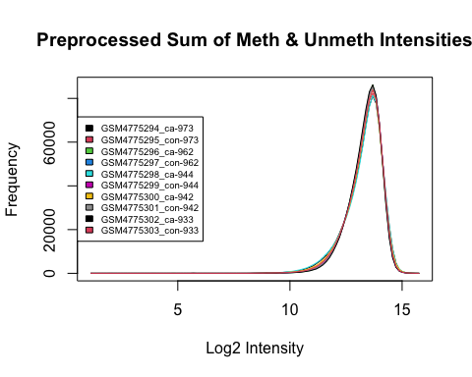
# Plot combined meth and unmeth intensities
multifreqpoly(
mat = log2(rbind(getMeth(fibromethyl_N) + 1, getUnmeth(fibromethyl_N)
) + 1),
main = "Preprocessed Combined Meth & Unmeth Intensities",
xlab = "Log2 Intensity",
legend = list(
x = "left",
legend = colnames(fibromethyl_N),
fill = 1:ncol(fibromethyl_N),
cex = 0.6
)
)
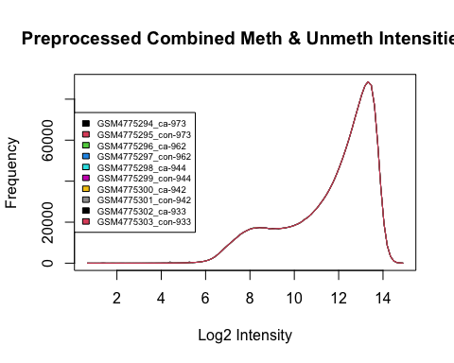
# Plot beta-values
multifreqpoly(
mat = getB(fibromethyl_N),
main = "Preprocessed Beta-values",
xlab = "Beta-value",
legend = list(
x = "top",
legend = colnames(fibromethyl_N),
fill = 1:ncol(fibromethyl_N),
cex = 0.6
)
)
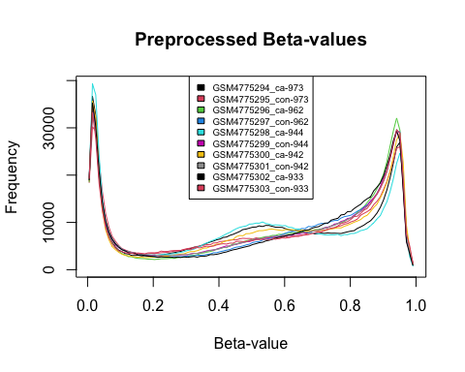
# Plot M-values
multifreqpoly(
mat = getM(fibromethyl_N),
main = "Preprocessed M-values",
xlab = "M-value",
legend = list(
x = "left",
legend = colnames(fibromethyl_N),
fill = 1:ncol(fibromethyl_N),
cex = 0.6
)
)
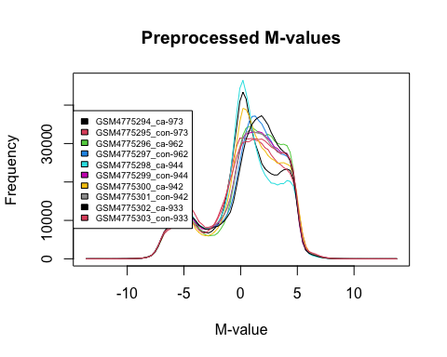

6. Differetial Methylaton analysis

6.1. Define the experimental design
- The block variable is set to the PatientID column, which groups samples by patient. This blocking factor accounts for the paired structure of the data, where each patient may contribute samples for both tissue types. By using table, the balance of samples between tissue types for each patient is checked.
- Design matrix is created with model.matrix to specify the relationship between the response variable (e.g., methylation) and the predictor (TissueType). This matrix includes dummy variables for tissue types, allowing the model to evaluate the effects of “ESCC” compared to “NORMAL”.
# 1. Get col_data information (patient data and tissue type)
col_data <- pData(fibromethyl_N)
# 2. Extract the tissue type information from the sample metadata and define it as a factor with levels "ESCC" (tumor) and "NORMAL" (healthy tissue)
col_data$TissueType <- factor(col_data$TissueType, levels = c("NORMAL", "ESCC"))
# 3. Use sub() function to remove the "ca-" and "con-" prefixes from PatientID
col_data$PatientID <- sub("^ca-|^con-", "", col_data$PatientID)
# 4. Set up the 'block' for adjusting patient-specific effects in the model
# Here, PatientID is used as the blocking factor to control for patient-specific effects (e.g., each patient could have samples from both tissue types)
block <- col_data$PatientID
table(col_data$PatientID, col_data$TissueType) # Check how many samples per patient and tissue type
##
## NORMAL ESCC
## 933 1 1
## 942 1 1
## 944 1 1
## 962 1 1
## 973 1 1
# 5. Create the design matrix based on TissueType
# The model matrix is created to specify the design of the study, where the outcome variable is modeled as a function of tissue type
design <- model.matrix(~ TissueType, data = col_data)
# 6. Check the design matrix to verify its structure
# The design matrix should show how each tissue type is coded (e.g., dummy variable for "ESCC" versus "NORMAL")
print(design)
## (Intercept) TissueTypeESCC
## GSM4775294_ca-973 1 1
## GSM4775295_con-973 1 0
## GSM4775296_ca-962 1 1
## GSM4775297_con-962 1 0
## GSM4775298_ca-944 1 1
## GSM4775299_con-944 1 0
## GSM4775300_ca-942 1 1
## GSM4775301_con-942 1 0
## GSM4775302_ca-933 1 1
## GSM4775303_con-933 1 0
## attr(,"assign")
## [1] 0 1
## attr(,"contrasts")
## attr(,"contrasts")$TissueType
## [1] "contr.treatment"

6.2. Estimate the correlation between samples from the same patient (patient-level correlation)
- Estimated correlation is around 0.06. It suggests a weak correlation between samples from the same patient. Weak correlation (0.06) implies that most of the variability in the methylation data is likely due to differences in tissue type (“NORMAL” vs “ESCC”) or other factors, rather than being heavily influenced by patient-specific characteristics.
# This is important when analyzing data from multiple samples per patient
#block = patient=specific block factor, getM provides methylation data matrix
cor_fit <- duplicateCorrelation(getM(fibromethyl_N), design, block = block)
# A result around 0.06 suggests weak correlation, indicating that the samples from the same patient do not exhibit strong similarity.
print(cor_fit$consensus.correlation)
## [1] 0.06511738

6.3. Fit a linear model to methylation M-values
-Fit a linear model to the methylation M-values using the lmFit function from the limma package. The design matrix specifies the comparison of interest (tissue type), the block accounts for patient-specific effects, and the correlation parameter incorporates the estimated correlation between paired samples from the same patient. This ensures that tissue-type differences are modeled while controlling for residual dependencies within patients.
# Step 2: Fit a linear model to methylation M-values
fit <- lmFit(getM(fibromethyl_N), design, block = block, correlation = cor_fit$consensus.correlation)

6.4. Define contrasts for differential methylation
-A contrast matrix is created using makeContrasts to specify the comparison of interest—in this case, “ESCC vs NORMAL.” This step sets up the framework for testing differential methylation between the two tissue types.
# Create a contrast matrix to compare ESCC vs NORMAL
contrast_matrix <- makeContrasts(ESCC_vs_NORMAL = TissueTypeESCC, levels = design)
## Warning in makeContrasts(ESCC_vs_NORMAL = TissueTypeESCC, levels = design):
## Renaming (Intercept) to Intercept
Empirical Bayes smoothing with eBayes is then performed to stabilize the variance estimates, improving statistical power and reliability in detecting differential methylation signals.
# Apply contrasts to the model using the contrast matrix and store in 'fit2'.
fit2 <- contrasts.fit(fit, contrast_matrix)
#Perform empirical Bayes smoothing to improve statistical power
fit2 <- eBayes(fit2)

6.5. Extract differentially methylated CpG sites
-The topTable function generates a table of differentially methylated CpG probes, sorted by significance. Adjusted p-values are calculated using the Benjamini-Hochberg (BH) method to control the false discovery rate (FDR). The resulting table provides information on the most significant CpG sites, including fold changes, p-values, and adjusted p-values.
# Generate a table of differentially methylated probes
# Adjust p-values using the Benjamini-Hochberg method (FDR control)
# Form result table
LIMMAout <- topTable(fit2, adjust = "BH", number = Inf)
# print result
head(LIMMAout)
## logFC AveExpr t P.Value adj.P.Val B
## cg23500559 5.231598 4.168630 25.35673 2.393338e-11 1.919478e-05 13.20075
## cg06770731 4.743592 3.199862 22.97741 7.176152e-11 1.919478e-05 12.68568
## cg22811668 5.368269 3.128400 22.63223 8.491750e-11 1.919478e-05 12.60171
## cg06492111 4.953505 3.924389 21.82208 1.273125e-10 1.919478e-05 12.39419
## cg01082422 4.741744 4.025537 21.80189 1.286276e-10 1.919478e-05 12.38882
## cg04808027 5.154883 3.576289 21.72451 1.338054e-10 1.919478e-05 12.36817

6.6. Count the number of genes with adjusted p-value < 0.05
-Out of all tested CpG sites, 35,994 (about 4.18%) are significantly differentially methylated at an adjusted p-value threshold of 0.05.
sum(LIMMAout$adj.P.Val < 0.05)
## [1] 35994
sum(LIMMAout$adj.P.Val<0.05)/length(LIMMAout$adj.P.Val)
## [1] 0.04181857

6.7. Volcano plot
-Significant sites (adjusted p-value < 0.05) are highlighted in color (e.g., red), indicating differential methylation with either higher (positive log2 fold change) or lower (negative log2 fold change) methylation in “ESCC” compared to “NORMAL”. The larger the -log10(p-value), the stronger the statistical significance.The roughly symmetrical distribution around the y-axis suggests that both hypermethylation (positive log2 fold change) and hypomethylation (negative log2 fold change) are present in “ESCC” compared to “NORMAL.”
volcanoplot(fit2, style="p-value", col=as.factor(LIMMAout$adj.P.Val < 0.05))
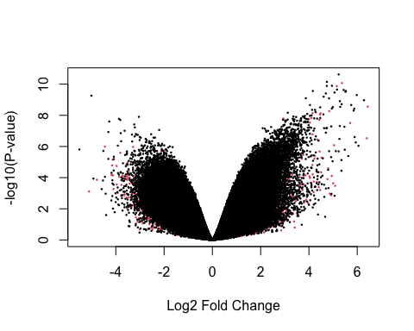

6.8. MA plot
-The majority of points cluster around a log fold change of 0, indicating no substantial differences in methylation for many CpG sites. The colored points (red) represent CpG sites with significant differential methylation, as determined by their adjusted p-value. These are spread across both positive and negative logFC values, indicating both hypermethylation and hypomethylation in “ESCC” compared to “NORMAL.
plot(LIMMAout$AveExpr, LIMMAout$logFC, col=as.factor(LIMMAout$adj.P.Val<0.05), pch=20, cex=0.5)
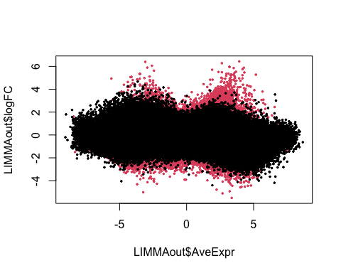

6.9. p-value histogram
- The bar on the very left indicates a large number of CpG sites with very low p-values (close to 0). This suggests that many CpG sites show strong evidence of differential methylation between tissue types (“ESCC” vs “NORMAL”). Beyond approximately 0.1, the p-values are distributed more uniformly, which is expected under the null hypothesis.
hist(x = LIMMAout$P.Value)
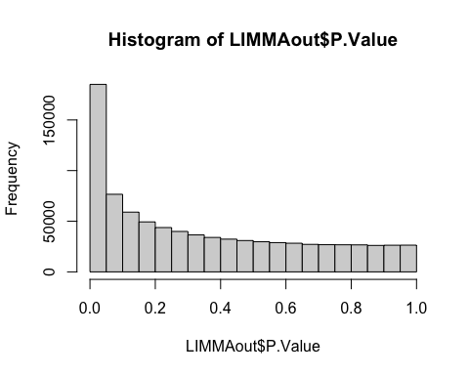

7. Check Methylation for top results

7.1. Check M-values for top results
#Check M-values for top results
getM(fibromethyl_N)[rownames(head(LIMMAout)), ]
## GSM4775294_ca-973 GSM4775295_con-973 GSM4775296_ca-962
## cg23500559 7.042695 1.2607643 6.829152
## cg06770731 5.539882 0.8153324 5.781019
## cg22811668 5.948366 0.1074965 5.715503
## cg06492111 6.019603 1.2807072 6.479344
## cg01082422 6.396022 1.8120104 6.579354
## cg04808027 6.766562 0.9467753 6.075986
## GSM4775297_con-962 GSM4775298_ca-944 GSM4775299_con-944
## cg23500559 2.006711 6.720035 1.3034339
## cg06770731 1.386503 5.269010 0.6053885
## cg22811668 1.059007 5.558811 0.4097697
## cg06492111 2.023288 6.497081 1.2022266
## cg01082422 1.584071 6.170070 1.8697109
## cg04808027 1.540002 5.976971 0.9094709
## GSM4775300_ca-942 GSM4775301_con-942 GSM4775302_ca-933
## cg23500559 6.812625 1.4718434 6.517637
## cg06770731 5.660398 0.6044385 5.607982
## cg22811668 6.310795 0.3652889 5.529195
## cg06492111 6.691989 1.1144202 6.317692
## cg01082422 6.840083 1.7733337 5.996518
## cg04808027 5.750769 0.8070853 6.198364
## GSM4775303_con-933
## cg23500559 1.7214003
## cg06770731 0.7286678
## cg22811668 0.2797632
## cg06492111 1.6175409
## cg01082422 1.2342000
## cg04808027 0.7909058
# Check beta-values for top results
getB(fibromethyl_N)[rownames(head(LIMMAout)), ]
## GSM4775294_ca-973 GSM4775295_con-973 GSM4775296_ca-962
## cg23500559 0.9881152 0.7032138 0.9868919
## cg06770731 0.9743836 0.6353753 0.9772876
## cg22811668 0.9786155 0.5169109 0.9763719
## cg06492111 0.9789182 0.7048864 0.9827594
## cg01082422 0.9796719 0.7733197 0.9812806
## cg04808027 0.9862625 0.6558413 0.9803935
## GSM4775297_con-962 GSM4775298_ca-944 GSM4775299_con-944
## cg23500559 0.7977593 0.9864938 0.7091791
## cg06770731 0.7204559 0.9699283 0.6011142
## cg22811668 0.6730617 0.9741997 0.5685523
## cg06492111 0.7981340 0.9833155 0.6937993
## cg01082422 0.7451105 0.9783843 0.7797380
## cg04808027 0.7411806 0.9791933 0.6501532
## GSM4775300_ca-942 GSM4775301_con-942 GSM4775302_ca-933
## cg23500559 0.9867557 0.7324584 0.9849898
## cg06770731 0.9758034 0.6009955 0.9753112
## cg22811668 0.9823566 0.5610731 0.9741889
## cg06492111 0.9846396 0.6807849 0.9815741
## cg01082422 0.9837269 0.7678668 0.9765842
## cg04808027 0.9769617 0.6339980 0.9816623
## GSM4775303_con-933
## cg23500559 0.7647443
## cg06770731 0.6212733
## cg22811668 0.5464472
## cg06492111 0.7502327
## cg01082422 0.6969803
## cg04808027 0.6314376
# Add the mean betas of the CAF and NAF group, and their absolute difference
LIMMAout$normalBeta <- rowMeans(getB(fibromethyl_N)[rownames(LIMMAout), pData(fibromethyl_N)$TissueType == "NORMAL"])
LIMMAout$tumorBeta <- rowMeans(getB(fibromethyl_N)[rownames(LIMMAout), pData(fibromethyl_N)$TissueType == "ESCC"])
deltaBeta <- getB(fibromethyl_N)[, pData(fibromethyl_N)$TissueType == "ESCC"] - getB(fibromethyl_N)[, pData(fibromethyl_N)$TissueType == "NORMAL"]
# Calculate the mean absolute value of differences between patients by CpG site
LIMMAout$deltaBeta <- rowMeans(abs(deltaBeta))

7.2. Annotation
# Extract annotation data from the preprocessed methylation object
anno <- getAnnotation(fibromethyl_N)
# Sort in the same order as limma output, remove filtered CpGs, add missing CpGs
anno <- anno[rownames(LIMMAout),]
# Update row names of the annotation data to match the LIMMA output
rownames(anno) <- rownames(LIMMAout)
# note that if any CpGs were present in the limma output but not in the annotation ,
# these have now been added as NA rows
# any CpGs that were present in the annotation but not in LIMMAout have been removed
colnames(anno)
## [1] "chr"
## [2] "pos"
## [3] "strand"
## [4] "Name"
## [5] "AddressA"
## [6] "AddressB"
## [7] "ProbeSeqA"
## [8] "ProbeSeqB"
## [9] "Type"
## [10] "NextBase"
## [11] "Color"
## [12] "Probe_rs"
## [13] "Probe_maf"
## [14] "CpG_rs"
## [15] "CpG_maf"
## [16] "SBE_rs"
## [17] "SBE_maf"
## [18] "Islands_Name"
## [19] "Relation_to_Island"
## [20] "Forward_Sequence"
## [21] "SourceSeq"
## [22] "UCSC_RefGene_Name"
## [23] "UCSC_RefGene_Accession"
## [24] "UCSC_RefGene_Group"
## [25] "Phantom4_Enhancers"
## [26] "Phantom5_Enhancers"
## [27] "DMR"
## [28] "X450k_Enhancer"
## [29] "HMM_Island"
## [30] "Regulatory_Feature_Name"
## [31] "Regulatory_Feature_Group"
## [32] "GencodeBasicV12_NAME"
## [33] "GencodeBasicV12_Accession"
## [34] "GencodeBasicV12_Group"
## [35] "GencodeCompV12_NAME"
## [36] "GencodeCompV12_Accession"
## [37] "GencodeCompV12_Group"
## [38] "DNase_Hypersensitivity_NAME"
## [39] "DNase_Hypersensitivity_Evidence_Count"
## [40] "OpenChromatin_NAME"
## [41] "OpenChromatin_Evidence_Count"
## [42] "TFBS_NAME"
## [43] "TFBS_Evidence_Count"
## [44] "Methyl27_Loci"
## [45] "Methyl450_Loci"
## [46] "Random_Loci"

7.3. Add interesting annotation to limma output
LIMMAout$Chromosome <- anno[,"chr"] # - Chromosome: Chromosomal location of each CpG site
LIMMAout$Position <- anno[,"pos"] # - Position: Genomic position of the CpG site within the chromosome
LIMMAout$Gene_ID <- anno[,"UCSC_RefGene_Name"] # - Gene_ID: Gene(s) associated with the CpG site based on RefGene annotations
LIMMAout$CpG_Feature <- anno[,"UCSC_RefGene_Group"] # - CpG_Feature: Specific genomic feature where the CpG site is located
LIMMAout$CpG_Island <- anno[,"Relation_to_Island"] # - CpG_Island: Relation of the CpG site to CpG islands
head(LIMMAout)
## logFC AveExpr t P.Value adj.P.Val B
## cg23500559 5.231598 4.168630 25.35673 2.393338e-11 1.919478e-05 13.20075
## cg06770731 4.743592 3.199862 22.97741 7.176152e-11 1.919478e-05 12.68568
## cg22811668 5.368269 3.128400 22.63223 8.491750e-11 1.919478e-05 12.60171
## cg06492111 4.953505 3.924389 21.82208 1.273125e-10 1.919478e-05 12.39419
## cg01082422 4.741744 4.025537 21.80189 1.286276e-10 1.919478e-05 12.38882
## cg04808027 5.154883 3.576289 21.72451 1.338054e-10 1.919478e-05 12.36817
## normalBeta tumorBeta deltaBeta Chromosome Position Gene_ID
## cg23500559 0.7414710 0.9866493 0.003626046 chr17 60744836 MRC2
## cg06770731 0.6358428 0.9745428 0.005058628 chr16 87863812 SLC7A5
## cg22811668 0.5732090 0.9771465 0.091810723 chr19 2046303 MKNK2;MKNK2
## cg06492111 0.7255674 0.9822414 0.050626221 chr16 87874392 SLC7A5
## cg01082422 0.7526031 0.9799295 0.005092396 chr5 179224751 MGAT4B;MGAT4B
## cg04808027 0.6625222 0.9808947 0.019776366 chr11 66102146 RIN1
## CpG_Feature CpG_Island
## cg23500559 Body Island
## cg06770731 3'UTR OpenSea
## cg22811668 Body;Body Island
## cg06492111 Body OpenSea
## cg01082422 3'UTR;3'UTR Island
## cg04808027 Body Island

8. Gene-level analysis
## Summarize data on the gene level
# remove CpGs with no gene annotation
LIMMAout_gene <- LIMMAout[LIMMAout$Gene_ID != "" & !is.na( LIMMAout$Gene_ID), ]
# Save CpG rownames (otherwise these are removed in the next step)
LIMMAout_gene$CpG <- rownames(LIMMAout_gene)
# Separate CpGs with multiple genes/features (this takes a while to run )
LIMMAout_gene <- LIMMAout_gene %>%
separate_rows(Gene_ID , CpG_Feature , CpG_Island , sep = ";") %>%
distinct() %>%
group_by(CpG, Gene_ID) %>%
mutate(CpG_Feature = paste(unique(CpG_Feature), collapse = ";"),
CpG_Island = paste(unique(CpG_Island), collapse = ";")) %>%
ungroup() %>%
distinct() %>%
as.data.frame()
# Select the most interesting columns(CpG, GeneID,Cpg_features, CPG_island, logFC, adg.p.val, normalBeeta, tumorBeta,)
#CpG: The CpG site identifier.
#Gene_ID: The gene associated with the CpG site.
#CpG_Feature: The feature of the CpG (e.g., promoter region, exon).
#CpG_Island: The CpG island associated with the site.
#logFC: The log fold-change of the methylation level between conditions (e.g., tumor vs. normal).
#adj.P.Val: The adjusted p-value for statistical significance.
#normalBeeta: The methylation beta value in the normal tissue.
#tumorBeta: The methylation beta value in the tumor tissue.
LIMMAout_gene <- LIMMAout_gene[, c(15, 12, 13, 14, 1, 5, 7, 8, 9)]
head(LIMMAout_gene)
## CpG Gene_ID CpG_Feature CpG_Island logFC adj.P.Val normalBeta
## 1 cg23500559 MRC2 Body Island 5.231598 1.919478e-05 0.7414710
## 2 cg06770731 SLC7A5 3'UTR OpenSea 4.743592 1.919478e-05 0.6358428
## 3 cg22811668 MKNK2 Body Island 5.368269 1.919478e-05 0.5732090
## 4 cg06492111 SLC7A5 Body OpenSea 4.953505 1.919478e-05 0.7255674
## 5 cg01082422 MGAT4B 3'UTR Island 4.741744 1.919478e-05 0.7526031
## 6 cg04808027 RIN1 Body Island 5.154883 1.919478e-05 0.6625222
## tumorBeta deltaBeta
## 1 0.9866493 0.003626046
## 2 0.9745428 0.005058628
## 3 0.9771465 0.091810723
## 4 0.9822414 0.050626221
## 5 0.9799295 0.005092396
## 6 0.9808947 0.019776366

8.1. Count Differentially Methylated Genes
Filter CpG sites associated with genes, separate rows with multiple annotations, and group CpGs by genes to summarize features.
# Count all significant defferential methylation CpGs with adjusted p-values < 0.05. A higher value indicates more CpG sites showing methylation differences.
sum(LIMMAout$adj.P.Val < 0.05)
## [1] 35994
sum(LIMMAout$adj.P.Val<0.05)/length(LIMMAout$adj.P.Val)
## [1] 0.04181857
# Count unique differentially methylated genes
length(unique(LIMMAout_gene$Gene_ID))
## [1] 27311
# Count unique differentially methylated genes with significant adjusted p-values. This value represents key targets for biological interpretation and is a main result of the study.
length(unique(LIMMAout_gene$Gene_ID[LIMMAout_gene$adj.P.Val < 0.05]))
## [1] 10317

8.2. Look for multiple CpGs in the same gene undergoing similar methylation differences
Count significant CpGs (adjusted p-value < 0.05). Identify unique differentially methylated genes, with or without adjusted p-value filtering.
# Filter by adjusted p-value < 0.05 and |logFC| > 1
# For each top gene, print information related to differentially methylated CpG sites.
topgenes <- unique(LIMMAout_gene$Gene_ID)[1:10] # ten most significant genes
for (gene in topgenes) {
LIMMAout_subset <-
LIMMAout_gene[(LIMMAout_gene$Gene_ID == gene) & (LIMMAout_gene$adj.P.Val < 0.05) &
(abs(LIMMAout_gene$logFC) > 1), ]
print(LIMMAout_subset)
}
## CpG Gene_ID CpG_Feature CpG_Island logFC adj.P.Val
## 1 cg23500559 MRC2 Body Island 5.231598 1.919478e-05
## 165 cg26168577 MRC2 Body OpenSea 3.257395 6.162687e-04
## 246 cg02314166 MRC2 Body OpenSea 3.766102 8.665471e-04
## 1308 cg09689317 MRC2 Body Island 2.725378 3.391470e-03
## 1559 cg13636531 MRC2 Body S_Shore 3.061417 3.984832e-03
## 2131 cg21768884 MRC2 3'UTR OpenSea 2.939778 5.452166e-03
## 3048 cg19683251 MRC2 Body S_Shelf 1.908320 7.518461e-03
## 3063 cg06873351 MRC2 3'UTR OpenSea 1.916555 7.548388e-03
## 4815 cg13999321 MRC2 Body OpenSea 1.574236 1.172052e-02
## 6285 cg06376951 MRC2 Body N_Shelf 1.072474 1.498265e-02
## 14085 cg27320439 MRC2 Body S_Shore 1.743332 2.933174e-02
## 18279 cg14497573 MRC2 Body S_Shore 2.193979 3.623379e-02
## 21121 cg19831935 MRC2 Body S_Shore 2.557798 4.059284e-02
## 21743 cg13108002 MRC2 Body N_Shore 1.298865 4.161619e-02
## 25487 cg11192417 MRC2 Body S_Shore 2.278540 4.761702e-02
## 26222 cg01522412 MRC2 Body N_Shore 1.065033 4.876372e-02
## normalBeta tumorBeta deltaBeta
## 1 0.7414710 0.9866493 0.0036260464
## 165 0.6889926 0.9497156 0.0019112256
## 246 0.7460100 0.9705855 0.0872313346
## 1308 0.7376160 0.9389893 0.1589075023
## 1559 0.7126731 0.9462014 0.0433822361
## 2131 0.6970057 0.9339538 0.0013304755
## 3048 0.7608639 0.9178367 0.0274312598
## 3063 0.5295088 0.8006418 0.0690671492
## 4815 0.8310593 0.9335023 0.1296821789
## 6285 0.7673429 0.8707354 0.0116166321
## 14085 0.4631714 0.7284125 0.0255891726
## 18279 0.5884273 0.8438233 0.0014501855
## 21121 0.6871139 0.8985885 0.0226049688
## 21743 0.5786470 0.7636686 0.0486937747
## 25487 0.5759453 0.8365111 0.0008519207
## 26222 0.7512718 0.8594512 0.0687247143
## CpG Gene_ID CpG_Feature CpG_Island logFC adj.P.Val
## 2 cg06770731 SLC7A5 3'UTR OpenSea 4.743592 1.919478e-05
## 4 cg06492111 SLC7A5 Body OpenSea 4.953505 1.919478e-05
## 35 cg06071246 SLC7A5 3'UTR OpenSea 3.123341 1.632642e-04
## 37 cg03486383 SLC7A5 3'UTR OpenSea 3.929510 1.801198e-04
## 48 cg27135163 SLC7A5 3'UTR OpenSea 3.470018 2.251219e-04
## 60 cg10034481 SLC7A5 3'UTR OpenSea 4.004042 2.460341e-04
## 73 cg04264781 SLC7A5 Body OpenSea 3.385898 2.817190e-04
## 96 cg26619943 SLC7A5 Body OpenSea 3.483341 3.623082e-04
## 106 cg03879320 SLC7A5 Body N_Shelf 2.868143 4.309852e-04
## 120 cg20757869 SLC7A5 ExonBnd;Body OpenSea 3.306592 5.010289e-04
## 134 cg00653312 SLC7A5 3'UTR OpenSea 3.051812 5.239395e-04
## 152 cg05393733 SLC7A5 Body OpenSea 2.783449 5.680618e-04
## 201 cg10169763 SLC7A5 Body OpenSea 3.187618 6.629683e-04
## 233 cg10099957 SLC7A5 Body OpenSea 3.080374 7.744473e-04
## 263 cg04481596 SLC7A5 3'UTR OpenSea 2.623416 9.289323e-04
## 313 cg00052925 SLC7A5 Body OpenSea 2.937030 1.055272e-03
## 319 cg12365660 SLC7A5 Body OpenSea 2.813832 1.076581e-03
## 412 cg03408354 SLC7A5 Body OpenSea 2.322280 1.335943e-03
## 482 cg04802238 SLC7A5 Body OpenSea 2.580464 1.454497e-03
## 586 cg16239834 SLC7A5 Body OpenSea 1.998070 1.707792e-03
## 673 cg04171052 SLC7A5 Body OpenSea 1.855024 1.907008e-03
## 698 cg26637881 SLC7A5 Body OpenSea 2.569461 1.926752e-03
## 778 cg08094280 SLC7A5 3'UTR OpenSea 1.791085 2.087982e-03
## 822 cg09618385 SLC7A5 3'UTR OpenSea 1.730656 2.241591e-03
## 888 cg07558761 SLC7A5 Body OpenSea 2.120085 2.381934e-03
## 889 cg13452738 SLC7A5 Body OpenSea 3.107219 2.387582e-03
## 891 cg07021906 SLC7A5 Body OpenSea 3.407113 2.394219e-03
## 911 cg02614661 SLC7A5 Body OpenSea 2.532339 2.465868e-03
## 924 cg11297271 SLC7A5 Body S_Shelf 2.108707 2.508493e-03
## 938 cg00069417 SLC7A5 Body OpenSea 1.975439 2.522915e-03
## 1155 cg03553613 SLC7A5 Body OpenSea 1.654515 2.969159e-03
## 1635 cg03801429 SLC7A5 Body Island 1.507772 4.195696e-03
## 1666 cg01856752 SLC7A5 Body OpenSea 2.128956 4.317189e-03
## 1867 cg02203067 SLC7A5 Body OpenSea 1.965063 4.808036e-03
## 2217 cg01829163 SLC7A5 Body OpenSea 2.211276 5.578469e-03
## 2251 cg05911082 SLC7A5 Body OpenSea 1.845601 5.676192e-03
## 2301 cg06665333 SLC7A5 Body OpenSea 2.486212 5.777188e-03
## 2725 cg08860287 SLC7A5 Body OpenSea 1.505841 6.725022e-03
## 3362 cg05534653 SLC7A5 Body N_Shelf 1.259166 8.341154e-03
## 8420 cg09285525 SLC7A5 Body OpenSea 1.008527 1.941873e-02
## 8970 cg02454636 SLC7A5 Body OpenSea 1.024530 2.040715e-02
## 13780 cg27467238 SLC7A5 Body OpenSea 1.631707 2.887849e-02
## 14623 cg27555036 SLC7A5 Body S_Shelf 2.589381 3.014473e-02
## 17551 cg27560818 SLC7A5 Body OpenSea 1.881559 3.500927e-02
## 17841 cg08798345 SLC7A5 Body OpenSea 1.525676 3.553382e-02
## normalBeta tumorBeta deltaBeta
## 2 0.6358428 0.9745428 0.005058628
## 4 0.7255674 0.9822414 0.050626221
## 35 0.5339823 0.9036311 0.002705924
## 37 0.6099555 0.9538025 0.098710142
## 48 0.6468668 0.9449307 0.036721215
## 60 0.6439844 0.9605991 0.022419743
## 73 0.8004700 0.9713585 0.054393915
## 96 0.5496089 0.9257820 0.007319308
## 106 0.5771645 0.8998299 0.031137831
## 120 0.6536694 0.9432375 0.083100517
## 134 0.6342321 0.9297037 0.058048600
## 152 0.6144654 0.9115580 0.124072664
## 201 0.6107036 0.9268692 0.005251928
## 233 0.6408401 0.9322154 0.013703580
## 263 0.6041801 0.8964762 0.103803885
## 313 0.5660373 0.9006377 0.002157308
## 319 0.6270383 0.9152810 0.158106909
## 412 0.5390938 0.8483088 0.053360507
## 482 0.7169388 0.9310916 0.110843886
## 586 0.5404808 0.8217807 0.078050030
## 673 0.6027043 0.8422565 0.098984235
## 698 0.6256917 0.9014636 0.005486620
## 778 0.6276577 0.8501573 0.021986761
## 822 0.5263061 0.7836572 0.003657920
## 888 0.5650907 0.8426766 0.104689152
## 889 0.5932710 0.9133274 0.004419630
## 891 0.6283181 0.9356214 0.061072289
## 911 0.4929465 0.8385133 0.009799716
## 924 0.4176892 0.7498636 0.077549109
## 938 0.6205203 0.8596165 0.229048478
## 1155 0.5862209 0.8119139 0.002084310
## 1635 0.5987398 0.8050927 0.008684184
## 1666 0.4851299 0.7964912 0.140306808
## 1867 0.5688260 0.8288447 0.010326125
## 2217 0.5534564 0.8409096 0.006888911
## 2251 0.5609942 0.8150819 0.224831000
## 2301 0.5207144 0.8437887 0.007795880
## 2725 0.5063465 0.7393515 0.141481522
## 3362 0.5616822 0.7507552 0.002552011
## 8420 0.5709845 0.7262993 0.215016450
## 8970 0.5480922 0.7097378 0.003905447
## 13780 0.4828548 0.7280913 0.034552925
## 14623 0.6676823 0.9024627 0.004575732
## 17551 0.6668649 0.8680180 0.092589329
## 17841 0.5530455 0.7685325 0.002659272
## CpG Gene_ID CpG_Feature CpG_Island logFC adj.P.Val
## 3 cg22811668 MKNK2 Body Island 5.368269 1.919478e-05
## 8 cg11634930 MKNK2 Body Island 5.439430 2.369801e-05
## 27 cg03246954 MKNK2 Body Island 4.949019 1.106738e-04
## 179 cg13220129 MKNK2 Body Island 3.431136 6.574630e-04
## 3493 cg11319132 MKNK2 Body S_Shore 2.704558 8.672947e-03
## 7173 cg26723446 MKNK2 Body S_Shore 2.484140 1.691058e-02
## 8211 cg14292923 MKNK2 Body S_Shore 2.154280 1.900195e-02
## 8309 cg06521145 MKNK2 Body N_Shore 1.391089 1.919791e-02
## 9358 cg17585440 MKNK2 TSS1500 S_Shore 1.083446 2.101144e-02
## 10459 cg23694389 MKNK2 Body N_Shore 1.183851 2.268639e-02
## 12745 cg21964793 MKNK2 Body;3'UTR Island 1.091853 2.700765e-02
## 13202 cg18179735 MKNK2 Body;3'UTR Island 1.145525 2.794902e-02
## 14452 cg08324490 MKNK2 Body S_Shore 1.329501 2.988280e-02
## normalBeta tumorBeta deltaBeta
## 3 0.5732090 0.9771465 0.091810723
## 8 0.6381371 0.9801963 0.033934223
## 27 0.7515918 0.9841822 0.135793373
## 179 0.5499751 0.9223921 0.058170709
## 3493 0.8123409 0.9569958 0.008104267
## 7173 0.7678519 0.9419549 0.154385690
## 8211 0.8157285 0.9470003 0.127451066
## 8309 0.2988329 0.5239696 0.015369385
## 9358 0.3045550 0.4801226 0.003494906
## 10459 0.6251154 0.7883215 0.146683173
## 12745 0.6529415 0.7969112 0.016375891
## 13202 0.5392880 0.7160531 0.210538546
## 14452 0.7695081 0.8809253 0.019296394
## CpG Gene_ID CpG_Feature CpG_Island logFC adj.P.Val
## 5 cg01082422 MGAT4B 3'UTR Island 4.741744 1.919478e-05
## 255 cg18484008 MGAT4B 3'UTR Island 2.666980 9.076237e-04
## 4439 cg04942710 MGAT4B Body;TSS1500 S_Shore 1.337412 1.081444e-02
## 5616 cg23011886 MGAT4B Body;TSS200 S_Shore 1.633629 1.352736e-02
## 8851 cg18133875 MGAT4B Body Island 1.937836 2.024997e-02
## 17952 cg06189266 MGAT4B Body N_Shore 1.397244 3.572069e-02
## normalBeta tumorBeta deltaBeta
## 5 0.7526031 0.9799295 0.005092396
## 255 0.6998690 0.9305111 0.056780204
## 4439 0.5175925 0.7276033 0.066283391
## 5616 0.6762016 0.8566758 0.140156397
## 8851 0.7042965 0.8877478 0.047917750
## 17952 0.6871855 0.8428847 0.004626366
## CpG Gene_ID CpG_Feature CpG_Island logFC adj.P.Val
## 6 cg04808027 RIN1 Body Island 5.154883 1.919478e-05
## 16 cg12912663 RIN1 Body Island 4.609287 3.425004e-05
## 17 cg20749584 RIN1 Body Island 3.871577 3.897635e-05
## 251 cg22777174 RIN1 Body N_Shore 2.501113 8.894055e-04
## 371 cg12068791 RIN1 Body S_Shore 2.350167 1.190420e-03
## 388 cg07543230 RIN1 Body N_Shore 2.669071 1.230719e-03
## 552 cg07948432 RIN1 Body Island 2.227603 1.619385e-03
## 1701 cg17274976 RIN1 Body N_Shore 1.883427 4.399004e-03
## 1720 cg19554304 RIN1 Body N_Shore 1.529751 4.468002e-03
## 23815 cg22719871 RIN1 TSS1500 S_Shelf 1.009564 4.513553e-02
## normalBeta tumorBeta deltaBeta
## 6 0.6625222 0.9808947 0.0197763660
## 16 0.5824681 0.9651364 0.1511727292
## 17 0.6220875 0.9542991 0.0387827699
## 251 0.6379298 0.9041587 0.0011364240
## 371 0.6270422 0.8908467 0.0185997317
## 388 0.6118150 0.9028406 0.0179960889
## 552 0.6733963 0.9017720 0.1878850879
## 1701 0.6023587 0.8429745 0.0005563855
## 1720 0.4899490 0.7328928 0.0577624611
## 23815 0.4903674 0.6562629 0.0700039820
## CpG Gene_ID CpG_Feature CpG_Island logFC adj.P.Val
## 7 cg03598185 SCAMP4 Body S_Shore 5.165343 2.369801e-05
## 148 cg01009414 SCAMP4 Body S_Shore 3.081909 5.335930e-04
## 6842 cg08617069 SCAMP4 Body Island 1.451703 1.625480e-02
## 16049 cg20243900 SCAMP4 5'UTR Island 2.710389 3.254099e-02
## 23888 cg09759578 SCAMP4 5'UTR Island 1.386509 4.528708e-02
## normalBeta tumorBeta deltaBeta
## 7 0.5604802 0.9727679 0.081412072
## 148 0.5019399 0.8890338 0.003336986
## 6842 0.8199474 0.9232984 0.039425172
## 16049 0.5115110 0.8336811 0.116785528
## 23888 0.8502727 0.9346349 0.066649973
## CpG Gene_ID CpG_Feature CpG_Island logFC adj.P.Val
## 9 cg23634417 TMEM79 Body OpenSea 4.162054 2.369801e-05
## 4538 cg15793285 TMEM79 Body OpenSea 1.717668 1.103738e-02
## 23645 cg07234388 TMEM79 Body;3'UTR S_Shore 1.017528 4.478596e-02
## normalBeta tumorBeta deltaBeta
## 9 0.7613842 0.9760728 0.060076021
## 4538 0.6929781 0.8782497 0.006954987
## 23645 0.3836959 0.5551006 0.104975123
## CpG Gene_ID CpG_Feature CpG_Island logFC adj.P.Val
## 10 cg07551314 PAQR7 Body S_Shelf 5.529181 2.369801e-05
## 181 cg00465927 PAQR7 Body S_Shelf 2.914898 6.574630e-04
## 1494 cg18128212 PAQR7 TSS1500 N_Shelf 2.684117 3.884025e-03
## 1916 cg19906087 PAQR7 5'UTR OpenSea 2.313283 4.913303e-03
## 2288 cg01566199 PAQR7 1stExon;5'UTR OpenSea 2.359152 5.746393e-03
## 19842 cg26875775 PAQR7 TSS1500 N_Shelf 2.310848 3.867677e-02
## normalBeta tumorBeta deltaBeta
## 10 0.6452556 0.9783074 0.003732244
## 181 0.6726108 0.9338941 0.069777710
## 1494 0.7166658 0.9344953 0.010731820
## 1916 0.6089295 0.8819786 0.001767613
## 2288 0.6759467 0.9060543 0.170217351
## 19842 0.6040530 0.8505582 0.006532866
## CpG Gene_ID CpG_Feature CpG_Island logFC adj.P.Val normalBeta
## 11 cg09102257 EGR1 Body Island 5.512564 2.410676e-05 0.4288241
## 229 cg12766556 EGR1 Body S_Shore 4.285075 7.737816e-04 0.6540784
## 365 cg07336840 EGR1 Body Island 3.523693 1.183424e-03 0.6029026
## 1264 cg23029363 EGR1 Body Island 4.520912 3.267318e-03 0.6295428
## 7689 cg01107476 EGR1 3'UTR S_Shore 1.754191 1.782142e-02 0.7579333
## tumorBeta deltaBeta
## 11 0.9463687 0.013712186
## 229 0.9632734 0.003931916
## 365 0.9221677 0.005125584
## 1264 0.9616977 0.003121432
## 7689 0.9027306 0.150525301
## CpG Gene_ID CpG_Feature CpG_Island logFC adj.P.Val
## 12 cg13224075 SLC7A1 Body OpenSea 5.059598 2.480818e-05
## 14 cg10752421 SLC7A1 Body OpenSea 5.980626 3.077974e-05
## 63 cg09750646 SLC7A1 3'UTR Island 3.119785 2.516104e-04
## 90 cg04783530 SLC7A1 5'UTR OpenSea 3.368510 3.621356e-04
## 97 cg03284642 SLC7A1 5'UTR OpenSea 3.983699 3.623082e-04
## 556 cg05126855 SLC7A1 5'UTR OpenSea 2.846302 1.624056e-03
## 784 cg01213557 SLC7A1 5'UTR OpenSea 2.273359 2.091680e-03
## 789 cg15003482 SLC7A1 5'UTR OpenSea 3.020990 2.091680e-03
## 866 cg04769514 SLC7A1 Body Island 2.762276 2.347621e-03
## 1121 cg03536202 SLC7A1 5'UTR OpenSea 3.029042 2.868157e-03
## 1303 cg09214535 SLC7A1 Body S_Shelf 1.610974 3.375324e-03
## 1521 cg05941208 SLC7A1 5'UTR OpenSea 2.408558 3.924981e-03
## 1807 cg26117398 SLC7A1 5'UTR OpenSea 1.922492 4.710376e-03
## 1994 cg10778996 SLC7A1 Body OpenSea 2.725658 5.125159e-03
## 2236 cg12014634 SLC7A1 3'UTR N_Shore 1.759301 5.645097e-03
## 3514 cg12823441 SLC7A1 Body OpenSea 1.943335 8.710623e-03
## 3570 cg08495784 SLC7A1 5'UTR OpenSea 2.170366 8.815224e-03
## 3829 cg10905736 SLC7A1 Body OpenSea 1.460197 9.395026e-03
## 4288 cg02381064 SLC7A1 Body Island 1.950493 1.043177e-02
## 4435 cg11069855 SLC7A1 5'UTR OpenSea 1.631293 1.080875e-02
## 5087 cg09887627 SLC7A1 Body S_Shore 2.338560 1.239649e-02
## 8285 cg21690645 SLC7A1 Body OpenSea 3.102462 1.912770e-02
## 9983 cg04688292 SLC7A1 5'UTR OpenSea 1.467072 2.196128e-02
## 11145 cg03904840 SLC7A1 Body OpenSea 1.289758 2.400492e-02
## 18734 cg17798847 SLC7A1 Body OpenSea 2.160145 3.697051e-02
## 21392 cg11760099 SLC7A1 Body OpenSea 1.566168 4.105913e-02
## 21933 cg02497486 SLC7A1 3'UTR N_Shelf 1.522965 4.189754e-02
## 22229 cg25493901 SLC7A1 Body Island 1.315183 4.244247e-02
## normalBeta tumorBeta deltaBeta
## 12 0.6710920 0.9790536 0.002598548
## 14 0.5314048 0.9768909 0.076213209
## 63 0.5735870 0.9163209 0.053093014
## 90 0.7026508 0.9542910 0.123818246
## 97 0.6306627 0.9532739 0.034838576
## 556 0.7609771 0.9518156 0.009015770
## 784 0.7086357 0.9160705 0.060158971
## 789 0.6895719 0.9389187 0.076090393
## 866 0.5822609 0.8962410 0.003474171
## 1121 0.6767714 0.9318097 0.057247181
## 1303 0.7819040 0.9128274 0.003724563
## 1521 0.5799041 0.8688864 0.159230301
## 1807 0.5456679 0.8135757 0.155078291
## 1994 0.7413099 0.9430031 0.005299450
## 2236 0.7719866 0.9170863 0.038809083
## 3514 0.8229133 0.9400921 0.148880049
## 3570 0.5362271 0.8251402 0.092006487
## 3829 0.5554890 0.7673703 0.279102106
## 4288 0.5304848 0.8036527 0.090656394
## 4435 0.6559003 0.8463273 0.119837321
## 5087 0.7015831 0.9096264 0.004098289
## 8285 0.6693293 0.9436582 0.056368255
## 9983 0.4601259 0.6954984 0.042700462
## 11145 0.7315039 0.8620954 0.337168058
## 18734 0.6888090 0.9115451 0.221464550
## 21392 0.7152229 0.8638731 0.003307736
## 21933 0.6162338 0.8081864 0.048883060
## 22229 0.5268736 0.7274738 0.006600670

8.3. Look for multiple CpGs in “promoter” regions undergoing similar methylation differences
Examine significant CpGs (adjusted p-value < 0.05, |logFC| > 1) for the top 10 genes. Print detailed information for CpGs undergoing similar methylation changes within the same gene.
LIMMAout_prom <- LIMMAout_gene[grepl("TSS|1stExon", LIMMAout_gene$CpG_Feature),]
# Extract top 10 genes based on promoter-region CpGs
topgenes_prom <- unique(LIMMAout_prom$Gene_ID)[1:10]
for (gene in topgenes_prom) {
LIMMAout_subset <- LIMMAout_gene[(LIMMAout_gene$Gene_ID == gene) &
(LIMMAout_gene$adj.P.Val < 0.05) &
(abs(LIMMAout_gene$logFC) > 1), ]
print(LIMMAout_subset)
}
## CpG Gene_ID CpG_Feature CpG_Island logFC adj.P.Val
## 15 cg26559315 LYNX1 5'UTR;TSS200;1stExon Island -5.012281 3.155983e-05
## 633 cg20541178 LYNX1 5'UTR;TSS200;1stExon Island -2.395904 1.811496e-03
## 5537 cg19021188 LYNX1 TSS200;TSS1500 S_Shore 1.360272 1.341528e-02
## 6260 cg23180489 LYNX1 TSS200;TSS1500 S_Shore 1.618603 1.493045e-02
## 6984 cg22687807 LYNX1 5'UTR;TSS1500;TSS200 Island -2.030340 1.649052e-02
## 7174 cg00399059 LYNX1 TSS200;TSS1500 S_Shore 1.652115 1.691058e-02
## 12023 cg22861548 LYNX1 TSS200;TSS1500 S_Shore 1.579000 2.561314e-02
## 19483 cg14078481 LYNX1 5'UTR;TSS1500;TSS200 Island -1.676142 3.813766e-02
## normalBeta tumorBeta deltaBeta
## 15 0.37686674 0.01848182 0.040404604
## 633 0.44460486 0.13566773 0.003206597
## 5537 0.78166715 0.89752181 0.068522702
## 6260 0.74868462 0.89739808 0.170720628
## 6984 0.05351832 0.01203907 0.216520943
## 7174 0.67733056 0.86226808 0.004585998
## 12023 0.72447265 0.88083060 0.001404304
## 19483 0.05759548 0.01656680 0.033141800
## CpG Gene_ID CpG_Feature CpG_Island logFC adj.P.Val
## 20 cg09186408 MIR33B TSS1500 S_Shore 5.354809 7.880409e-05
## 1020 cg04805065 MIR33B TSS1500 S_Shore 2.393231 2.703555e-03
## 1340 cg24161106 MIR33B Body S_Shore 4.357819 3.483005e-03
## 9685 cg09494646 MIR33B TSS200 S_Shore 2.015692 2.151063e-02
## 22688 cg11393407 MIR33B Body S_Shore 1.108190 4.315823e-02
## normalBeta tumorBeta deltaBeta
## 20 0.5454586 0.9710167 0.100213600
## 1020 0.5667297 0.8662002 0.104546943
## 1340 0.6646099 0.9620120 0.013174287
## 9685 0.8300868 0.9448818 0.002585406
## 22688 0.8814366 0.9382320 0.004355187
## CpG Gene_ID CpG_Feature CpG_Island logFC adj.P.Val
## 45 cg11256132 C1orf100 TSS200 OpenSea 3.358188 0.0002227901
## 6540 cg15797341 C1orf100 Body OpenSea -2.578105 0.0155165613
## normalBeta tumorBeta deltaBeta
## 45 0.5802006 0.9269854 0.05428335
## 6540 0.9119444 0.6598192 0.00274622
## CpG Gene_ID CpG_Feature CpG_Island logFC adj.P.Val
## 55 cg07733567 MIR1180 TSS200 Island 4.337818 0.0002439811
## 280 cg24553547 MIR1180 TSS200 Island 2.997281 0.0009693345
## 693 cg19157647 MIR1180 TSS200 Island 1.942658 0.0019141035
## 3243 cg24547137 MIR1180 TSS200 Island 1.377482 0.0079487114
## 6064 cg04864152 MIR1180 TSS200 Island 1.771365 0.0144967207
## 11974 cg05896714 MIR1180 Body Island 1.929805 0.0255339080
## normalBeta tumorBeta deltaBeta
## 55 0.6514701 0.9660486 0.014685207
## 280 0.6024511 0.9135871 0.002722963
## 693 0.6568314 0.8757438 0.203405546
## 3243 0.6511554 0.8264463 0.025546168
## 6064 0.6775928 0.8694585 0.065338122
## 11974 0.5038459 0.7755602 0.114102685
## CpG Gene_ID CpG_Feature CpG_Island logFC adj.P.Val
## 58 cg27650212 SLC13A3 5'UTR;TSS1500 S_Shore 3.661991 0.0002439811
## 13259 cg04145275 SLC13A3 5'UTR OpenSea -1.726671 0.0280448372
## 14893 cg23364614 SLC13A3 TSS1500 OpenSea 1.736897 0.0304963128
## 21754 cg12127137 SLC13A3 Body OpenSea -1.071173 0.0416334411
## 22753 cg10341355 SLC13A3 Body OpenSea -1.615833 0.0432628539
## normalBeta tumorBeta deltaBeta
## 58 0.7815419 0.9704460 0.003023098
## 13259 0.8947866 0.7255618 0.069759318
## 14893 0.7659731 0.9069149 0.073124531
## 21754 0.7274920 0.5623433 0.125337463
## 22753 0.8116987 0.5883045 0.033916714
## CpG Gene_ID CpG_Feature CpG_Island logFC adj.P.Val
## 62 cg02376018 BCL6 5'UTR;TSS1500 N_Shore 3.398516 0.0002489914
## 209 cg18146226 BCL6 Body OpenSea 3.553807 0.0006685821
## 1180 cg09181580 BCL6 Body OpenSea 2.847295 0.0030688374
## 2747 cg09643398 BCL6 5'UTR;TSS200 N_Shore 1.669873 0.0067370998
## 2773 cg10819062 BCL6 5'UTR;TSS1500 N_Shelf 1.648828 0.0068286619
## 9759 cg06070445 BCL6 5'UTR;TSS1500 N_Shore 1.842631 0.0215860310
## 10475 cg21739584 BCL6 5'UTR;TSS200 N_Shelf 1.478951 0.0227403136
## 15511 cg05663031 BCL6 5'UTR;TSS1500 N_Shore 1.238357 0.0316336305
## 18725 cg13552858 BCL6 5'UTR;TSS1500 N_Shore 1.008211 0.0369672271
## normalBeta tumorBeta deltaBeta
## 62 0.6424487 0.9433554 0.011414882
## 209 0.6183102 0.9391522 0.169839102
## 1180 0.6008968 0.9068196 0.005851157
## 2747 0.5723708 0.8048910 0.004220105
## 2773 0.7997421 0.9189906 0.095316152
## 9759 0.4586686 0.7371679 0.162721322
## 10475 0.6145756 0.8067279 0.046715022
## 15511 0.4731128 0.6737073 0.005300192
## 18725 0.5086524 0.6717047 0.001808258
## CpG Gene_ID CpG_Feature CpG_Island logFC adj.P.Val
## 78 cg09229423 MIR24-1 TSS1500 N_Shore 3.959660 0.0002880614
## 308 cg02268620 MIR24-1 TSS1500 N_Shore 3.345215 0.0010299029
## 968 cg09951047 MIR24-1 Body Island 3.506372 0.0026118733
## 1057 cg07975356 MIR24-1 TSS1500 N_Shore 3.248058 0.0027713333
## 1198 cg26417468 MIR24-1 TSS1500 N_Shore 2.857575 0.0031124717
## 1370 cg00532885 MIR24-1 TSS200 Island 3.484964 0.0035303111
## 1818 cg02324722 MIR24-1 TSS200 Island 2.755305 0.0047225718
## 10666 cg20355301 MIR24-1 TSS200 N_Shore 1.630566 0.0230722452
## normalBeta tumorBeta deltaBeta
## 78 0.5932930 0.9458353 0.114794551
## 308 0.6633520 0.9369806 0.168417176
## 968 0.5548181 0.9190847 0.046058132
## 1057 0.5178688 0.8956363 0.004747814
## 1198 0.5930421 0.9018136 0.108022136
## 1370 0.4613562 0.8837701 0.026417716
## 1818 0.5845020 0.8909160 0.044459909
## 10666 0.4114772 0.6725705 0.025244474
## CpG Gene_ID CpG_Feature CpG_Island logFC adj.P.Val
## 89 cg00898447 BCAR1 TSS1500;TSS200;Body S_Shore 3.682239 0.0003621356
## 1274 cg00319595 BCAR1 TSS1500;TSS200;Body S_Shore 2.334216 0.0033071796
## 3092 cg06528803 BCAR1 Body;TSS1500 S_Shelf 2.321867 0.0076234008
## 5720 cg12185172 BCAR1 Body;TSS1500 S_Shore 1.708461 0.0137501237
## 6491 cg09066997 BCAR1 TSS1500;TSS200;Body S_Shore 1.725173 0.0154782608
## 6754 cg22837325 BCAR1 TSS1500;Body N_Shore 1.281472 0.0160425032
## 7613 cg02853019 BCAR1 Body;TSS1500 S_Shelf 1.182774 0.0176809933
## 11961 cg10361675 BCAR1 Body;TSS1500;TSS200 S_Shore 1.445599 0.0255022136
## 12124 cg04060571 BCAR1 Body N_Shore 1.190876 0.0257196535
## 13065 cg03451204 BCAR1 Body;TSS1500 N_Shore 1.145685 0.0277247604
## 16678 cg05389731 BCAR1 Body;5'UTR;TSS1500 S_Shore 1.135534 0.0337865225
## 20877 cg15317982 BCAR1 5'UTR;Body OpenSea 1.147529 0.0401975696
## normalBeta tumorBeta deltaBeta
## 89 0.7209481 0.9645709 0.162774953
## 1274 0.4975648 0.8241779 0.181097535
## 3092 0.6479085 0.8902404 0.004008397
## 5720 0.6902989 0.8703511 0.089319274
## 6491 0.8118111 0.9273383 0.153117512
## 6754 0.5088628 0.7112834 0.057681779
## 7613 0.5677076 0.7453717 0.001715570
## 11961 0.6063604 0.8006450 0.197311110
## 12124 0.2933008 0.4853162 0.089114977
## 13065 0.6091091 0.7712727 0.003474752
## 16678 0.4061332 0.5965163 0.121544297
## 20877 0.5652003 0.7368936 0.005537411
## CpG Gene_ID CpG_Feature CpG_Island logFC adj.P.Val
## 91 cg08611602 BRMS1 TSS1500 Island 2.994397 0.0003623082
## 163 cg14370595 BRMS1 TSS1500 Island 3.851575 0.0006157255
## 23814 cg22719871 BRMS1 3'UTR;Body S_Shelf 1.009564 0.0451355268
## 25446 cg23242341 BRMS1 TSS1500 N_Shore 1.060360 0.0475813391
## normalBeta tumorBeta deltaBeta
## 91 0.6791918 0.9388910 0.09267614
## 163 0.5396734 0.9326559 0.06494666
## 23814 0.4903674 0.6562629 0.07000398
## 25446 0.6039996 0.7563414 0.08178723
## CpG Gene_ID CpG_Feature CpG_Island logFC adj.P.Val
## 92 cg08611602 B3GNT1 1stExon Island 2.994397 0.0003623082
## 164 cg14370595 B3GNT1 1stExon Island 3.851575 0.0006157255
## 25447 cg23242341 B3GNT1 Body N_Shore 1.060360 0.0475813391
## normalBeta tumorBeta deltaBeta
## 92 0.6791918 0.9388910 0.09267614
## 164 0.5396734 0.9326559 0.06494666
## 25447 0.6039996 0.7563414 0.08178723

9. Gene set analysis
# filter significant probes
sign_probes <- LIMMAout[LIMMAout$adj.P.Val < 0.01, ]
# laod annotation
library(IlluminaHumanMethylationEPICanno.ilm10b4.hg19)
hm850 <- getAnnotation(IlluminaHumanMethylationEPICanno.ilm10b4.hg19)
probenames <- rownames(sign_probes)
probes <- hm850[probenames, ]
# trnasform to Granges
library(GenomicRanges)
probes_gr <- GRanges(
seqnames = probes$chr,
ranges = IRanges(start = probes$pos, end = probes$pos),
strand = "*"
)
ProbeToGene <- getNearestGene(probes_gr)
head(ProbeToGene)
## queryHits subjectHits distance nearestGeneSymbol
## 1 1 24916 0 MRC2
## 2 2 21987 0 SLC7A5
## 3 3 10072 0 MKNK2
## 4 4 21987 0 SLC7A5
## 5 5 3589 0 MGAT4B
## 6 6 24621 0 RIN1
# filterout probes with distnce <500
ProbeToGene <- ProbeToGene[ProbeToGene$distance < 500, ]
table(ProbeToGene$distance < 500)
##
## TRUE
## 3763
EntrezIDs <- mapIds(org.Hs.eg.db, ProbeToGene$nearestGeneSymbol, 'ENTREZID', 'SYMBOL')
## 'select()' returned 1:1 mapping between keys and columns
EntrezIDs <- EntrezIDs[!(duplicated(EntrezIDs) | is.na(EntrezIDs))]
goanaOut <- goana(de=EntrezIDs, species="Hs", trend=T)
goanaOut <- goanaOut[order(goanaOut$P.DE, decreasing=FALSE),]
goanaOut$FDR.DE <- p.adjust(goanaOut$P.DE, method="BH")
topGOcpg <- topGO(goanaOut, ontology="BP", number=50)
topGOcpg
## Term
## GO:0007275 multicellular organism development
## GO:0048731 system development
## GO:0016043 cellular component organization
## GO:0048856 anatomical structure development
## GO:0009653 anatomical structure morphogenesis
## GO:0007399 nervous system development
## GO:0071840 cellular component organization or biogenesis
## GO:0032502 developmental process
## GO:0022008 neurogenesis
## GO:0030182 neuron differentiation
## GO:0048699 generation of neurons
## GO:0030154 cell differentiation
## GO:0048869 cellular developmental process
## GO:0034330 cell junction organization
## GO:0030030 cell projection organization
## GO:0051128 regulation of cellular component organization
## GO:0023051 regulation of signaling
## GO:0010646 regulation of cell communication
## GO:0120036 plasma membrane bounded cell projection organization
## GO:0048518 positive regulation of biological process
## GO:0048666 neuron development
## GO:0048522 positive regulation of cellular process
## GO:0048468 cell development
## GO:0000902 cell morphogenesis
## GO:0031175 neuron projection development
## GO:0051179 localization
## GO:0007155 cell adhesion
## GO:0009966 regulation of signal transduction
## GO:0048513 animal organ development
## GO:0048583 regulation of response to stimulus
## GO:0032501 multicellular organismal process
## GO:0050794 regulation of cellular process
## GO:0050789 regulation of biological process
## GO:0050793 regulation of developmental process
## GO:0048858 cell projection morphogenesis
## GO:0031344 regulation of cell projection organization
## GO:0120039 plasma membrane bounded cell projection morphogenesis
## GO:0007154 cell communication
## GO:0023052 signaling
## GO:0032989 cellular anatomical entity morphogenesis
## GO:0035556 intracellular signal transduction
## GO:0009719 response to endogenous stimulus
## GO:0048812 neuron projection morphogenesis
## GO:0065007 biological regulation
## GO:0120035 regulation of plasma membrane bounded cell projection organization
## GO:0009887 animal organ morphogenesis
## GO:0051234 establishment of localization
## GO:0071495 cellular response to endogenous stimulus
## GO:0006810 transport
## GO:0009888 tissue development
## Ont N DE P.DE FDR.DE
## GO:0007275 BP 4764 743 7.651162e-43 8.630893e-39
## GO:0048731 BP 4072 641 7.161575e-37 4.039308e-33
## GO:0016043 BP 6581 926 1.395453e-36 6.296562e-33
## GO:0048856 BP 6016 862 3.796255e-36 1.427455e-32
## GO:0009653 BP 2757 474 2.737031e-35 7.111302e-32
## GO:0007399 BP 2539 446 2.836830e-35 7.111302e-32
## GO:0071840 BP 6791 938 8.297934e-34 1.872097e-30
## GO:0032502 BP 6593 913 5.976749e-33 1.225831e-29
## GO:0022008 BP 1741 330 9.584236e-32 1.663307e-28
## GO:0030182 BP 1426 282 4.108803e-30 6.179913e-27
## GO:0048699 BP 1508 293 6.054228e-30 8.536839e-27
## GO:0030154 BP 4448 650 1.987092e-27 2.490599e-24
## GO:0048869 BP 4450 650 2.264693e-27 2.689144e-24
## GO:0034330 BP 766 177 8.429546e-27 9.508949e-24
## GO:0030030 BP 1611 296 5.026238e-26 5.154407e-23
## GO:0051128 BP 2459 405 1.017517e-25 9.980957e-23
## GO:0023051 BP 3554 538 1.393356e-25 1.309812e-22
## GO:0010646 BP 3559 538 1.971577e-25 1.779230e-22
## GO:0120036 BP 1569 286 1.446015e-24 1.208280e-21
## GO:0048518 BP 6411 856 2.121442e-24 1.709352e-21
## GO:0048666 BP 1157 228 4.441081e-24 3.455008e-21
## GO:0048522 BP 5861 794 5.424893e-24 4.079701e-21
## GO:0048468 BP 2838 445 8.204932e-24 5.971338e-21
## GO:0000902 BP 973 200 1.977714e-23 1.394350e-20
## GO:0031175 BP 1010 205 2.675934e-23 1.775640e-20
## GO:0051179 BP 5335 732 3.564134e-23 2.297441e-20
## GO:0007155 BP 1533 276 7.254304e-23 4.546232e-20
## GO:0009966 BP 3131 470 3.353744e-21 2.044968e-18
## GO:0048513 BP 3052 460 4.609371e-21 2.736632e-18
## GO:0048583 BP 4116 582 1.650292e-20 9.546725e-18
## GO:0032501 BP 7918 996 2.632020e-20 1.484525e-17
## GO:0050794 BP 11713 1376 1.225284e-19 6.428752e-17
## GO:0050789 BP 12273 1429 2.217177e-19 1.136858e-16
## GO:0050793 BP 2555 393 2.530001e-19 1.268430e-16
## GO:0048858 BP 668 144 5.373247e-19 2.579273e-16
## GO:0031344 BP 676 145 6.466494e-19 3.039387e-16
## GO:0120039 BP 663 143 6.809660e-19 3.135362e-16
## GO:0007154 BP 6687 857 1.057010e-18 4.675924e-16
## GO:0023052 BP 6595 846 1.710969e-18 7.283242e-16
## GO:0032989 BP 786 160 1.856127e-18 7.754828e-16
## GO:0035556 BP 2721 409 2.409243e-18 9.882714e-16
## GO:0009719 BP 1758 290 2.824535e-18 1.137934e-15
## GO:0048812 BP 647 139 3.085671e-18 1.221330e-15
## GO:0065007 BP 12701 1464 3.213383e-18 1.249951e-15
## GO:0120035 BP 659 140 6.437457e-18 2.420591e-15
## GO:0009887 BP 1025 192 7.426225e-18 2.746608e-15
## GO:0051234 BP 4698 633 1.816732e-17 6.404263e-15
## GO:0071495 BP 1505 253 5.423713e-17 1.882529e-14
## GO:0006810 BP 4385 595 6.632608e-17 2.233407e-14
## GO:0009888 BP 2032 319 7.358249e-17 2.441315e-14
# print result
topGOcpg_sorted <- topGOcpg[order(topGOcpg$N), ]
head(topGOcpg_sorted)
## Term
## GO:0048812 neuron projection morphogenesis
## GO:0120035 regulation of plasma membrane bounded cell projection organization
## GO:0120039 plasma membrane bounded cell projection morphogenesis
## GO:0048858 cell projection morphogenesis
## GO:0031344 regulation of cell projection organization
## GO:0034330 cell junction organization
## Ont N DE P.DE FDR.DE
## GO:0048812 BP 647 139 3.085671e-18 1.221330e-15
## GO:0120035 BP 659 140 6.437457e-18 2.420591e-15
## GO:0120039 BP 663 143 6.809660e-19 3.135362e-16
## GO:0048858 BP 668 144 5.373247e-19 2.579273e-16
## GO:0031344 BP 676 145 6.466494e-19 3.039387e-16
## GO:0034330 BP 766 177 8.429546e-27 9.508949e-24
library(doParallel)
registerDoParallel(cores = 4)
fibromethyl_gr <- preprocessFunnorm(fibromethyl_RG)
## [preprocessFunnorm] Background and dye bias correction with noob
## [preprocessFunnorm] Mapping to genome
## [preprocessFunnorm] Quantile extraction
## [preprocessFunnorm] Normalization
dmrs <- bumphunter(fibromethyl_gr, design = design, coef=2, cutoff = 0.25, B=500, maxGap=500, verbose=TRUE, nullMethod="bootstrap")
## [bumphunterEngine] Parallelizing using 4 workers/cores (backend: doParallelMC, version: 1.0.17).
## [bumphunterEngine] Computing coefficients.
## [bumphunterEngine] Performing 500 bootstraps.
## Loading required package: rngtools
## [bumphunterEngine] Computing marginal bootstrap p-values.
## [bumphunterEngine] cutoff: 0.25
## [bumphunterEngine] Finding regions.
## [bumphunterEngine] Found 6885 bumps.
## [bumphunterEngine] Computing regions for each bootstrap.
## [bumphunterEngine] Estimating p-values and FWER.
head(names(dmrs))
## [1] "table" "coef" "fitted" "pvaluesMarginal"
## [5] "null" "algorithm"

10. Identify differentially methylated regions (DMRs): bumphunter
sign_bumps <- dmrs$table[dmrs$table$fwerArea<0.10,]
#For the significant bumps, construct a GRanges object which can then be used to get the nearest gene symbol.
dmrs_GR <- makeGRangesFromDataFrame(sign_bumps[,1:3])
bumpsToGenes <- getNearestGene(dmrs_GR)
head(bumpsToGenes)
## queryHits subjectHits distance nearestGeneSymbol
## 2152 1 3126 0 SEPTIN9
## 2440 2 12122 0 ZNF790
## 1177 3 20447 0 TXNRD1
#Filter out bumps that are far away (>=500bp) from their nearest gene, their impact is probably not as high on the gene as closely differentially methylated regions.
table(bumpsToGenes$distance < 500)
##
## TRUE
## 3
bumpsToGenes <- bumpsToGenes[bumpsToGenes$distance < 500,]
#Goana uses Entrez gene identifiers, we need to convert our gene symbols to entrez ids. For this purpose we use the org.Hs.eg.db package:
EntrezIDs_bmp <- mapIds(org.Hs.eg.db, bumpsToGenes$nearestGeneSymbol, 'ENTREZID', 'SYMBOL')
## 'select()' returned 1:1 mapping between keys and columns
### 'select()' returned 1:1 mapping between keys and columns
#subset for non duplicated and mapped genes
EntrezIDs_bmp <- EntrezIDs_bmp[!(duplicated(EntrezIDs_bmp) | is.na(EntrezIDs_bmp))]
#Overrepresentation analysis with goana:
goanaOut_bmp <- goana(de=EntrezIDs_bmp, species="Hs", trend=T)
#FDR multiple testing adjustment:
goanaOut_bmp <- goanaOut_bmp[order(goanaOut_bmp$P.DE, decreasing=FALSE),]
goanaOut_bmp$FDR.DE <- p.adjust(goanaOut_bmp$P.DE, method="BH")
topGObumps <- topGO(goanaOut_bmp, ontology="BP", number=50)
head(topGObumps)
## Term Ont N DE
## GO:1902857 positive regulation of non-motile cilium assembly BP 9 1
## GO:1902855 regulation of non-motile cilium assembly BP 12 1
## GO:0045724 positive regulation of cilium assembly BP 29 1
## GO:0045454 cell redox homeostasis BP 41 1
## GO:1905515 non-motile cilium assembly BP 66 1
## GO:1902017 regulation of cilium assembly BP 74 1
## P.DE FDR.DE
## GO:1902857 0.001300139 1
## GO:1902855 0.001733269 1
## GO:0045724 0.004185303 1
## GO:0045454 0.005913730 1
## GO:1905515 0.009508196 1
## GO:1902017 0.010656592 1
#Order topGObumps on number of genes in the GO term, this will show more “specific” GO terms (less genes in the term means a term lower in the hierarchy).
topGObumps[order(topGObumps$N),]
## Term
## GO:1902857 positive regulation of non-motile cilium assembly
## GO:1902855 regulation of non-motile cilium assembly
## GO:0045724 positive regulation of cilium assembly
## GO:0045454 cell redox homeostasis
## GO:1905515 non-motile cilium assembly
## GO:1902017 regulation of cilium assembly
## GO:0001707 mesoderm formation
## GO:0048332 mesoderm morphogenesis
## GO:1902117 positive regulation of organelle assembly
## GO:0098869 cellular oxidant detoxification
## GO:0120034 positive regulation of plasma membrane bounded cell projection assembly
## GO:0061640 cytoskeleton-dependent cytokinesis
## GO:1990748 cellular detoxification
## GO:0097237 cellular response to toxic substance
## GO:0001704 formation of primary germ layer
## GO:0007498 mesoderm development
## GO:0098754 detoxification
## GO:0000910 cytokinesis
## GO:0007369 gastrulation
## GO:0120032 regulation of plasma membrane bounded cell projection assembly
## GO:0060491 regulation of cell projection assembly
## GO:1902115 regulation of organelle assembly
## GO:0009636 response to toxic substance
## GO:0031346 positive regulation of cell projection organization
## GO:0060271 cilium assembly
## GO:0044782 cilium organization
## GO:0010638 positive regulation of organelle organization
## GO:0044089 positive regulation of cellular component biogenesis
## GO:0120031 plasma membrane bounded cell projection assembly
## GO:0030031 cell projection assembly
## GO:0048729 tissue morphogenesis
## GO:0048598 embryonic morphogenesis
## GO:0051301 cell division
## GO:0120035 regulation of plasma membrane bounded cell projection organization
## GO:0031344 regulation of cell projection organization
## GO:0019725 cellular homeostasis
## GO:0044087 regulation of cellular component biogenesis
## GO:0070925 organelle assembly
## GO:0051130 positive regulation of cellular component organization
## GO:0009790 embryo development
## GO:0033043 regulation of organelle organization
## GO:0048646 anatomical structure formation involved in morphogenesis
## GO:0022402 cell cycle process
## GO:0120036 plasma membrane bounded cell projection organization
## GO:0030030 cell projection organization
## GO:0042592 homeostatic process
## GO:0007049 cell cycle
## GO:0050794 regulation of cellular process
## GO:0050789 regulation of biological process
## GO:0065007 biological regulation
## Ont N DE P.DE FDR.DE
## GO:1902857 BP 9 1 0.001300139 1
## GO:1902855 BP 12 1 0.001733269 1
## GO:0045724 BP 29 1 0.004185303 1
## GO:0045454 BP 41 1 0.005913730 1
## GO:1905515 BP 66 1 0.009508196 1
## GO:1902017 BP 74 1 0.010656592 1
## GO:0001707 BP 76 1 0.010943552 1
## GO:0048332 BP 78 1 0.011230457 1
## GO:1902117 BP 84 1 0.012090838 1
## GO:0098869 BP 99 1 0.014239608 1
## GO:0120034 BP 111 1 0.015956379 1
## GO:0061640 BP 117 1 0.016814016 1
## GO:1990748 BP 119 1 0.017099785 1
## GO:0097237 BP 129 1 0.018527796 1
## GO:0001704 BP 131 1 0.018813232 1
## GO:0007498 BP 140 1 0.020097010 1
## GO:0098754 BP 158 1 0.022661205 1
## GO:0000910 BP 188 1 0.026924916 1
## GO:0007369 BP 200 1 0.028626923 1
## GO:0120032 BP 204 1 0.029193817 1
## GO:0060491 BP 206 1 0.029477181 1
## GO:1902115 BP 223 1 0.031883552 1
## GO:0009636 BP 260 1 0.037107191 1
## GO:0031346 BP 360 1 0.051131041 1
## GO:0060271 BP 385 1 0.054615598 1
## GO:0044782 BP 412 1 0.058369326 1
## GO:0010638 BP 506 1 0.071360328 1
## GO:0044089 BP 507 1 0.071497883 1
## GO:0120031 BP 583 1 0.081912430 1
## GO:0030031 BP 596 1 0.083686029 1
## GO:0048729 BP 616 1 0.086410179 1
## GO:0048598 BP 618 1 0.086682297 1
## GO:0051301 BP 643 1 0.090079210 1
## GO:0120035 BP 659 1 0.092248808 1
## GO:0031344 BP 676 1 0.094550225 1
## GO:0019725 BP 824 1 0.114421960 1
## GO:0044087 BP 989 1 0.136231064 1
## GO:0070925 BP 1002 1 0.137933975 1
## GO:0051130 BP 1122 1 0.153547587 1
## GO:0009790 BP 1128 1 0.154323279 1
## GO:0033043 BP 1183 1 0.161411719 1
## GO:0048646 BP 1271 1 0.172670648 1
## GO:0022402 BP 1294 1 0.175596618 1
## GO:0120036 BP 1569 1 0.210048359 1
## GO:0030030 BP 1611 1 0.215224044 1
## GO:0042592 BP 1724 1 0.229036759 1
## GO:0007049 BP 1816 1 0.240162062 1
## GO:0050794 BP 11713 3 0.179612545 1
## GO:0050789 BP 12273 3 0.206628163 1
## GO:0065007 BP 12701 3 0.229010101 1
#Look at the overlap between GO terms for the CpG based analysis & the region based analysis.
intersect(topGObumps$Term, topGOcpg$Term)
## [1] "regulation of plasma membrane bounded cell projection organization"
## [2] "regulation of cell projection organization"
## [3] "regulation of cellular process"
## [4] "regulation of biological process"
## [5] "plasma membrane bounded cell projection organization"
## [6] "cell projection organization"
## [7] "biological regulation"
length(intersect(topGObumps$Term, topGOcpg$Term))/50
## [1] 0.14
which(topGObumps$Term %in% intersect(topGObumps$Term, topGOcpg$Term))
## [1] 34 35 44 45 46 47 48
which(topGOcpg$Term %in% intersect(topGObumps$Term, topGOcpg$Term))
## [1] 15 19 32 33 36 44 45

11. Create a bar plot for the top 10 GO terms
- Top GO Terms: The plot shows the most significant biological processes, with “neuron projection morphogenesis” having the most genes (~1000) involved.
- Gene Count: Longer bars indicate more genes associated with each term. For example, “neuron projection morphogenesis” is the most gene-rich process.
- Adjusted p-value (Color): The color gradient indicates statistical significance, with blue (low p-values) representing more significant terms like “neuron projection morphogenesis” and “animal organ morphogenesis”. These terms are strongly associated with the CpG changes observed in your analysis.
# Sort the GO results by the number of genes (N)
topGOcpg_sorted <- topGOcpg[order(topGOcpg$N), ]
# Create a bar plot for the top 10 GO terms
ggplot(topGOcpg_sorted[1:10, ], aes(x = reorder(Term, -N), y = N, fill = FDR.DE)) +
geom_bar(stat = "identity", width = 0.8) + # Create bars with adjusted width
coord_flip() + # Flip coordinates for better readability of GO terms
labs(title = "Top 10 GO Terms for CpG Analysis", # Title of the plot
x = "GO Term", # Label for x-axis
y = "Count of Genes", # Label for y-axis
fill = "p.adjust"
)
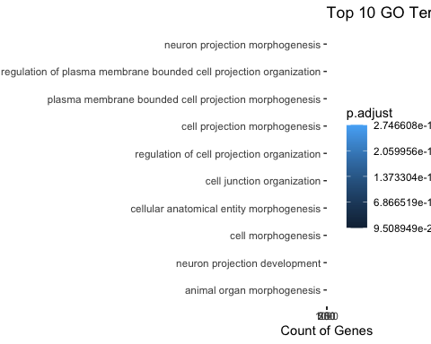

12. Writing data for comparison of results
write.table(EntrezIDs, sep= "\t", file="EntrezIDs_CpG_results.txt")
write.table(EntrezIDs_bmp, sep= "\t", file="EntrezIDs_bmp_results.txt")
CpG_GSA_res <- topGO(goanaOut, ontology="BP", number=100)
bmp_GSA_res <- topGO(goanaOut_bmp, ontology="BP", number=100)
write.table(CpG_GSA_res, sep= "\t", file="CpG_GSA_results.txt")
write.table(bmp_GSA_res, sep= "\t", file="bmp_GSA_results.txt")

Appendix B:

RNA-Seq Analysis of Esophageal Squamous Cell Carcinoma (ESCC) and Paired Normal Tissue
Chaeyoung Kim
2024-12-13
This R script identifies differentially expressed genes between esophageal squamous cell carcinoma (ESCC) tissue and paired normal tissue from six individual patients. MultiQC analysis was performed using an HPC environment, and this script processes pre-aligned gene count data published on GEO. The analysis begins with general data exploration, followed by preprocessing, normalization, and statistical analysis using the “edgeR” package.

General info
- Species: Homo Sapiens
- Sequencing device: Illumina HiSeq 2500
- Single- or paired-end sequencing: Paired-end sequencing
- Samples: This dataset includes six ESCC tumor and six adjacent normal tissue samples obtained from six individuals
- Muli Qc performed with HPC. Trimming and mapping has not been done due to the issue regarding the access into HPC. Instead, statistical analysis performed with raw count data downloaded from NCBI (https://www.ncbi.nlm.nih.gov/geo/query/acc.cgi?acc=GSE194116).

load required packages
##load required package
library(edgeR)
library(limma)
library(AnnotationDbi)
library(org.Hs.eg.db)
library(GO.db)
library(clusterProfiler)

Setup working directory
setwd("/Users/kimchaeyoung/Desktop/Applied_HT_analysis/Project")

Load dataset
# Read in text file
rnadatafull <- read.table("GSE194116_Raw_gene_counts_matrix.txt", header = T, sep = "\t", quote = "")
#Have a look at the data
head(rnadatafull)
## ensembl_id gene_name Normal.1.count Normal.2.count Normal.3.count
## 1 ENSG00000000003 TSPAN6 2043 2635 1566
## 2 ENSG00000000005 TNMD 3 8 3
## 3 ENSG00000000419 DPM1 339 320 304
## 4 ENSG00000000457 SCYL3 717 689 567
## 5 ENSG00000000460 C1orf112 206 229 172
## 6 ENSG00000000938 FGR 178 702 636
## Normal.4.count Normal.5.count Normal.6.count ECA.1.count ECA.2.count
## 1 1150 1396 2053 1321 787
## 2 6 5 3 0 0
## 3 296 410 427 887 528
## 4 747 725 787 422 594
## 5 231 234 331 483 796
## 6 551 230 304 276 144
## ECA.3.count ECA.4.count ECA.5.count ECA.6.count
## 1 417 999 1202 646
## 2 0 0 1 0
## 3 873 488 530 778
## 4 710 550 530 441
## 5 690 622 625 564
## 6 241 262 254 706
# save ensemble IDs and gene names in separate variable
geneIDs <- rnadatafull[,1:2]
head(geneIDs)
## ensembl_id gene_name
## 1 ENSG00000000003 TSPAN6
## 2 ENSG00000000005 TNMD
## 3 ENSG00000000419 DPM1
## 4 ENSG00000000457 SCYL3
## 5 ENSG00000000460 C1orf112
## 6 ENSG00000000938 FGR

1. Preprocess data
## Separate numerical data (count data) from annotation
rownames(rnadatafull) <- 1:nrow(rnadatafull)
rnadata <- rnadatafull[, 3:14]
## Make annotation for design later on
individuals <- factor(c("patient1", "patient2", "patient3", "patient4", "patient5", "patient6","patient1", "patient2", "patient3", "patient4", "patient5", "patient6"))
cvst <- factor(c("Normal", "Normal", "Normal", "Normal", "Normal", "Normal","ESCC","ESCC","ESCC","ESCC","ESCC","ESCC"))

1.1. Further preprocessing
# Create DGEList object: 'rnadata' contains the count data, and 'rnadatafull[, 1:2]' contains gene information
y <- DGEList(rnadata, genes = rnadatafull[, 1:2])
# Optional filter
# 'lib.size' refers to the library size of each sample. We calculate CPM (Counts Per Million) values,and apply a filtering threshold (cutoff) to remove genes with low counts.
cutoff <- 3 / (mean(y$samples$lib.size) / 1000000)
#Keep genes with CPM greater than the cutoff in at least 6 samples:
keep <- rowSums(cpm(y) > cutoff) >= 6
#This provides information on how many genes passed the filtering criteria
summary(keep)
## Mode FALSE TRUE
## logical 15849 24315
# Update DGEList object to include only the filtered genes
y <- y[keep, , keep.lib.sizes = FALSE]

1.2. Normalization
y <- calcNormFactors(y)
# Have a look at the library sizes and normalization factors
y$samples
## group lib.size norm.factors
## Normal.1.count 1 22294014 0.9438172
## Normal.2.count 1 21970627 0.9856696
## Normal.3.count 1 21787999 0.9169301
## Normal.4.count 1 19353923 1.0573374
## Normal.5.count 1 20592391 1.0111336
## Normal.6.count 1 18508014 1.0568192
## ECA.1.count 1 20507630 1.0195277
## ECA.2.count 1 17650965 1.0776411
## ECA.3.count 1 17247682 1.0271229
## ECA.4.count 1 19620147 0.9853978
## ECA.5.count 1 22725078 0.9369623
## ECA.6.count 1 19252943 0.9958464

1.3. MDS plot
- Visualize Sample Similarity -The MDS plot clearly distinguishes between the Normal and ECA groups, effectively highlighting significant biological differences between the two conditions. The variability within the ECA group suggests heterogeneity, offering potential insights through further analysis.
# Define colors for Normal (black) and ECA (red)
colors <- ifelse(grepl("^Normal", rownames(y$samples)), "black", "red")
# Plot MDS with specified colors
plotMDS(y, col=colors, main = "MDS Plot: Normal vs ECA")
# Add legend
legend("topright", legend=c("Normal", "ECA"), col=c("black", "red"), pch=16)
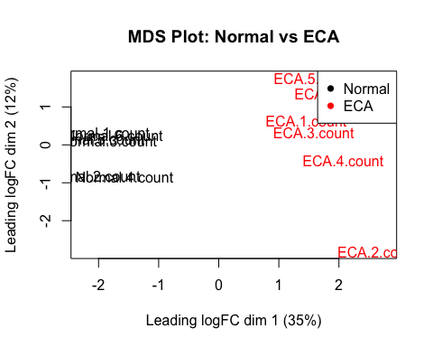

2. EdgeR differential expression analysis - Paired analysis
- as my dataset has been obtained from paired design experiment, perform paired analysis

2.1. Create design matrix
In paired data analysis, I need to account for within-individual variation to correctly identify the effects of the variable of interest (cvst in this case). The design matrix (model.matrix) is created to include both the condition (cvst) and the individual effect (individuals) as factors. This ensures that any differences detected between conditions are not confounded by differences inherent to the individuals.
# Create a design matrix: The 'cvst' variable represents the condition (e.g., Normal vs ECA), and 'individuals' represents the paired samples (e.g., patient1, patient2, etc.).
# The design matrix specifies how the data is modeled in terms of the experimental design.
design <- model.matrix(~ cvst + individuals)
design
## (Intercept) cvstNormal individualspatient2 individualspatient3
## 1 1 1 0 0
## 2 1 1 1 0
## 3 1 1 0 1
## 4 1 1 0 0
## 5 1 1 0 0
## 6 1 1 0 0
## 7 1 0 0 0
## 8 1 0 1 0
## 9 1 0 0 1
## 10 1 0 0 0
## 11 1 0 0 0
## 12 1 0 0 0
## individualspatient4 individualspatient5 individualspatient6
## 1 0 0 0
## 2 0 0 0
## 3 0 0 0
## 4 1 0 0
## 5 0 1 0
## 6 0 0 1
## 7 0 0 0
## 8 0 0 0
## 9 0 0 0
## 10 1 0 0
## 11 0 1 0
## 12 0 0 1
## attr(,"assign")
## [1] 0 1 2 2 2 2 2
## attr(,"contrasts")
## attr(,"contrasts")$cvst
## [1] "contr.treatment"
##
## attr(,"contrasts")$individuals
## [1] "contr.treatment"
rownames(design) <- colnames(y)
y <- estimateDisp(y, design)

2.2 Plot BCV (biological coefficient of variation) plot
- shows the relationship between the biological variation of gene expression
- The graph shows high variability in lowly expressed genes, with variability decreasing and stabilizing as expression levels increase. The blue trend line effectively captures the decreasing variability pattern, and most genes are close to the red common BCV line, indicating that dispersion estimates are appropriately calculated. Highly variable genes may require further analysis.
plotBCV(y, main = "BCV Plot: Biological Coefficient of Variation")
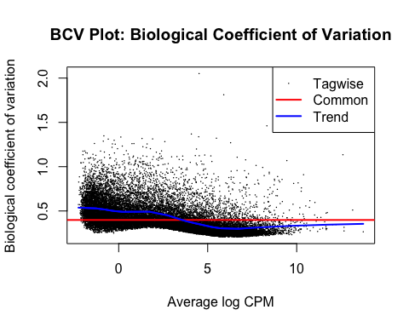

2.3. Fitting model and making a qq-plot to evaluate goodness of fit.
-The central points follow the theoretical distribution well, indicating the model fits most of the data appropriately. However, deviations at the tails suggest the model may not handle extreme values effectively.
# glmQLFit, glmLRT 수행
fit <- glmQLFit(y, design)
gof(fit,plot=TRUE)
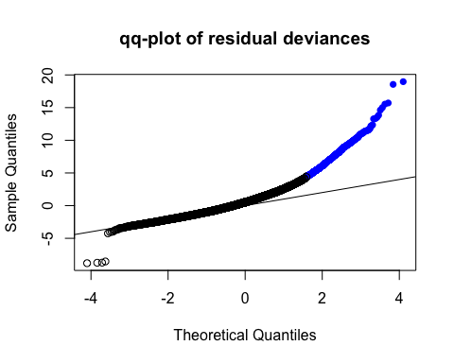

2.4. glmQSFTest
- Evaluate the significance of coefficients (in this case, the second coefficient).The argument coef = 2 specifies that the second coefficient in the model. The null hypothesis tested here is that there is no difference in expression between the groups being compared (e.g., Normal vs. ESCC).
# glmQLFTest() performs a Likelihood Ratio Test (LRT) based on the fitted model
qlf <- glmQLFTest(fit, coef = 2)
summary(qlf)
## Length Class Mode
## coefficients 170205 -none- numeric
## fitted.values 291780 -none- numeric
## deviance 24315 -none- numeric
## iter 24315 -none- numeric
## failed 24315 -none- logical
## method 1 -none- character
## unshrunk.coefficients 170205 -none- numeric
## df.residual 24315 -none- numeric
## design 84 -none- numeric
## offset 291780 CompressedMatrix numeric
## dispersion 1 -none- numeric
## prior.count 1 -none- numeric
## leverage 291780 -none- numeric
## unit.deviance.adj 291780 -none- numeric
## unit.df.adj 291780 -none- numeric
## df.residual.adj 24315 -none- numeric
## deviance.adj 24315 -none- numeric
## average.ql.dispersion 1 -none- numeric
## df.prior 1 -none- numeric
## var.post 24315 -none- numeric
## var.prior 24315 -none- numeric
## samples 3 data.frame list
## genes 2 data.frame list
## AveLogCPM 24315 -none- numeric
## table 4 data.frame list
## comparison 1 -none- character
## df.test 24315 -none- numeric
## df.total 24315 -none- numeric
resP <- topTags(qlf, n = nrow(qlf$table))
# Save the full result of the differential expression analysis to a text file
write.table(resP$table , file = "resP_edgeR_ESCC.txt", col.names = T, row.names = F, sep = "\t", quote = F)
rownames(resP$table) <- y$genes$ensembl_id
# Filter the result to only include genes with a p-value less than 0.05 (statistically significant genes)
resP_edgeR <- resP$table[resP$table[, ncol(resP$table)] < 0.05, ]
# Display the number of rows (genes) in the filtered result
num_rows <- nrow(resP_edgeR)
cat("Number of rows in resP_edgeR:", num_rows, "\n")
## Number of rows in resP_edgeR: 7305
dim(resP_edgeR)
## [1] 7305 7
down_regulated <- sum(resP_edgeR$logFC < 0)
down_regulated
## [1] 3525
up_regulated <- sum(resP_edgeR$logFC > 0)
up_regulated
## [1] 3780

2.5. Create Volvano plot
- visualize the results of differential expression analysis
- Genes on the left and right are downregulated and upregulated, respectively. Black points represent genes with no significant change.
# -log10 transform of Pvalue
resP$table$negLogP <- -log10(resP$table$PValue)
with(resP$table, plot(logFC, negLogP,
pch = 16, cex = 0.6,
col = ifelse(PValue < 0.05, "red", "black"),
main = "Volcano Plot: Differential Expression",
xlab = "Log2 Fold Change",
ylab = "-Log10 P-value"))
abline(h = -log10(0.05), col = "blue")
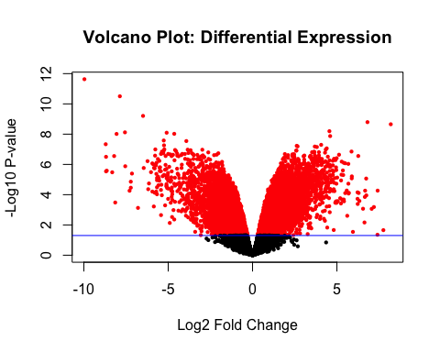

2.6. Creating MA plot
-Visualize the relationship between the mean expression level (average expression) and the log fold change (difference in expression) for each gene between two conditions. -The red points, which are spread out, indicate genes with significant differences in expression between the tumor and normal tissue samples. These are the genes that are most likely biologically relevant for further investigation.
with(resP$table , plot(logCPM , logFC , pch = 16, cex = 0.2, main = "MA-plot of log fold changes between expression values in tumor and normal tissue."))
with(resP$table, points(logCPM[FDR < 0.05], logFC[FDR < 0.05], pch =
16, col = "red", cex = 0.6))
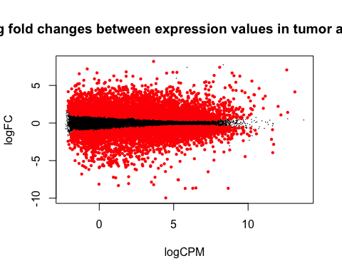

2.7 Plot histogram of P-values
- visualize the distribution of p-values obtained from statistical tests, to evaluate the reliability of the results.
- The majority of p-values are very small, indicating strong evidence for the effects tested in most of the comparisons.
hist(resP$table$PValue, main = "Histogram of P-values", xlab = "P-value", col = "lightblue")
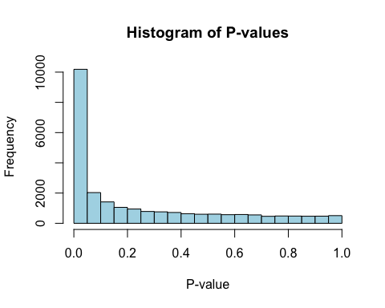

2.8. Top10 differentially expressed genes
- Display the most significant differential expression results (top10) between normal and ESCC tissue in the RNA-seq analysis.
head(resP$table[, c(1, 2, 3, 6, 7)], 10)
## ensembl_id gene_name logFC PValue FDR
## ENSG00000000003 ENSG00000170373 CST1 -9.966594 2.335211e-12 5.678066e-08
## ENSG00000000419 ENSG00000170454 KRT75 -7.865582 3.137313e-11 3.814188e-07
## ENSG00000000457 ENSG00000099953 MMP11 -6.491084 6.212125e-10 5.034927e-06
## ENSG00000000460 ENSG00000187848 P2RX2 6.810847 1.607231e-09 9.769953e-06
## ENSG00000000938 ENSG00000181092 ADIPOQ 8.193276 2.219090e-09 1.079144e-05
## ENSG00000000971 ENSG00000137766 UNC13C 4.555104 6.374277e-09 2.351332e-05
## ENSG00000001036 ENSG00000123500 COL10A1 -7.563470 7.600829e-09 2.351332e-05
## ENSG00000001084 ENSG00000173157 ADAMTS20 -5.091863 8.057611e-09 2.351332e-05
## ENSG00000001167 ENSG00000099812 MISP -4.641954 9.502751e-09 2.351332e-05
## ENSG00000001460 ENSG00000127928 GNGT1 -8.060504 9.670295e-09 2.351332e-05

3. Gene Set Analysis
# Display the first 10 rows of resP_edgeR
head(resP_edgeR, 10)
## ensembl_id gene_name logFC logCPM F
## ENSG00000000003 ENSG00000170373 CST1 -9.966594 4.469789 492.1460
## ENSG00000000419 ENSG00000170454 KRT75 -7.865582 3.506998 299.4413
## ENSG00000000457 ENSG00000099953 MMP11 -6.491084 7.313593 560.6491
## ENSG00000000460 ENSG00000187848 P2RX2 6.810847 1.809978 177.2143
## ENSG00000000938 ENSG00000181092 ADIPOQ 8.193276 3.649818 266.4165
## ENSG00000000971 ENSG00000137766 UNC13C 4.555104 1.393889 211.5872
## ENSG00000001036 ENSG00000123500 COL10A1 -7.563470 5.320874 337.5784
## ENSG00000001084 ENSG00000173157 ADAMTS20 -5.091863 1.056572 169.7713
## ENSG00000001167 ENSG00000099812 MISP -4.641954 2.615540 276.4453
## ENSG00000001460 ENSG00000127928 GNGT1 -8.060504 1.972294 201.4226
## PValue FDR
## ENSG00000000003 2.335211e-12 5.678066e-08
## ENSG00000000419 3.137313e-11 3.814188e-07
## ENSG00000000457 6.212125e-10 5.034927e-06
## ENSG00000000460 1.607231e-09 9.769953e-06
## ENSG00000000938 2.219090e-09 1.079144e-05
## ENSG00000000971 6.374277e-09 2.351332e-05
## ENSG00000001036 7.600829e-09 2.351332e-05
## ENSG00000001084 8.057611e-09 2.351332e-05
## ENSG00000001167 9.502751e-09 2.351332e-05
## ENSG00000001460 9.670295e-09 2.351332e-05
EntrezIDs <- mapIds(org.Hs.eg.db, rownames(resP_edgeR), 'ENTREZID', 'ENSEMBL')
## 'select()' returned 1:many mapping between keys and columns
sign_genes_entrez <- resP_edgeR[!(duplicated(EntrezIDs) | is.na(EntrezIDs)), ]
rownames(sign_genes_entrez) <- EntrezIDs[!(duplicated(EntrezIDs) | is.na(EntrezIDs))]
goanaOut <- goana(de=rownames(sign_genes_entrez), species="Hs", trend=T)
goanaOut <- goanaOut[order(goanaOut$P.DE, decreasing=FALSE),]
goanaOut$FDR.DE <- p.adjust(goanaOut$P.DE, method="BH")
topGORNA <- topGO(goanaOut, ontology="BP", number=50)
goanaOut_BP <- goanaOut[goanaOut$Ont == "BP",]
print(paste("Amount of significant GO Biological Process terms:",
as.character(sum(goanaOut_BP$FDR.DE < 0.05))))
## [1] "Amount of significant GO Biological Process terms: 2066"
topGORNA[order(topGORNA$N),]
## Term Ont N
## GO:0046907 intracellular transport BP 1357
## GO:0015031 protein transport BP 1415
## GO:0045184 establishment of protein localization BP 1701
## GO:0033554 cellular response to stress BP 1847
## GO:0071705 nitrogen compound transport BP 1903
## GO:0051649 establishment of localization in cell BP 1947
## GO:0071702 organic substance transport BP 2370
## GO:0051128 regulation of cellular component organization BP 2459
## GO:0008104 protein localization BP 2505
## GO:0070727 cellular macromolecule localization BP 2516
## GO:0006796 phosphate-containing compound metabolic process BP 2559
## GO:0006793 phosphorus metabolic process BP 2585
## GO:0009056 catabolic process BP 2668
## GO:0035556 intracellular signal transduction BP 2721
## GO:0036211 protein modification process BP 2958
## GO:0033036 macromolecule localization BP 3004
## GO:0051173 positive regulation of nitrogen compound metabolic process BP 3083
## GO:0043412 macromolecule modification BP 3191
## GO:0044085 cellular component biogenesis BP 3368
## GO:0051641 cellular localization BP 3384
## GO:0031325 positive regulation of cellular metabolic process BP 3440
## GO:0010604 positive regulation of macromolecule metabolic process BP 3506
## GO:0023051 regulation of signaling BP 3554
## GO:0010646 regulation of cell communication BP 3559
## GO:0006996 organelle organization BP 3623
## GO:0009893 positive regulation of metabolic process BP 3816
## GO:0006950 response to stress BP 3984
## GO:0048731 system development BP 4072
## GO:0048583 regulation of response to stimulus BP 4116
## GO:0006810 transport BP 4385
## GO:0051234 establishment of localization BP 4698
## GO:0007275 multicellular organism development BP 4764
## GO:0019538 protein metabolic process BP 4915
## GO:0051179 localization BP 5335
## GO:0048522 positive regulation of cellular process BP 5861
## GO:1901564 organonitrogen compound metabolic process BP 5992
## GO:0048856 anatomical structure development BP 6016
## GO:0048518 positive regulation of biological process BP 6411
## GO:0016043 cellular component organization BP 6581
## GO:0032502 developmental process BP 6593
## GO:0071840 cellular component organization or biogenesis BP 6791
## GO:0051716 cellular response to stimulus BP 7616
## GO:0050896 response to stimulus BP 9228
## GO:0006807 nitrogen compound metabolic process BP 10169
## GO:0044238 primary metabolic process BP 10655
## GO:0071704 organic substance metabolic process BP 11820
## GO:0008152 metabolic process BP 12343
## GO:0065007 biological regulation BP 12701
## GO:0009987 cellular process BP 17647
## GO:0008150 biological_process BP 18888
## DE P.DE FDR.DE
## GO:0046907 726 1.805689e-48 7.023818e-46
## GO:0015031 741 5.490232e-45 1.769502e-42
## GO:0045184 857 1.775893e-43 5.488484e-41
## GO:0033554 913 4.027524e-42 1.180065e-39
## GO:0071705 962 5.990434e-50 2.502781e-47
## GO:0051649 1012 2.552662e-60 1.745170e-57
## GO:0071702 1124 1.083296e-41 3.133365e-39
## GO:0051128 1198 3.758547e-52 1.630704e-49
## GO:0008104 1249 8.118462e-62 6.105354e-59
## GO:0070727 1254 5.747424e-62 4.471297e-59
## GO:0006796 1188 8.048540e-39 2.087162e-36
## GO:0006793 1203 5.700192e-40 1.549422e-37
## GO:0009056 1246 1.796958e-42 5.334363e-40
## GO:0035556 1291 1.174837e-48 4.650088e-46
## GO:0036211 1381 1.551464e-47 5.833763e-45
## GO:0033036 1458 1.247079e-63 1.042050e-60
## GO:0051173 1388 1.647746e-37 4.040738e-35
## GO:0043412 1495 3.598045e-53 1.623510e-50
## GO:0044085 1516 2.144000e-41 6.122883e-39
## GO:0051641 1672 3.325261e-82 4.688826e-79
## GO:0031325 1532 8.929622e-39 2.289332e-36
## GO:0010604 1583 1.783354e-44 5.666794e-42
## GO:0023051 1612 6.779363e-47 2.353065e-44
## GO:0010646 1607 2.836963e-45 9.276047e-43
## GO:0006996 1696 2.854111e-61 2.012237e-58
## GO:0009893 1712 1.409038e-46 4.816561e-44
## GO:0006950 1749 1.449126e-40 4.036263e-38
## GO:0048731 1813 3.624565e-47 1.297997e-44
## GO:0048583 1830 3.364395e-47 1.224260e-44
## GO:0006810 1977 1.973898e-57 1.141875e-54
## GO:0051234 2108 3.960634e-60 2.553024e-57
## GO:0007275 2126 2.087326e-58 1.239267e-55
## GO:0019538 2204 2.354865e-63 1.897432e-60
## GO:0051179 2416 1.302743e-76 1.469560e-73
## GO:0048522 2575 9.664818e-67 8.721919e-64
## GO:1901564 2699 8.710776e-86 1.403742e-82
## GO:0048856 2587 2.623950e-56 1.345430e-53
## GO:0048518 2801 7.704438e-72 7.900901e-69
## GO:0016043 2953 6.361506e-95 1.104015e-91
## GO:0032502 2813 3.844905e-59 2.344457e-56
## GO:0071840 3055 1.260280e-101 2.369432e-98
## GO:0051716 3129 8.980741e-48 3.434144e-45
## GO:0050896 3659 4.849122e-40 1.334159e-37
## GO:0006807 4095 3.608089e-60 2.394179e-57
## GO:0044238 4270 1.375643e-61 1.001157e-58
## GO:0071704 4573 6.011754e-43 1.832854e-40
## GO:0008152 4775 1.747721e-47 6.463990e-45
## GO:0065007 4846 1.565525e-38 3.924422e-36
## GO:0009987 6561 1.545568e-72 1.660456e-69
## GO:0008150 6892 3.116839e-68 3.057348e-65
#### Gene Set Analysis
# GO analysis (Biological Process)
go_results <- enrichGO(gene = rownames(sign_genes_entrez),
OrgDb = org.Hs.eg.db,
ont = "BP", # GO Biological Process (BP)
pAdjustMethod = "BH",
pvalueCutoff = 0.05,
qvalueCutoff = 0.05)
go_results_df <- as.data.frame(go_results)
#visualize only top10 Go results
barplot(go_results, showCategory = 10)
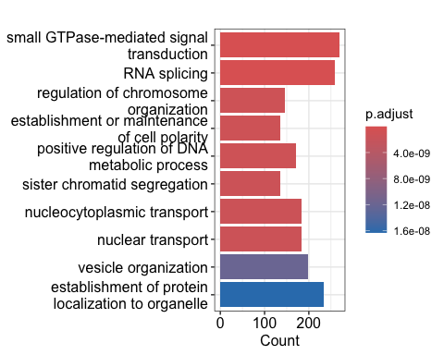
RNAseq_GSA_res <- topGO(goanaOut, ontology="BP", number=100)
# write GSA results into text file for further analysis
write.table(RNAseq_GSA_res, sep= "\t", file="RNAseq_GSA_results.txt")

4. save the results for futher analysis
edgeR_res <- resP_edgeR[order(resP_edgeR$FDR, decreasing=F),]
write.table(edgeR_res, sep= "\t", file="RNAseq_results.txt")
RNAseq_GSA_res <- topGO(goanaOut, ontology="BP", number=100)
write.table(RNAseq_GSA_res, sep= "\t", file="RNAseq_GSA_results.txt")

Appendix C:

Result comparison
Chaeyoung Kim
2024-12-19
This R markdown the comparison of results of two data analysis.
setwd("/Users/kimchaeyoung/Desktop/Applied_HT_analysis/Project/results/")
dir <- "/Users/kimchaeyoung/Desktop/Applied_HT_analysis/Project/results/"
library(org.Hs.eg.db)
## Loading required package: AnnotationDbi
## Loading required package: stats4
## Loading required package: BiocGenerics
##
## Attaching package: 'BiocGenerics'
## The following objects are masked from 'package:stats':
##
## IQR, mad, sd, var, xtabs
## The following objects are masked from 'package:base':
##
## anyDuplicated, aperm, append, as.data.frame, basename, cbind,
## colnames, dirname, do.call, duplicated, eval, evalq, Filter, Find,
## get, grep, grepl, intersect, is.unsorted, lapply, Map, mapply,
## match, mget, order, paste, pmax, pmax.int, pmin, pmin.int,
## Position, rank, rbind, Reduce, rownames, sapply, setdiff, table,
## tapply, union, unique, unsplit, which.max, which.min
## Loading required package: Biobase
## Welcome to Bioconductor
##
## Vignettes contain introductory material; view with
## 'browseVignettes()'. To cite Bioconductor, see
## 'citation("Biobase")', and for packages 'citation("pkgname")'.
## Loading required package: IRanges
## Loading required package: S4Vectors
##
## Attaching package: 'S4Vectors'
## The following object is masked from 'package:utils':
##
## findMatches
## The following objects are masked from 'package:base':
##
## expand.grid, I, unname
##
library(VennDiagram)
## Loading required package: grid
## Loading required package: futile.logger

Load in data
results_files <- list.files(pattern = ".*.txt")
for (i in 1:length(results_files)) { #loop through .txt files, assign them to their respective variables
assign(sub("\\..*","",results_files[i]), read.table(results_files[i])) }

1. Fitration of RNA_seq results
This section filters the RNA-seq results based on an FDR threshold of 0.05, sorts the data by row names, and then performs an analysis based on CpG methylation data. A Venn diagram is created to visualize the overlap between the significant RNA-seq results and the CpG analysis.
# RNAseq filtering
# Filtering RNAseq results with an FDR less than 0.05 and sorting the results by row names
RNAseq_filtered <- RNAseq_results[RNAseq_results$FDR < 0.05, ]
RNAseq_filtered <- RNAseq_filtered[order(rownames(RNAseq_filtered)), ]
ENS_RNA <- rownames(RNAseq_filtered[RNAseq_filtered$FDR<0.05,])

2.Comparison between RNA-seq analysis vs differentially methylated regions (DMRs)
- no overlappings
EntrezIDs_bmp <- read.table("EntrezIDs_bmp_results.txt", header = TRUE)
# Extracting the 'x' column as a vector
EntrezIDs_bmp_vec <- EntrezIDs_bmp$x
ENS_bmp <- mapIds(org.Hs.eg.db, as.character(EntrezIDs_bmp_vec), 'ENSEMBL', 'ENTREZID')
## 'select()' returned 1:many mapping between keys and columns
ENS_bmp_uniq <- ENS_bmp[!(duplicated(ENS_bmp) | is.na(ENS_bmp))]
# Create a Venn diagram to visualize the overlap between RNAseq results and DMRs
grid.newpage()
draw.pairwise.venn(
area1 = length(rownames(RNAseq_filtered)), # RNAseq filtered area
area2 = length(ENS_bmp_uniq), # CpG analysis area
cross.area = length(intersect(rownames(RNAseq_filtered), ENS_bmp_uniq)), # Intersection area
category = c("Significant for RNA-seq", "Significant differential methylation (bumps) "), # Category labels
fill = c("skyblue", "mediumorchid"),
lty = "blank"
)
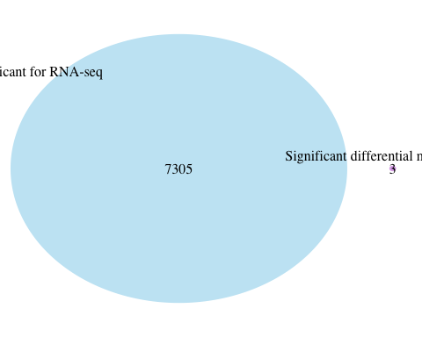
## (polygon[GRID.polygon.1], polygon[GRID.polygon.2], polygon[GRID.polygon.3], polygon[GRID.polygon.4], text[GRID.text.5], text[GRID.text.6], text[GRID.text.7], text[GRID.text.8])

3. Comparison betwen RNA-seq analysis and CpG based analysis
EntrezIDs_CpG <- read.table("EntrezIDs_CpG_results.txt", header = TRUE)
# Extracting the 'x' column as a vector
EntrezIDs_CpG_vec <- EntrezIDs_CpG$x
ENS_CpG <- mapIds(org.Hs.eg.db, as.character(EntrezIDs_CpG_vec), 'ENSEMBL', 'ENTREZID')
## 'select()' returned 1:many mapping between keys and columns
ENS_CpG_uniq <- ENS_CpG[!(duplicated(ENS_CpG) | is.na(ENS_CpG))]
# Create a Venn diagram to visualize the overlap between RNAseq results and CpG methylation results
grid.newpage()
draw.pairwise.venn(
area1 = length(rownames(RNAseq_filtered)), # RNAseq filtered area
area2 = length(ENS_CpG_uniq), # CpG analysis area
cross.area = length(intersect(rownames(RNAseq_filtered), ENS_CpG_uniq)), # Intersection area
category = c("Significant for RNAseq", "Significant for CpG"), # Category labels
fill = c("skyblue", "mediumorchid"),
lty = "blank"
)
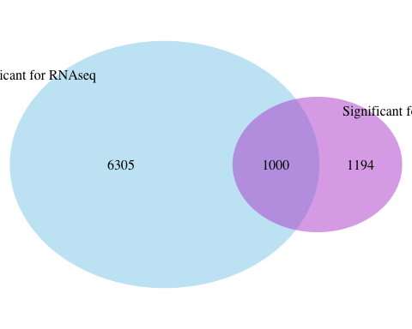
## (polygon[GRID.polygon.9], polygon[GRID.polygon.10], polygon[GRID.polygon.11], polygon[GRID.polygon.12], text[GRID.text.13], text[GRID.text.14], text[GRID.text.15], text[GRID.text.16], text[GRID.text.17])

4. Genes and Terms of interest
The diagram reveals that there are 26 GO terms that are shared by both RNA-seq and methylation analyses, which might represent biological processes or functions that are affected by both gene expression and DNA methylation
print("Ensembl gene IDs that are significant:")
## [1] "Ensembl gene IDs that are significant:"
# Extract GO terms from RNA-seq analysis results
Metterms <- bmp_GSA_results$Term # Extract GO terms related to RNA-seq
# Extract GO terms from methylation analysis results
RNAterms <- RNAseq_GSA_results$Term # Extract GO terms related to methylation analysis
# Create a new graphics page for the Venn diagram
grid.newpage()
grid.newpage()
draw.pairwise.venn(length(RNAterms), length(Metterms), length(intersect(RNAterms,Metterms)), category = c("Top terms for RNA", "Top terms for Methylation"),
lty = rep("blank", 2), fill = c("light blue", "mediumorchid"), alpha = rep(0.5, 2), cat.pos = c(0, 0), cat.dist = rep(0.025, 2))
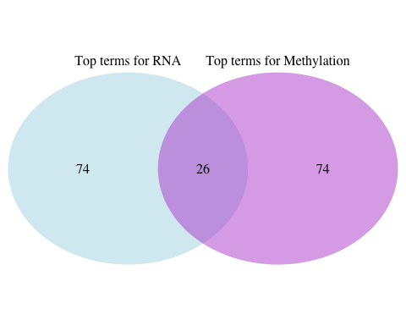
## (polygon[GRID.polygon.18], polygon[GRID.polygon.19], polygon[GRID.polygon.20], polygon[GRID.polygon.21], text[GRID.text.22], text[GRID.text.23], text[GRID.text.24], text[GRID.text.25], text[GRID.text.26])

5. Ensembl gene IDs that are significant for the two analyses (RNAseq and CpG)
This section finds the common genes between RNA-seq and CpG methylation analysis.
# Find common genes between RNAseq results and CpG analysis
print("Ensembl gene IDs that are significant for the two analyses:")
## [1] "Ensembl gene IDs that are significant for the two analyses:"
common_genes <- intersect(ENS_RNA, ENS_CpG) # Identify genes that are significant in both RNAseq and CpG analyses\
head(common_genes)
## [1] "ENSG00000001460" "ENSG00000001617" "ENSG00000001629" "ENSG00000002746"
## [5] "ENSG00000002822" "ENSG00000003147"
# Top GO terms overlapping for the two analyses
print("Top overlapping GO terms:")
## [1] "Top overlapping GO terms:"
common_terms <- intersect(RNAterms, Metterms) # Identify common GO terms between RNAseq and methylation analysis
head(common_terms)
## [1] "cellular component organization or biogenesis"
## [2] "cellular component organization"
## [3] "cellular process"
## [4] "positive regulation of biological process"
## [5] "positive regulation of cellular process"
## [6] "organelle organization"
# Genes of interest (GOI) based on the common genes found in RNAseq and CpG
# Extract genes of interest from RNAseq results based on the common genes.
GOI <- RNAseq_results[which(rownames(RNAseq_results) %in% common_genes), ]
rownames(GOI) <- mapIds(org.Hs.eg.db, rownames(GOI), 'SYMBOL', 'ENSEMBL') # Convert ENSEMBL IDs to SYMBOLs
## 'select()' returned 1:many mapping between keys and columns
# Terms of interest (POI) based on the common GO terms
# Extract terms of interest based on the common GO terms.
POI <- RNAseq_GSA_results[which(RNAseq_GSA_results$Term %in% common_terms), ]
# View top 10 rows of both GOI and POI
# Display the top 10 genes and GO terms of interest.

5.1. GOI
In this analysis, positive logFC values indicate up-regulated genes, meaning these genes have increased expression in the experimental condition compared to the control. Genes like CFLAR, KDM1A, and RBM6 are examples of up-regulated genes. On the other hand, negative logFC values indicate down-regulated genes, meaning these genes have decreased expression in the experimental condition. Examples of down-regulated genes include STPG1, SEMA3F, ANKIB1, HECW1, MAD1L1, and ICA1, which all show reduced expression. Therefore, genes with positive logFC values are up-regulated, while genes with negative logFC values are down-regulated in the experimental group.
head(GOI, n=10)
## ensembl_id gene_name logFC logCPM F PValue
## STPG1 ENSG00000127928 GNGT1 -8.060504 1.9722937 201.4226 9.670295e-09
## SEMA3F ENSG00000060718 COL11A1 -8.703936 5.7733561 216.5736 4.633264e-08
## ANKIB1 ENSG00000228742 LINC02577 -5.249074 1.6900926 120.7926 5.485484e-08
## HECW1 ENSG00000095203 EPB41L4B -2.977733 4.0113937 188.9327 1.070544e-07
## MAD1L1 ENSG00000223485 LINC01615 -4.594110 0.1554300 86.6495 1.114826e-07
## ICA1 ENSG00000214336 FOXI3 -5.372894 0.6769829 129.1362 1.431481e-07
## CFLAR ENSG00000116983 HPCAL4 3.527323 2.3264447 177.2282 1.553250e-07
## MTMR7 ENSG00000119547 ONECUT2 -3.808518 0.9149784 132.8048 1.764565e-07
## KDM1A ENSG00000197256 KANK2 1.914136 7.4096116 163.7816 2.069153e-07
## RBM6 ENSG00000076555 ACACB 2.451443 5.8016488 163.0520 2.112539e-07
## FDR
## STPG1 2.351332e-05
## SEMA3F 8.046987e-05
## ANKIB1 8.336221e-05
## HECW1 8.606043e-05
## MAD1L1 8.606043e-05
## ICA1 8.606043e-05
## CFLAR 8.606043e-05
## MTMR7 8.606043e-05
## KDM1A 8.606043e-05
## RBM6 8.606043e-05

5.2. POI
The terms with higher DE values indicate biological processes that are most impacted by the experimental conditions. For example, the “cellular process” term (GO:0009987) is associated with 6561 DE genes, meaning that a significant portion of the genes in this category show altered expression.
head(POI, n=10)
## Term Ont N DE
## GO:0071840 cellular component organization or biogenesis BP 6791 3055
## GO:0016043 cellular component organization BP 6581 2953
## GO:0009987 cellular process BP 17647 6561
## GO:0048518 positive regulation of biological process BP 6411 2801
## GO:0048522 positive regulation of cellular process BP 5861 2575
## GO:0006996 organelle organization BP 3623 1696
## GO:0032502 developmental process BP 6593 2813
## GO:0007275 multicellular organism development BP 4764 2126
## GO:0048856 anatomical structure development BP 6016 2587
## GO:0051128 regulation of cellular component organization BP 2459 1198
## P.DE FDR.DE
## GO:0071840 1.260280e-101 2.369432e-98
## GO:0016043 6.361506e-95 1.104015e-91
## GO:0009987 1.545568e-72 1.660456e-69
## GO:0048518 7.704438e-72 7.900901e-69
## GO:0048522 9.664818e-67 8.721919e-64
## GO:0006996 2.854111e-61 2.012237e-58
## GO:0032502 3.844905e-59 2.344457e-56
## GO:0007275 2.087326e-58 1.239267e-55
## GO:0048856 2.623950e-56 1.345430e-53
## GO:0051128 3.758547e-52 1.630704e-49

