**Instructions:**

* Install oracle VM VirtualBox manager.
* Install Ubuntu OS (platform) on your VirtualBox and ensure XV6 is up and running.
* Open the command prompt and run the following commands.

1. Cd 6.828/
2. cd changes/
3. Make
4. Make qemu-nox



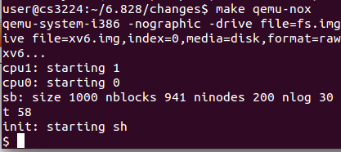

* Ensure Xv6 is up as shown in the above screenshot

**Lseek():**

* Use make qemu.
* Lseek FILENAME
* Cat FILENAME

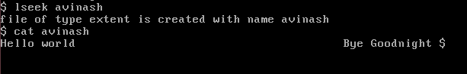

**Extent File Creation:**

* Make qemu-nox
* Extent filename



**Display status of the extent file:**

* Make qemu-nox
* Stat filename

