**Instructions:**

* Install oracle VM VirtualBox manager.
* Install Ubuntu OS (platform) on your VirtualBox and ensure XV6 is up and running.
* Open the command prompt and run the following commands.

1. Cd 6.828/
2. Cd xv6-public/
3. Make
4. Make qemu-nox

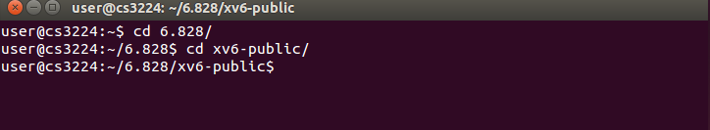

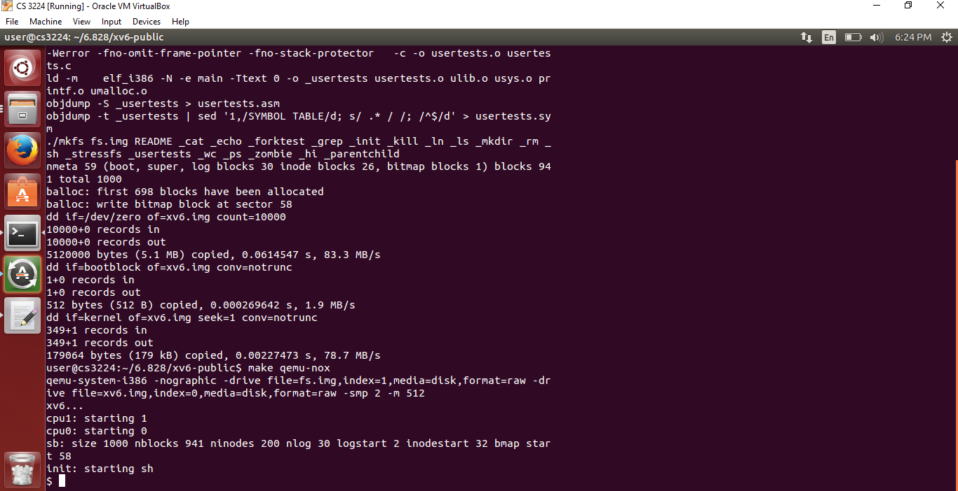

* Ensure Xv6 is up as shown in the above screenshot
* Enter uv2p command to get the physical address of the given virtual address.