

**Networking Platform**

**for graduates and students**

**Requirement specification**

2021.11.19.

**Introduction to Software Engineering 41**

**TEAM 7**

Team Leader Jiyeol Park

Team Member Shinhyeon Park

Team Member Mujin Gwak

Team Member Chaewon Jeong

Team Member Hayoung Cho

Team Member Bohyeon Mo

Team Member Sojeong Um

CONTENTS

1. Introduction 6

1.1. Purpose 6

1.2. Scope 6

1.3. Definitions, Acronyms, and Abbreviation 7

1.4. Overview 7

2. Overall Description 8

2.1. Product Perspective 8

2.2. System Interfaces 8

2.3. User Interfaces 8

2.4. User Interfaces 9

2.5. Hardware Interfaces 9

2.6. Software Interfaces 9

2.7. Communications Interfaces 10

2.8. Memory Constraints 10

3. Specific Requirements 10

3.1. User Characteristics 10

3.3.1. SKKU Administrator 10

3.3.2. SKKU Student 11

3.3.3. SKKU Graduate 11

3.2. Constraint 12

4. Assumption and Dependencies 12

5. Functional Requirements 13

5.1. User Case Diagram 13

5.2. Use Case of review analysis 13

5.2.1. Student 13

5.2.1. Graduates 14

5.3. Process Model 15

6. External interface requirement 15

6.1. User Interfaces 15

6.2. Hardware interfaces 19

6.3. Software interfaces 19

7. System Evolution 19

7.1. Assumption 20

7.2 Limitation 20

7.3. Evolutions 20

8. Supporting Information 21

8.1. Document History 21

|  |
| --- |
| LIST OF TABLES  table 1 Table of acronyms and abbreviations 6  table 2 Table of terms and definitions 7  table 3 student review analysis 13  table 4 graduates (1) 13  table 5 graduates (2) 13  table 6 graduates (3) 14  table 7 user interface of login 15  table 8 user interface of senior profile update 16  table 9 user interface of look around 16  table 10 user interface of private conversation 17  table 11 user interface of speech 17  table 12 hardware interface of applicable device for the system 18  table 13 software interface of VRchat for unity 18 |

# **1. Introduction**

## 1.1. Purpose

This document is a Software Requirements Specification (SRS) for providing networking platform for graduates and students based on VRChat. This service is designed and implemented by Team 7 of the Introduction to Software Engineering at Sungkyunkwan University. The requirements for this are summarized, analyzed, and the system is designed and implemented based on the contents described.

In this document, Team 7 is the main reader, and Team 7 designs and implements the functions of networking platform for graduates and students according to this specification. Additionally, professors, TAs, and team members in the Introduction to Software Engineering class can be the main readers.

The purpose of this document is to outline and publish the Requirement Specification for networking platform for graduates and students. Our platform will provide a space for graduates and students to meet online. Users can easily access the information of graduates and enjoy meeting in a private space by meeting with the desired audience. All of this is done in the metaverse provided by VRChat.

## 1.2. Scope

Our network platform is intended to facilitate encounters between graduates and students, and to make them comfortable and enjoyable anytime, anywhere. Our system works in the world based on VRChat. We offer alumni information inquiries, plazas where you can meet them, and private spaces. Above all, we hope to provide a comfortable user experience along with the best places for both graduates and students.

## 1.3. Definitions, Acronyms, and Abbreviation

The following table explains the acronyms and abbreviations used in this document.

|  |  |
| --- | --- |
| **Acronyms& Abbreviations** | **Explanation** |
| Asset | an item that you can use in the game or project |
| Event | a type of special delegates which are used when you want to notify other classes when something happens |
| Udon | programming language built completely in-house by the VRChat Development Team |

table Table of acronyms and abbreviations

The following table defines certain technical terms used in this document.

|  |  |
| --- | --- |
| **Terms** | **Definitions** |
| User | Someone who uses a system |
| System administrator | Someone who quantify the keywords included in the reviews for each laptop and manage the system |
| Back-End | Application part that is not directly accessed by the user, such as the server and database |
| Front-End | The user interface, also known as the presentation layer of an application |
| Algorithm | A set of rules or procedures followed by a computer in problem-solving operations |
| Software | The programs and other operating information used by a computer |
| Network | For connect devices together so that they can share information. In this system, it usually means internet |

table Table of terms and definitions

## 1.4. Overview

The remainder of this Software Requirements Specifications Document includes eight chapters and appendixes. The second chapter provides an overall description of the product perspective, including the several interfaces, the system functionality and system interaction with other systems. The third chapter provides user (system administrator, user, and vendor) characteristics. The fourth chapter briefly mentions assumptions and dependencies. The fifth chapter describes the functional requirements of our system for users, such as how the system should react to particular inputs, how it should behave in particular systems, and what it should not do. The sixth chapter describes external interface requirements, and the seventh chapter describes system evolution, the limitations of our system and what we can do to overcome them. All members contributed equally to the production of this project. We hope that you, the reader, enjoy viewing this document.

# **2. Overall Description**

## 2.1. Product Perspective

This service is designed for the students who want to connect with graduates. This application helps students to easily find information about graduates. And students find the desired graduates and contact them to make a reservation. They can step into a private space with the graduates and enjoy candid conversations in the metaverse space. This application will use the VRChat platform, and it will be able to provide a comfortable meeting without interruption of exchange between people in the Corona era.

## 2.2. System Interfaces

Our service is powered by VRChat. Therefore, it must comply with the system specifications required by VRChat. Our service has limited access to databases and servers.

## 2.3. User Interfaces

An interface is provided through the screen of the monitor, and information can be input through input of the keyboard and mouse. Unlike existing VR platforms, it is possible to play with a similar control method to FPS only on the desktop, but to enjoy various contents, it is recommended using VR. As of 2021, VR devices with specifications that can enjoy VRChat have not been popularized, so the financial barriers to entry are evaluated to be quite high. The devices that have been confirmed to work are as follows: HTC VIVE, Oculus Rift/Oculus Rift S, Windows Mixed Reality, Samsung Odyssey HMD series.

## 2.4. User Interfaces

An interface is provided through the screen of the monitor, and information can be input through input of the keyboard and mouse. Unlike existing VR platforms, it is possible to play with a similar control method to FPS only on the desktop, but to enjoy various contents, it is recommended using VR. As of 2021, VR devices with specifications that can enjoy VRChat have not been popularized, so the financial barriers to entry are evaluated to be quite high. The devices that have been confirmed to work are as follows: HTC VIVE, Oculus Rift/Oculus Rift S, Windows Mixed Reality, Samsung Odyssey HMD series.

## 2.5. Hardware Interfaces

VRChat requires a Windows operating system. Graphics card must also be NVIDIA GeForce® GTX 970 or higher, AMD Radeon™ R9 290 or higher, and Intel UHD Graphics 610 or higher. Processor must be Intel® i5-4590 or higher, AMD FX 8350 or higher to run smoothly.

## 2.6. Software Interfaces

The system is intended for Windows version at least Windows 7, Windows 8.1, Windows 10.

## 2.7. Communications Interfaces

Since our service is based on VRChat, there is no need to consider the interfaces related to protocols, servers, and databases.

## 2.8. Memory Constraints

Our system requires at least 4GB of RAM and 1GB of storage space.

# **3. Specific Requirements**

## 3.1. User Characteristics

In this section, we describe who the stakeholders are and properties of each type of parsona. Therefore, we will deal with the relationship between each party and our system, the purpose of each party, and the basic background knowledge and context.

### 3.3.1. SKKU Administrator

We set the purpose of the system to provide a window for students and graduates of Sungkyunkwan University to communicate freely even if they do not visit the campus offline. Therefore, the actual manager and final owner of our system will be the manager of Sungkyunkwan University, and the persona will have several requirements.

The first is obstructive. As it is a venue for exchanges between graduates and enrolled students, access to the system of enrolled students from other schools not related to Sungkyunkwan University should be restricted. The second is reliability. Since anonymous and online exchanges take place and the system is based on the brand image of Sungkyunkwan University, the reliability of the system should be strengthened to prevent problems such as abusive language or unhealthy use.

### 3.3.2. SKKU Student

In the case of users, there are two categories, one of which is a student attending Sungkyunkwan University. Users of this type are currently taking major classes at Sungkyunkwan University and have not yet completed them. Although he has various majors and interests such as computer engineering, electrical and electronic engineering, and business administration, he wants more realistic and specific information for career exploration because there is little information available as a student.

The value that Sungkyunkwan University student users value is accessibility. Although it is an online channel, if the system is not easily available to obtain and exchange information, it will be difficult to be widely used even though it is a well-intended system.

### 3.3.3. SKKU Graduate

Another user type, Sungkyunkwan University graduate, has more diverse characteristics than enrolled students. Graduates graduated from Sungkyunkwan University and are still working, but they still have affection for their alma mater, so they came to help their students as much as possible.

Therefore, the value they value will be the guarantee of anonymity. Although the system is used with good intentions, if one's personal information is disclosed too much, the burden of information exchange will increase and the utilization rate of graduates will be greatly reduced. In addition, since the system is used in the midst of busy times, accessibility will be emphasized like students.

## 3.2. Constraint

When implementing and designing this system, we should consider some contents.

* A bit of freedom in computer specification.
* Use at least three open source systems for fast implementation.
* All development should be done within 2 weeks from the date started.
* At least three iterations of testing from users.
* For realistic feeling, use AR or VR technology.
* Should set a specific area design concept.
* Contain some Object that users can reminiscent about SKKU.
* Design a movement line that makes it convenient to use the space.

# **4. Assumption and Dependencies**

All systems and technology written in this document should be implemented based on the Windows OS environment. The reason is simple. In Korea, most SKKU students and graduates use Windows OS, so our system must fit in the Windows environment. and for scalability, it is important to consider compatibility with other ARVR development tools and platforms. because many systems using ARVR technology use C# scripting and Unity platform, we must make our system fit to that kind of dependency.

# **5. Functional Requirements**

## 5.1. User Case Diagram

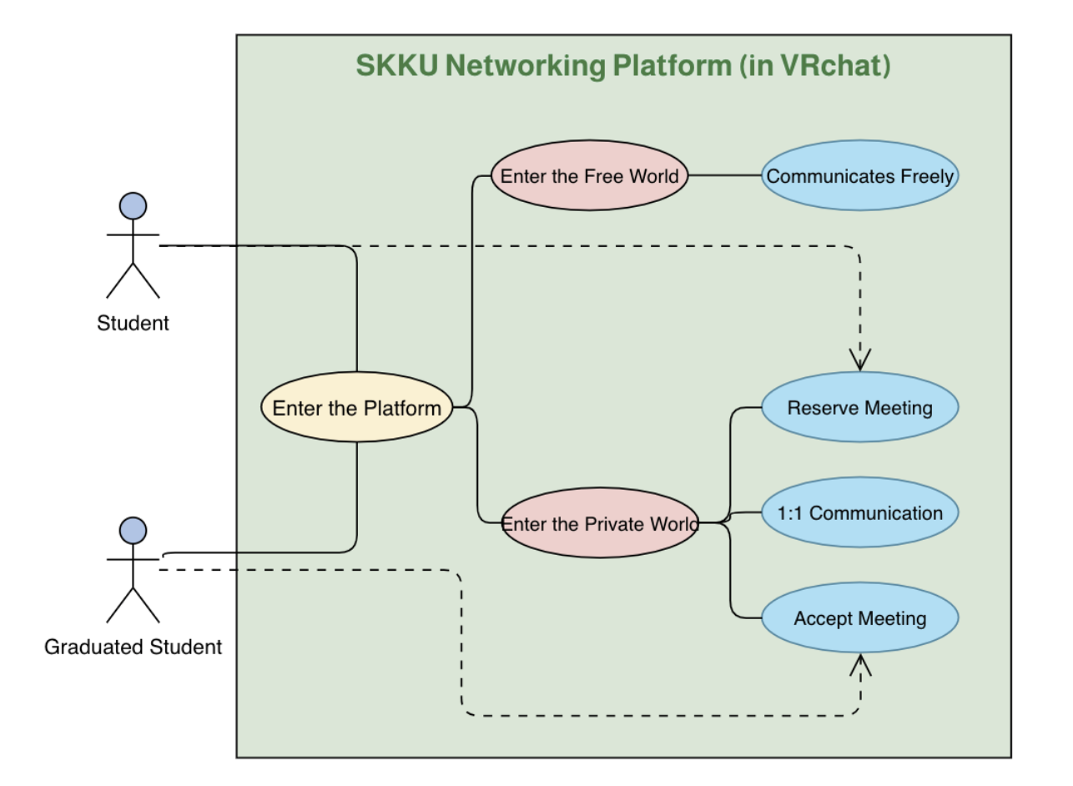

figure Use case diagram

## 5.2. Use Case of review analysis

### 5.2.1. Student

|  |  |
| --- | --- |
| ***Use Case Name*** | ***Review Analysis*** |
| Actor | Student (재학생) |
| Description | It is configured to communicate with graduates through a networking platform. Students can enter the platform, book meetings with graduates, and communicate freely. |
| Normal Course | a. Enter the Platform  b-1. Enter the Free World : Communicates Freely  b-2. Enter the Private World : 1:1 Communication (with Graduated Student)  & Reserve Meeting |
| Precondition | * The user should sign up VRChat platform * The user should enter our networking platform |
| Post Condition | N/A |
| Assumptions | Suppose that the number of users is guaranteed enough to communicate with each other and operate the platform. |

table student review analysis

### 5.2.1. Graduates

|  |  |
| --- | --- |
| ***Use Case Name*** | ***Graduates - Enter the platform*** |
| Actor | Graduates |
| Description | This is a description of graduates entering the VRChat platform. All users, including graduates, can enter the platform with identical rights. |
| Normal Course | 1. Log in to VR Chat Service. 2. Enter World which we made for our service. |
| Precondition | Graduates should register VR Chat service. |
| Post Condition | N/A |
| Assumptions | N/A |

table graduates (1)

|  |  |
| --- | --- |
| ***Use Case Name*** | ***Graduates - Enter the Private World*** |
| Actor | Graduates |
| Description | This case shows Entering the private world. Private World is a place to hold counseling with students. Users can enter the private world via portal in the main world. |
| Normal Course | 1. Find right portal for counseling. 2. Graduates take a role to hold a counseling. |
| Precondition | 1. Graduates should enter the main world 2. Graduates should enter the private world first as the organizer of the counseling. |
| Post Condition | N/A |
| Assumptions | Graduates and Students have same outward appearance. Graduates can take a role by entering the private world for the first time. |

table graduates (2)

|  |  |
| --- | --- |
| ***Use Case Name*** | ***Graduates - Accept Meeting*** |
| Actor | Graduates |
| Description | This case shows how graduates accept meeting in the private room. Acceptance can be implemented by blocking the portal. If we unblock, enabling students to enter the private world, we accept students. If we block, disabling students to enter the private world, we don’t accept students to enter the private world. |
| Normal Course | 1. Graduates enter the private world as an organizer of counseling. 2. Using attributes or features of assets, graduates enable or disable portal. 3. The availability of the portal means whether the organizer accepts the students or not. |
| Precondition | Graduates should enter the world first as the organizer of the private world. |
| Post Condition | N/A |
| Assumptions | Graduates can take a role as an organizer so that graduates can control the acceptance of the private world. Assets have proper attributes for this scenario. |

table graduates (3)

## 5.3. Process Model

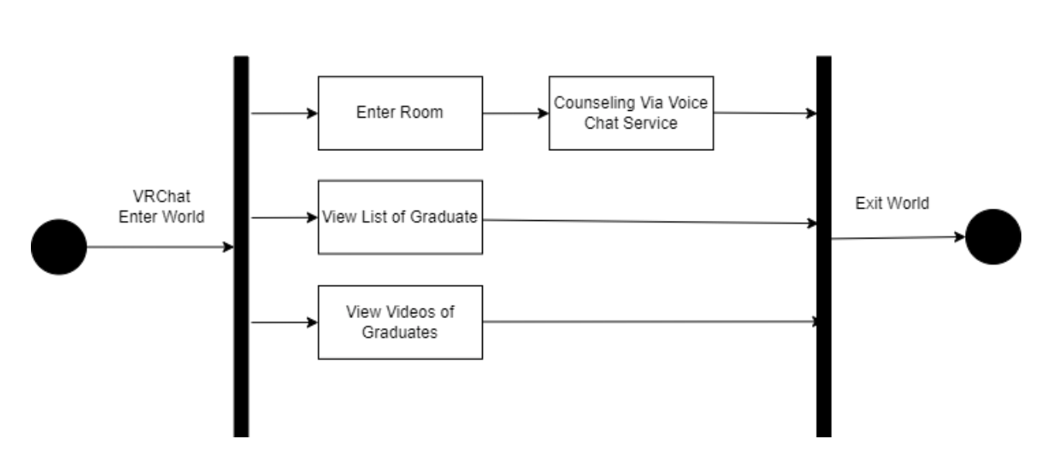

figure process model

# **6. External interface requirement**

## 6.1. User Interfaces

|  |  |
| --- | --- |
| ***Name*** | ***login*** |
| Purpose/Description | There are two types of Users: senior and junior. Both seniors and juniors must certify that they are SKKU students before logging in. Graduates can log in as juniors, but still enrolled students can log in only as juniors. |
| Input source/ Output destination | Users / VRChat |
| Range/  Accuracy/  Margin of error | Accounts as many as the number of students and graduates of SKKU / Accuracy of duplicates, errors, and changes of students' accounts / Margin of errors in duplicates, errors, and changes of students' accounts |
| Unit | Screen |
| Time/ Velocity | After all input data is received by the user device/communication time between the user device and the SKKU server. |
| Relationship with other input/outputs | The type of each account affects the overall interface. |
| Format and configuration of screen | 1. Screen to enter whether the user is a senior or junior.  2. Screen for entering login information of the user. |
| Format and configuration of window | 1. Screen to notify that the user has successfully logged in.  2. Screen to notify that the user has failed to log in. |
| Data type | Text, Widget |
| Instruction type | Instruction mapped to the login button |
| Exit message | “login succeed” or “ login failed” |

table user interface of login

|  |  |
| --- | --- |
| ***Name*** | ***senior profile update*** |
| Purpose/Description | After the senior logs in, the profile is entered, updated, and changed. This profile has seniors' academic backgrounds, departments, and experiences. After that, seniors can add career-based speech or conversation topics. |
| Input source/ Output destination | Users / VRchat |
| Range/  Accuracy/  Margin of error | The number of senior experiences. / Accuracy and completeness of senior experiences. / Margin of errors in senior experiences. |
| Unit | page |
| Time/ Velocity | After all input data is received by the user device / Time to determine if senior’s career is right |
| Relationship with other input/outputs | The senior's department and career have an effect on the junior's tour. |
| Format and configuration of screen | 1. Screen where senior can enter their academic backgrounds, departments.  2. Screen where seniors can enter, add, update, and change their experiences.  3. Screen that attaches certification or official data to acknowledge senior’s experiences. |
| Format and configuration of window | 1. Window that says senior profile was successfully entered.  2. Windows that says authentication data is needed.  3. Window that says the profile that input errors. |
| Data type | Text, Widget |
| Instruction type | Instruction mapped to the profile input button |
| Exit message | “profile successfully entered” or “profile input errors” |

table user interface of senior profile update

|  |  |
| --- | --- |
| ***Name*** | ***senior profile and career(experiences) look around*** |
| Purpose/Description | When juniors succeed in logging in, they enter the entrance area. And I enter the public area and look around the profiles and careers of seniors. At this time, you can meet juniors or seniors similar to your interests. |
| Input source/ Output destination | Users / VRchat |
| Range/  Accuracy/  Margin of error | The number of seniors who put up profiles. / The accuracy of whether the profiles and experiences of the seniors are properly listed. / Margin of errors in profiles and experiences of the seniors |
| Unit | Window / page |
| Time/ Velocity | The time when seniors' profiles and experiences are loaded on the screen. |
| Relationship with other input/outputs | N/A |
| Format and configuration of screen | 1. The screen about the entrance area for juniors.  2. Screen for the public area with profiles and experiences past the entrance area.  3. Image screen that lists each senior's profile and experience. |
| Format and configuration of window | window with seniors' profiles, experiences, and speeches. |
| Data type | Text, Widget, Image |
| Instruction type | Images linked to each senior's profile. |
| Exit message | N/A |

table user interface of look around

|  |  |
| --- | --- |
| ***Name*** | ***Private conversation*** |
| Purpose/Description | When seniors post profiles related to their careers, juniors look at them and choose seniors they are interested in. When a senior posts a comfortable time, juniors apply for private conversations. When the schedule is set, the senior and junior go into a private room and have a private conversation. |
| Input source/ Output destination | N/A |
| Range/  Accuracy/  Margin of error | The number of juniors who want to talk to their seniors. / Accuracy about whether the seniors that junior was interested in match with the seniors in private rooms. / Margin of errors in whether the seniors that junior was interested in match with the seniors in private rooms. |
| Unit | Screen |
| Time/ Velocity | N/A |
| Relationship with other input/outputs | N/A |
| Format and configuration of screen | 1. Screen for room where juniors and seniors can talk.  2. Screen where senior transcribing to tell juniors. |
| Format and configuration of window | A window that contains information about a senior artist in front of a private door. |
| Data type | Widget |
| Instruction type | The blackboard button senior press to transcribe.  A chair for juniors and seniors. |
| Exit message | “time’s up” |

table user interface of private conversation

|  |  |
| --- | --- |
| ***Name*** | ***speech*** |
| Purpose/Description | You can give a speech in a large lecture room other than a private room. This corresponds to the case of seniors with many juniors or special experiences who are interested. The speech begins at a fixed time for the senior. |
| Input source/ Output destination | Users / VRChat |
| Range/  Accuracy/  Margin of error | The number of juniors who want to hear the senior's speech. / N/A / N/A |
| Unit | Screen |
| Time/ Velocity | N/A |
| Relationship with other input/outputs | Information on this speech should also be updated in the public room where the profile is posted. |
| Format and configuration of screen | The screen where you give a speech. |
| Format and configuration of window | N/A |
| Data type | Widget |
| Instruction type | A chair for juniors |
| Exit message | “time’s up” |

table user interface of speech

## 6.2. Hardware interfaces

|  |  |
| --- | --- |
| ***Name*** | ***Applicable device for the system*** |
| Purpose/Description | Enable users to take advantage of the service provided by the desktop/laptop window. |

table hardware interface of applicable device for the system

## 6.3. Software interfaces

|  |  |
| --- | --- |
| ***Name*** | ***Firebase Real-time Database*** |
| Purpose/Description | Users can use this service by installing VRChat provided by unity. It is based on Windows platform and Unity engine. However, it is not completely completed yet, and new features and elements are being updated regularly like other games, Yandre Simulator. |
| Input source/ Output destination | N/A |
| Range/  Accuracy/  Margin of error | Depends on the performance of the unity and VRChat |
| Unit | Query |
| Time/ Velocity | Instant reaction |
| Relationship with other input/outputs | Related to all inputs/outputs from unity |
| Format and configuration of screen | N/A |
| Format and configuration of window | N/A |
| Data type | Udon |
| Instruction type | Query statement |
| Exit message | N/A |

table software interface of VRChat for unity

# **7. System Evolution**

In this section, we describe the basic assumptions and limitations of the system and changes and complements as user requirements change. This section is useful for system designers as it may help them avoid design decisions that would constrain likely future changes to the system.

## 7.1. Assumption

|  |
| --- |
| **Operating system: Windows 8.1, Windows 10**  **Processor: Intel® i5-4590 / AMD FX 8350 equivalent or greater**  **Memory: 4 GB RAM**  **Graphics: NVIDIA GeForce® GTX 970 / AMD Radeon™ R9 290 equivalent or greater**  **DirectX: Version 11**  **Network: Broadband Internet connection**  **Storage: 1 GB available space** |

It is assumed that the user meets the minimum VRChat specifications above, communicates using Korean, and is able to use a microphone and speaker. In general, VRChat supports VR devices, but considering the development schedule, it is assumed that all users connect using a PC.

## 7.2 Limitation

An act of harassing other users by using avatars or noises that cause discomfort may occur.

After the VRChat version patch, the use of some functions may be restricted depending on the usage restrictions of the script.

## 7.3. Evolutions

In order to exclude a user who acts inappropriately in VRChat, all users must block that person. So, the administrator must reside and introduce the blocking method as a guide and inform the ID of the user who is acting inappropriately.

Although VRChat rarely limits the use of scripts, developers should always check the patch history so that they can respond immediately if they occur.

Through this, it will be possible to prevent malicious users and quickly solve the problem of using functions due to changes in VRChat policy.

# **8. Supporting Information**

## 8.1. Document History

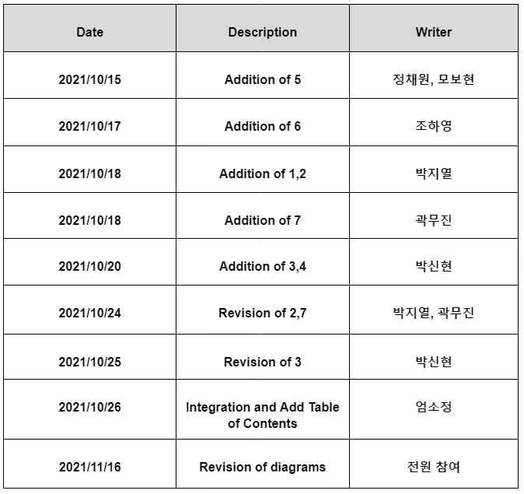table 14 document history