**System Design Document for Course-Planning Problem in Oklahoma Christian University**

**Team-9**

**1.Veeraiah chowdary Jasti**

**2.Rakesh Chaganti**

**3.Anirudh Reddy Pasula**

**1. Overview of Solution**

This section describes the key functional and non-functional requirements of the proposed solution which are being explained in detail as follows:

1.**System Flow:**

1. **Admin Logins**

* Admin login
* Admin logout

1. **Add Courses**

* Admin adds course
* Course name
* Course id

1. **Update Courses**

* Update course name
* Update course id

1. **Delete Courses**

* Delete courses
* Delete course name
* Delete course id
* Delete course data

1. **Add Lecturers data**

* Add lecturers name
* Add lecturers id
* Add lecturers course

1. **Update Lecturers data**

* Update lecturers name
* Update lecturers id
* Update lecturers courses

1. **Update Course schedule**

* Update course schedule
* Update course dates

1. **Director login**

* User name
* Password
* Login

1. **Director view schedules**

* View student complaints
* Respond to student complaints
* Close student complaints
* Change course schedule

1. **Add degree plans**

* Add degree plans
* Update degree plans

1. **Import data**

* Import courses data
* Import students data
* Import lecturers data

**Non-Functional Requirement**

**Usability of the Project:**

This application has high user interface where it gives essential support to OCU for updating and managing its course schedules. There are only two users in this application like admin and Director.

**Reliability of the Project:**

The project has reliable features because it is a college based application where each and every activity or data entered will be genuine and entire data provided in the application is copy righted to OCU University.

**Performance of the Project:**

The performance of the project is faster where for every single access users can view the course list, students registered and lectures assigned.

**Supportability of the Project:**

The proposed project gives end support to the user’s front end and backend where the auto updates are followed and updated by the admin.

**Interface of the Project:**

The project has higher user interface where the admin of the application manages entire front end and backend activities of the application and Director will access the management activities of the application.

**Training of the Project:**

The proposed project offers some guidelines to the users in order to use the functional activities of the application that invalids confusion to students in viewing courses.

**Operations of the Project:**

The operational activities of the application are accessed and managed by the project admin.

**Legal Activities of the Project:**

The proposed application has greater efficacy in proving its legal authority where no illegal activities are performed and entire data is hypothecated to OCU University.

**The system design meets the objectives as stated in the requirements**.

* Improving current manual course schedule system by replacing manual course enrollment and schedule system to online system
* Improving course management and schedules at OC
* Improving speed and accuracy of course schedules by generating a course schedule desktop application.
* Improving student satisfaction on course schedules at OC
* We reduce risks and problems associated with manual entry by implementing online scheduling system
* Reducing the human error while manually scheduling the courses
* Reducing the time taken to schedule the courses
* Automating the process such that it is cost effective as it uses lesser resources
* It makes administration process easier for the management for scheduling the classes
* Scheduling the classes efficiently and effectively with the process

**2.Technology Solution**

This system will be a single system solution. It has these features:

* Local Database
* GUI Interface
* File import for initialization

This system will use the following technologies:

* Java
* Java Swing UI framework
* MySQL database
* Run on Windows or MAC

The system is designed to function on a stand alone Windows 10 based PC with 4G of memory and 200 GB hard drive.

**3.User Interface**

This project explores the key screenshots of the proposed project solution using wireframes where each and every activity is being explained in detail as follows:

**Main Menu**

View Students

View Lecturers

View Courses

OCU Home Page

**Course Schedule Menu**

OCU Course Schedule Menu

Update Schedule

Add Schedule

Update lecturers

Add lecturers

Update students

import students data

Update Course

Add Course

View Course

**Admin Login Menu**

Update Course Schedule

Add or Update Lecturers

Add or Update Students

Add or Update Courses

Login

**Course Schedule Menu**

Delete courses

Update courses

Add courses

Course Schedule

**Main Screens**

**Home Page**

|  |  |
| --- | --- |
| **Screen** | Home Page |
| **Description** | Admin Gives Preferred User Id and password to login to app |
| **Fields** | |  |  | | --- | --- | | **Label** | **Field** | | - |  | |
| **Actions** | Home Page Displays |

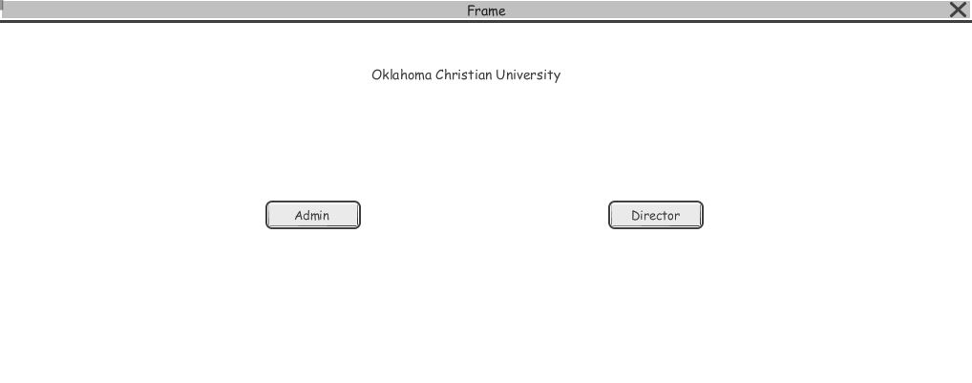

**LOGIN PAGE:**

|  |  |
| --- | --- |
| **Screen** | Admin Login Authentication |
| **Description** | Admin Gives Preferred User Id and password to login to app |
| **Fields** | |  |  | | --- | --- | | **Label** | **Field** | | - | Login | |
| **Actions** | Admin login |

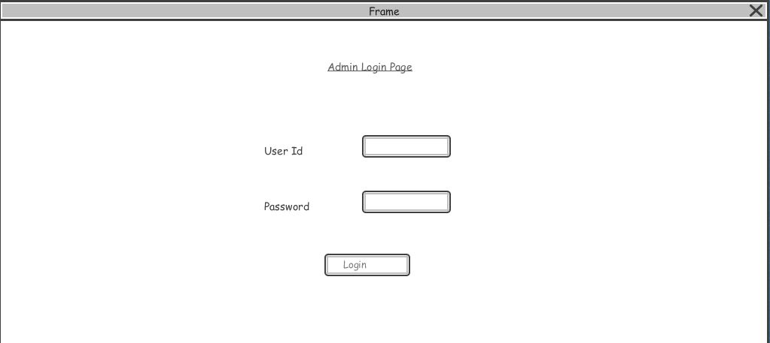

**Admin Logout**

|  |  |
| --- | --- |
| **Screen** | Admin Logout |
| **Description** | Admin Gives Preferred to logout |
| **Fields** | |  |  | | --- | --- | | **Label** | **Field** | | - | Logout | |
| **Actions** | Admin logout Accepted |

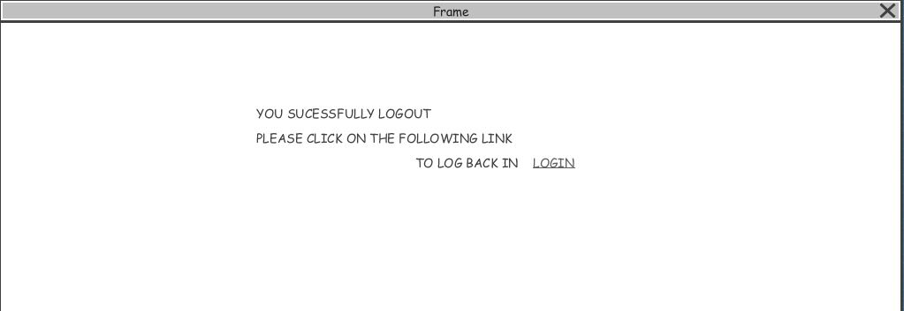

**Admin Home page**

|  |  |
| --- | --- |
| **Screen** | Admin Home page |
| **Description** | Admin clicks on Login button |
| **Fields** | |  |  | | --- | --- | | **Label** | **Field** | | - | Home Page | |
| **Actions** | Admin Home Page |

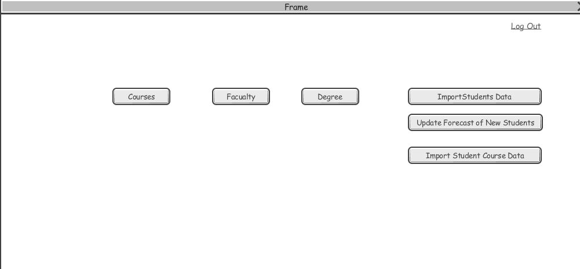

**Courses**

|  |  |
| --- | --- |
| **Screen** | Courses |
| **Description** | Admin clicks on course button |
| **Fields** | |  |  | | --- | --- | | **Label** | **Field** | | - | Course page | |
| **Actions** | Course page displays |

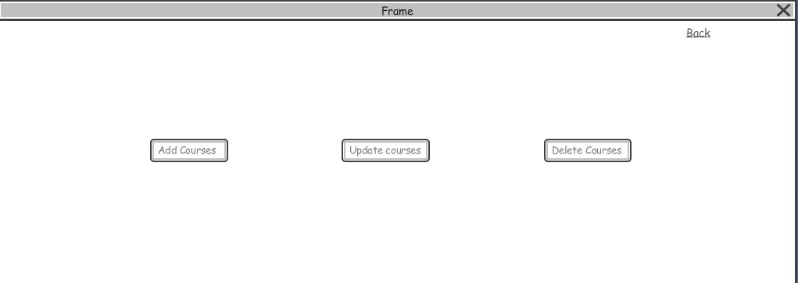

**Adding Courses**

|  |  |
| --- | --- |
| **Screen** | Adding courses |
| **Description** | Admin clicks on add course button |
| **Fields** | |  |  | | --- | --- | | **Label** | **Field** | | - | Add course | |
| **Actions** | Admin adds courses |

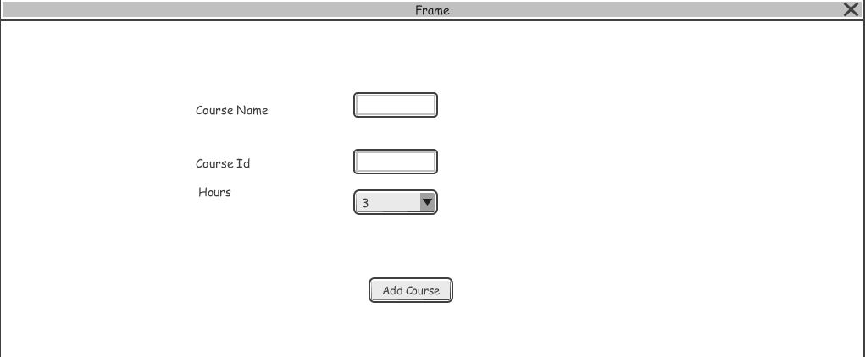

**Updating Courses**

|  |  |
| --- | --- |
| **Screen** | Update courses |
| **Description** | Admin clicks on update course button |
| **Fields** | |  |  | | --- | --- | | **Label** | **Field** | | - | Update course | |
| **Actions** | Admin updates courses |

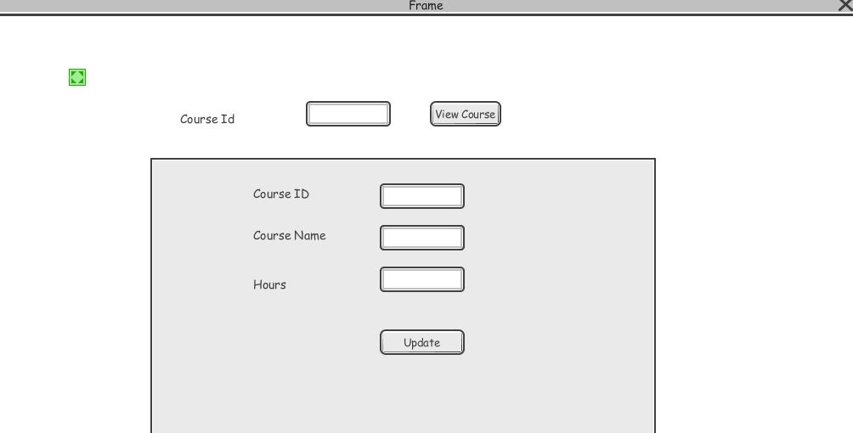

**Deleting Courses**

|  |  |
| --- | --- |
| **Screen** | Delete courses |
| **Description** | Admin clicks on delete course button |
| **Fields** | |  |  | | --- | --- | | **Label** | **Field** | | - | Delete course | |
| **Actions** | Admin delete courses |

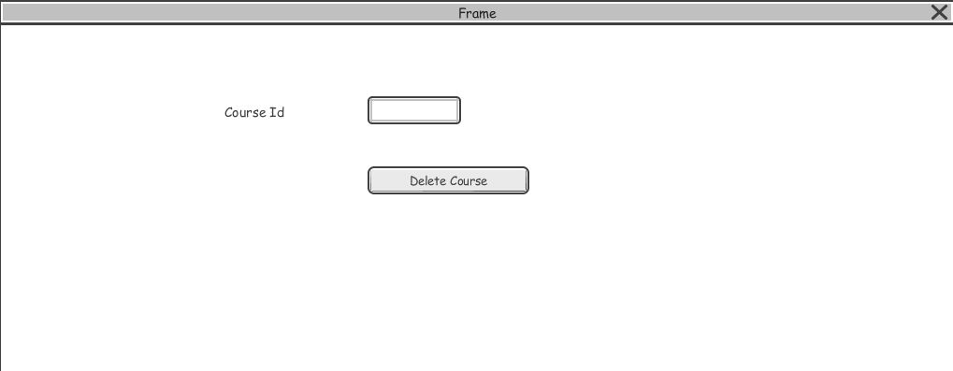

**Lecturer Home Page**

|  |  |
| --- | --- |
| **Screen** | Lecture Home Page |
| **Description** | Admin clicks on lecturers button |
| **Fields** | |  |  | | --- | --- | | **Label** | **Field** | | - | Lecturer home page | |
| **Actions** | Lecturer Home Page displays |

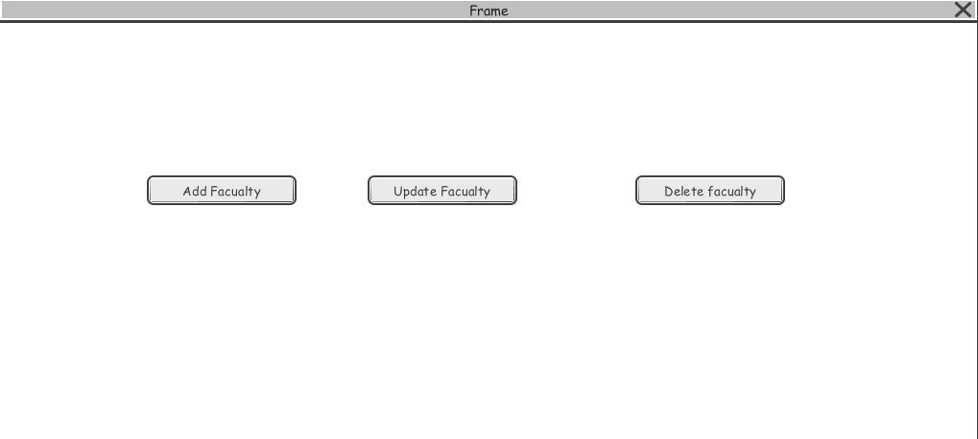

**Adding Lecturers Data**

|  |  |
| --- | --- |
| **Screen** | Adding lecturers |
| **Description** | Admin clicks on add lecturers button |
| **Fields** | |  |  | | --- | --- | | **Label** | **Field** | | - | Add lecturer | |
| **Actions** | Admin adds lecturers |

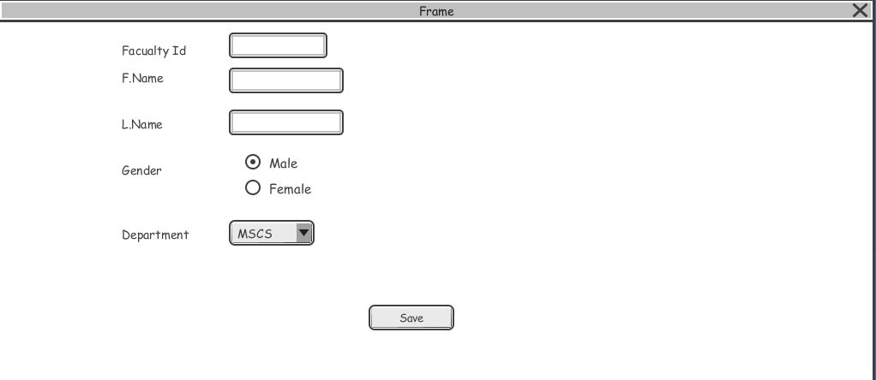

**Updating Lecturers Data**

|  |  |
| --- | --- |
| **Screen** | Update Students |
| **Description** | Admin clicks on update lecturers button |
| **Fields** | |  |  | | --- | --- | | **Label** | **Field** | | - | Update lecturers | |
| **Actions** | Admin updates lecturers |

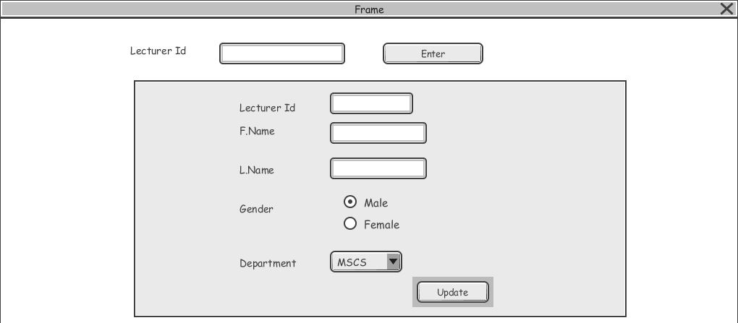

**Deleting Lecturer Data**

|  |  |
| --- | --- |
| **Screen** | Delete lecturers |
| **Description** | Admin clicks on delete lecturers button |
| **Fields** | |  |  | | --- | --- | | **Label** | **Field** | | - | Delete lecturers | |
| **Actions** | Admin delete lecturers |

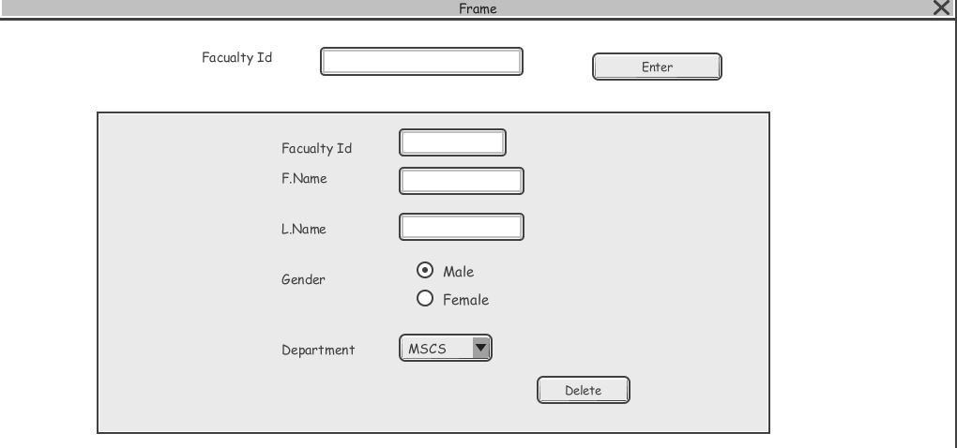

**Director Login**

|  |  |
| --- | --- |
| **Screen** | Director Login |
| **Description** | Director clicks on Login button |
| **Fields** | |  |  | | --- | --- | | **Label** | **Field** | | - | Login | |
| **Actions** | Director Logins to system |

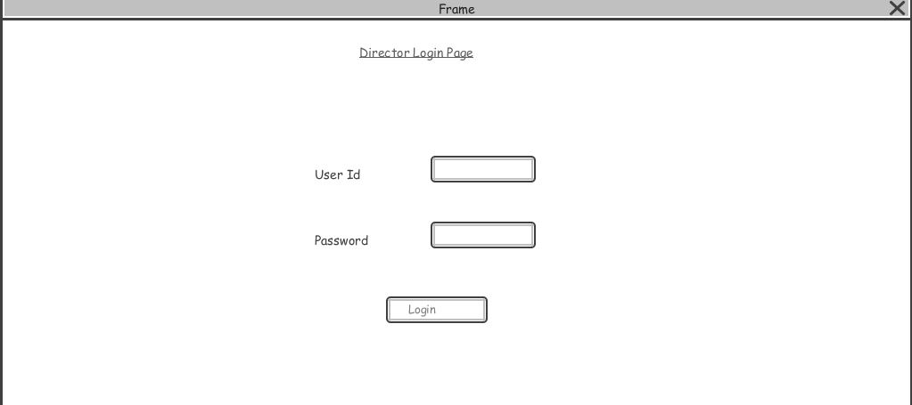

**Director Logout**

|  |  |
| --- | --- |
| **Screen** | Director Logout |
| **Description** | Director clicks on Logout button |
| **Fields** | |  |  | | --- | --- | | **Label** | **Field** | | - | Logout | |
| **Actions** | Director Logouts to system |



**Director Changing Course Schedule**

|  |  |
| --- | --- |
| **Screen** | Director Changing course schedule |
| **Description** | Director clicks on change course schedule |
| **Fields** | |  |  | | --- | --- | | **Label** | **Field** | | - | Change course schedule | |
| **Actions** | Director closes student complaints on course schedule |

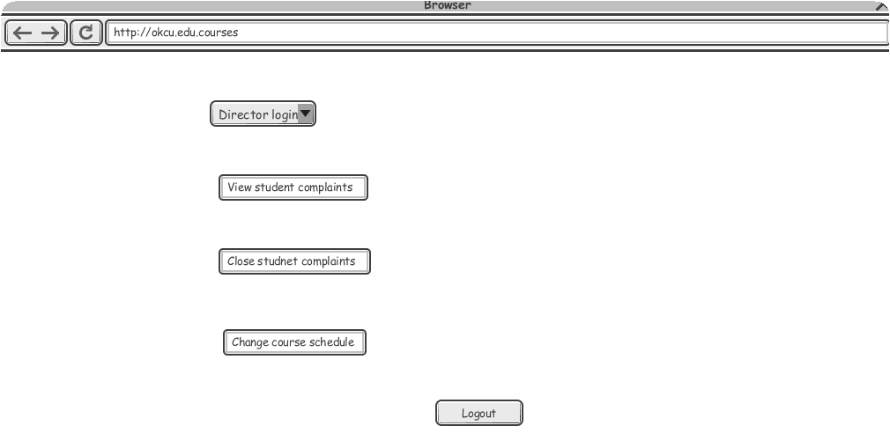

**Admin Adding Degree Plans**

|  |  |
| --- | --- |
| **Screen** | Admin Adding degree plans |
| **Description** | Admin clicks on degree plans button |
| **Fields** | |  |  | | --- | --- | | **Label** | **Field** | | - | Adding Degree plans | |
| **Actions** | Admin adds degree plans |

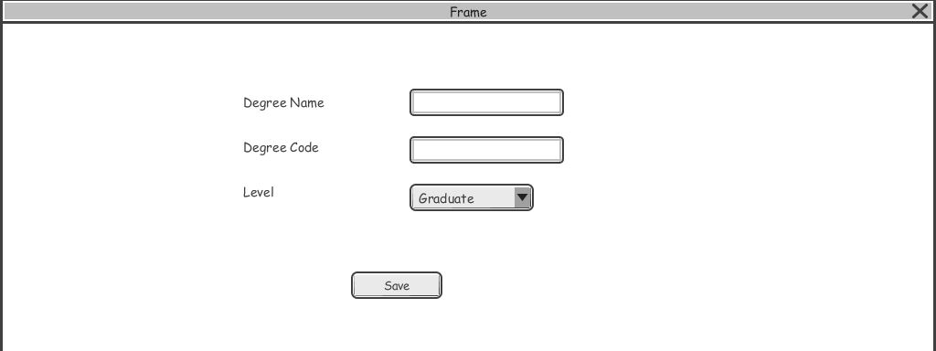

**Admin Updating Degree Plan**

|  |  |
| --- | --- |
| **Screen** | Admin Updating degree plans |
| **Description** | Admin clicks on update degree plans button |
| **Fields** | |  |  | | --- | --- | | **Label** | **Field** | | - | Updating Degree plans | |
| **Actions** | Admin updates degree plans |

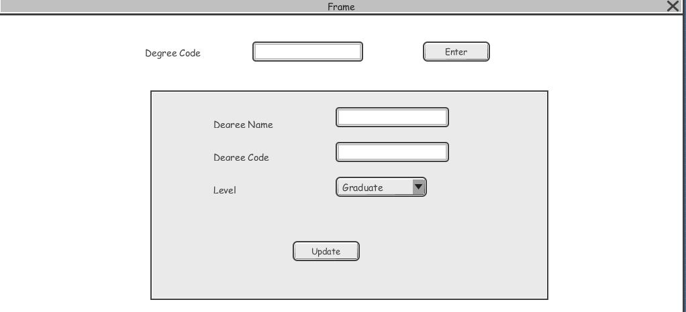

**Admin Deleting Degree Plan**

|  |  |
| --- | --- |
| **Screen** | Admin Deleting degree plans |
| **Description** | Admin clicks on Deletes degree plans button |
| **Fields** | |  |  | | --- | --- | | **Label** | **Field** | | - | Deleting Degree plans | |
| **Actions** | Admin Deleting degree plans |

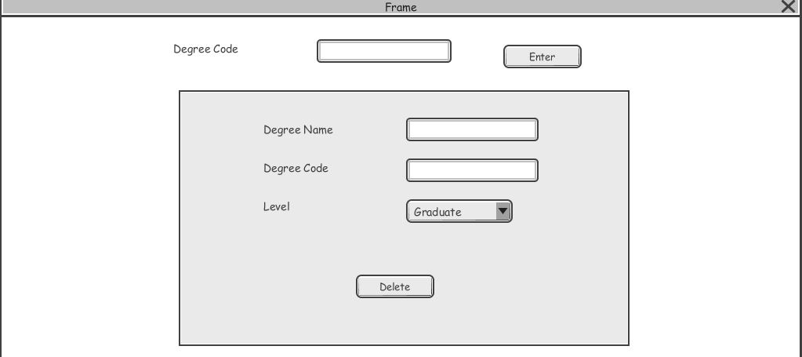

**Admin Importing User Data**

|  |  |
| --- | --- |
| **Screen** | Admin imports user data |
| **Description** | Admin clicks on import data button |
| **Fields** | |  |  | | --- | --- | | **Label** | **Field** | | - | Importing data | |
| **Actions** | Admin imports courses, students and lecturers data |

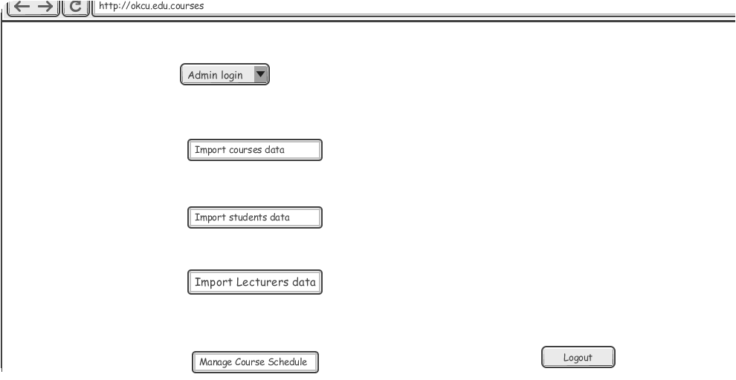

**Director Home Page**

|  |  |
| --- | --- |
| **Screen** | Director Home Page |
| **Description** | Director clicks the Director page button |
| **Fields** | |  |  | | --- | --- | | **Label** | **Field** | | - | Director Home Page | |
| **Actions** | Director Home Page Displays |

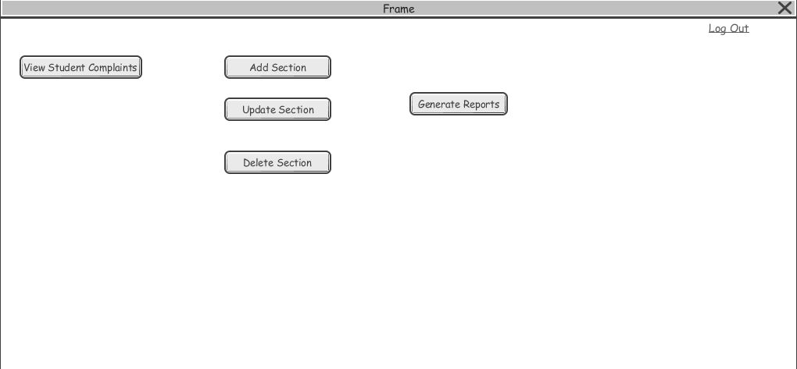

**Admin Viewing Course Schedule**

|  |  |
| --- | --- |
| **Screen** | Admin Viewing course schedule |
| **Description** | Admin clicks on course schedule |
| **Fields** | |  |  | | --- | --- | | **Label** | **Field** | | - | Viewing course schedule | |
| **Actions** | Admin views course schedule |

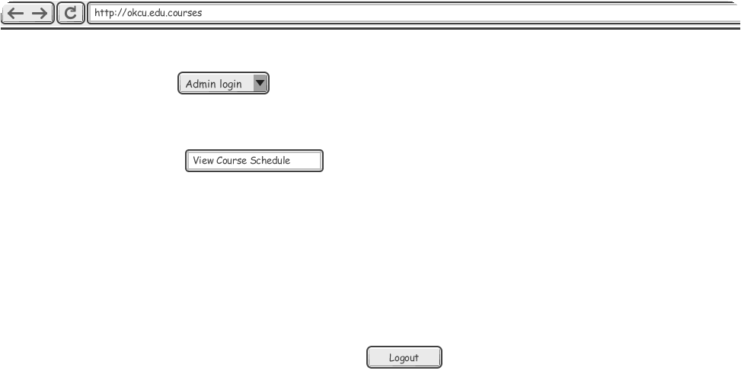

**Director Add Section**

|  |  |
| --- | --- |
| **Screen** | Director add section |
| **Description** | Director clicks on add section button |
| **Fields** | |  |  | | --- | --- | | **Label** | **Field** | | - | Add section | |
| **Actions** | Director adding sections |

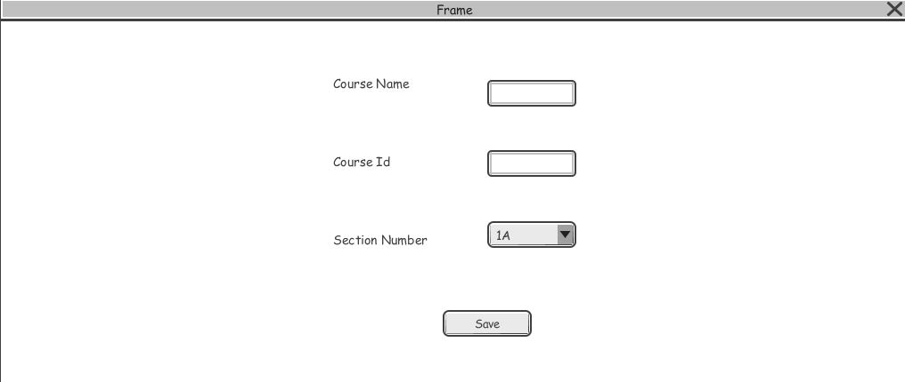

**Director Update Section**

|  |  |
| --- | --- |
| **Screen** | Director Update section |
| **Description** | Director clicks on update section button |
| **Fields** | |  |  | | --- | --- | | **Label** | **Field** | | - | update section | |
| **Actions** | Director updating sections |

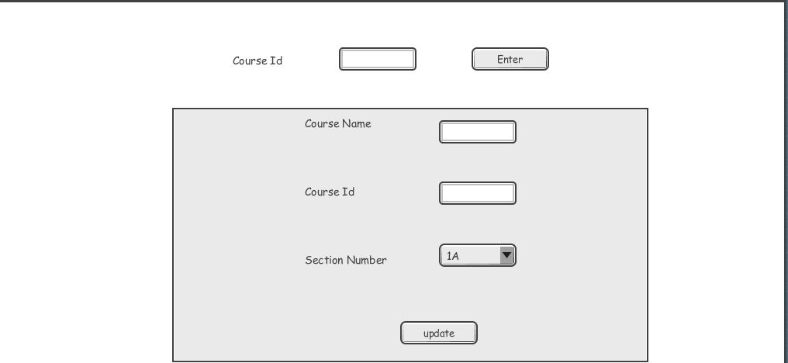

**Director Deleting Section**

|  |  |
| --- | --- |
| **Screen** | Director delete section |
| **Description** | Director clicks on delete section button |
| **Fields** | |  |  | | --- | --- | | **Label** | **Field** | | - | delete section | |
| **Actions** | Director deleting sections |

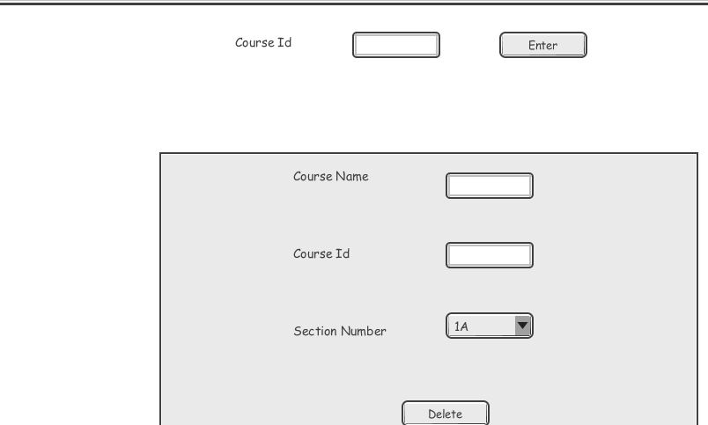

**Admin Viewing Course Schedule**

|  |  |
| --- | --- |
| **Screen** | Admin Updating course schedule |
| **Description** | Admin clicks on updating course schedule |
| **Fields** | |  |  | | --- | --- | | **Label** | **Field** | | - | Updating course schedule | |
| **Actions** | Admin updates course schedule |

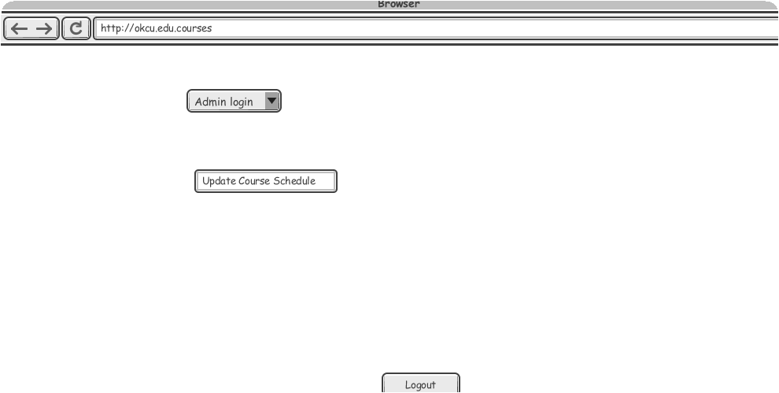

**Admin Import Student Data**

|  |  |
| --- | --- |
| **Screen** | Admin Importing Student Data |
| **Description** | Student data was imported |
| **Fields** | |  |  | | --- | --- | | **Label** | **Field** | | - | Admin importing student data | |
| **Actions** | Student data was imported |

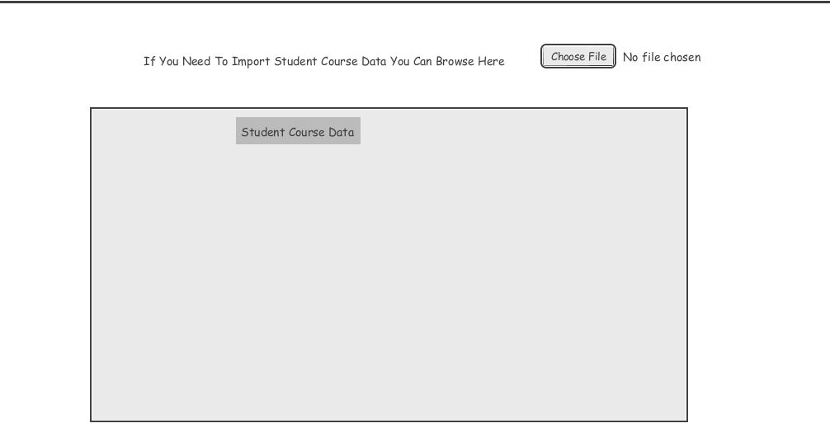

**4. Object Model**

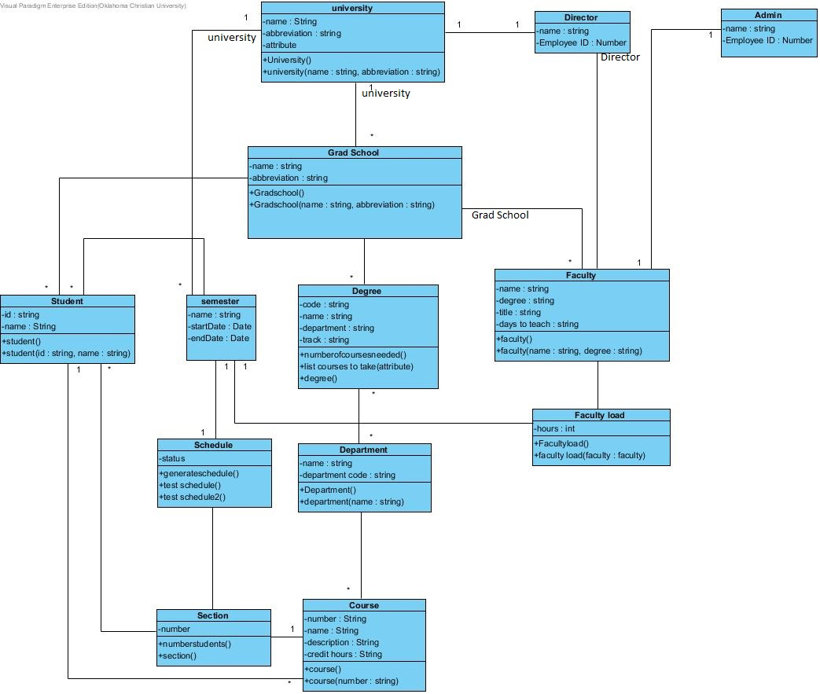

**5.Object Interaction Diagram**

Student Sequence Diagram:

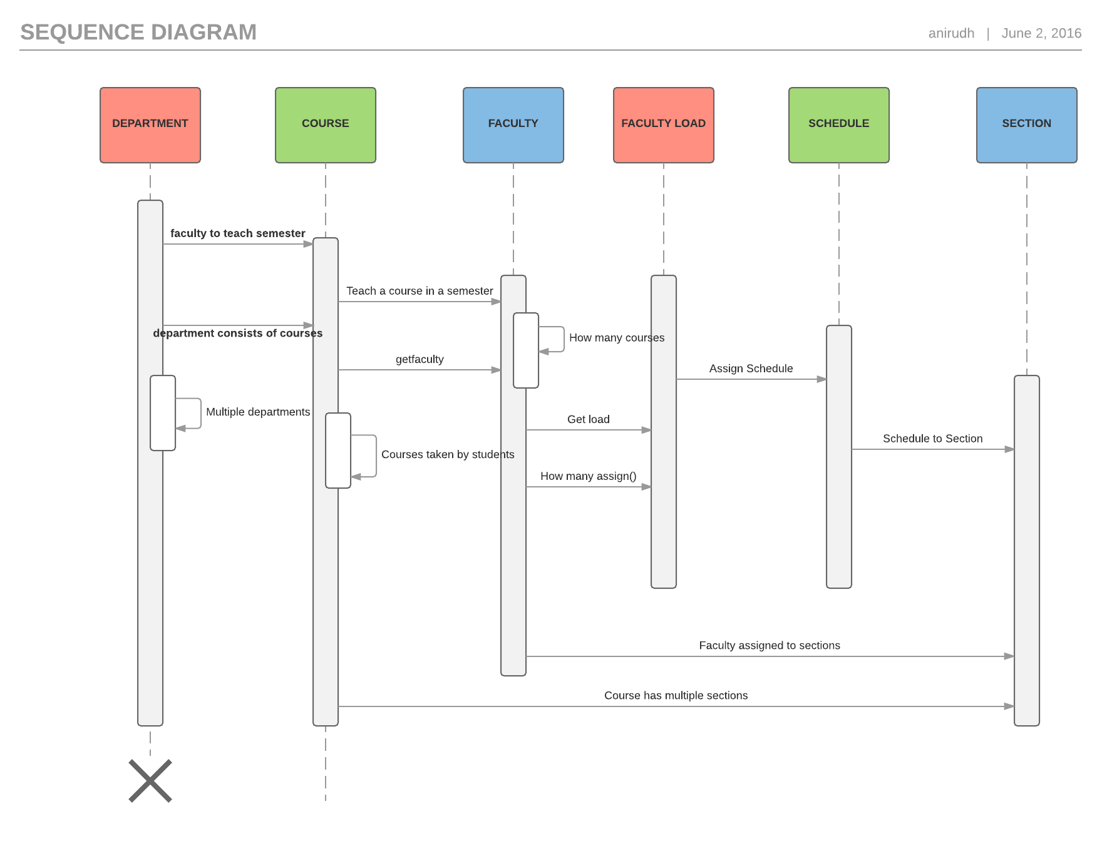

University Sequence Diagram:

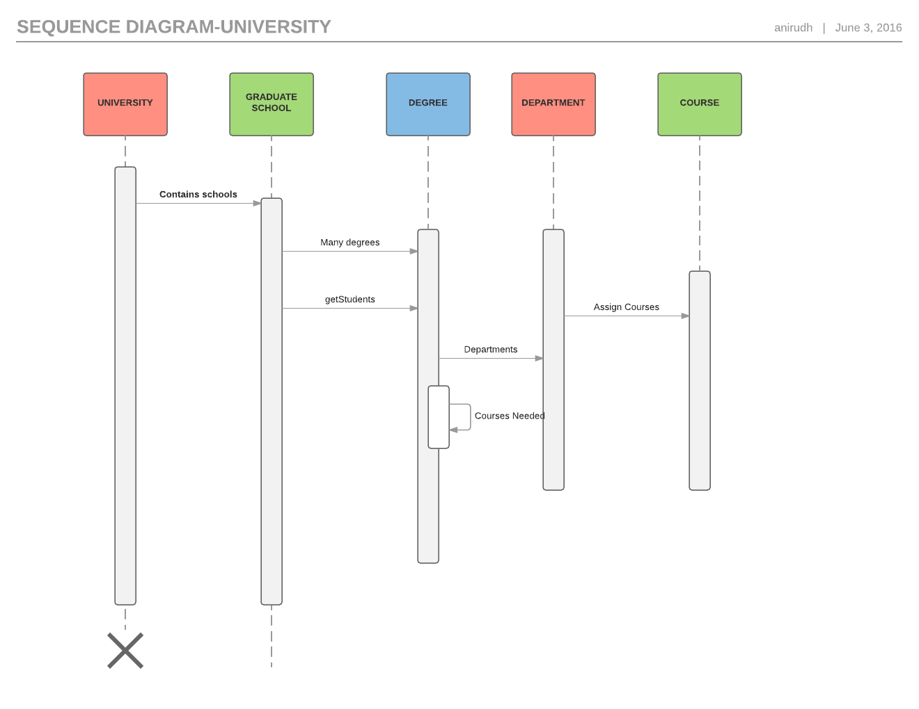

Student Sequence Diagram:

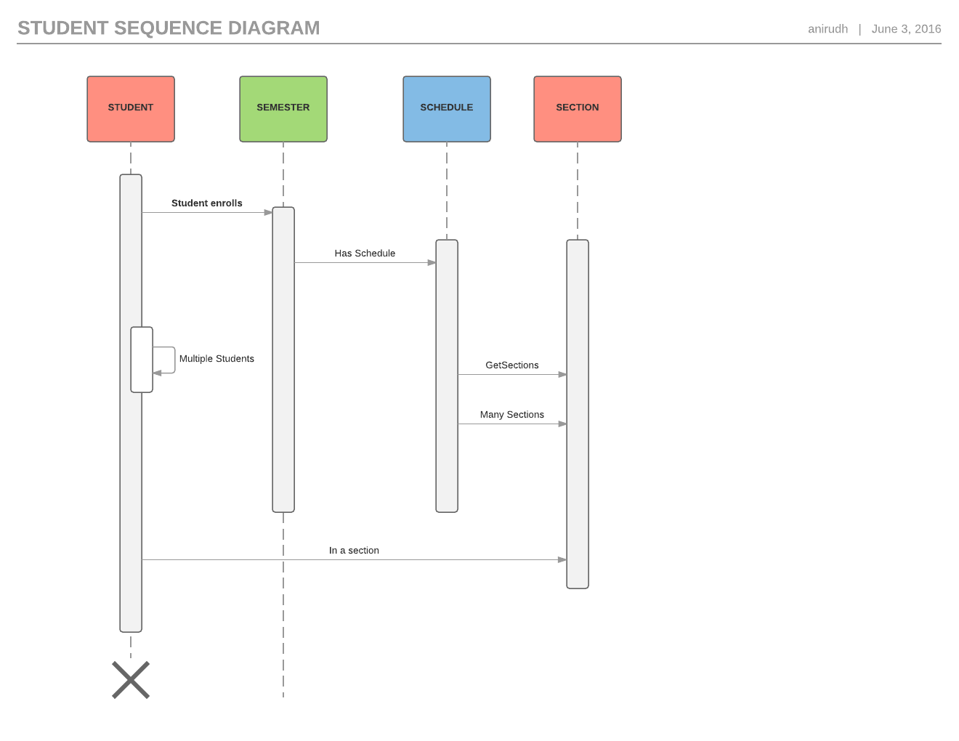

**6. Entity Relationship Diagram**

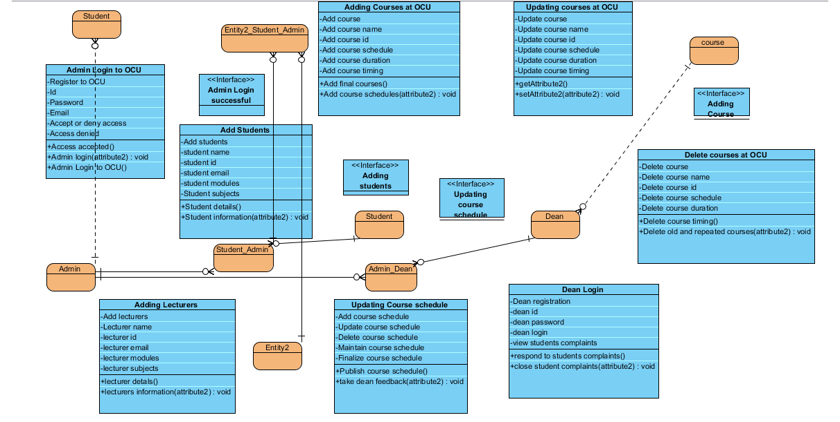

**7.Algorithm**

initialization {this routine creates a population of N individuals, satisfying for every individual a

set of constraints:

- every teacher (row) is given the right amount of hours to be taught.

- some hours are set to the "fixed hour status", which means they cannot be moved.}

while (NOT_VERIFIED_END_TEST) do {the end test is on the number of iterations performed}

begin

apply reproduction;

apply crossover;

for l:=1 to N do

beginif (LOCAL_ON) then apply local search {LOCAL_ON is a Boolean variable}

if (num_infeasibilities > MAX_INFEASIBILITIES) then apply filter

{MAX_INFEASIBILITIES is a system constant}

end;

**8. External Interface Specifications**

The external file interfaces are being described in detail in this section where CSV file formats are imported in this section. The CSV file is imported and involves the data loaded and the courses added per page.

Key Data Fields:

Users:

Admin

Director

Add Courses

Update Courses

Delete course

Add Students

Update students

Delete students

Add lecturers

Update lecturers

Delete lecturers

Add degree plans

Update degree plans

**Sample Data**

|  |
| --- |
| Admin Module: |
| Here application admin from the college will update, modify and manage the course related information including number of courses, course registered, course allotted and course schedule. |
| Adding Courses Module: |
| Here admin adds the courses and course schedules in the system for making final schedules and allotments to the professors. |
| Updating Courses Module: |
| Here admin updates course information, course schedules and course allocations as per university requirement. Admin updates about faculty degree programs as well including course programs individually. |
| Deleting Courses Module: |
| Here admin will delete the course data and information which is crashed or stopped by the college. |
| Director Access Module: |
| Here Director will access the system in order to respond and resolve student complaints or issues raised on course schedules. |
|  |

**Class Descriptions**

## Features of Project

|  |  |
| --- | --- |
| Visibility | Open |
| Abstract | Fake |
| Leaf | Fake |
| Root | Fake |
| Active | Fake |

## Summary of Attributes

| Name | Description |
| --- | --- |
| Legal authenticated code |  |

## Operations Summary

| Name | Description |
| --- | --- |
| Admin Login |  |
| Admin credentials are authenticated |  |
| Admin credentials are accepted |  |

## Attributes of OCU Courses

### Login

|  |  |
| --- | --- |
| Visibility | Open |
| Type | String |

## Operations

### getAuthorizationCode

|  |  |
| --- | --- |
| Visibility | Open |
| Return Type | String |

### isAuthorized

|  |  |
| --- | --- |
| Visibility | Open |
| Return Type | Close |

### setAuthorizationCode

|  |  |
| --- | --- |
| Visibility | Open |
| Return Type | Close |

## Relationships

| Relationship | From | To |
| --- | --- | --- |
| unauthorized | Login | Logout |
| unauthorized | Add courses | Update courses |
| unauthorized | Manage courses | Delete courses |

# Adding course

## Features

|  |  |
| --- | --- |
| Visibility | Open |
| Abstract | Fake |
| Leaf | Fake |
| Root | Fake |
| Active | Fake |

## Attributes Summary

| Name | Description |
| --- | --- |
| Courses added |  |

## Operations Summary

| Name | Description |
| --- | --- |
| Add courses |  |
| Update courses |  |

## Attributes

### amtTendered

|  |  |
| --- | --- |
| Visibility | Secured |
| Type | BigDecimal |

## Operations

### Get courses added

|  |  |
| --- | --- |
| Visibility | Open |
| Return Type | BigDecimal |

### Get courses updated

|  |  |
| --- | --- |
| Visibility | Open |
| Return Type | Invalid |

## Relationships

| Relationship | From | To |
| --- | --- | --- |
| unauthorized | Course | Schedule |

# CashDrawer

## Features

|  |  |
| --- | --- |
| Visibility | Open |
| Abstract | Fake |
| Leaf | Fake |
| Root | Fake |
| Active | Fake |

## Attributes Summary

| Name | Description |
| --- | --- |
| Courses |  |
| Course schedule |  |

## Operations Summary

| Name | Description |
| --- | --- |
| add Courses |  |
| update Courses |  |
| Delete courses |  |
| Update schedule |  |

## Attributes

### Degree plans

|  |  |
| --- | --- |
| Visibility | secured |
| Type | BigDecimal |

### position

|  |  |
| --- | --- |
| Visibility | secured |
| Type | input |

## Operations

### Add degree plans

|  |  |
| --- | --- |
| Visibility | open |
| Return Type | BigDecimal |

### Update degree plans

|  |  |
| --- | --- |
| Visibility | open |
| Return Type | int |

### View students data

|  |  |
| --- | --- |
| Visibility | open |
| Return Type | invalid |

### View lecturers data

|  |  |
| --- | --- |
| Visibility | open |
| Return Type | invalid |

## Relationships

| Relationship | From | To |
| --- | --- | --- |
| unauthorized | Admin | Director |

## Traceability

| Type | Value |
| --- | --- |
| Transit To | Adding degree plans for course schedule |

# Cashier

## Features

|  |  |
| --- | --- |
| Visibility | open |
| Abstract | fake |
| Leaf | fake |
| Root | fake |
| Active | fake |

## Attributes Summary

| Name | Description |
| --- | --- |
| Id |  |
| password |  |
| user |  |
| Plans |  |

## Operations Summary

| Name | Description |
| --- | --- |
| getid |  |
| getpassword |  |
| getuser |  |
| isauthenticated |  |
| setadd courses |  |
| setupdate courses |  |
| setdelete courses |  |

## Attributes

### number

|  |  |
| --- | --- |
| Visibility | secured |
| Type | String |

### password

|  |  |
| --- | --- |
| Visibility | secured |
| Type | String |

### users

|  |  |
| --- | --- |
| Visibility | secured |
| Type | Users |

### Time

|  |  |
| --- | --- |
| Visibility | secured |
| Type | Session |

## Operations

### gelid

|  |  |
| --- | --- |
| Visibility | open |

### getpassword

|  |  |
| --- | --- |
| Visibility | open |

### getUsers

|  |  |
| --- | --- |
| Visibility | open |
| Return Type | Users |

### isAuthenticated

|  |  |
| --- | --- |
| Visibility | open |
| Return Type | Admin |

### setcourses list

|  |  |
| --- | --- |
| Visibility | open |
| Return Type | invalid |

### setdegree plans

|  |  |
| --- | --- |
| Visibility | open |
| Return Type | invalid |

### setstudents data

|  |  |
| --- | --- |
| Visibility | open |
| Return Type | invalid |

## Relationships

| Relationship | From | To |
| --- | --- | --- |
| unauthorized | admin | student |
| unauthorized | admin | lecturer |
| unauthorized | admin | Director |

# Verify

## Features

|  |  |
| --- | --- |
| Visibility | Open |
| Abstract | fake |
| Leaf | fake |
| Root | fake |
| Active | fake |

## Attributes Summary

| Name | Description |
| --- | --- |
| Courses id |  |
| Courses added |  |
| Courses updated |  |
| Courses deleted |  |

## Operations Summary

| Name | Description | |
| --- | --- | --- |
| get course id |  | |
| getcourse lecturers |  | |
| getcourse timings |  | |
| getlecturers assigned |  | |
| get course schedule |  | |
|  | |

## Attributes

### Course Id

|  |  |
| --- | --- |
| Visibility | secured |
| Type | String |

### Courses finalized

|  |  |
| --- | --- |
| Visibility | secured |
| Type | BigDecimal |

### checkCourses finalized

|  |  |
| --- | --- |
| Visibility | secured |
| Type | String |

### check final course schedule

|  |  |
| --- | --- |
| Visibility | secured |
| Type | String |

## Operations

### check updated course schedule

|  |  |
| --- | --- |
| Visibility | open |
| Return Type | String |

### View degree plans

|  |  |
| --- | --- |
| Visibility | open |
| Return Type | BigDecimal |

### get updated degree plans

|  |  |
| --- | --- |
| Visibility | open |
| Return Type | String |

### get final degree plans id

|  |  |
| --- | --- |
| Visibility | open |
| Return Type | String |

### setAccountNumber

|  |  |
| --- | --- |
| Visibility | open |
| Return Type | invalid |

### setAmtTendered

|  |  |
| --- | --- |
| Visibility | open |
| Return Type | invalid |

### setCheckNumber

|  |  |
| --- | --- |
| Visibility | open |
| Return Type | invalid |

### setRoutingNumber

|  |  |
| --- | --- |
| Visibility | open |
| Return Type | invalid |

## Relationships

| Relationship | From | To |
| --- | --- | --- |
| unauthorized | Authorized admin access | Check |

# Dean Response

## Features

|  |  |
| --- | --- |
| Visibility | open |
| Abstract | fake |
| Leaf | fake |
| Root | fake |
| Active | fake |

## Attributes Summary

| Name | Description |
| --- | --- |
| View complaints |  |
| Respond to complaints |  |
| Close complaints |  |