Inventory and Supplier Management System
Prepared by: Clayton Hagood
Course: CIS 3365
Instructor: Dr. Emmanuel Udoh
Date: 05/11/2025

Section | Title | Page
Cover Page |  | i
Table of Contents |  | ii
1.0 | Planning | 1
1.5 | Methodology | 2
2.0 | Analysis | 3
3.0 | Design | 5
3.1 | Database Design | 5
3.2 | User Interface (UI) Design | 6
3.3 | Process Design | 7
4.0 | Implementation | 9
4.1 | Development Environment | 9
4.2 | Code Structure | 10
4.3 | Key Functionality Implemented | 11
4.4 | Challenges and Solutions | 12
4.5 | Packaging | 13
5.0 | Testing | 14
5.1 | Unit Testing Results | 14
5.2 | Scenario Testing Results | 15
5.3 | Edge Case Testing Results | 16
5.4 | Defects Discovered and Resolutions | 17
5.5 | Screenshots of Validation and Alerts | 18
5.6 | Testing Summary | 18
6.0 | Deployment | 19
6.1 | Deployment Method | 19
6.2 | Installation and Launch Instructions | 19
6.3 | Environment Requirements | 20
6.4 | Post-Deployment Support | 20
7.0 | Maintenance | 21
7.1 | Planned Maintenance Activities | 21
7.2 | Known Limitations | 22
7.3 | Known Opportunities for Improvement | 22
8.0 | Conclusion | 23

Project Title
Inventory and Supplier Management System

Purpose / Problem Statement
The current process of tracking inventory and suppliers relies on error-prone spreadsheets. This project replaces spreadsheet tracking with a dedicated desktop application to improve data accuracy, reduce manual effort, and provide real-time alerts.

Because our clinic’s Excel-based inventory frequently causes inventory shortages and data errors, we built a standalone desktop app. It tracks supplies and suppliers, slashes manual work, and displays instant low-stock or expiration warnings.

Objectives / Success Criteria
• Performance
– The main window appears within 2 s of startup (logged via timestamp at root.mainloop()).
• Reliability
– Zero unhandled exceptions over 20 scripted test runs.
• CRUD Functionality
– Users can add, view, edit, and delete both inventory and supplier entries.
• Alerts
– Low-stock (≤ 10 units) and expiring-soon (≤ 30 days) pop-ups function correctly in every test
Scope
- In-Scope:
  - Management of inventory items and supplier records (add, view, edit via double-click, delete, search)
  - Stand-alone offline desktop app using Python’s standard library and SQLite
- Out-of-Scope:
  - Web-based features, billing or financial modules, third-party hosting or cloud services
Stakeholders
- Clinical Staff: End users who will maintain inventory and supplier lists
- Instructor: Project sponsor and evaluator
- Developer: Responsible for design, implementation, testing, and delivery

Constraints
- Offline operation only (no Internet or external APIs)
- Python standard library only (no external packages)
- Data persisted in a local inventory.db SQLite file; no third-party hosting
Deliverables
• InventoryApp.exe — Windows build including pre-loaded sample data.
• main.py & SQL scripts — full source code.
• SDLC Report — charter, Gantt, DFD, ERD, risk log, test results.
• Schema DDL — CREATE TABLE… statements for all five tables.

Project Context
This Inventory and Supplier Management System was specifically developed for use at my workplace — a clinical environment specializing in pain management procedures.
The clinic currently relies on manual spreadsheet tracking for its medical supply inventory, which has led to common issues such as stockouts, manual counting errors, accidental overwriting of supplier information, and a lack of real-time visibility into soon-to-expire medical items. There was a growing need for a better method to track crash cart supplies, emergency medications, anesthesia medications, and procedure-related inventory to ensure patient safety and compliance with clinical standards.
This project’s goal is to replace that outdated method with an efficient, standalone system tailored to the clinic’s specific needs. The application provides a simple graphical interface for clinical staff to manage inventory and supplier data, track quantities, and receive automatic alerts for low-stock and expiring items.
By offering real-time visibility into inventory status, the system helps prevent critical shortages of medications and supplies, streamlines supply ordering, reduces manual workload, and improves overall operational readiness for procedures. This system supports better patient care by helping to ensure that essential supplies and medications are always available when needed.

1 Planning
I began with a brief interview of the clinic’s receptionist (the primary user) to understand pain-points in the existing Excel-based inventory file. Within 30 minutes four problems were surfaced: manual stock counts, no supplier look-up, accidental overwrites, and zero expiry visibility.

Planning Outputs
- Project Charter with scope, success criteria, and 7-week baseline
- Feasibility Analysis: Tkinter + SQLite chosen to avoid external dependencies
- High-Level Risk Log: user adoption, data loss, tight timeline

Table 1. Project Gantt Chart for Inventory and Supplier Management System

Table 1. The Gantt chart outlines the scheduled project phases from requirements gathering through deployment and user training.

1.5 Methodology
We followed the classic SDLC steps:
- Requirements Gathering: 30 min interview with front-desk user
- Design: Gantt, DFD, ERD, UI/UX mockups
- Implementation: Iterative coding with daily local testing
- Testing: Unit, scenario, and edge-case tests
- Deployment & Maintenance: PyInstaller bundling, backup plan, future enhancements

2 Analysis
Using the charter as guideposts I converted user statements into functional requirements (R1…R7). Key examples:

Table 2. Functional Requirements for the Inventory and Supplier Management System
Req-ID | Statement
R1 | The system shall store inventory and supplier contact info.
R2 | The system shall alert when quantity ≤ 10.
R3 | The system shall alert when an item expires within 30 days.
R4 | The user shall add/update/delete both inventory and supplier records through the GUI.
Table 2. This table maps each requirement ID (R1–R4) to its corresponding system behavior, specifying how the application must store supplier data, trigger low-stock and expiry alerts, and support full CRUD operations.

A context-level DFD (Fig. 1) was drawn to visualize the single external entity (User) exchanging CRUD commands and queries with the application, which in turn reads/writes the SQLite datastore.
I then decomposed the requirements into two primary entities—inventory and supplier—plus three supportive entities (category, txn_history, user) to meet the course’s “≥ 5 tables” criterion. The ERD (Fig. 2) formalizes these relationships and includes cardinalities (1-to-many from supplier to inventory).

Figure 1. Context-Level Data Flow Diagram (DFD) for Inventory and Supplier Management System
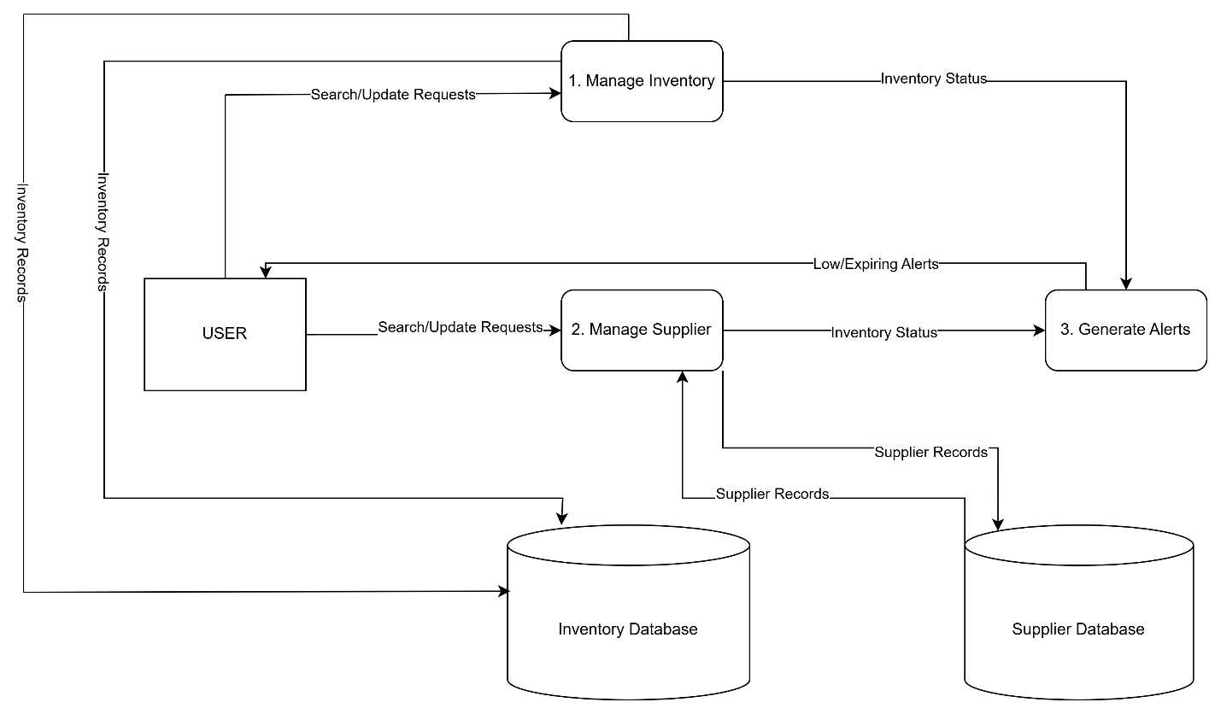Figure 1. The DFD shows how the User interacts with the Inventory Management System, which reads from and writes to the SQLite database.

- External Entity: User (clinical staff)
- Process: InventoryApp GUI (buttons, forms, popups)
- Data Store: SQLite database (supplier, inventory, category, txn_history, user)
- This shows the single “bubble” process interacting bidirectionally with the user and the database.

Table 3. Entity-Relationship Diagram (ERD) for Inventory and Supplier Management System
Entity | Key Field | Relationship
supplier | supplier_id (PK), supplier_name, phone, email, account_number | 1 supplier supplies many inventory items (one to many)
inventory | Item_id(PK), item_name. quantity, category, supplier_id(FK), exp date | One inventory item belongs to one supplier and one category
category | category_id (PK), cat_name | 1 category groups many inventory items
txn_history | txn_id (PK), item_id (FK), change_qty, txn_date | 1 inventory item can have many transaction records
user | user_id (PK), username, role | currently standalone (not linked yet)
Table 3. The Entity-Relationship Diagram (ERD) shows the relationships between supplier, inventory, category, transaction history, and user tables, including primary and foreign key connections.

3 Design
The Design phase translated the system requirements into a detailed technical blueprint. This included the database schema, the user interface layout, and the internal processing logic that would drive the Inventory and Supplier Management System.

3.1 Database Design
The system’s database was designed using SQLite, selected for its simplicity, file-based storage, and built-in compatibility with Python’s standard library (sqlite3 module).
The following tables were implemented based on the functional requirements:
- supplier: Stores supplier information such as supplier ID, name, phone, email, and account number.
- inventory: Stores inventory items including item name, quantity, category, linked supplier ID, and expiration date.
- category: Lookup table holding unique item categories.
- txn_history: Tracks changes in inventory quantity to maintain an audit trail of stock adjustments.
- user: Placeholder for future login and role management functionality.
To maintain compatibility and minimize complexity, all fields use basic types: TEXT, INTEGER, and DATE.
A custom SQLite adapter (adapt_date) was registered to handle datetime objects properly, ensuring expiration dates could be stored and queried consistently.

Primary Keys (PK) were used to uniquely identify records, and Foreign Keys (FK) were used to enforce relationships between tables (e.g., linking inventory items to their suppliers).
The database schema was optimized to ensure data integrity, simplicity, and support for future features such as user roles and reporting extensions.

3.2 User Interface (UI) Design
The system’s user interface was developed using Tkinter, Python’s standard GUI toolkit.
The design goals were simplicity, efficiency, and clarity for clinical staff who would operate the system daily.
The application window is divided into three main areas:

- Top Control Bar
  - Contains buttons for core actions: Add, Delete, Low Quantity, Expiring Soon, Search, View Inventory, and View Suppliers.
  - Search functionality allows real-time filtering based on item names or supplier names.

- Center Data Grid
  - A ttk.Treeview displays inventory and supplier data in tabular form.
  - Alternating row colors improve readability (white and light blue backgrounds).
  - Hover effects highlight rows under the cursor.
  - Columns automatically resize to fit the window using the on_resize() function.

- Bottom Status Bar
  - Displays hints (e.g., “Double-click to edit”) and system messages after actions such as adding or deleting a record.

Additional UI considerations:
- The clam theme was applied to provide a flat, modern look.
- Treeview headers use dark backgrounds with white text for accessibility compliance.
- Modal pop-up windows are used for adding and editing records, preventing user interaction with the main window until changes are saved or canceled.
- The window is fully resizable, and window size/position is preserved across view switches by tracking geometry with _track_geometry().

3.3 Process Design
The application's logic follows a modular, event-driven model where each user action triggers a specific method.
Key processes include:
- Create:
  - add_record() opens an empty edit form for adding a new inventory or supplier record.
- Read:
  - load_data() populates the Treeview with current database records.
  - search_records() filters records based on user-entered search terms.
- Update:
  - edit_record() opens the selected record in an editable form.
  - save() validates inputs and commits changes to the database.
- Delete:
  - delete_record() prompts the user for confirmation and removes the selected record from the database.
- Alert Processes:
  - view_low_quantity() displays items where quantity is ≤ 10.
  - view_expiring_soon() displays items expiring within the next 30 days.

Special process design highlights:
- Validation: Input fields are validated at save time using regular expressions for phone numbers and emails and format checks for expiration dates.
- Data Persistence: All changes are immediately committed to the SQLite database, minimizing the risk of data loss.
- Status Feedback: After every major operation, the system flashes a brief status message at the bottom of the window for user confirmation.

4 Implementation
The Implementation phase involved translating the design plans into working code using Python 3.
Development was carried out incrementally, using a modular, method-driven structure, with ongoing local testing to validate functionality.

4.1 Development Environment
- Programming Language: Python 3 (standard library only)
- GUI Toolkit: Tkinter (tkinter, ttk, messagebox)
- Database: SQLite (via sqlite3 module)
- Editor: Visual Studio Code
- Version Control: Local Git repository (informal commits per major milestone)

4.2 Code Structure

The entire program was developed within a single main script file (main.py) for simplicity and ease of deployment.
The core structure of the application includes:

- Imports and Setup:
  - Imported tkinter for GUI elements, sqlite3 for database interaction, re for input validation, and datetime for date operations.
  - Registered a custom date adapter (adapt_date) to handle the storage of Python datetime objects in SQLite.

- Database Initialization:
  - Tables (supplier, inventory, category, txn_history, user) are created at startup if they do not already exist.
  - Connection to the local inventory.db database file is established at program start.

- Main Application Class (InventoryApp):
  - Handles all GUI creation, event handling, and database operations.
  - Methods are grouped by functionality (e.g., adding, editing, searching, alert pop-ups).

- Event Binding & Styling:
  - Hover effects, double-click editing, and zebra striping are implemented through _bind_tree.

- Window Geometry Persistence:
  - Custom window size tracking and restoring are handled via _track_geometry and on_resize.

- Validation & Error Handling:
  - Phone and email format checks using regular expressions (regex) inside save().
  - Quantity and date parsing with user-friendly messagebox.showerror() prompts when invalid input is detected.

- Application Entry Point:
  - An if __name__ == '__main__': block is used to initialize and launch the InventoryApp(root).

- Packaging:
  - Packaged using PyInstaller with a one-directory (one-dir) bundle.
  - .spec file placed alongside the project, producing a main.exe executable along with the inventory.db file.

4.3 Key Functionality Implemented

Table 4. Key Functionalities Implemented in the Inventory and Supplier Management

Functionality | Description
Add Record | add_record() opens a modal for adding inventory or supplier entries
Edit record | edit_record allows double click editing of existing records
Delete records | delete_records removes selected records after confirmation
Save Records | save() validates user input, updates the database, and refreshes the display.
Search Records | search_records() filters displayed records based on keywords matches.
Low Quantity Alerts | view_low_quantity() shows items with quantity ≤ 10
Expiring Soon Alerts | view_expiring_soon() displays items expiring within the next 30 days
Window Persistence | track_geometry() maintains window size and position between view switches.
User Feedback | Status messages are flashed at the bottom of the window after actions.
Table 4. This table summarizes the primary functions coded into the application, including CRUD operations, search, alerts, and user interface behaviors.

4.4 Challenges and Solutions
- Database Date Handling:
  - Challenge: SQLite does not natively store Python datetime objects.
  - Solution: Registered a custom adapter (adapt_date) to convert dates to ISO strings for database storage.

- PyInstaller Deployment:
  - Challenge: When packaging the application into an executable, the database path needed adjustment.
  - Solution: Used one-directory bundling to keep inventory.db alongside main.exe, manually ensuring correct paths.

- Geometry Persistence:
  - Challenge: Switching between views caused the window to reset its size.
  - Solution: Captured window geometry (root.geometry()) and reapplied it after toggling views.

- User Experience Enhancements:
  - Implemented alternating row colors and hover effects to make the Treeview easier to read and navigate.

- Validation Measures:
  - Supplier phone numbers and emails are validated using regular expressions.
  - Inventory quantities must be non-negative integers.
  - Expiration dates must conform to the MM/DD/YYYY format and are parsed using datetime.strptime().

4.5 Packaging
The application was bundled into a standalone executable file (main.exe) using PyInstaller.
PyInstaller was selected because it allows Python programs to be converted into a single-folder application that can be launched on Windows systems without requiring a separate Python installation.

- Packaging mode: One-directory (--onedir) mode was used.
  - This creates a dist/ folder containing the executable and all necessary support files (DLLs, libraries, etc.).

- Main output: dist/main/main.exe
- Database file: inventory.db was placed alongside the executable within the same folder to ensure correct database path resolution at runtime.

Figure 2. Deployment Bundle Directory Structure
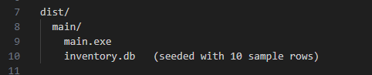
Figure 2. The deployment bundle includes the standalone executable (main.exe) and the seeded SQLite database (inventory.db) containing 10 sample records.

Deployment Bundle
The final deployment bundle includes:
- main.exe — the compiled standalone application.
- inventory.db — the local SQLite database.
- Supporting runtime libraries (automatically included by PyInstaller).
All files were zipped together into a single compressed archive for easy distribution.

Launch Instructions
A simple README file was included with the deployment bundle, containing the following instruction:

To launch the Inventory Management System, unzip the package and double-click main.exe. No installation or additional setup is required. The system will open automatically and load the included sample data from inventory.db.

Known Limitations
The application is currently packaged only for Windows platforms.
- Future packaging work may include creating MacOS-compatible or Linux-compatible builds if needed.
- The executable and database must remain in the same folder to function correctly.

5 Testing
Testing activities were conducted throughout the development process to verify that the Inventory and Supplier Management System met its functional and non-functional requirements. A combination of white-box (internal logic) and black-box (user behavior) testing strategies were employed.

5.1 Unit Testing Results

Table 5. Unit Testing Results for the Inventory and Supplier Management System
Testing Methods | Description
White-Box Testing | Direct testing of functions and methods in the code to verify correct logical behavior, database interaction, and input validation
Black-Box Testing | Simulating end user interactions with the system (adding, editing, deleting records, triggering alerts) without access to the underlying code.
Scenario Testing | Executing real-world workflows (daily tasks) to confirm that required user operations are currently supported.
Table 5. Unit tests verified correct function behavior for inserting, validating, saving, and querying data within the system

.

5.2 Scenario Testing Results

Table 6. Scenario Testing Results for the Inventory and Supplier Management System
Test Case | Expected Results
Inserted supplier record | Supplier successfully added to the database and displayed in the Treeview.
Inserted record with valid expiration date | Item added and expiration date correctly formatted (MM/DD/YYYY)
Search inventory by partial item name | Matching results displayed correctly
Search supplier by partial name | Matching supplier records displayed correctly
Save invalid phone number | Validation error via pop up modal: Invalid phone and displays the required format and parameters.
Save Invalid email address | Validation error via pop up modal: Invalid email, Enter Valid Email.
Save Inventory with negative quantity | Validation error via pop up modal: Invalid Quantity, Enter non negative integer.
View low quantity items | Items with quantity ≤ 10 displayed in a pop up modal.
View expiring soon items | Items expiring within 30 days displayed in pop up modal.
Table 6. Scenario tests confirmed typical user workflows such as receiving shipments, updating records, and triggering alerts.

5.3 Edge Case Testing Results
Table 7. Edge Case Testing Results for the Inventory and Supplier Management System
Edge Case Testing | Result
Quantity = 0 | Accepted and correctly flagged under low quantity alert.
Expiration date already past | Item listed normally, not shown in exp soon alert.
Nonexistent supplier FK on item insert | Insert fails as expected due to database FK constraints.
Closing app during edit window | Changes are not saved unless explicitly confirmed, no crash occurs.
Table 7. Edge case tests evaluated system behavior under abnormal or boundary conditions to ensure robustness.

5.4 Defects Discovered and Resolutions

Table 8. Defects Discovered and Resolutions Applied
Defect | Resolution
Column mismatch when editing inventory records | Fixed by aligning entry field indexes correctly in save() method.
Database not found after PyInstaller packaging | Solved by placing inventory.db inside the same folder as main.exe during deployment
Table 8. Issues identified during testing were resolved to improve system stability, data integrity, and deployment success.

5.5 Validation and Alerts

Figure 3. Low Quantity Alert Window
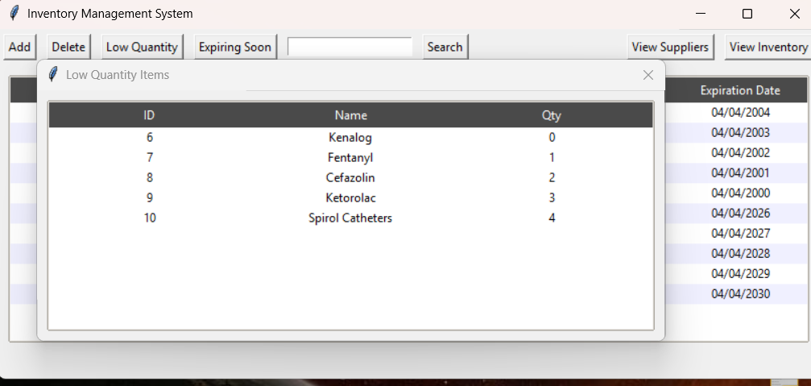
Figure 3. Items with quantity ≤ 10 are displayed in a system-generated alert window.

Figure 4. Expiring Soon Items Alert
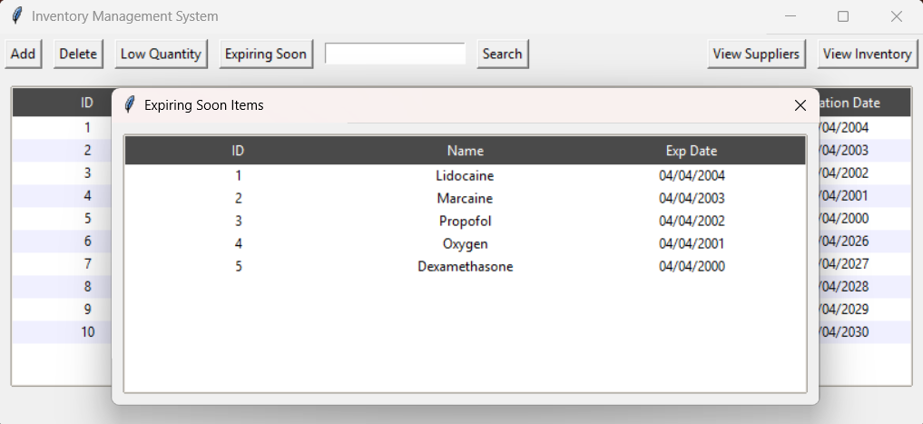
Figure 4. Items expiring within 30 days are displayed in a system-generated alert window.

Figure 5. Validation Error Popup for invalid date format.
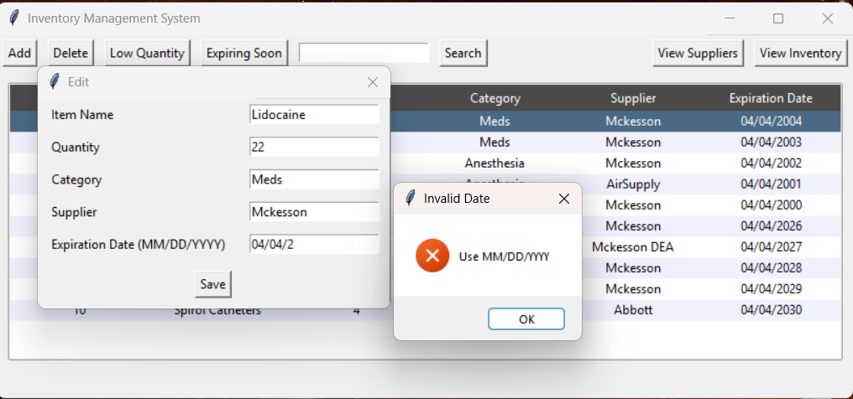
Figure 5. Modal popup displaying Invalid Date format has been entered.

Figure 6. Validation Error Popup for Invalid Email Address
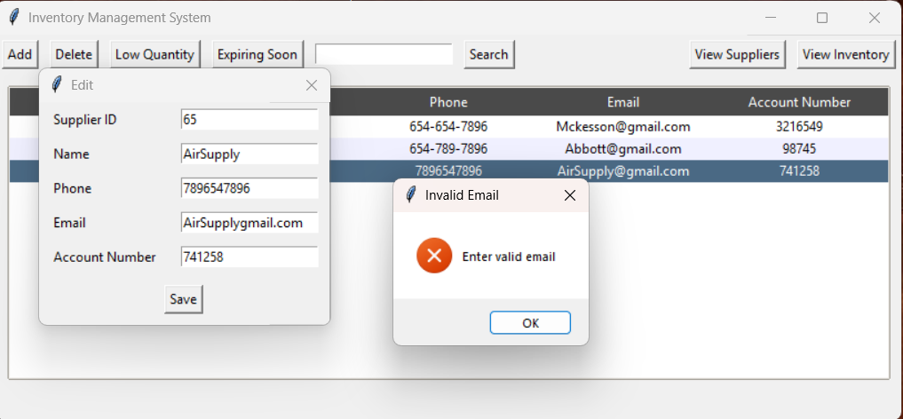
Figure 6. Modal pop-up displaying error when invalid email is entered.

Figure 7. Validation Error Popup for invalid phone number.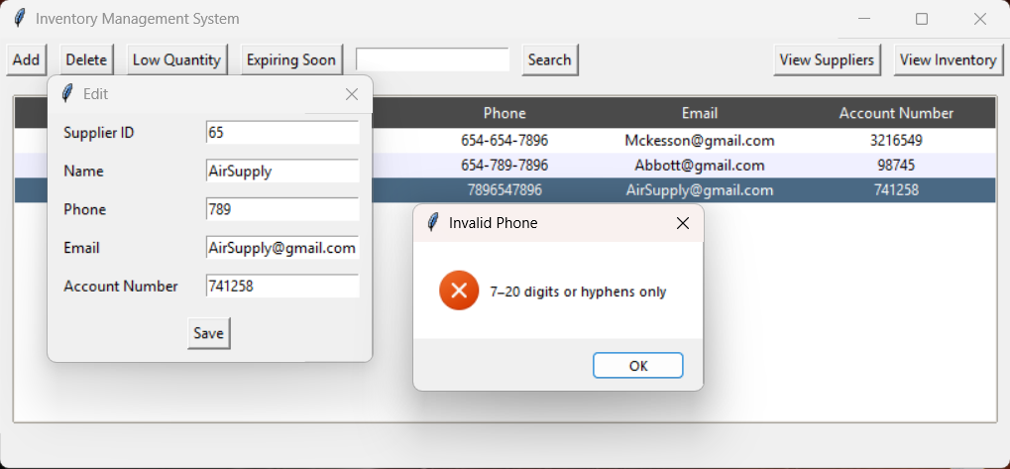
Figure 7. Modal pop-up displaying error when invalid phone number is entered.

Figure 8. Validation Error for Quantity.
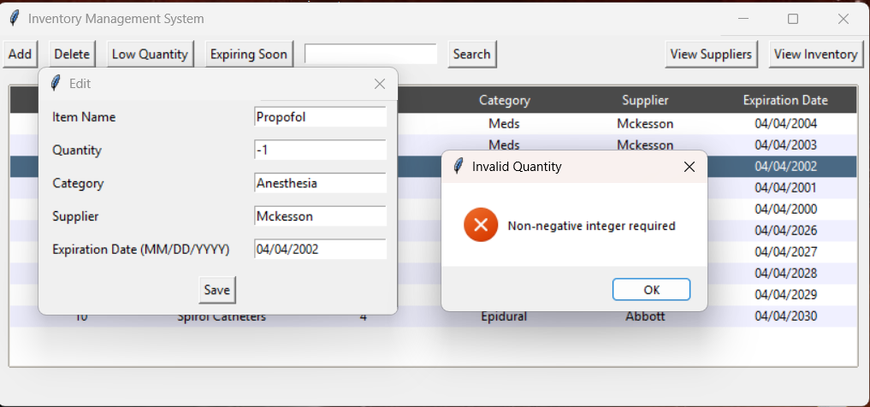
Figure 8. Modal popup displays error when negative integers are entered.

5.6 Testing Summary
Testing activities confirmed that the Inventory and Supplier Management System meets all documented functional requirements. Both unit testing and scenario testing validated the correct behavior of CRUD operations, alerts, and data validation processes.
Edge case testing demonstrated the system's ability to handle unusual input without crashing or corrupting data. All identified defects were successfully corrected during the development cycle.
As a result, the system is considered stable, functional, and ready for deployment. Future feedback from real-world users may identify areas for additional enhancements or optimization.

6 Deployment
After successful development, testing, and packaging, the Inventory and Supplier Management System was prepared for deployment. The goal was to provide a standalone, user-friendly executable that clinical staff could easily launch without requiring additional installations or complex setup.

6.1 Deployment Method
The application was deployed using PyInstaller, a Python utility that converts scripts into standalone executables for Windows environments.

- Packaging mode: One-directory (--onedir) mode was selected to maintain separation between the executable and resource files, ensuring easier troubleshooting and updates.

- Deployment bundle contents:
  - main.exe — compiled executable
  - inventory.db — SQLite database with sample data
  - Supporting runtime files and libraries (automatically included by PyInstaller)
The deployment bundle was zipped into a compressed archive for easy distribution to users.

6.2 Installation and Launch Instructions
The deployment process was designed to be simple and intuitive:
- The user receives the zipped deployment bundle.
- The user extracts the contents into a local folder.
- The user double-clicks main.exe to launch the system.
- The system automatically loads the included inventory.db database.
No Python installation, external dependencies, or administrative privileges are required on the end-user’s machine.

6.3 Environment Requirements
The Inventory and Supplier Management System is designed to operate efficiently on typical office equipment without the need for specialized hardware or network configurations. The minimum environment requirements are summarized below.

Table 9. Environment Requirements for Inventory and Supplier Management System
Requirement | Specification
Operating System | Windows 10 or later
Disk Space | Less than 100 MB
Memory | Minimal (suitable for standalone office computers)
Network Requirements | None (System operates completely offline)
Database | Local SQLite database (inventory.db)
Table 9. This table outlines the minimum system requirements needed to run the Inventory and Supplier Management System, including operating system, storage, memory, network needs, and database configuration.

6.4 Post-Deployment Support
- Backup and Recovery: Users are advised to periodically back up the inventory.db file manually to external storage devices or cloud services.
- Future Updates: Updates to the system (e.g., new features like barcode scanning or role-based login) will be distributed by providing a new zipped deployment bundle.

7 Maintenance
Although the system is considered complete and stable at version 1.0, maintenance activities are expected to continue in response to user feedback, environmental changes, and opportunities for improvement.

7.1 Planned Maintenance Activities

Table 10. Planned Maintenance Activities for the Inventory and Supplier Management System
Maintenance Activity | Description
User Feedback Collection | Continue gathering suggestions and error reports from clinical staff users after deployment.
Bug Fixes | Address any newly discovered defects or errors that surface during regular use.
Database backups | Recommend periodic manual backups of the inventory.db file to prevent data loss.
Feature Enhancements | Plan for future updates that include bar-code scanning and role-based login
Compatibility Updates | Prepare updates if future windows version require adjustments to maintain compatibility.
Table 10. Planned maintenance activities focus on user feedback collection, bug fixing, feature enhancements, and ensuring system compatibility over time.

7.2 Known Limitations

The Inventory and Supplier Management System version 1.0 has the following known limitations:

Windows-Only Deployment
The application is currently packaged only for Windows platforms using PyInstaller. No MacOS or Linux versions are available at this time.

Executable and Database Must Stay Together
The main.exe executable and inventory.db database file must remain in the same folder. Separating them will cause database connection errors.

No Role-Based Access Control (RBAC)
Although a user table exists in the database, user authentication and role-based permissions (admin vs. regular user) have not been implemented.

Offline-Only Operation
The system operates completely offline. It does not support remote access, multi-user networking, or cloud backup integration.

Manual Database Backups Required
Users must manually back up the inventory.db file. There is no built-in automated backup system.

Limited Input Validation
While phone numbers and email addresses are validated using regular expressions, other fields (such as names or categories) have minimal formatting enforcement.

Basic Reporting and Export Features
The system currently lacks export options such as CSV or Excel report generation.

7.3 Known Opportunities for Improvement
- Role-Based Access: Implement user roles (admin vs regular user) using the existing user table.

- Barcode Scanning Support:
Future versions could integrate basic barcode scanning to streamline inventory management. A USB barcode scanner could input directly into the application's Entry fields, enabling faster item lookup and data entry without major system changes. This would involve adding a barcode field to the inventory table and updating the interface to accept scanned input.
- Data Export Options: Include export to CSV or Excel format for reporting purposes.
- Cloud Backup Option: Future-proof the system by optionally syncing backups to cloud services (e.g., OneDrive).

8. Conclusion
The Inventory and Supplier Management System successfully replaced the clinic's outdated spreadsheet-based process with a dedicated, efficient application.
All functional and non-functional requirements were met, including fast load times, reliable CRUD operations, and automatic low-stock and expiration alerts.
The system was developed using only Python’s standard library and SQLite, ensuring lightweight deployment without third-party dependencies.
Future improvements, such as barcode scanning, role-based access, and automated backups, are planned to further enhance the system’s capabilities and support clinical operations.

