RAHUL KUMAR

Linkedin: rahul-kumar-90a696200 Email: rahulchahar2001@gmail.com
Github: github.com/chahar01 Mobile: +91-7417098003

Skills
- Languages: Java, Python
- Tools/Platforms: MySQL
- Soft Skills: Communication Skill , Analytical & Problem Solving Skill

Certificates

Tech Blitz 2025 Hackathon . Duration:- 24 hr

The Event focused on building impactful solution in web Development and Artificial Intelligence, featuring expert- led session and mentorship

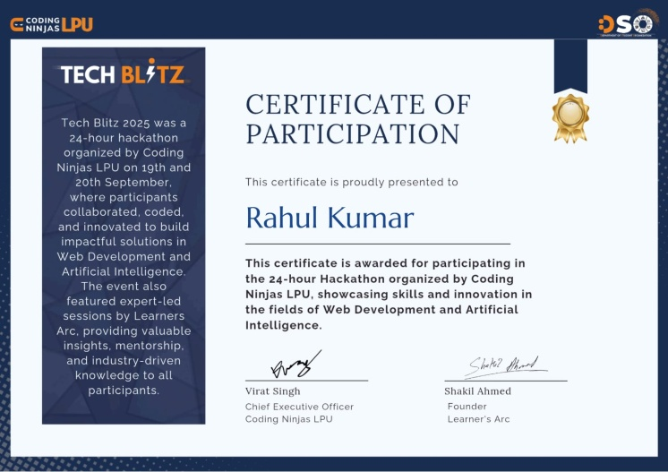

Education

Lovely Professional University Punjab, India

Master of Computer Application (Hons.) Cyber Security Present
•
Dr. B.R. Ambedkar University (DBRAU) Agra, India
•

Bachelor of Science :Percentage- 71% July 2021 - July 2024
Kendriya Vidyalaya no.4 Jaipur, Rajasthan
•

Intermediate: Percentage – 72% April 2018 - may 2019

