Data Quality in Digital Twin Systems: Managing Consistency and Accuracy in Simulated Environments.
Chahat Gill (300219167)
Submission Date: 10th April

- Abstract
The abstract also foreshadows the fact that the paper deals with the issue of ensuring the high-quality data synchronization between physical sensors and virtual counterparts. Through the simulation of a motor system of 1,000 records with Python, the project reveals certain data quality problems such as missing values, invalid records, and lag in synchronization. The conclusion states that the dataset is highly valid, but synchronization gaps can have a severe effect on the reliability of the digital twin, which needs to be corrected with the help of automated approaches.

- Introduction
The introduction is dedicated to the issue of data inconsistency in digital twin models, where network latency or sensor failures tend to interrupt real-time synchronization. This issue is especially problematic since even the slightest differences in timing can result in a "sync gap," which would make the digital simulation diverge from the physical reality. Although different synchronization algorithms are available, this project suggests a data profiling solution to identify these errors before they affect activities down the line. To be transparent and reproducible, all the project scripts, datasets, and visual results are recorded in a GitHub repository.

- Experimental Setup
The approach includes a Python-based simulation modeled by using the libraries of Pandas and NumPy to create 1000 seconds of time-series data of a factory motor. The algorithm logic works in three steps: initially, the generation of the baseline sensor data with normal distributions; second, the artificial errors are added to the sensor data (the missing values, negative RPM values, etc.); and finally, the calculation of the Sync Error is made as the absolute difference between the physical and digital temperature states. The system operates on user-supplied raw sensor logs, which are in the form of a CSV file and the system should produce detailed quality summaries and performance graphs.

- Results and Discussion

The experimental outcomes found severe quality failures in three dimensions. Analysis of completeness indicated that there were 50 records missing in the physical temperature sensor, indicating that there may have been incomplete data transmission. Validity checks were used to ensure that 10 records had negative RPM values which are physically impossible and were recorded as invalid entries. Moreover, the analysis of the synchronization and the corresponding graph, called “sync_gap_chart.png”, also indicated a stable temperature delay of 5 degrees, which proves that the digital twin was not perfectly synchronized with the real-world system.
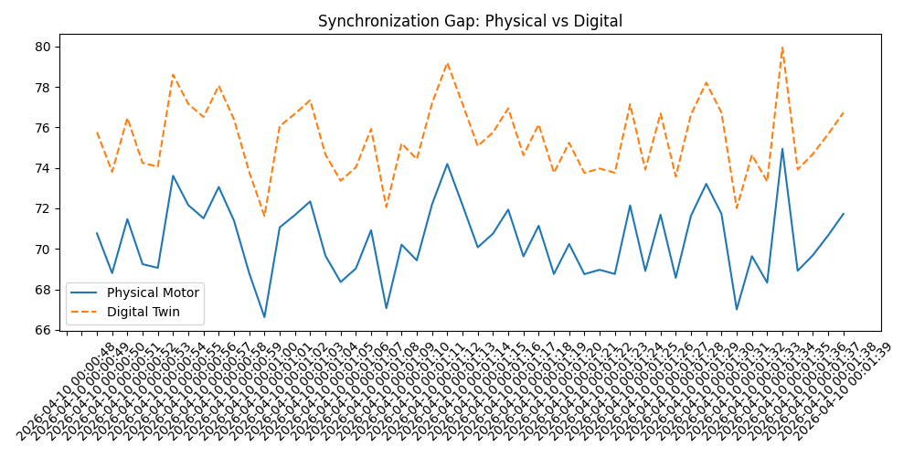

- Summary and Conclusions
Overall, this project shows that a digital twin model may manifest itself as valid at a row level without the structural synchronization biases. The main point of learning is that data quality profiling is the key to digital twin ecosystems to ensure reasonable and plausible outputs. To guarantee the integrity of the virtual model in future work, automated ETL validation rules are proposed that may identify sensor gaps and correct them automatically on the fly. This would guarantee a stronger and smoother data flow between the virtual and physical realm.

- References

- COMP 331 Project Topics Document: This source provided the foundational research objective for Topic T4, focusing on managing consistency and accuracy in Digital Twin systems.

- COMP 331 Course Template and Guidelines: Used for the structural organization of the final project report and experimental setup requirements.

- Pandas Documentation: The technical reference for utilizing the Python Pandas library for time-series generation, frequency handling (e.g., using 's' for seconds), and data cleaning.

- Matplotlib and Seaborn Libraries: Used for creating visual evidence of synchronization gaps through histogram and time-series plotting.

- Academic Research on Digital Twins: General academic concepts regarding the synchronization between real-world physical systems and their digital counterparts.

