Multi-Touch Marketing Attribution and ROI Dashboard
Internship Project Report

Project Type: Data Analytics Project
Tools Used: Python, Pandas, Google Colab, Tableau, CSV Dataset
Submitted By: GROUP 10
Submitted To: Infotact Solutions & Co.
Date: June 2026
Project Objective
To build a Multi-Touch Marketing Attribution and ROI Dashboard that helps marketing teams identify which marketing channels contribute most to customer conversions, revenue, ROAS, and CAC.

Contents
- 1. Executive Problem Statement
- 2. Business Objectives
- 3. Dataset Description
- 4. Data Cleaning and Preparation
- 5. Attribution Models Implemented
- 6. KPI Calculations
- 7. Dashboard Preview
- 8. Dashboard Interpretation and Key Insights
- 9. Project File Structure
- 10. Conclusion

1. Executive Problem Statement
E-commerce and SaaS companies spend money across multiple marketing channels such as Google Ads, Meta Ads, TikTok Ads, LinkedIn Ads, Email, Organic Search, Referral, and Direct traffic. A customer may interact with several channels before finally converting. For example, a customer may first click a Meta ad, later visit the website through Organic Search, and finally convert through Google Ads.
Traditional Last-Click Attribution gives all conversion credit to the final channel. This can create incorrect marketing decisions because earlier touchpoints also influence the customer journey. This project solves the problem by using Multi-Touch Attribution models such as First-Touch, Last-Touch, and Linear Attribution.
The final dashboard helps marketing managers compare channel performance, identify high-return campaigns, calculate ROAS and CAC, and make better marketing budget allocation decisions.

2. Business Objectives
- Clean and prepare marketing touchpoint data for analysis.
- Identify converted customer journeys from raw event-level records.
- Build First-Touch, Last-Touch, and Linear Attribution models.
- Calculate key marketing KPIs such as Total Spend, Revenue, Conversions, ROAS, and CAC.
- Create an interactive Tableau dashboard for marketing performance analysis.
- Help business users understand which marketing channels generate better return on investment.

3. Dataset Description
The dataset used in this project is a synthetic multi-touch marketing dataset. Each row represents one marketing touchpoint or customer event in a journey.
Metric | Value
Total Rows | 1,926
Total Columns | 26
Unique Customer Journeys | 500
Total Touchpoints / Events | 1,926
Total Conversions | 209
Marketing Channels | 8
Total Ad Spend | $1,920.94
Total Revenue | $61,086.75
Overall Conversion Rate | 41.80%
Overall ROAS | 31.80
Overall CAC | $9.19

Important dataset columns include:
Column | Description
event_id | Unique ID for each marketing event
user_id | Unique customer ID
journey_id | Full customer journey ID
channel | Marketing channel such as Google Ads or Email
campaign | Campaign name
funnel_stage | Awareness, Consideration, Decision, or Purchase
ad_spend | Marketing cost for a touchpoint
is_conversion | 1 means the journey converted, 0 means not converted
conversion_value | Revenue generated from a conversion

4. Data Cleaning and Preparation
The data cleaning process was completed in Google Colab using Python and Pandas. The following steps were performed:
- Loaded the raw CSV dataset into a Pandas DataFrame.
- Converted timestamp columns into datetime format.
- Converted ad spend and conversion value into numeric format.
- Filled missing numeric values with zero where appropriate.
- Removed duplicate event records using event_id.
- Sorted customer journeys by journey_id and event_timestamp_utc.
- Exported the cleaned dataset as cleaned_multi_touch_attribution_dataset.csv.

5. Attribution Models Implemented
Model | Logic | Business Use
First-Touch Attribution | The first marketing channel in a converted customer journey receives full conversion and revenue credit. | Useful for identifying channels that start customer awareness.
Last-Touch Attribution | The final marketing channel before conversion receives full conversion and revenue credit. | Useful for identifying channels that close conversions.
Linear Attribution | All touchpoints in a converted journey share conversion and revenue credit equally. | Useful for fairly distributing credit across the full journey.

The project first identified all converted journeys where is_conversion = 1. Then all touchpoints belonging to those journeys were selected for attribution modeling. This ensured that both early-stage and late-stage marketing interactions were considered.

6. KPI Calculations
KPI | Formula
Total Spend | Sum of ad_spend
Total Revenue | Sum of conversion_value
Conversions | Count of converted journeys
ROAS | Attributed Revenue / Total Spend
CAC | Total Spend / Attributed Conversions
Conversion Rate | Total Conversions / Total Journeys

Attribution Model | Top Channel by Revenue | Attributed Conversions | Attributed Revenue
First-Touch | Organic Search | 48.00 | $16,715.44
Last-Touch | Google Ads | 67.00 | $19,152.57
Linear | Google Ads | 44.36 | $12,877.62

Note: Organic Search, Direct, and Referral have zero ad spend in this synthetic dataset. Therefore, their ROAS and CAC values should be interpreted as not applicable rather than compared directly with paid channels.

7. Dashboard Preview
The Tableau dashboard contains four main visual sections: Channel Revenue, ROAS by Channel, CAC by Channel, and Conversions by Channel. It is designed to help business users compare marketing performance across channels and attribution models.
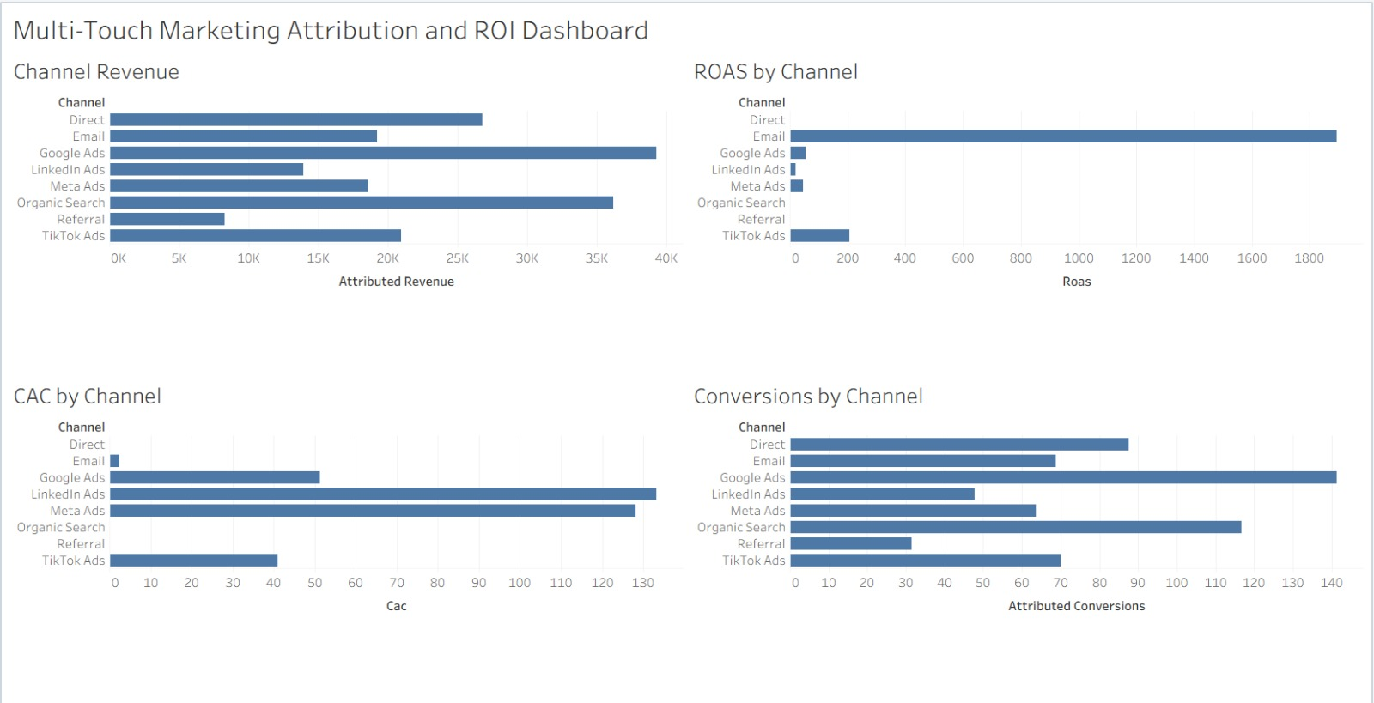
Figure 1: Multi-Touch Marketing Attribution and ROI Dashboard created in Tableau

8. Dashboard Interpretation and Key Insights
- Google Ads shows strong performance in revenue and conversions, especially under Last-Touch and Linear attribution models. This indicates that Google Ads is effective at capturing high-intent users near the end of the journey.
- Organic Search contributes significant attributed revenue and conversions, showing that non-paid discovery plays an important role in the customer journey.
- Email has very high ROAS in the dataset because it has very low spend compared with attributed revenue. This suggests Email can be a cost-efficient remarketing channel.
- LinkedIn Ads and Meta Ads show higher CAC compared with some other channels, so these channels should be monitored for cost efficiency.
- Using only Last-Touch Attribution may over-credit closing channels and under-credit awareness channels. Multi-touch attribution gives a more balanced view.

Recommended Actions
- Increase investment in channels that show strong attributed revenue and efficient CAC.
- Use Google Ads for high-intent conversion campaigns, but compare with Linear Attribution before final budget decisions.
- Continue using Email as a low-cost remarketing channel.
- Review LinkedIn Ads and Meta Ads campaigns to reduce CAC and improve campaign targeting.
- Use the dashboard filter to compare First-Touch, Last-Touch, and Linear Attribution before reallocating marketing budget.

9. Project File Structure
multi_touch_attribution_roi_dashboard/
|-- data/
| |-- multi_touch_attribution_dataset.csv
| |-- cleaned_multi_touch_attribution_dataset.csv
| |-- attribution_model_output.csv
| |-- attribution_channel_summary.csv
|
|-- notebooks/
| |-- 01_data_cleaning_and_eda.ipynb
| |-- 03_kpi_calculation_and_modeling.ipynb
|
|-- sql/
| |-- 02_attribution_model_queries.sql
|
|-- dashboard/
| |-- multi_touch_attribution_dashboard.twbx
|
|-- reports/
| |-- multi_touch_attribution_roi_report.docx
| |-- dashboard_screenshot.png

10. Conclusion
This project successfully demonstrates how Multi-Touch Attribution can provide a more accurate view of marketing performance than traditional Last-Click Attribution. By comparing First-Touch, Last-Touch, and Linear Attribution models, the dashboard helps marketing teams understand the real contribution of each channel across the customer journey.
The final Tableau dashboard enables better budget allocation by identifying high-revenue channels, efficient ROAS channels, expensive CAC channels, and customer journey patterns that lead to conversions. The project also demonstrates practical data analytics skills including data cleaning, KPI calculation, attribution modeling, data visualization, and business reporting.

