Closed Orbit

FindOrbit6, FindSyncOrbit, FindOrbit4, and FindOrbit

FindOrbit4

FindOrbit4 finds the closed orbit for a particle with a constant momentum deviation δ set by the user. It assumes a simplified model of the ring in order to restrict the problem only to transverse dimensions. To use FindOrbit4 element pass functions must not change δ (no RF cavity, no radiation) or have any time dependence. Then δ can be treated as a model parameter instead of a variable.

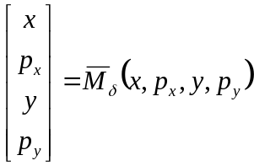

The iterative scheme is

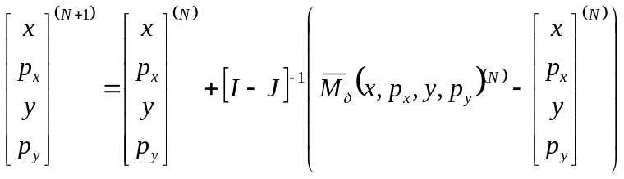

Where J is the Jacobian matrix of the map

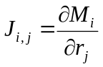 Where indexes i,j = 1…4and 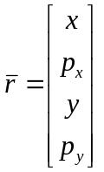4-d phase space vector

FindSyncOrbit

In FindSyncOrbit the path lengthening Δτ is imposed externally.
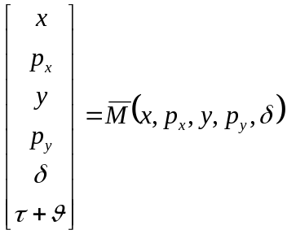
If we model the ring with no momentum kick, no radiation, and no time dependence we can reduce the number of dimensions to 5.

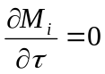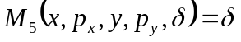

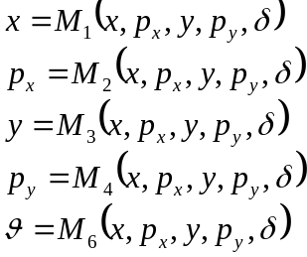

We can write it in the same form as () and apply the same iterative scheme ()

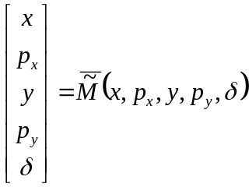 where 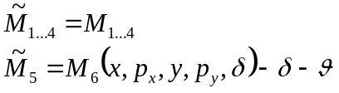

FindOrbit6
FindOrbit6 finds the closed orbit in the full 6-d phase space. In order for the iterative process to converge in 6 dimensions a cavity must be present and have meaningful values for peak voltage and frequency. Cavity voltage must also be sufficient to compensate for the radiation losses for the solution to exist.

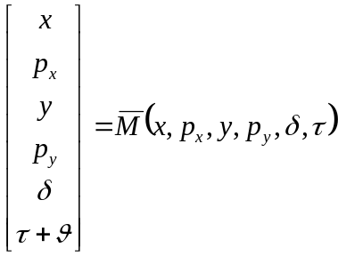

It is similar to orbit finding functions in other accelerator codes

