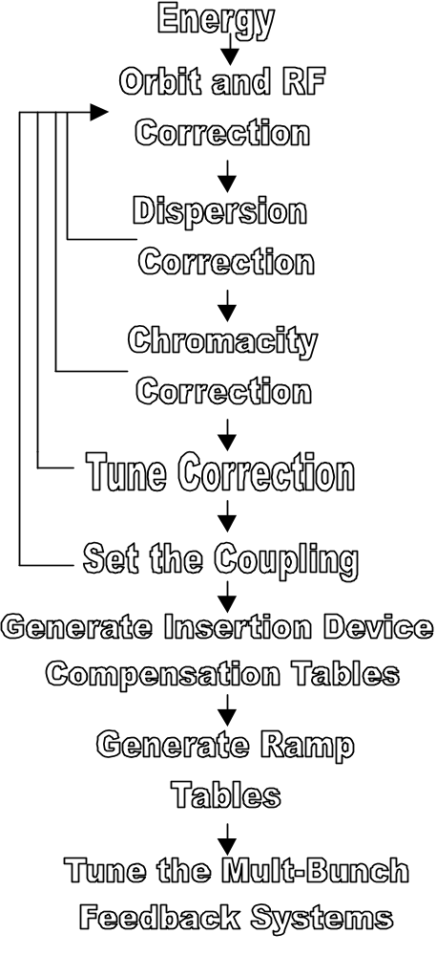GENERAL RECIPE FOR STORAGE RING SETUP
The goal of storage ring setup is to maintain the week to week repeatability of storage ring operation. The main issues involved in setup are the following.
- Magnet lattice and RF frequency
- Energy ⇒ Bend
- Tune ⇒ QF and QD
- Chromaticity ⇒ SF and SD
- Dispersion ⇒ QFA
- Orbit ⇒ HCM, VCM, and RF frequency
- Coupling ⇒ Skew quadrupoles
- Insertion device compensation – feed forward table generation
- Ramp table generation

GOLDEN PARAMETERS AND TOLERANCES

The "golden" parameters for the often change, however, here is the current list.
- Orbit: use getgolden to obtain the lastest golden orbit. After global orbit correction, the remaining RMS error in the BPMs should be below 90 microns. Typically it is 30-60 microns. After setting user bumps (local bumps), the straight section BPMs should be within a few microns of the golden orbit.
- Check the golden page for the latest tune and chromaticity settings. The tolerance on the tune is ±.005 and chromacity is ±.5 units.
- The setpoint for SQSD2 is a moving target. The last setpoints were: 1.5 amps at 1.5 GeV and 1 amps at 1.9 GeV multi-bunch. Check the golden page for the latest settings.
- The tolerance for setting the RF frequency is difficult to quantify. Basically, check to make sure that the sum of the horizontal arc corrector magnets is close to zero (a few tenths of an ampere). Also, run findrf and look at the dispersion function and the orbit to see if it looks reasonable.
- The tolerance for setting the QFA is even more difficult to quantify then the RF frequency. In the process of learning how to optimize QFA, one will get a good idea of how well one can do. Optimizing the QFA setpoint does not have to be done at every setup. It is usually

done after a long shutdown or after a major change to the lattice.

FULL MACHINE SETUP (from a shutdown)
- Control system startup
- Storage ring vacuum must be good or it is a waste of time to continue.
- Check storage ring hardware functionality: DCCT, scrapers, tune measurement system, RF frequency, insertion device control, etc.
- Set the proper RF frequency and power.
- Set the defaults on the following storage ring channels.
- Set BPM averaging to obtain a 2 Hz data rate
- Set power supply ramp rates (if available)
- Set quadrupole shunts off
- Power supplies test
- Check that all PS can reach their maximum/minimum current (or at least ∼80% max/min for CMs)
- Check AM noise (monmags)
- Check AM-SP offset (monmags)
- Check samples rates (monrates)
- Check step response (magstep)
- BPMs tests (need stored beam)
- Check that all BPMs calibrate
- Check samples rate (monrates)
- Check orbit response matrix (checkbpms)
- Check AM noise (Gausian, stationary, outliers) (monbpm)
- Check current dependants: fill to max current and monitor decay (ideally with a reduced lifetime)
- Check for nonlinearities of the BPM button voltages
- Beam-base alignment
- Find QF, QD, and QFA centers
- Scan the small gap vacuum chambers for lifetime changes
- Check for high beam loss levels in the straight sections
- Determine user bumps
- Scan the small gap vacuum chambers for lifetime changes
- Do the “general storage ring setup procedure” as described below with the following exceptions:
- Only correct the orbit to the BPMs with known offsets
- Correct to the offset orbit (not the golden orbit)
- Do not turn on the skew quadrupoles
- LOCO analysis:
- Find BPM and corrector magnet gains
- Minimize beta beat using QF and QD families
- etc
- With the new quadrupole settings, redo the storage ring setup procedure as done in step 10.
- After setting the user bumps (setbumps), save the final orbit as the new golden orbit. For the insertion device sectors, it is usually set by a user request. However, after a long shutdown it is best if the beamlines can align to the new photon beam position. The ease (and desire) of realigning a beamline depends greatly on the individual beamlines. It is best to spend a physics shift to align the insertion device users with the minimum orbit change from the new offset orbit (small angle changes usually produce large adjustments for the users). For the non-insertion device sectors, the golden orbit should equal the offset orbit. To date, the bend magnet beamlines have always been very accommodating to changes in the golden orbit due to beam based alignment.
- One may want to “mechanically” zero (match the impedance of the 4 buttons) the BPMs about the new golden orbit to minimize current dependence. It’s a good idea, but it has never been done.
- Set the skew quadrupoles (w/ orbit correction) based on lifetime (400 to 200 milliampere change in 4-6 hours).
- Generate feed forward tables for insertion devices.
- Test the wiggler tune compensation. The tune compensation is based on the last feed forward table generated. In order to regenerate the quadrupole setpoints, make sure the tune measurement is working properly with a 5 second or less update period and call ffgettbl with the third input set to 1 (ffsettbl(Sector,2,1)).
- Optimize Injection:
- Booster to storage ring energy match (FFT(FAD) of injected beam should equal stored beam tunes).
- Minimize vertical orbit of injected beam using FADs.
- If necessary, make a closed orbit bump closer to the septum.
- etc.
- Generate energy ramping tables for 1.9 GeV operation if necessary (section 10.5) or run srrampadjust to base ramp tables on a curve fit connecting the present injection and production lattices.
- Tune the longitudinal and transverse feedback systems.
- Document the state of the machine for future comparisons.
- Hardware: monbpm, monmags, monrates, etc
- Physics parameters: dispersion, beta beat, chromaticity, etc

GENERAL STORAGE RING SETUP PROCEDURE (usually bi-weekly)
- Go to the computer controlled RF synthesizer (9.74 or 3.06 dbm amplitude depending on the synthesizer).
- Set the appropriate RF cavity temperatures
- Cycle the lattice and setup the storage ring like it was for the last user shift (srcontrol) with the following exceptions.
- Multi-bunch feedback off, with the appropriate RF cavity temperatures.
- Multi-bunch mode, even if the setup is for a two-bunch mode. The behavior of the BPMs in two-bunch mode is questionable.
- Set all skew quadrupoles to zero current.
- Fill to 45 mAmps (45-35 is an OK range to operate in). Reduce the fill rate to .2-.3 mAmps per shot so that the fill pattern is more even.
- Calibrate the BPMs
- Basic SR hardware check: srinit, monrates, monbpm, checkbpms
- If necessary, generate response matrices
- Orbit (measbpmresp)
- Tune (meastuneresp)
- Chromaticity (measchroresp)
- Global Orbit Correction (srsetup – orbit correction)
- All BPMs
- Correct to the golden orbit
- All corrector magnets
- Start from zero corrector strength (if possible) on the first iteration or if the RF frequency was changed.
- Correct the RF frequency
- The mean of the arc horizontal corrector magnets should be close to zero (analcm). The conversion from change in RF frequency to change in mean(arc HCM) is approximately -.0014 MHz/ampere (i.e., a positive change in RF frequency will decrease the mean corrector strength).
- The dot product of the orbit and dispersion function should be small (findrf).
(Iterate steps 5 and 6 as necessary)
- Correct the chromaticity (meastchro, stepchro, or setchro)
(Iterate steps 5, 6, and 7 as necessary)
- Correct the tunes (gettune, steptune, or settune)
(Iterate steps 5, 6, 7, and 8 as necessary)
- Dispersion correction (findqfa) is usually only needed about once a year. If QFA needs to be changed, then iterate steps 5, 6, 7, 8, and 9.
- Save as the production lattice. For 1.5 GeV, also save this lattice as the injection lattice.
- Cycle the lattice and refill.
- Redo steps 5-10 except do not zero the corrector on the first iteration.
- Set the user bumps (setbumps) using the sextupole corrector magnets if the bump is large.
- Save as the production lattice. For 1.5 GeV, also save this lattice as the injection lattice.
- Cycle the lattice and refill.
- At this point the lattice should be in very good shape. If not, go back to step 12. If small changes to the orbit need to be make do so without using the sextupole corrector magnets (due to hysteresis).
- Set the user bumps (setbumps) without using the sextupole corrector magnets. It is best to do a global orbit correction as done at the top of every fill (which includes a setbumps).
- For 1.5 GeV operation, save as the injection lattice (srsave).
- If necessary, set the skew quadrupole (SQSD2) with orbit correction (setskewq). Base setting on a 400 to 200 milliampere change in 4-6 hours.
- Save as the production lattice (srsave).
- Test injection. An injection bump may be required for good injection efficiency (bumpinj). The skew quadrupoles should be off for good injection efficiency (except 2-bunch). For 1.9 GeV operation, ramp down to 1.5 GeV and verify that this lattice is good for injection. Occasionally, the 1.5 GeV upper branch will need a full setup (only use the BPMs with known offsets and correct to the offset orbit with no user bumps, and do not set the skew quadrupoles).
- Cycle and verify that the orbit, tunes, RF, chromaticity, and injection rate are acceptable. It is OK to correct the orbit without sextupole corrector magnets but that is it.
- For 1.9 GeV operation update the ramp tables (srrampadjust).
- Generate feed forward tables (ffgettbl, see Section 2.0).
- Go back to the low-noise RF synthesizer and input the proper frequency manually.

