Web & Mobile app
for automated management and monitoring of electrical projects

A brief report about the project

Chaima Sahli

Brief Scope about the company

ELECPOWER is a company specializing in assembling and installing electrical cabinets for various projects.
Currently, the entire management process is handled on paper, making it inefficient and difficult to track.
This project aims to automate the management of electrical projects, making it easier for both admins and employees to monitor progress, track resources, and streamline operations.

Project Overview
The system consists of two main components:
- Web Application (for Admins)
- Mobile Application (for Employees)
Each version has features tailored to its users.
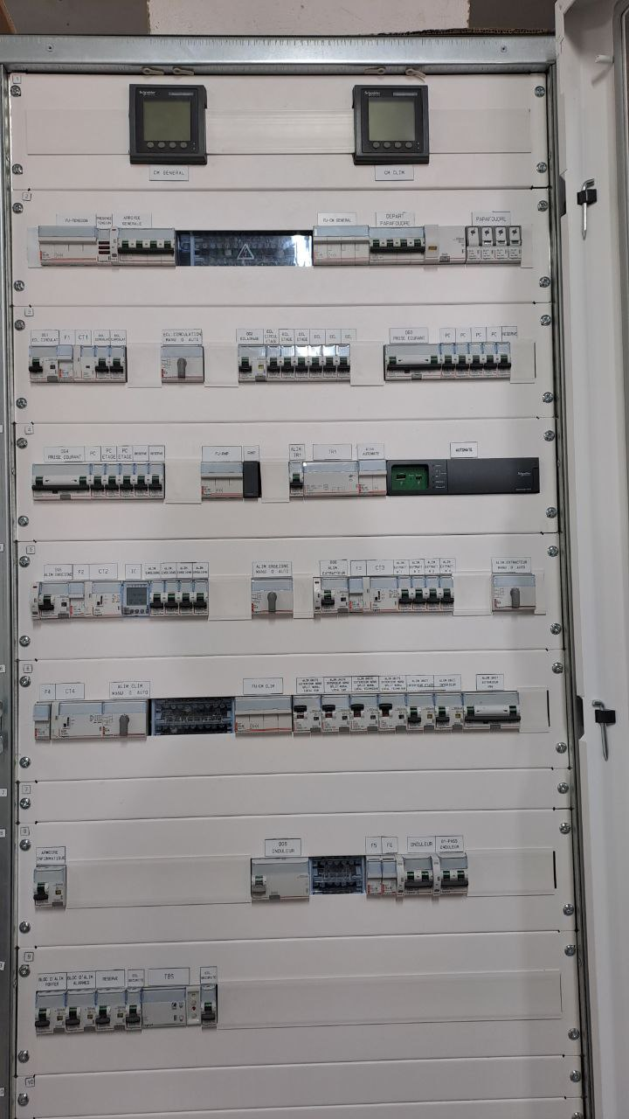

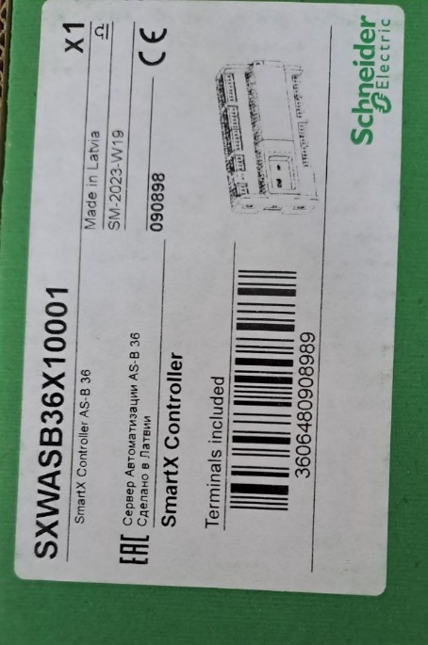

picture of an electrical cabinet picture of a material

Web Application Features

Project Management
Admins can:
- View all projects
- Create a new project by filling out a form
- Update or delete a project
- Track project progress and status.

To prevent long forms, after creating a project, the admin can later add necessary electrical components separately.

Resource Management
Admins can:
- Allocate and track electrical components for each project
- View available stock and quantity
- Filter by availability
- Add articles to a project

Electrical Cabinet Management
Each project has one Electrical cabinet. Once a project is created, a dedicated page for the electrical cabinet details will be generated

QR Code Management
Each Electrical cabinet has a unique QR code that links to its details.
- The QR code is generated automatically upon project creation
- It contains a unique URL
- Employees can scan it with the mobile app to access project information
- It can also be printed and attached to the physical Electrical cabinet for easy tracking

Employee Management
- manage employee profiles and assign roles within projects
- Add edit delete Employee profiles
- Search and filter functionalities

Reporting and analytics
- Generate reports for project process, resource usage and employee performance
- Analytical dashboard: graphs of projects timeline and resource allocation
- Export in PDF or Excel format

Notifs and alerts
- Keep admin informed of critical updates
- Real time notifs (project deadlines, resource shortage...)

Mobile Application Features

Project Assignment & Dashboard
- Employees log in and view their assigned projects.
- Display projects with progress indicators to see upcoming deadlines
- View Project details
- Status Update ( in progress / completed)

Task Management
- Add tasks related to the projects
- View task details (description, deadline..)
- Add notes to report issues (missing materials, delays, malfunctions)
- Mark task as completed
- Edit/ delete tasks

QR code Scanner
- Employee navigates to the QR Scanner feature
- Scan QR code of the cabinet (using device camera)
- fetch and display details (technical details, maintenance history, assigned project info)

Intervention & Maintenance
Employees can take different actions post-scan:
- Confirm Installation Completion
- Request Maintenance if Armoire Needs Fixing
- Report on Malfunctions or Missing Components
If maintenance is needed, the app will notify the admin and generate an
intervention request.

Resource Tracking & Requests
Employees can track available resources (electrical components) for each project and confirm their usage.
If a component is missing, they can request additional resources from the admin.

Incident Reports
- Report issues or incidents during project execution
- Employees can attach images & notes to reports.
- Reports are sent to admins for review & action.
- Incident Tracking: View Incidents and their resolution tracking

Notifs and alerts
Keep employees informed about project updates, task changes, and schedule alerts

