Customer Shopping Behavior Analysis
Python · PostgreSQL · Power BI | 3,900 orders | $233,081 revenue

1. Project Overview
This project analyzes customer shopping behavior using transactional data from 3,900 purchases across various product categories. The goal is to uncover insights into spending patterns, customer segments, product preferences, and subscription behavior to guide strategic business decisions.

2. Executive Summary
3,900  Orders (unique customers) | $233,081  Total revenue | $59.76  Average order value | 3.75  Average review rating
Key takeaways from the analysis:
- Two categories carry the business. Clothing and Accessories generate 76.6% of revenue; average order value is similar everywhere ($57–$60), so revenue follows order volume.
- Spending is remarkably uniform. Average spend differs by only about $1.40 across age groups, and subscribers spend $59.49 vs $59.87 for non-subscribers.
- Men drive about two-thirds of revenue ($157,890 vs $75,191) through more orders, not bigger baskets.
- Subscriptions are under-used. Only 27% of customers subscribe, and 72.4% of repeat buyers (2,518 people) are not subscribed.
- "Loyal" is too broad to be useful. About 80% of customers (3,116) exceed 10 previous purchases, so the segment needs tighter tiers.

3. Dataset Summary
- Rows: 3,900
- Columns: 18 (raw) / 19 (cleaned, after feature engineering)
- Key Features:
  - Customer demographics (Age, Gender, Location, Subscription Status)
  - Purchase details (Item Purchased, Category, Purchase Amount, Season, Size, Color)
  - Shopping behavior (Discount Applied, Promo Code Used, Previous Purchases, Frequency of Purchases, Review Rating, Shipping Type)
- Missing Data: 37 values in the Review Rating column

4. Exploratory Data Analysis using Python
Data preparation and cleaning was carried out in Python with pandas:
- Data Loading: Imported the dataset using pandas.
- Initial Exploration: Used df.info() to check structure and .describe() for summary statistics.
- Missing Data Handling: Checked for null values and imputed the Review Rating column using the median rating of each product category.
- Column Standardization: Renamed columns to snake_case for readability and consistency.
- Feature Engineering:
  - Created age_group by binning customer ages into quartiles (Young Adult 18–31, Adult 32–44, Middle-aged 45–57, Senior 58–70).
  - Created purchase_frequency_days from the frequency_of_purchases labels.
- Data Consistency Check: Verified that discount_applied and promo_code_used were identical; dropped promo_code_used as redundant.
- Database Integration: Loaded the cleaned DataFrame into PostgreSQL for SQL analysis.

5. Data Analysis using SQL (Business Transactions)
Structured analysis was run in PostgreSQL to answer key business questions. Each result below is a live screenshot from pgAdmin.
- Revenue by Category — total orders, revenue, and average order value per category.
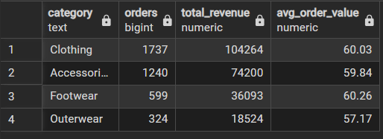
Clothing and Accessories together account for over 76% of total revenue.
- Revenue and Average Rating by Age Group.
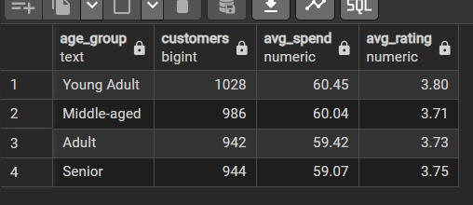
Young Adults spend the most per order and rate their purchases the highest, but the differences are small ($59.07–$60.45 average spend).
- Most Popular Payment Methods.
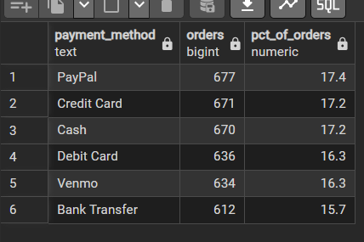
Spending is spread fairly evenly across payment methods — PayPal leads by a narrow margin (17.4%).
- Top 10 States by Revenue.
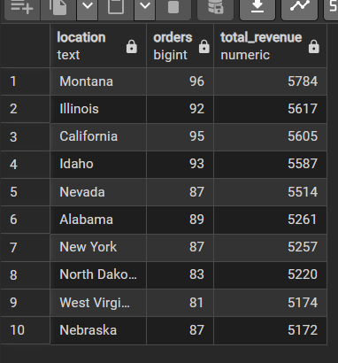
Montana, Illinois, and California lead — but the spread across the top 10 is narrow (within ~$600 of each other).
- High-Spending Customers — a candidate "VIP" segment for marketing (979 customers qualify; first 10 of the top 25 shown).
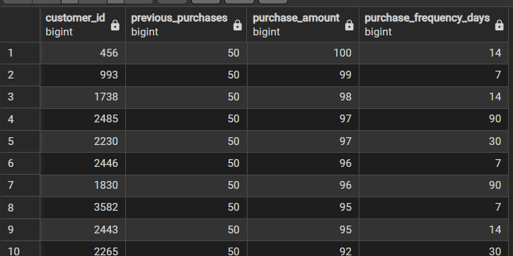
979 customers (about 25%) have above-average previous purchases and above-average spend. The top 25 all sit at the maximum of 50 previous purchases and spend $84–$100 per order — a natural target list for loyalty offers.
- Revenue by Gender.
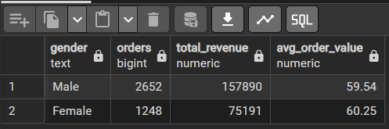
Male customers placed more than twice as many orders and generated over double the revenue — but Female customers had a slightly higher average order value ($60.25 vs $59.54).
- Top 5 Highest-Rated Products.
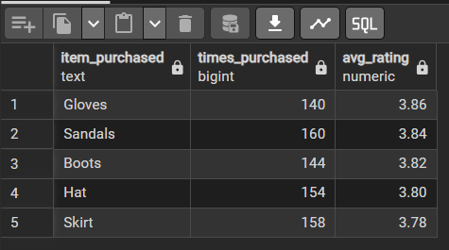
Gloves, Sandals and Boots lead on rating, but the top five span only 0.08 points (3.78–3.86), so ratings barely separate products.
- Products Most Often Bought with a Discount (% of orders).
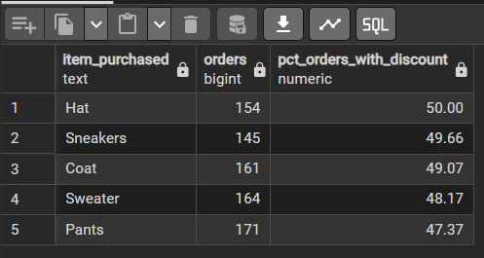
Roughly half of Hat, Sneakers and Coat orders carry a discount. Discounted orders average $59.28 vs $60.13 without a discount, so discounts are not lifting order value.
- Customer Segmentation — New (1 purchase), Returning (2–10), and Loyal (11+ previous purchases).
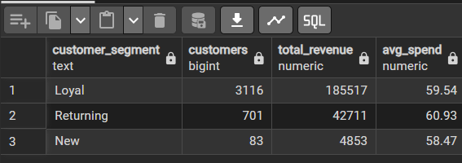
The Loyal segment is both the largest group and the biggest revenue contributor ($185,517), but at ~80% of customers the 11+ threshold is too broad to single out your best customers.
- Top 3 Products per Category — best sellers within each category.
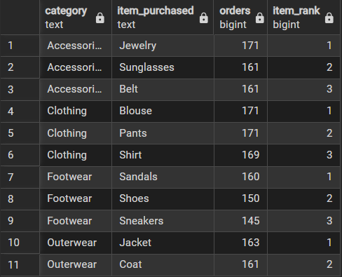
Top sellers by category: Jewelry (Accessories), Blouse and Pants (Clothing, tied at 171), Sandals (Footwear) and Jacket (Outerwear). Sandals also rank #2 on rating.
- Repeat Buyers & Subscriptions — whether customers with more than 5 previous purchases are more likely to subscribe.
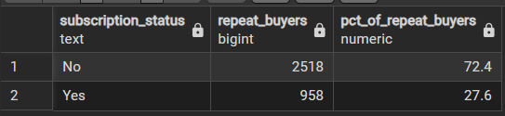
Most repeat buyers are still not subscribed — repeat purchasing and subscribing appear to be largely independent behaviors.
- Seasonal Purchase Trends.
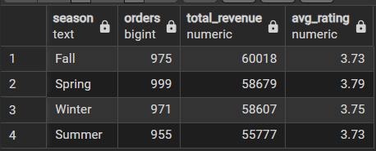
Fall drives the most revenue; Spring has the highest average satisfaction.

6. Dashboard in Power BI
Finally, an interactive dashboard was built in Power BI to present these insights visually.
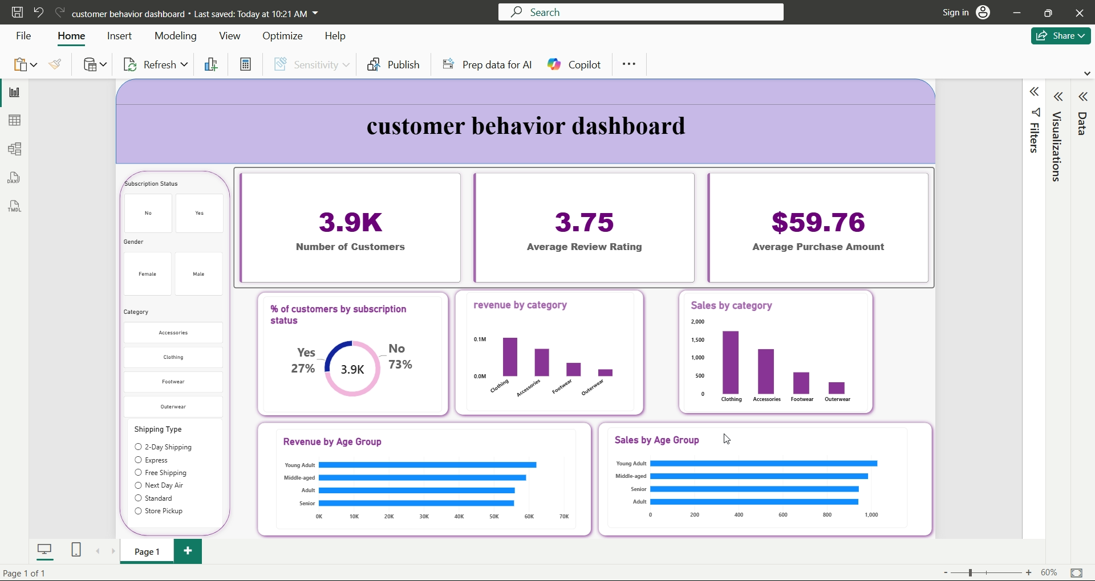
Customer Behavior Dashboard — 3,900 customers, $59.76 average purchase, 3.75 average rating, 27% subscribed.

7. Business Recommendations
- Prioritize Clothing and Accessories — together they bring in $178,464 (76.6% of revenue); focus marketing spend and inventory there, and test cross-selling to grow Outerwear (7.9%).
- Redesign the Subscription Offer — only 27% subscribe and subscribers spend about the same ($59.49 vs $59.87), so the current perks do not raise order value; test benefits that do.
- Tighten the Loyalty Tiers — 80% of customers count as Loyal and generate $185,517; split them into percentile-based tiers (for example 11–25, 26–40, 40+ purchases) before building a rewards program.
- Run Outreach on the VIP List — 979 customers (25%) are above average on both purchase frequency and spend; start with the top 25 (50 previous purchases, up to $100 per order) for early-access or personal offers.
- Feature Proven Products — Sandals are both the top Footwear seller and the #2 rated product (3.84); Gloves (3.86) rate highest; Jewelry, Blouse and Pants are top sellers — strong candidates for featured placement.
- Check Discount ROI — Hats, Sneakers and Coats are discounted on about half of their orders, yet discounted orders average $59.28 vs $60.13; confirm margins before extending discounts.
- Convert Repeat Buyers to Subscribers — 2,518 customers with more than 5 previous purchases are not subscribed (72.4% of repeat buyers) — the largest ready-made target list.

8. Limitations & Notes
- Small differences. Gaps across age groups, states, seasons and payment methods are small and were not statistically tested; treat them as directional.
- Segment definitions. Age groups are quartile-based; the Loyal cut-off (11+ purchases) is not selective; the VIP list uses above-average thresholds.
- Imputed ratings. 37 missing review ratings (0.9%) were filled with the category median.
- Missing context. The data has no dates or costs, so trends over time, churn, and margin or discount ROI cannot be measured; findings show association, not causation.

