[Organization Name]
API Gateway Enterprise Architecture Standard
Architecture and Operating Model
Version | 1.1
Status | Draft
Date | 21 September 2026
Document ID | [Document ID]
Classification | [Classification]

Document Control
Document title | API Gateway Enterprise Architecture Standard
Document ID | [Document ID]
Version | 1.1
Status | Draft
Classification | [Classification]
Document owner | [Document owner, Infrastructure Team]
Author | [Author]
Effective date | [Effective date]
Review cycle | [Review cycle, e.g. annual]
Next review date | [Next review date]
Revision History
Version | Date | Author | Description
1.1 | 2026-09-21 | [Author] | Draft. Settles three open issues (all three optional capabilities stay optional per API; consumer configuration in Git defined; Security Managers approve exceptions) and makes the security core mandatory.
1.0 | 2026-09-21 | [Author] | First issue (draft). Converted from the architecture and operating-model notes (README.md); review decisions recorded.
Approval
Role | Name | Signature | Date
[Role] | [Name]
[Role] | [Name]
[Role] | [Name]

Contents
1 Introduction
1.1 Purpose
1.2 Scope
1.3 Audience
1.4 Normative language
1.5 Definitions and abbreviations
1.6 References
2 Architectural Principles
2.1 Central API entry point
2.2 Infrastructure, not business logic
2.3 Ownership
2.4 Self-service with guardrails
2.5 Summary of principles
3 Roles and Responsibilities
3.1 Roles
3.2 Responsibility matrix
4 Identity, Authentication and Authorization
4.1 Consumer categories
4.2 C2B authentication
4.3 B2B authentication
4.4 Authorization
5 Traffic Management
5.1 Routing
5.2 Version routing
5.3 Load balancing boundary
5.4 Health checks
5.5 Timeouts
5.6 Retry policy
5.7 Rate limiting
6 API Policy Capabilities
6.1 Transformation
6.2 Caching
6.3 Schema validation
7 API Contract, Lifecycle and Developer Portal
7.1 API contract
7.2 API lifecycle
7.3 Deprecation
7.4 Consumer lifecycle
7.5 Developer Portal
8 Configuration Management
8.1 Git as the source of truth
8.2 GitOps
8.3 Secrets
9 Observability and Audit
9.1 Runtime logging
9.2 Metrics
9.3 Audit
10 Availability and Deployment Architecture
10.1 Availability
10.2 Controlled reset
10.3 Distributed deployment
10.4 Centralized management and distributed runtime
11 Governance and Exceptions
11.1 Governance model
11.2 Mandatory guardrails
11.3 Standards
11.4 Guidelines
11.5 Organizational governance
11.6 Exceptions
12 Platform Boundaries
12.1 Boundary overview
12.2 Gateway and WAF
12.3 Gateway and Load Balancer
12.4 Gateway and Identity Provider
12.5 Gateway and application
13 Vendor Neutrality
13.1 Principle
13.2 Vendor-specific capabilities
Appendix A — Capability Summary and Requirements Register
A.1 Capability summary
A.2 Requirements register
Appendix B — Operating Model
Appendix C — Open Issues and Decisions Pending
List of Figures
Figure 1 — C2B authentication and access flow
Figure 2 — B2B authentication and access flow
Figure 3 — API lifecycle
Figure 4 — Configuration change flow
Figure 5 — Centralized management with distributed Data Planes
Figure 6 — API Gateway operating model
List of Tables
Table 1 — Requirement levels
Table 2 — Definitions and abbreviations
Table 3 — Summary of architectural principles
Table 4 — Roles
Table 5 — Responsibility matrix
Table 6 — Consumer categories
Table 7 — Example of operation-level authorization
Table 8 — Division of authorization decisions
Table 9 — Example of version routing
Table 10 — Division of responsibilities between the Gateway and load balancing
Table 11 — Example of per-API rate limits for one consumer
Table 12 — Technical validation versus business validation
Table 13 — Sources of audit evidence
Table 14 — Governance mechanisms
Table 15 — Boundaries between the Gateway and adjacent components
Table 16 — Capability summary
Table 17 — Requirements by chapter and level
Table 18 — Requirements register
Table 19 — Open issues

1 Introduction

1.1 Purpose
This document defines the enterprise architecture, operating model, responsibilities and required capabilities of the API Gateway platform of [Organization Name]. It is the normative reference for the design and operation of the platform, for application teams that expose APIs through it, and for governance, security and audit stakeholders.
The API Gateway is an enterprise infrastructure layer positioned between API consumers and backend services. Its purpose is to provide a consistent, secure, observable and governed entry point for web traffic, while allowing application teams to manage their APIs independently within organizational guardrails.
The API Gateway is not a business-logic layer. The core principle of this document is:
Application teams own their APIs and business policies. The infrastructure team owns the platform, its capabilities, and the technical guardrails around it.

1.2 Scope
This document applies to the handling of web traffic to backend services through the API Gateway. The scope is intentionally expressed as web traffic, rather than by a fixed list of protocols, so that the architecture is not unnecessarily coupled to a specific application protocol.
GW-INT-001 The Platform shall support the exposure and management of web-based API traffic.
GW-INT-002 The Platform architecture should remain independent of any specific application protocol.
GW-INT-003 The Platform should be capable of supporting HTTP/HTTPS, GraphQL, gRPC and MCP APIs, and other web-based API technologies.
SOAP is outside the scope of this document.
The following are within the scope of this document:
- WebSocket and streaming traffic.
- Service-to-service (east-west) traffic.
- Multi-tenant use of the Platform.
- Non-production environments.
The following adjacent systems are outside the scope of this document, except for the boundaries defined in Chapter 12: the Web Application Firewall (WAF), the organization's Load Balancer, the Identity Provider, the secrets-management solution, and the business logic of individual applications.

1.3 Audience
- The Infrastructure Team, which owns and operates the Platform.
- Application Teams that design, expose and operate APIs through the Gateway.
- Information security, risk and audit stakeholders.
- Enterprise architecture and governance bodies.

1.4 Normative language
The key words below are used to indicate requirement levels. They are written in bold where they appear in a numbered requirement.
Table 1 — Requirement levels
Keyword | Level | Meaning
shall, shall not | Mandatory | An absolute requirement or prohibition.
should, should not | Recommended | There may be valid reasons to deviate in particular circumstances, but the implications must be understood and weighed before a different course is chosen.
may | Optional | The item is permitted but not required.

These terms are used in accordance with BCP 14 (RFC 2119 and RFC 8174) and only when written in lower-case bold within a numbered requirement.
Each requirement carries an identifier of the form GW-AAA-NNN, where AAA identifies the subject area (the chapter) and NNN is a sequence number within it. Requirements apply to the Platform unless they name a different party. Paragraphs headed Rationale or Note, and shaded statements of principle, are informative and do not add requirements.
Capability and enablement. Where this document requires the Platform to provide a capability (for example rate limiting, caching or schema validation), the capability must be available. Unless a requirement states otherwise, whether it is enabled for a specific API is decided by the Application Team according to the needs of that API.

1.5 Definitions and abbreviations
Table 2 — Definitions and abbreviations
Term | Definition
Access token | A short-lived credential issued by the Identity Provider that a consumer presents to access an API.
API Gateway (Gateway) | The infrastructure layer between API consumers and backend services at which access, security and operational policies for API traffic are enforced.
API Platform (Platform) | The complete capability operated by the Infrastructure Team: the Gateway Data Plane, the Management Plane, GitOps integration and the Developer Portal.
Application Team | The team that owns an API, its contract and its business logic.
B2B | Business to Business: access where the consumer is another system or application.
C2B | Consumer to Business: access where the consumer is a human user.
Client credential | A long-lived credential that a B2B client uses to obtain access tokens.
Consumer | A user or system that calls an API through the Gateway.
Data Plane | The Gateway runtime instances that process API traffic.
Developer Portal | The portal through which APIs are discovered, documented and access to them is requested.
GitOps | An operating model in which configuration is defined in Git and changes are reviewed, validated, approved and deployed automatically.
Guardrail | An organizational requirement that is technically enforced by the Platform.
Guideline | Recommended practice that is documented but not technically enforced.
IdP | Identity Provider: the organization's system that authenticates users and clients and issues tokens.
Infrastructure Team | The team that owns and operates the Platform.
Load Balancer | Infrastructure that distributes traffic between instances of a backend.
Management Plane | The management layer used to configure and manage Gateways; also referred to as the control plane or central management.
Security Managers | The team [team name] designated by the organization to approve exceptions to this document.
Site | A location or environment in which applications run and in which a Gateway may be deployed.
Source of truth | The single authoritative location from which the deployed state is derived.
Standard | The organization's defined, consistent way of operating APIs.
TTL | Time to live: the period for which a cached item is considered valid.
WAF | Web Application Firewall: a control that protects applications against application-layer attacks.

1.6 References
- BCP 14: RFC 2119, Key words for use in RFCs to Indicate Requirement Levels, and RFC 8174, Ambiguity of Uppercase vs Lowercase in RFC 2119 Key Words.
- [Organizational information-security policy]
- [Organizational API governance standards, when issued]

2 Architectural Principles
This chapter states the principles on which the remainder of the document is based.

2.1 Central API entry point
GW-PRN-001 APIs exposed for consumption outside their immediate service boundary shall be exposed through the API Gateway.
GW-PRN-002 Direct exposure of an API that allows consumers to bypass the organization's authentication, authorization, rate-limiting, logging and security controls shall not be permitted.
Rationale. The Gateway provides a consistent enforcement point for API access.

2.2 Infrastructure, not business logic
GW-PRN-003 The Gateway shall not implement application business logic.
GW-PRN-004 The Platform should enable Application Teams to expose and manage APIs without requiring the Infrastructure Team to understand or implement the business logic of any application.

2.3 Ownership
GW-PRN-005 Application Teams shall own the APIs they expose through the Gateway, including API design, API contract, business semantics, consumers, access requirements, authorization requirements, versioning, deprecation, retirement, documentation and consumer lifecycle.
GW-PRN-006 The Infrastructure Team shall own the Gateway platform, its capabilities and the technical guardrails around it.
GW-PRN-007 The Infrastructure Team should not become the owner of an API solely because the API is implemented through the Gateway.

2.4 Self-service with guardrails
GW-PRN-008 The Platform should operate on a model of self-service with guardrails.
GW-PRN-009 Within organizational guardrails, the Platform should enable Application Teams to carry out the following themselves:
- Create APIs.
- Configure routes.
- Configure backend mappings.
- Configure authentication requirements.
- Configure authorization policies.
- Configure rate limits.
- Configure transformations.
- Configure caching where appropriate.
- Manage API versions.
- Manage consumers.
- Manage the API lifecycle.
GW-PRN-010 The Infrastructure Team should provide the Platform and enforce organizational requirements where technically appropriate.
Note. Not every organizational guideline needs to become a hard technical restriction. See Chapter 11.

2.5 Summary of principles
The following principles summarize the architecture. Each is specified in the chapter or section indicated.
Table 3 — Summary of architectural principles
# | Principle | Specified in
1 | The Gateway is the central enforcement point for APIs exposed beyond their service boundary. | Section 2.1
2 | The Gateway is infrastructure, not business logic. | Section 2.2
3 | Application Teams own their APIs; the Infrastructure Team owns the Platform. | Section 2.3
4 | Self-service is provided within organizational guardrails. | Section 2.4
5 | C2B access uses short-lived access tokens issued by the organizational IdP. | Section 4.2
6 | B2B access separates the client credential used to obtain tokens from the access token used to reach APIs; long-lived credentials are not transmitted with every request. | Section 4.3
7 | Routing, version routing and health checks belong in the Gateway; load balancing between backend instances remains a separate responsibility. | Section 5.1, 5.3, 5.4
8 | Timeouts are required; automatic retries are not enabled by default. | Section 5.5, 5.6
9 | Rate limiting protects services and enforces consumption policies. | Section 5.7
10 | Transformation, caching and schema validation are available capabilities, enabled where appropriate and never used to implement business logic. | Chapter 6
11 | WAF functionality remains separate from the Gateway. | Section 12.2
12 | Git is the source of truth for API configuration; production changes follow a controlled GitOps process; secrets are never stored in Git. | Chapter 8
13 | Audit logging is mandatory for administrative and configuration changes. | Section 9.3
14 | The Platform provides at least 99.9% monthly availability. | Section 10.1
15 | Gateways are deployed at the sites where applications run; centralized management is combined with a distributed runtime, and loss of the Management Plane does not immediately stop configured API traffic. | Section 10.3, 10.4
16 | Governance combines enforceable guardrails with standards and guidelines. | Chapter 11
17 | The architecture remains as vendor agnostic as reasonably possible. | Chapter 13

The overall objective is to provide a secure, highly available, observable, governed and self-service API platform while keeping the ownership boundary clear:
The infrastructure team provides and protects the road. The application team owns where the road goes and what happens at the destination.

3 Roles and Responsibilities

3.1 Roles
Table 4 — Roles
Role | Description
Application Team | Owns an API and its business logic; defines requirements for access, authorization, routing and rate limits; manages consumers and the API lifecycle.
Infrastructure Team | Owns and operates the Platform; provides the capabilities and guardrails through which Application Teams manage their APIs.
Governance body | Defines API standards and policies for the organization (see Section 11.5).
Security Managers | Approve exceptions to this document (see Section 11.6).

3.2 Responsibility matrix
GW-ROL-001 Responsibilities shall be allocated between Application Teams and the Infrastructure Team as set out in Table 5.
Table 5 — Responsibility matrix
Area | Application Team | Infrastructure Team
API design | Owns | Provides platform support
API contract | Owns | Provides platform capability
Business logic | Owns | Not responsible
Consumers | Owns | Provides platform capability
Authorization policy | Defines the requirement | Provides enforcement
Authentication platform | Consumes | Provides
Routing | Defines the destination | Provides the capability
Rate limiting | Defines the requirement | Provides the capability
Health checks | Defines the appropriate endpoint and behavior | Provides the capability
Gateway platform | Consumes | Owns
Availability of the Gateway | — | Owns
GitOps platform | Consumes | Provides
Logging platform | Consumes | Provides
Audit | Participates | Owns the platform
WAF | Separate capability | Separate responsibility
Load balancing | Application and platform architecture | Provides Gateway integration

4 Identity, Authentication and Authorization

4.1 Consumer categories
The Gateway distinguishes between two primary consumer categories. The categories describe the consumer and its identity model, not a specific product implementation.
Table 6 — Consumer categories
Category | Consumer | Identity model
C2B (Consumer to Business) | A human user | Authenticates through the organization's IdP and receives a short-lived access token.
B2B (Business to Business) | Another system or application | Uses a client credential to obtain a short-lived access token from the IdP or token service.

GW-IAM-001 The Gateway should distinguish between C2B and B2B consumers.
GW-IAM-002 The Gateway shall authenticate the consumers of the APIs it exposes.
GW-IAM-003 APIs without consumer authentication shall not be permitted.
Note. The lifetime of access tokens is defined by the owner of the Identity Provider and is outside the scope of this document.

4.2 C2B authentication
C2B represents access where the consumer is a human user.
GW-IAM-004 C2B users shall authenticate through the organization's Identity Provider.
GW-IAM-005 C2B access shall use short-lived access tokens issued by the organization's Identity Provider.
GW-IAM-006 The Gateway shall validate the identity and the relevant claims presented by the consumer.
GW-IAM-007 The Gateway may pass trusted identity information to the application, such as user ID, groups, roles, claims, scopes and other organizational identity attributes.
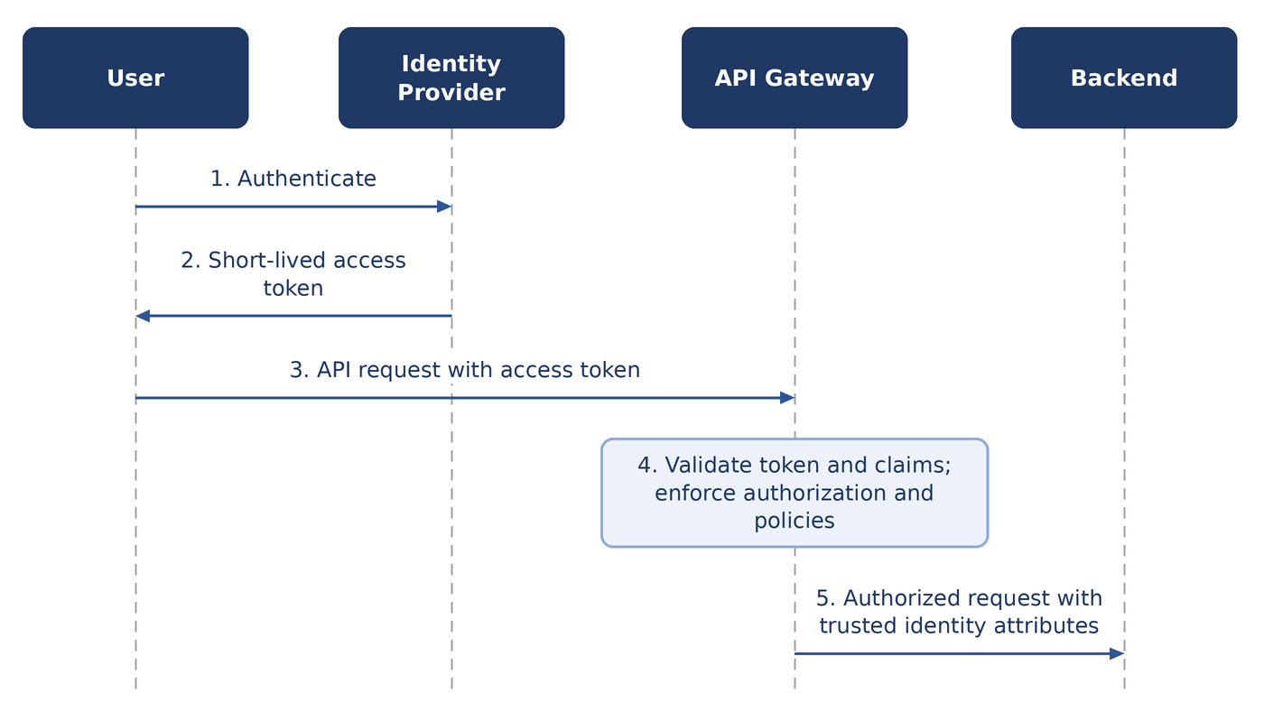
Figure 1 — C2B authentication and access flow

4.3 B2B authentication
B2B represents access where the consumer is another system or application. The architecture avoids repeatedly sending long-lived credentials across the network. It therefore distinguishes between the client identity or credential used to obtain tokens, and the access token used to access APIs.
GW-IAM-008 B2B clients shall use a client credential to obtain a short-lived access token, and then present that access token for API access.
GW-IAM-009 The long-lived client credential shall not be used as the API access credential for every request.
GW-IAM-010 Long-lived credentials shall not be continuously transmitted across the network.
Rationale. This model gives better control over credential exposure, token lifetime, revocation, rotation, auditing and authorization.
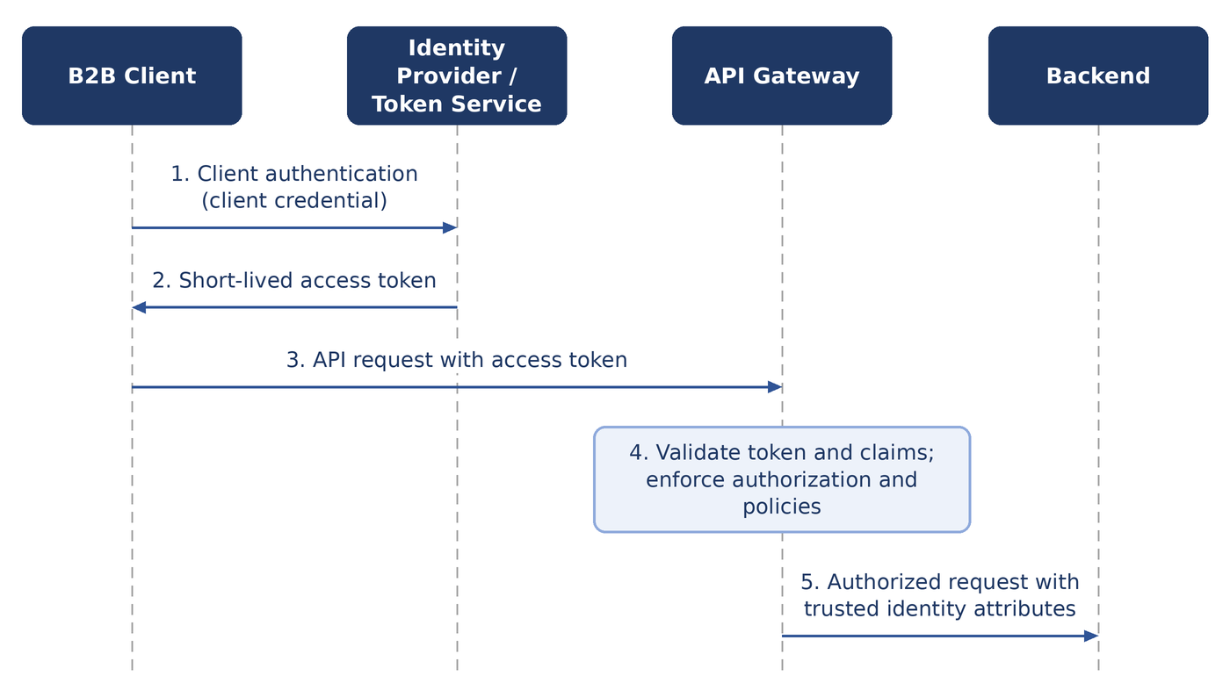
Figure 2 — B2B authentication and access flow

4.4 Authorization
GW-IAM-011 The Gateway shall enforce authorization at the API and operation level.
GW-IAM-012 Gateway authorization decisions may be based on the following:
- Identity
- Groups
- Roles
- Claims
- Scopes
- Policies
- Consumer identity
Table 7 — Example of operation-level authorization
Consumer | Request | Decision
Consumer A | GET /customers | Allowed
Consumer A | DELETE /customers | Denied

GW-IAM-013 The application shall remain responsible for authorization decisions that require business context.
GW-IAM-014 The Gateway shall not implement business authorization logic.
Table 8 — Division of authorization decisions
Component | Question answered
Gateway | Is this consumer allowed to call GET /customers/{id}?
Application | Is this user allowed to access customer #123?

5 Traffic Management

5.1 Routing
GW-TRF-001 The Gateway shall route requests to the appropriate backend.
GW-TRF-002 The Gateway shall support the following methods of routing:
- Path-based routing
- Host-based routing
- API-based routing
- Operation-based routing
- Version routing

5.2 Version routing
GW-TRF-003 The Gateway shall provide the technical capability to route traffic between API versions.
Table 9 — Example of version routing
Request path | Backend
/api/v1/customers | Backend v1
/api/v2/customers | Backend v2

GW-TRF-004 The Application Team shall decide which versions exist, which consumers use each version, and when a version is deprecated and retired.

5.3 Load balancing boundary
GW-TRF-005 The Gateway shall not serve as the organization's general-purpose Load Balancer.
GW-TRF-006 Responsibilities should be divided between the Gateway and load-balancing infrastructure as set out in Table 10.
Table 10 — Division of responsibilities between the Gateway and load balancing
The Gateway handles | Load-balancing infrastructure handles
- API routing  - API-level policies  - API-level health checks  - API-level timeouts | - Distribution between backend instances  - Backend pool management  - Infrastructure-level traffic distribution  - Instance-level availability

GW-TRF-007 The Gateway may integrate with load-balancing infrastructure where appropriate.

5.4 Health checks
GW-TRF-008 The Gateway shall be able to determine whether a backend is available before routing traffic to it.
GW-TRF-009 Gateway health checking shall support the following:
- HTTP health endpoints
- Configurable intervals
- Timeouts
- Failure thresholds
- Recovery thresholds
- Backend-specific configuration
GW-TRF-010 The Gateway shall use the result of health checks to make routing decisions.
GW-TRF-011 The Application Team shall expose an appropriate health endpoint for its backend.
Note. Regular health checks apply to the backends of all API technologies. No protocol-specific health-check mechanism is defined.

5.5 Timeouts
GW-TRF-012 The Gateway shall enforce timeouts at the following levels:
- Connection timeout
- Backend response timeout
- Request timeout
GW-TRF-013 Timeouts should be configurable according to the characteristics of the API.
Rationale. Timeouts protect both the Gateway and backend services from indefinitely hanging requests.

5.6 Retry policy
GW-TRF-014 Automatic retries should not be enabled by default.
Rationale. Retries can create additional load against an already unhealthy backend and may cause unexpected application behavior. By default, when a backend request times out, the Gateway does not send the request again.
GW-TRF-015 Automatic retries may be enabled for a specific use case only when all of the following conditions are met:
- The operation is known to be safe to repeat.
- The backend behavior is understood.
- The retry policy is explicitly defined.
- The additional load is acceptable.
Note. The default position is: Timeout: yes. Automatic retry: no.

5.7 Rate limiting
Rate limiting provides significant protection against accidental overload, excessive consumer usage, misbehaving applications, traffic spikes, resource exhaustion and abuse.
GW-TRF-016 The Gateway shall provide rate limiting as a capability.
GW-TRF-017 Rate limits may be applied based on the following:
- Consumer
- API
- Operation
- Client identity
- Token
- Other relevant attributes
Table 11 — Example of per-API rate limits for one consumer
Consumer | API | Limit
Consumer A | API A | 100 requests per second
Consumer A | API B | 20 requests per second

GW-TRF-018 Rate limiting should be enabled for an API where it can help protect the API or its backend.
Note. Enabling rate limiting is optional. It is not required for every API.

6 API Policy Capabilities

6.1 Transformation
Rationale. Transformation can resolve many integration conflicts without requiring backend changes. For example, a consumer can use a new API format while the Gateway presents the legacy format to the backend.
GW-POL-001 The Gateway shall provide transformation as a capability.
GW-POL-002 The Gateway may perform technical transformations such as the following:
- Header manipulation
- Path rewriting
- Request mapping
- Response mapping
- Protocol-level adaptations
- Version compatibility transformations
GW-POL-003 Transformation should be used for technical compatibility.
GW-POL-004 Transformation shall not be used to implement business logic.

6.2 Caching
GW-POL-005 The Gateway shall provide caching as a capability.
GW-POL-006 Caching should be used where it can help and where it is safe and appropriate.
Note. Enabling caching is optional. It is not required for every API.
GW-POL-007 The caching configuration of an API should take the following into account:
- Cache TTL
- Cache key
- HTTP cache headers
- Authentication context
- Authorization context
- Data sensitivity
- Data freshness
- Cache invalidation
GW-POL-008 Caching shall not cause one consumer to receive data belonging to another consumer.
GW-POL-009 The Gateway shall not become a business-data store.
GW-POL-010 Business-driven cache invalidation shall remain an application responsibility.

6.3 Schema validation
GW-POL-011 The Gateway shall provide schema validation as a capability.
GW-POL-012 The Gateway may validate the following:
- Request structure
- Response structure
- Required fields
- Data types
- Payload size
- API contract compliance
Rationale. Schema validation provides an additional layer of protection for backend services.
GW-POL-013 Schema validation should be enabled for an API where it can help protect its backend.
Note. Enabling schema validation is optional. It is not required for every API.
GW-POL-014 Schema validation should not be used to implement business validation.
Table 12 — Technical validation versus business validation
Component | Example of validation
Gateway (technical) | customer_id must be an integer.
Application (business) | customer_id must belong to the authenticated user.

7 API Contract, Lifecycle and Developer Portal

7.1 API contract
GW-LCY-001 Every API shall have a defined technical contract.
GW-LCY-002 The contract should describe the following:
- Endpoints
- Methods
- Parameters
- Headers
- Request schemas
- Response schemas
- Error responses
- Authentication requirements
- Authorization requirements
- Versions
GW-LCY-003 The contract should be version controlled as part of the API lifecycle.

7.2 API lifecycle
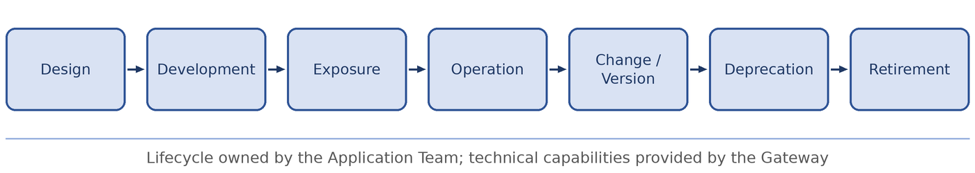
Figure 3 — API lifecycle
GW-LCY-004 The Application Team shall own the API lifecycle.
GW-LCY-005 The Gateway shall provide the technical capabilities required to implement the API lifecycle.

7.3 Deprecation
GW-LCY-006 When an API version is deprecated, the Application Team should do the following:
- Identify the consumers.
- Provide migration guidance.
- Define a retirement date.
- Monitor usage.
- Eventually remove access.

7.4 Consumer lifecycle
GW-LCY-007 The Application Team, as API owner, shall be responsible for the following:
- Adding consumers.
- Removing consumers.
- Changing consumer permissions.
- Reviewing unused consumers.
- Revoking access when it is no longer required.

7.5 Developer Portal
GW-LCY-008 The Platform shall provide a Developer Portal.
GW-LCY-009 The Developer Portal should provide the following:
- API discovery
- API documentation
- API versions
- Authentication requirements
- Authorization requirements
- Usage information
- Access request information
GW-LCY-010 The Developer Portal should give clear instructions on how to obtain authorization to consume an API.
The mechanism for issuing credentials or granting access depends on the organization's implementation and is not inherently a responsibility of the Gateway.
GW-LCY-011 The API owner shall be responsible for the accuracy of the API documentation.

8 Configuration Management

8.1 Git as the source of truth
GW-CFG-001 API configuration shall be synchronized with Git.
GW-CFG-002 Git shall serve as the source of truth for the following:
- API definitions
- Routes
- Policies
- Gateway configuration
- Version configuration
- Consumer configuration: consumer identity, entitlements (APIs and operations) and rate limits
Note. Consumer credentials are never held in Git. See Section 8.3.
GW-CFG-003 Direct manual changes to production Gateway configuration should be avoided.
Rationale. Using Git as the source of truth provides change history, review, auditability, rollback, reproducibility and consistency between environments.

8.2 GitOps
The preferred operating model is GitOps.
GW-CFG-004 Changes to Gateway configuration should follow this sequence:
- Defined in Git.
- Reviewed.
- Validated.
- Approved.
- Deployed automatically.
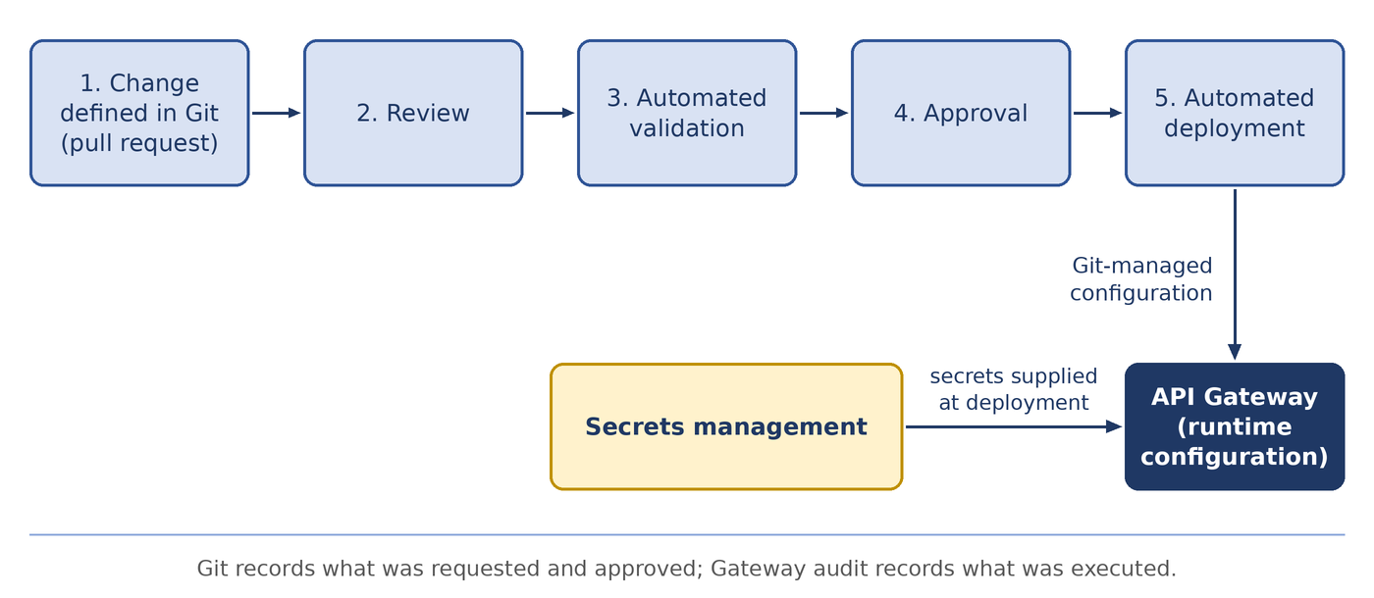
Figure 4 — Configuration change flow
GW-CFG-005 Production shall not depend on undocumented manual configuration.
GW-CFG-006 The deployed state should be reproducible from the repository.

8.3 Secrets
GW-CFG-007 Secrets, including passwords, private keys, API secrets, client secrets and long-lived credentials, shall not be stored in Git.
GW-CFG-008 Secrets shall be stored in a dedicated secrets-management solution.
GW-CFG-009 The deployment process should combine the configuration held in Git with the secrets held in the secrets-management solution to produce the runtime configuration.

9 Observability and Audit

9.1 Runtime logging
GW-OBS-001 The Gateway shall provide centralized observability.
GW-OBS-002 At a minimum, runtime logging shall record the following:
- Consumer identity
- API
- Operation
- Timestamp
- HTTP status
- Request result
- Latency
- Rejection reason
- Rate-limit information where relevant
GW-OBS-003 The Gateway should not log sensitive business payloads by default.
GW-OBS-004 Which information is sensitive should be defined per API by the Application Team.
GW-OBS-005 Observability should integrate with the organization's existing logging and monitoring systems.

9.2 Metrics
GW-OBS-006 The Gateway shall expose metrics for the following:
- Request volume
- Error rate
- Latency
- Backend latency
- Availability
- Rate limiting
- Authentication failures
- Authorization failures
- Backend failures
- Gateway health
GW-OBS-007 Metrics should be available by the following dimensions:
- API
- Operation
- Consumer
- Backend
- Environment

9.3 Audit
GW-OBS-008 Audit logging shall be performed for all administrative and configuration activities.
GW-OBS-009 Audit logs shall record at least the following:
- Who performed the action.
- What was changed.
- When it was changed.
- Which API or configuration was affected.
GW-OBS-010 Audit logs shall be sent to a centralized system outside the direct control of the person performing the operation.
Two complementary sources of evidence exist for each change, as set out in Table 13.
Table 13 — Sources of audit evidence
Source | Evidence provided
Git | What change was requested and approved.
Gateway audit | What was actually changed or executed.

Note. No retention period is defined for runtime logs or audit logs.

10 Availability and Deployment Architecture

10.1 Availability
GW-AVL-001 The Platform shall provide at least 99.9% monthly availability during regular operation.
Availability is measured during regular operation; planned maintenance is excluded from the calculation. This commitment applies to the Gateway platform and does not imply availability of backend applications.
Note. For information: 99.9% availability in a 30-day month allows approximately 43 minutes of unavailability during regular operation.
GW-AVL-002 The Platform shall not contain a single point of failure.
GW-AVL-003 The Platform shall provide the following:
- Multiple Gateway instances
- Failure tolerance
- Controlled upgrades
- Controlled resets
- Rollback capability
- Health-based traffic management

10.2 Controlled reset
GW-AVL-004 Gateway resets and restarts should be performed in a controlled manner.
GW-AVL-005 Maintenance should be performed on a rolling basis.
GW-AVL-006 A planned Gateway reset shall not intentionally prevent new requests from being served when redundant capacity is available.
Note. Existing sessions may be affected during a reset where this is technically unavoidable.

10.3 Distributed deployment
GW-AVL-007 The Gateway should be deployed close to the applications it serves.
GW-AVL-008 Where an application exists in multiple sites, the Gateway shall be available in each relevant site.
GW-AVL-009 A failure or network partition affecting another site shall not prevent local APIs from operating.
Rationale. This reduces dependency on a remote site for local application traffic.

10.4 Centralized management and distributed runtime
GW-AVL-010 The Platform should combine a centralized Management Plane with a distributed Data Plane.
GW-AVL-011 The Management Plane may be centralized.
GW-AVL-012 The Data Plane shall be distributed.
GW-AVL-013 The loss of the Management Plane shall not immediately stop already-configured API traffic.
GW-AVL-014 The Data Plane shall continue to operate indefinitely using its last known valid configuration while the Management Plane is unavailable.
GW-AVL-015 The Management Plane should be restorable within one hour.
Note. New configuration changes may depend on the availability of the Management Plane.
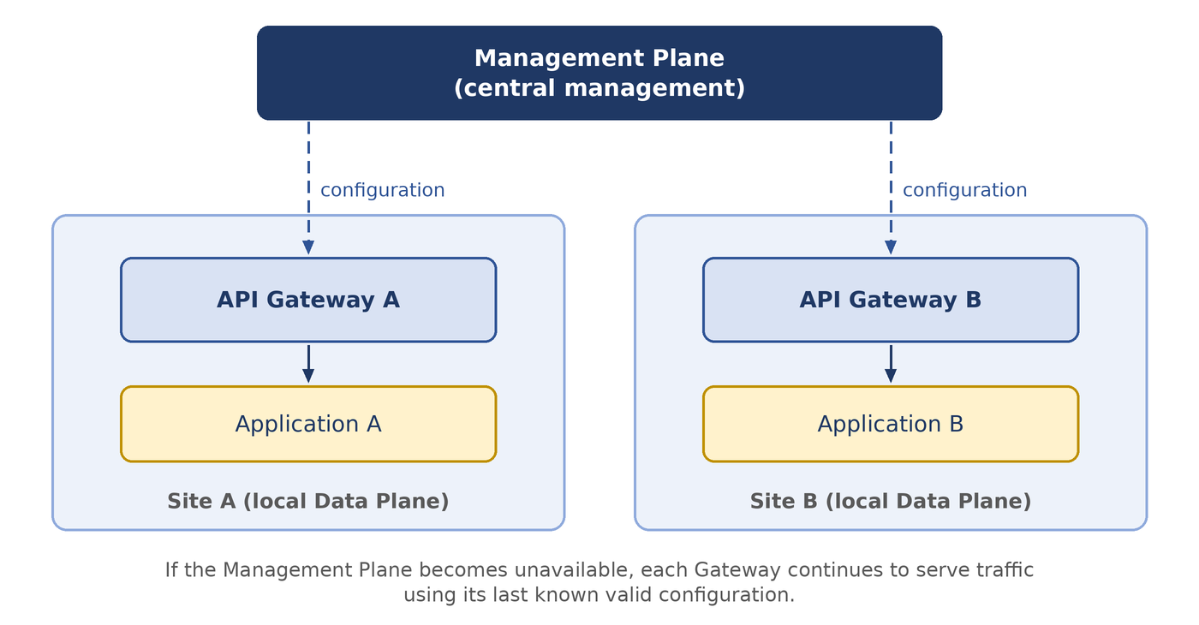
Figure 5 — Centralized management with distributed Data Planes

11 Governance and Exceptions

11.1 Governance model
Governance combines three mechanisms, described in Table 14. The overall principle is:
Enforce what can safely and consistently be enforced; document and guide the rest.
Table 14 — Governance mechanisms
Mechanism | Purpose | Enforcement
Mandatory guardrails | Requirements that can and should be technically enforced. | Technically enforced by the Platform.
Standards | The organization's preferred and consistent way of operating APIs. | Technically enforced where practical.
Guidelines | Decisions that cannot or should not be enforced by technology. | Documented and guided; not enforced.

11.2 Mandatory guardrails
GW-GOV-001 Requirements that are suitable for technical enforcement should be implemented as mandatory Gateway guardrails.
GW-GOV-002 Mandatory guardrails should include the following:
- HTTPS at required boundaries
- Authentication
- Required logging
- Maximum request size
- Mandatory organizational policies
Note. Communication within the cluster, including between the Gateway and backend services, uses HTTP. No minimum TLS version and no maximum request size are defined by this document.

11.3 Standards
GW-GOV-003 Standards should define the organization's preferred and consistent way of operating APIs.
GW-GOV-004 Where practical, standards should be technically enforced.

11.4 Guidelines
Not every architectural or operational decision can or should be enforced by technology.
GW-GOV-005 Decisions that are not suited to technical enforcement should remain guidelines.
Examples of guidelines include:
- Recommended caching
- Recommended timeout values
- Recommended API versioning strategy
- Recommended use of transformation

11.5 Organizational governance
GW-GOV-006 An organizational governance body should define API standards and policies.
GW-GOV-007 The Infrastructure Team should implement the requirements defined by the governance body as Gateway capabilities and guardrails.
GW-GOV-008 Where organizational governance is not yet mature, the Infrastructure Team may temporarily provide governance for the Gateway platform itself.
GW-GOV-009 Interim governance of the Gateway platform shall not make the Infrastructure Team the owner of individual APIs.
Note. An organizational governance body has not yet been defined. Interim governance by the Infrastructure Team therefore applies.

11.6 Exceptions
GW-GOV-010 The Platform should support a controlled exception mechanism.
GW-GOV-011 An exception should have the following:
- A documented reason.
- An identified owner.
- Approval by the Security Managers.
- Risk considerations.
- An expiration or review date where appropriate.
GW-GOV-012 Exceptions should not become an alternative to proper architecture.

12 Platform Boundaries

12.1 Boundary overview
The Gateway is one component of a wider security and infrastructure architecture. Table 15 summarizes the boundary between the Gateway and each adjacent component.
Table 15 — Boundaries between the Gateway and adjacent components
Adjacent component | The Gateway is responsible for | The adjacent component is responsible for
WAF | - Authentication  - Authorization  - Routing  - Rate limiting  - API policies  - Request controls  - Timeouts  - API-level transformations  - API contract validation  - API observability | - Attack signatures  - SQL injection detection  - Cross-site scripting detection  - Malicious payload detection  - Bot protection  - Other application security controls
Load Balancer | - Consumer to API handling  - Authentication and authorization  - Rate limiting and policy  - Routing and transformation  - Observability | - Distribution between backend instances  - Backend pool management
Identity Provider | - Consuming identity  - Validating tokens  - Enforcing API authorization  - Passing trusted identity information downstream | - User authentication  - Client authentication  - Token issuance  - Identity lifecycle
Application | - Infrastructure-level protection | - Business authorization  - Business validation  - Business logic  - Data access control  - Business-level auditing

12.2 Gateway and WAF
GW-BND-001 The Gateway shall not attempt to become a WAF.
GW-BND-002 A WAF may be placed in front of the Gateway when the security architecture requires it.

12.3 Gateway and Load Balancer
GW-BND-003 The Gateway and the organization's Load Balancer may coexist.
GW-BND-004 The boundary between the Gateway and the Load Balancer should be clearly defined, as described in Section 5.3.

12.4 Gateway and Identity Provider
The Gateway does not need to be the organization's Identity Provider.
GW-BND-005 The Gateway shall consume identity and validate the tokens issued by the Identity Provider.
GW-BND-006 The Identity Provider shall remain responsible for user authentication, client authentication, token issuance and identity lifecycle.

12.5 Gateway and application
GW-BND-007 The Gateway shall provide infrastructure-level protection.
GW-BND-008 The application shall remain responsible for business authorization, business validation, business logic, data access control and business-level auditing.
The division of authorization decisions is illustrated in Table 8.

13 Vendor Neutrality

13.1 Principle
GW-VND-001 The Gateway architecture should minimize unnecessary vendor lock-in.
GW-VND-002 The following should remain conceptually independent of any specific product:
- API contracts
- API lifecycle
- Authentication model
- Authorization model
- GitOps workflow
- Governance model
- Observability requirements
- Deployment model

13.2 Vendor-specific capabilities
GW-VND-003 Vendor-specific capabilities may be used when they provide significant value.
GW-VND-004 Vendor-specific capabilities that are used should be identified as implementation-specific.
The goal is not to guarantee zero migration effort. The goal is to ensure that:
The organization's API architecture and policies are not unnecessarily defined by the implementation details of a single Gateway product.

Appendix A — Capability Summary and Requirements Register

A.1 Capability summary
Table 16 summarizes the status of each capability. Required means the Platform shall provide the capability and apply it. Required capability means the Platform shall provide the capability, and the Application Team decides whether to enable it for a given API. Preferred identifies the preferred operating model. The remaining entries identify responsibilities that lie outside the Gateway.
Table 16 — Capability summary
Capability | Status | Specified in
API routing | Required | Section 5.1
Version routing | Required | Section 5.2
Health checks | Required | Section 5.4
Timeouts | Required | Section 5.5
Automatic retry | Not recommended by default | Section 5.6
Authentication | Required | Section 4.1, 4.2, 4.3
Authorization | Required | Section 4.4
Rate limiting | Required capability | Section 5.7
Transformation | Required capability | Section 6.1
Caching | Required capability | Section 6.2
Schema validation | Required capability | Section 6.3
API documentation | Required | Section 7.1, 7.5
Developer Portal | Required | Section 7.5
Git integration | Required | Section 8.1
GitOps | Preferred operating model | Section 8.2
Audit logs | Required | Section 9.3
Runtime logs | Required | Section 9.1
Metrics | Required | Section 9.2
High availability | Required | Section 10.1
Distributed Data Plane | Required | Section 10.3
Centralized management | Preferred | Section 10.4
WAF | Separate component | Section 12.2
Load Balancer | Separate responsibility | Section 5.3, 12.3
Business logic | Application responsibility | Section 2.2, 12.5
Secrets storage | Separate secure system | Section 8.3
Vendor neutrality | Architectural principle | Chapter 13

A.2 Requirements register
The register lists every numbered requirement in this document. It is generated from the requirement text, so it always matches the body of the document.
Table 17 — Requirements by chapter and level
Chapter | Mandatory | Recommended | Optional | Total
1 Introduction | 1 | 2 | 0 | 3
2 Architectural Principles | 5 | 5 | 0 | 10
3 Roles and Responsibilities | 1 | 0 | 0 | 1
4 Identity, Authentication and Authorization | 11 | 1 | 2 | 14
5 Traffic Management | 11 | 4 | 3 | 18
6 API Policy Capabilities | 7 | 5 | 2 | 14
7 API Contract, Lifecycle and Developer Portal | 6 | 5 | 0 | 11
8 Configuration Management | 5 | 4 | 0 | 9
9 Observability and Audit | 6 | 4 | 0 | 10
10 Availability and Deployment Architecture | 9 | 5 | 1 | 15
11 Governance and Exceptions | 1 | 10 | 1 | 12
12 Platform Boundaries | 5 | 1 | 2 | 8
13 Vendor Neutrality | 0 | 3 | 1 | 4
Total | 68 | 49 | 12 | 129

Table 18 — Requirements register
ID | Section | Level
GW-INT-001 | 1.2 Scope | Mandatory
GW-INT-002 | 1.2 Scope | Recommended
GW-INT-003 | 1.2 Scope | Recommended
GW-PRN-001 | 2.1 Central API entry point | Mandatory
GW-PRN-002 | 2.1 Central API entry point | Mandatory
GW-PRN-003 | 2.2 Infrastructure, not business logic | Mandatory
GW-PRN-004 | 2.2 Infrastructure, not business logic | Recommended
GW-PRN-005 | 2.3 Ownership | Mandatory
GW-PRN-006 | 2.3 Ownership | Mandatory
GW-PRN-007 | 2.3 Ownership | Recommended
GW-PRN-008 | 2.4 Self-service with guardrails | Recommended
GW-PRN-009 | 2.4 Self-service with guardrails | Recommended
GW-PRN-010 | 2.4 Self-service with guardrails | Recommended
GW-ROL-001 | 3.2 Responsibility matrix | Mandatory
GW-IAM-001 | 4.1 Consumer categories | Recommended
GW-IAM-002 | 4.1 Consumer categories | Mandatory
GW-IAM-003 | 4.1 Consumer categories | Mandatory
GW-IAM-004 | 4.2 C2B authentication | Mandatory
GW-IAM-005 | 4.2 C2B authentication | Mandatory
GW-IAM-006 | 4.2 C2B authentication | Mandatory
GW-IAM-007 | 4.2 C2B authentication | Optional
GW-IAM-008 | 4.3 B2B authentication | Mandatory
GW-IAM-009 | 4.3 B2B authentication | Mandatory
GW-IAM-010 | 4.3 B2B authentication | Mandatory
GW-IAM-011 | 4.4 Authorization | Mandatory
GW-IAM-012 | 4.4 Authorization | Optional
GW-IAM-013 | 4.4 Authorization | Mandatory
GW-IAM-014 | 4.4 Authorization | Mandatory
GW-TRF-001 | 5.1 Routing | Mandatory
GW-TRF-002 | 5.1 Routing | Mandatory
GW-TRF-003 | 5.2 Version routing | Mandatory
GW-TRF-004 | 5.2 Version routing | Mandatory
GW-TRF-005 | 5.3 Load balancing boundary | Mandatory
GW-TRF-006 | 5.3 Load balancing boundary | Recommended
GW-TRF-007 | 5.3 Load balancing boundary | Optional
GW-TRF-008 | 5.4 Health checks | Mandatory
GW-TRF-009 | 5.4 Health checks | Mandatory
GW-TRF-010 | 5.4 Health checks | Mandatory
GW-TRF-011 | 5.4 Health checks | Mandatory
GW-TRF-012 | 5.5 Timeouts | Mandatory
GW-TRF-013 | 5.5 Timeouts | Recommended
GW-TRF-014 | 5.6 Retry policy | Recommended
GW-TRF-015 | 5.6 Retry policy | Optional
GW-TRF-016 | 5.7 Rate limiting | Mandatory
GW-TRF-017 | 5.7 Rate limiting | Optional
GW-TRF-018 | 5.7 Rate limiting | Recommended
GW-POL-001 | 6.1 Transformation | Mandatory
GW-POL-002 | 6.1 Transformation | Optional
GW-POL-003 | 6.1 Transformation | Recommended
GW-POL-004 | 6.1 Transformation | Mandatory
GW-POL-005 | 6.2 Caching | Mandatory
GW-POL-006 | 6.2 Caching | Recommended
GW-POL-007 | 6.2 Caching | Recommended
GW-POL-008 | 6.2 Caching | Mandatory
GW-POL-009 | 6.2 Caching | Mandatory
GW-POL-010 | 6.2 Caching | Mandatory
GW-POL-011 | 6.3 Schema validation | Mandatory
GW-POL-012 | 6.3 Schema validation | Optional
GW-POL-013 | 6.3 Schema validation | Recommended
GW-POL-014 | 6.3 Schema validation | Recommended
GW-LCY-001 | 7.1 API contract | Mandatory
GW-LCY-002 | 7.1 API contract | Recommended
GW-LCY-003 | 7.1 API contract | Recommended
GW-LCY-004 | 7.2 API lifecycle | Mandatory
GW-LCY-005 | 7.2 API lifecycle | Mandatory
GW-LCY-006 | 7.3 Deprecation | Recommended
GW-LCY-007 | 7.4 Consumer lifecycle | Mandatory
GW-LCY-008 | 7.5 Developer Portal | Mandatory
GW-LCY-009 | 7.5 Developer Portal | Recommended
GW-LCY-010 | 7.5 Developer Portal | Recommended
GW-LCY-011 | 7.5 Developer Portal | Mandatory
GW-CFG-001 | 8.1 Git as the source of truth | Mandatory
GW-CFG-002 | 8.1 Git as the source of truth | Mandatory
GW-CFG-003 | 8.1 Git as the source of truth | Recommended
GW-CFG-004 | 8.2 GitOps | Recommended
GW-CFG-005 | 8.2 GitOps | Mandatory
GW-CFG-006 | 8.2 GitOps | Recommended
GW-CFG-007 | 8.3 Secrets | Mandatory
GW-CFG-008 | 8.3 Secrets | Mandatory
GW-CFG-009 | 8.3 Secrets | Recommended
GW-OBS-001 | 9.1 Runtime logging | Mandatory
GW-OBS-002 | 9.1 Runtime logging | Mandatory
GW-OBS-003 | 9.1 Runtime logging | Recommended
GW-OBS-004 | 9.1 Runtime logging | Recommended
GW-OBS-005 | 9.1 Runtime logging | Recommended
GW-OBS-006 | 9.2 Metrics | Mandatory
GW-OBS-007 | 9.2 Metrics | Recommended
GW-OBS-008 | 9.3 Audit | Mandatory
GW-OBS-009 | 9.3 Audit | Mandatory
GW-OBS-010 | 9.3 Audit | Mandatory
GW-AVL-001 | 10.1 Availability | Mandatory
GW-AVL-002 | 10.1 Availability | Mandatory
GW-AVL-003 | 10.1 Availability | Mandatory
GW-AVL-004 | 10.2 Controlled reset | Recommended
GW-AVL-005 | 10.2 Controlled reset | Recommended
GW-AVL-006 | 10.2 Controlled reset | Mandatory
GW-AVL-007 | 10.3 Distributed deployment | Recommended
GW-AVL-008 | 10.3 Distributed deployment | Mandatory
GW-AVL-009 | 10.3 Distributed deployment | Mandatory
GW-AVL-010 | 10.4 Centralized management and distributed runtime | Recommended
GW-AVL-011 | 10.4 Centralized management and distributed runtime | Optional
GW-AVL-012 | 10.4 Centralized management and distributed runtime | Mandatory
GW-AVL-013 | 10.4 Centralized management and distributed runtime | Mandatory
GW-AVL-014 | 10.4 Centralized management and distributed runtime | Mandatory
GW-AVL-015 | 10.4 Centralized management and distributed runtime | Recommended
GW-GOV-001 | 11.2 Mandatory guardrails | Recommended
GW-GOV-002 | 11.2 Mandatory guardrails | Recommended
GW-GOV-003 | 11.3 Standards | Recommended
GW-GOV-004 | 11.3 Standards | Recommended
GW-GOV-005 | 11.4 Guidelines | Recommended
GW-GOV-006 | 11.5 Organizational governance | Recommended
GW-GOV-007 | 11.5 Organizational governance | Recommended
GW-GOV-008 | 11.5 Organizational governance | Optional
GW-GOV-009 | 11.5 Organizational governance | Mandatory
GW-GOV-010 | 11.6 Exceptions | Recommended
GW-GOV-011 | 11.6 Exceptions | Recommended
GW-GOV-012 | 11.6 Exceptions | Recommended
GW-BND-001 | 12.2 Gateway and WAF | Mandatory
GW-BND-002 | 12.2 Gateway and WAF | Optional
GW-BND-003 | 12.3 Gateway and Load Balancer | Optional
GW-BND-004 | 12.3 Gateway and Load Balancer | Recommended
GW-BND-005 | 12.4 Gateway and Identity Provider | Mandatory
GW-BND-006 | 12.4 Gateway and Identity Provider | Mandatory
GW-BND-007 | 12.5 Gateway and application | Mandatory
GW-BND-008 | 12.5 Gateway and application | Mandatory
GW-VND-001 | 13.1 Principle | Recommended
GW-VND-002 | 13.1 Principle | Recommended
GW-VND-003 | 13.2 Vendor-specific capabilities | Optional
GW-VND-004 | 13.2 Vendor-specific capabilities | Recommended

Appendix B — Operating Model
Figure 6 summarizes the operating model. Application Teams operate their APIs through the Platform by defining them in Git. The Infrastructure Team owns the Platform, which combines central management with a distributed Data Plane and enforces the capabilities described in this document. Organizational governance defines the standards that the Platform implements as guardrails.
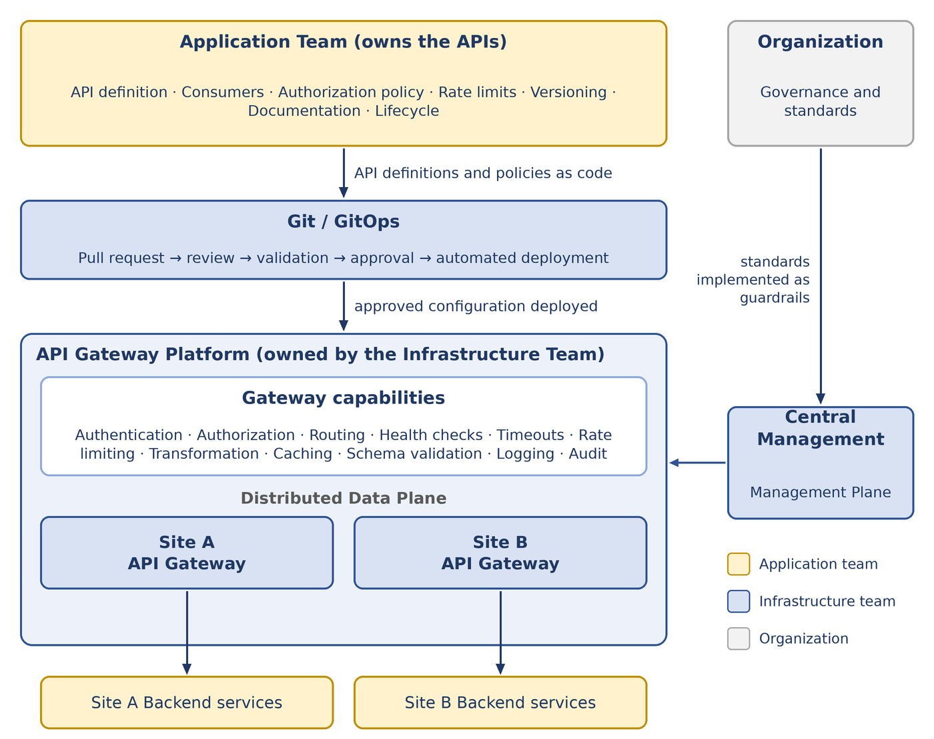
Figure 6 — API Gateway operating model

Appendix C — Open Issues and Decisions Pending
The following items are not defined in this version of the document. They are recorded here so that they are resolved deliberately rather than by default.
Table 19 — Open issues
ID | Topic | Decision or information required | Related
OI-01 | Governance body | Define the organizational governance body, including its owner and mandate. Until then the Infrastructure Team provides interim governance for the Platform, and the Security Managers approve exceptions. | Section 11.5, 11.6

