[Organization Name]
API Gateway Enterprise Architecture Standard
Architecture and Operating Model
Version | 1.3
Status | Draft
Date | 22 September 2026
Document ID | [Document ID]
Classification | [Classification]

Document Control
Document title | API Gateway Enterprise Architecture Standard
Document ID | [Document ID]
Version | 1.3
Status | Draft
Classification | [Classification]
Document owner | [Document owner, Infrastructure Team]
Author | [Author]
Effective date | [Effective date]
Review cycle | [Review cycle, e.g. annual]
Next review date | [Next review date]
Revision History
Version | Date | Author | Description
1.3 | 2026-09-22 | [Author] | Draft. Table 6 (Section 12.1) lists only the responsibilities of the adjacent component; the column for the Gateway's own responsibilities is removed.
1.2 | 2026-09-21 | [Author] | Draft. Rewritten as continuous prose: numbered requirements and the requirements register removed; obligations expressed in plain must / should / can wording.
1.1 | 2026-09-21 | [Author] | Draft. Settles three open issues (all three optional capabilities stay optional per API; consumer configuration in Git defined; Security Managers approve exceptions) and makes the security core mandatory.
1.0 | 2026-09-21 | [Author] | First issue (draft). Converted from the architecture and operating-model notes (README.md); review decisions recorded.
Approval
Role | Name | Signature | Date
[Role] | [Name]
[Role] | [Name]
[Role] | [Name]

Contents
1 Introduction
1.1 Purpose
1.2 Scope
1.3 Audience
1.4 How to read this document
1.5 Definitions and abbreviations
1.6 References
2 Architectural Principles
2.1 Central API entry point
2.2 Infrastructure, not business logic
2.3 Ownership
2.4 Self-service with guardrails
2.5 Summary of principles
3 Roles and Responsibilities
3.1 Roles
3.2 Responsibility matrix
4 Identity, Authentication and Authorization
4.1 Consumer categories
4.2 C2B authentication
4.3 B2B authentication
4.4 Authorization
5 Traffic Management
5.1 Routing
5.2 Version routing
5.3 Load balancing boundary
5.4 Health checks
5.5 Timeouts
5.6 Retry policy
5.7 Rate limiting
6 API Policy Capabilities
6.1 Transformation
6.2 Caching
6.3 Schema validation
7 API Contract, Lifecycle and Developer Portal
7.1 API contract
7.2 API lifecycle
7.3 Deprecation
7.4 Consumer lifecycle
7.5 Developer Portal
8 Configuration Management
8.1 Git as the source of truth
8.2 GitOps
8.3 Secrets
9 Observability and Audit
9.1 Runtime logging
9.2 Metrics
9.3 Audit
10 Availability and Deployment Architecture
10.1 Availability
10.2 Controlled reset
10.3 Distributed deployment
10.4 Centralized management and distributed runtime
11 Governance and Exceptions
11.1 Governance model
11.2 Mandatory guardrails
11.3 Standards
11.4 Guidelines
11.5 Organizational governance
11.6 Exceptions
12 Platform Boundaries
12.1 Boundary overview
12.2 Gateway and WAF
12.3 Gateway and Load Balancer
12.4 Gateway and Identity Provider
12.5 Gateway and application
13 Vendor Neutrality
13.1 Principle
13.2 Vendor-specific capabilities
Appendix A — Capability Summary
Appendix B — Operating Model
Appendix C — Open Issues
List of Figures
Figure 1 — C2B authentication and access flow
Figure 2 — B2B authentication and access flow
Figure 3 — API lifecycle
Figure 4 — Configuration change flow
Figure 5 — Centralized management with distributed Data Planes
Figure 6 — API Gateway operating model
List of Tables
Table 1 — Definitions and abbreviations
Table 2 — Summary of architectural principles
Table 3 — Roles
Table 4 — Responsibility matrix
Table 5 — Consumer categories
Table 6 — Boundaries between the Gateway and adjacent components
Table 7 — Capability summary

1 Introduction

1.1 Purpose
This document sets out the enterprise architecture and operating model of the API Gateway platform of [Organization Name]. It is the reference for the design and operation of the platform, for the application teams that expose APIs through it, and for the security, risk, audit and governance functions that oversee it.
The API Gateway is an enterprise infrastructure layer positioned between API consumers and backend services. It gives the organization a consistent, secure, observable and governed entry point for web traffic, and it allows application teams to manage their own APIs independently, within organizational guardrails. The API Gateway is not a business-logic layer. The principle behind the whole document is a division of ownership:
Application teams own their APIs and business policies. The infrastructure team owns the platform, its capabilities, and the technical guardrails around it.

1.2 Scope
The Gateway handles web traffic to backend services. The scope is deliberately defined as web traffic, not as a fixed list of protocols, so that the architecture is not coupled to any one application protocol. The platform is intended to support HTTP/HTTPS, GraphQL, gRPC and MCP, together with other web-based API technologies. WebSocket and streaming traffic, service-to-service (east-west) traffic, multi-tenant use of the platform and non-production environments are also within scope. SOAP is outside the scope of this document.
The following adjacent systems are outside the scope of this document, except for the boundaries described in Chapter 12: the Web Application Firewall (WAF), the organization's Load Balancer, the Identity Provider, the secrets-management solution, and the business logic of individual applications.

1.3 Audience
The document is written for the Infrastructure Team, which owns and operates the platform; for the Application Teams that design, expose and operate APIs through it; for information-security, risk and audit stakeholders; and for enterprise-architecture and governance bodies.

1.4 How to read this document
The document is written as continuous text. Where it says that something must or must not be done, the rule is mandatory. Where it says that something should be done, or is recommended, it describes expected practice from which a team can depart for a good reason, provided it understands the consequences. Where it says that something can or may be done, it is optional. Statements that describe what the Gateway or a team does, for example that the Gateway validates the access token, set out how the platform is required to operate. The words are used in the sense of BCP 14 (RFC 2119 and RFC 8174).
Capability and enablement. Where this document says that the platform provides a capability, for example rate limiting, caching or schema validation, the capability must be available. Unless the text says otherwise, whether it is enabled for a specific API is decided by the Application Team according to the needs of that API.

1.5 Definitions and abbreviations
Table 1 — Definitions and abbreviations
Term | Definition
Access token | A short-lived credential issued by the Identity Provider that a consumer presents to access an API.
API Gateway (Gateway) | The infrastructure layer between API consumers and backend services at which access, security and operational policies for API traffic are enforced.
API Platform (Platform) | The complete capability operated by the Infrastructure Team: the Gateway Data Plane, the Management Plane, GitOps integration and the Developer Portal.
Application Team | The team that owns an API, its contract and its business logic.
B2B | Business to Business: access where the consumer is another system or application.
C2B | Consumer to Business: access where the consumer is a human user.
Client credential | A long-lived credential that a B2B client uses to obtain access tokens.
Consumer | A user or system that calls an API through the Gateway.
Data Plane | The Gateway runtime instances that process API traffic.
Developer Portal | The portal through which APIs are discovered, documented and access to them is requested.
GitOps | An operating model in which configuration is defined in Git and changes are reviewed, validated, approved and deployed automatically.
Guardrail | An organizational requirement that is technically enforced by the Platform.
Guideline | Recommended practice that is documented but not technically enforced.
IdP | Identity Provider: the organization's system that authenticates users and clients and issues tokens.
Infrastructure Team | The team that owns and operates the Platform.
Load Balancer | Infrastructure that distributes traffic between instances of a backend.
Management Plane | The management layer used to configure and manage Gateways; also referred to as the control plane or central management.
Security Managers | The team [team name] designated by the organization to approve exceptions to this document.
Site | A location or environment in which applications run and in which a Gateway can be deployed.
Source of truth | The single authoritative location from which the deployed state is derived.
Standard | The organization's defined, consistent way of operating APIs.
TTL | Time to live: the period for which a cached item is considered valid.
WAF | Web Application Firewall: a control that protects applications against application-layer attacks.

1.6 References
- BCP 14: RFC 2119, Key words for use in RFCs to Indicate Requirement Levels, and RFC 8174, Ambiguity of Uppercase vs Lowercase in RFC 2119 Key Words.
- [Organizational information-security policy]
- [Organizational API governance standards, when issued]

2 Architectural Principles
This chapter states the principles on which the rest of the document rests.

2.1 Central API entry point
APIs that are exposed for consumption outside their immediate service boundary must be exposed through the API Gateway. Exposing such an API directly, so that consumers can bypass the organization's authentication, authorization, rate-limiting, logging and security controls, is not permitted. The Gateway is therefore the consistent enforcement point for API access.

2.2 Infrastructure, not business logic
The Gateway is infrastructure, not business logic, and it does not implement application business logic. The platform is intended to let Application Teams expose and manage APIs without requiring the Infrastructure Team to understand or implement the business logic of any application.

2.3 Ownership
Application Teams own the APIs they expose through the Gateway. Ownership covers the design and contract of the API, its business semantics, its consumers, the access and authorization requirements that apply to it, versioning, deprecation and retirement, documentation, and the consumer lifecycle. The Infrastructure Team owns the Gateway platform, its capabilities and the technical guardrails around it. The Infrastructure Team should not become the owner of an API merely because that API is implemented through the Gateway.

2.4 Self-service with guardrails
The preferred operating model is self-service with guardrails. Within organizational guardrails, Application Teams should be able to create APIs, configure routes and backend mappings, configure authentication requirements and authorization policies, set rate limits, configure transformations, configure caching where appropriate, manage API versions and consumers, and manage the API lifecycle themselves. The Infrastructure Team provides the platform and, where it is technically appropriate, enforces organizational requirements. Not every organizational guideline needs to become a hard technical restriction; Chapter 11 explains how the different kinds of rule are handled.

2.5 Summary of principles
The principles are summarized in Table 2, with the place where each is developed.
Table 2 — Summary of architectural principles
# | Principle | Developed in
1 | The Gateway is the central enforcement point for APIs exposed beyond their service boundary. | Section 2.1
2 | The Gateway is infrastructure, not business logic. | Section 2.2
3 | Application Teams own their APIs; the Infrastructure Team owns the Platform. | Section 2.3
4 | Self-service is provided within organizational guardrails. | Section 2.4
5 | C2B access uses short-lived access tokens issued by the organizational IdP. | Section 4.2
6 | B2B access separates the client credential used to obtain tokens from the access token used to reach APIs; long-lived credentials are not transmitted with every request. | Section 4.3
7 | Routing, version routing and health checks belong in the Gateway; load balancing between backend instances remains a separate responsibility. | Section 5.1, 5.3, 5.4
8 | Timeouts are required; automatic retries are not enabled by default. | Section 5.5, 5.6
9 | Rate limiting protects services and enforces consumption policies. | Section 5.7
10 | Transformation, caching and schema validation are available capabilities, enabled where appropriate and never used to implement business logic. | Chapter 6
11 | WAF functionality remains separate from the Gateway. | Section 12.2
12 | Git is the source of truth for API configuration; production changes follow a controlled GitOps process; secrets are never stored in Git. | Chapter 8
13 | Audit logging is mandatory for administrative and configuration changes. | Section 9.3
14 | The Platform provides at least 99.9% monthly availability. | Section 10.1
15 | Gateways are deployed at the sites where applications run; centralized management is combined with a distributed runtime, and loss of the Management Plane does not immediately stop configured API traffic. | Section 10.3, 10.4
16 | Governance combines enforceable guardrails with standards and guidelines. | Chapter 11
17 | The architecture remains as vendor agnostic as reasonably possible. | Chapter 13

The overall objective is to provide a secure, highly available, observable, governed and self-service API platform while keeping the ownership boundary clear:
The infrastructure team provides and protects the road. The application team owns where the road goes and what happens at the destination.

3 Roles and Responsibilities

3.1 Roles
Four roles appear throughout the document, and Table 3 describes them.
Table 3 — Roles
Role | Description
Application Team | Owns an API and its business logic; defines requirements for access, authorization, routing and rate limits; manages consumers and the API lifecycle.
Infrastructure Team | Owns and operates the Platform; provides the capabilities and guardrails through which Application Teams manage their APIs.
Governance body | Defines API standards and policies for the organization (see Section 11.5).
Security Managers | Approve exceptions to this document (see Section 11.6).

3.2 Responsibility matrix
Table 4 sets out how responsibilities are allocated between Application Teams and the Infrastructure Team.
Table 4 — Responsibility matrix
Area | Application Team | Infrastructure Team
API design | Owns | Provides platform support
API contract | Owns | Provides platform capability
Business logic | Owns | Not responsible
Consumers | Owns | Provides platform capability
Authorization policy | Defines the requirement | Provides enforcement
Authentication platform | Consumes | Provides
Routing | Defines the destination | Provides the capability
Rate limiting | Defines the requirement | Provides the capability
Health checks | Defines the appropriate endpoint and behavior | Provides the capability
Gateway platform | Consumes | Owns
Availability of the Gateway | — | Owns
GitOps platform | Consumes | Provides
Logging platform | Consumes | Provides
Audit | Participates | Owns the platform
WAF | Separate capability | Separate responsibility
Load balancing | Application and platform architecture | Provides Gateway integration

4 Identity, Authentication and Authorization

4.1 Consumer categories
The Gateway distinguishes between two primary categories of consumer, described in Table 5. The categories describe the consumer and its identity model, not a specific product.
Table 5 — Consumer categories
Category | Consumer | Identity model
C2B (Consumer to Business) | A human user | Authenticates through the organization's IdP and receives a short-lived access token.
B2B (Business to Business) | Another system or application | Uses a client credential to obtain a short-lived access token from the IdP or token service.

The Gateway authenticates the consumers of the APIs it exposes, and APIs without consumer authentication are not permitted.
Note. The lifetime of access tokens is defined by the owner of the Identity Provider and is outside the scope of this document.

4.2 C2B authentication
C2B represents access where the consumer is a human user. C2B users must authenticate through the organization's Identity Provider (IdP) and must use the short-lived access tokens that it issues. The Gateway validates the identity and the relevant claims presented with each request. It can pass trusted identity information on to the application, such as the user ID, groups, roles, claims, scopes and other organizational identity attributes. Figure 1 shows the flow.
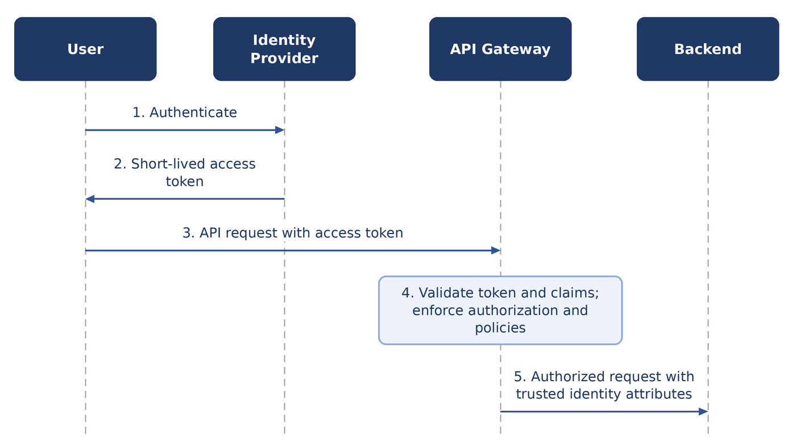
Figure 1 — C2B authentication and access flow

4.3 B2B authentication
B2B represents access where the consumer is another system or application. To avoid sending long-lived credentials across the network again and again, the architecture separates two things: the client credential, which a B2B client uses only to obtain a token, and the short-lived access token, which it presents to reach APIs. A B2B client must use its client credential to obtain a short-lived access token from the Identity Provider or token service, and must present that token, not the long-lived credential, when it calls an API. Long-lived credentials must not be transmitted with every request. This gives better control over credential exposure, token lifetime, revocation, rotation, auditing and authorization. Figure 2 shows the flow.
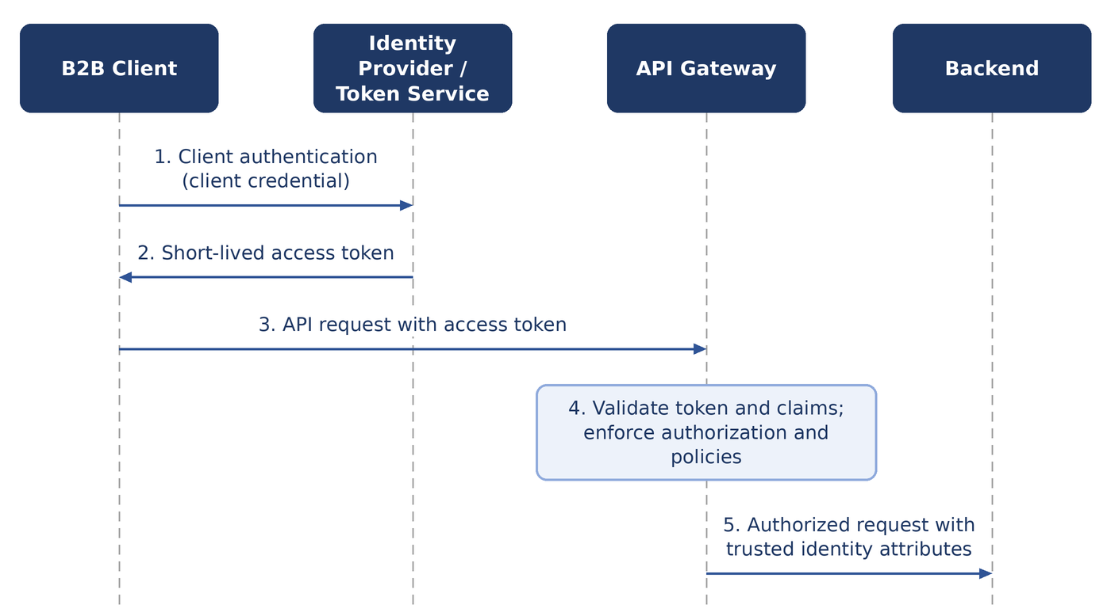
Figure 2 — B2B authentication and access flow

4.4 Authorization
The Gateway enforces authorization at the API and operation level. For example, a consumer can be allowed to call GET /customers and denied DELETE /customers. Gateway authorization decisions can be based on identity, groups, roles, claims, scopes, policies and consumer identity.
The application remains responsible for authorization decisions that require business context, and the Gateway does not implement business authorization logic. The two questions differ: the Gateway asks whether this consumer is allowed to call GET /customers/{id}, while the application asks whether this user is allowed to access customer #123.

5 Traffic Management

5.1 Routing
The Gateway routes each request to the appropriate backend. It supports path-based, host-based, API-based, operation-based and version routing.

5.2 Version routing
Routing between API versions is an important Gateway capability, and the Gateway provides the technical means to do it. For example, requests to /api/v1/customers can be routed to one backend and requests to /api/v2/customers to another. The decisions about versions stay with the Application Team, which decides which versions exist, which consumers use each one, and when a version is deprecated and retired.

5.3 Load balancing boundary
The Gateway is not the organization's general-purpose Load Balancer and must not be used as one. The Gateway handles API routing, API-level policies, API-level health checks and API-level timeouts. A dedicated Load Balancer, or the application infrastructure, handles the distribution of traffic between backend instances, backend pool management, infrastructure-level traffic distribution and instance-level availability. The Gateway can integrate with load-balancing infrastructure where appropriate.

5.4 Health checks
The Gateway must be able to determine whether a backend is available before it routes traffic to it. It does this with regular health checks, which apply to the backends of all API technologies; no protocol-specific mechanism is defined. Health checking supports HTTP health endpoints, configurable intervals and timeouts, failure and recovery thresholds, and backend-specific configuration. The Application Team is responsible for exposing an appropriate health endpoint for its backend, and the Gateway uses the result to make its routing decisions.

5.5 Timeouts
Timeouts are a required Gateway capability. The Gateway enforces a connection timeout, a backend response timeout and a request timeout, which protects both the Gateway and the backend services from requests that hang indefinitely. Timeouts should be configurable according to the characteristics of each API.

5.6 Retry policy
Automatic retries should not be enabled by default. A retry can add load to a backend that is already unhealthy and can cause unexpected application behavior, so when a backend request times out the Gateway does not send it again. A retry can be enabled for a specific use case, but only when the operation is known to be safe to repeat, the behavior of the backend is understood, the retry policy is explicitly defined, and the additional load is acceptable.
Note. The default position is: Timeout: yes. Automatic retry: no.

5.7 Rate limiting
Rate limiting protects against accidental overload, excessive consumer usage, misbehaving applications, traffic spikes, resource exhaustion and abuse. The Gateway provides it as a capability. Limits can be applied per consumer, API, operation, client identity, token or other relevant attribute; for example, one consumer can be allowed 100 requests per second on one API and 20 on another. Rate limiting is optional for each API and is not required for every API, but it is recommended where it can help protect the API or its backend.

6 API Policy Capabilities

6.1 Transformation
Transformation is a valuable Gateway capability because it can resolve many integration conflicts without changes to the backend. For example, a consumer can use a new API format while the Gateway presents the legacy format to the backend. The Gateway provides transformation as a capability and can perform technical transformations such as header manipulation, path rewriting, request and response mapping, protocol-level adaptations and version-compatibility transformations. Transformation is for technical compatibility; it must not be used to implement business logic.

6.2 Caching
The Gateway provides caching as a capability. Caching is optional for each API, and it is recommended where it can help and where it is safe and appropriate. The cache configuration of an API should take into account the cache TTL and key, HTTP cache headers, the authentication and authorization context, data sensitivity, data freshness and invalidation. Caching must never cause one consumer to receive data that belongs to another. The Gateway does not act as a business-data store, and business-driven cache invalidation remains an application responsibility.

6.3 Schema validation
The Gateway provides schema validation as a capability. It can validate request and response structure, required fields, data types, payload size and compliance with the API contract, and so gives backend services an additional layer of protection. Schema validation is optional for each API and is recommended where it can help protect the backend. It should not be used to implement business validation: the Gateway can check that customer_id is an integer, but only the application can check that customer_id belongs to the authenticated user.

7 API Contract, Lifecycle and Developer Portal

7.1 API contract
Every API must have a defined technical contract, and the contract should be version controlled as part of the API lifecycle. It should describe the endpoints, methods, parameters, headers, request and response schemas, error responses, authentication and authorization requirements, and versions.

7.2 API lifecycle
The API lifecycle runs from design through development, exposure and operation, and then change or versioning, deprecation and retirement, as shown in Figure 3. The Application Team owns the lifecycle. The Gateway provides the technical capabilities needed to carry it out.
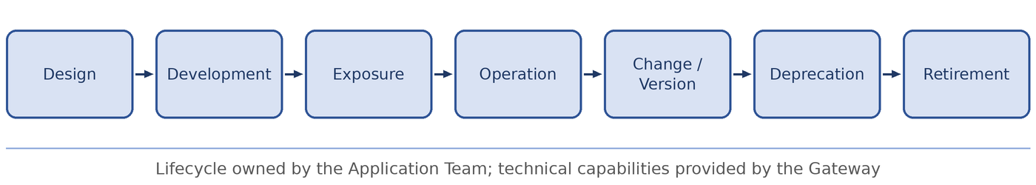
Figure 3 — API lifecycle

7.3 Deprecation
When an API version is deprecated, the Application Team should identify its consumers, provide migration guidance, define a retirement date and monitor usage, and should eventually remove access to it.

7.4 Consumer lifecycle
The Application Team, as API owner, is responsible for adding and removing consumers, changing their permissions, reviewing consumers that are no longer used, and revoking access when it is no longer required.

7.5 Developer Portal
The Platform provides a Developer Portal. The portal should offer API discovery, documentation, versions, authentication and authorization requirements, usage information and access-request information, and it should give clear instructions on how to obtain authorization to consume an API. How credentials are issued or access is granted depends on the organization's implementation and is not inherently a responsibility of the Gateway. The API owner is responsible for the accuracy of the API documentation.

8 Configuration Management

8.1 Git as the source of truth
API configuration is synchronized with Git, and Git is the source of truth for API definitions, routes, policies, Gateway configuration, version configuration and consumer configuration. Consumer configuration means the consumer's identity, its entitlements (the APIs and operations it can use) and its rate limits. Consumer credentials are never held in Git; see Section 8.3. Direct manual changes to production Gateway configuration should be avoided. Working from Git provides change history, review, auditability, rollback, reproducibility and consistency between environments.

8.2 GitOps
The preferred operating model is GitOps. A change is defined in Git, reviewed, validated, approved and deployed automatically, as shown in Figure 4. Production must not depend on undocumented manual configuration, and the deployed state should be reproducible from the repository.
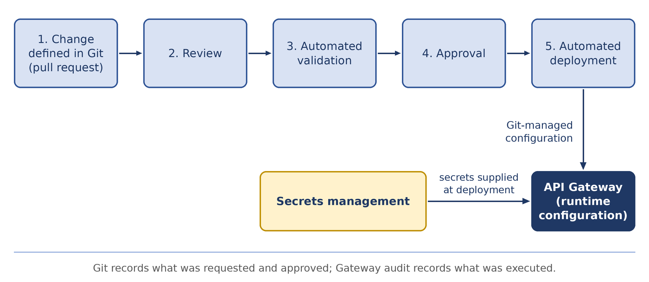
Figure 4 — Configuration change flow

8.3 Secrets
Secrets, including passwords, private keys, API secrets, client secrets and long-lived credentials, must not be stored in Git. They are held in a dedicated secrets-management solution, and the deployment process should combine the configuration in Git with the secrets in that solution to produce the runtime configuration.

9 Observability and Audit

9.1 Runtime logging
The Gateway provides centralized observability. As a minimum, runtime logs record the consumer identity, the API and operation, the timestamp, the HTTP status, the result of the request, the latency, the reason for any rejection and, where relevant, rate-limit information. The Gateway should not log sensitive business payloads by default. Which information is sensitive is defined per API by the Application Team, and the payloads of an API that involves sensitive information should not be logged. Observability should integrate with the organization's existing logging and monitoring systems.

9.2 Metrics
The Gateway exposes metrics for request volume, error rate, latency, backend latency, availability, rate limiting, authentication failures, authorization failures, backend failures and Gateway health. Metrics should be available by API, operation, consumer, backend and environment.

9.3 Audit
Audit logging is mandatory for all administrative and configuration activities. An audit record states who performed the action, what was changed, when it was changed, and which API or configuration was affected. Audit logs are sent to a centralized system outside the direct control of the person performing the operation. Two complementary sources of evidence exist for every change: Git shows what change was requested and approved, and the Gateway audit shows what was actually changed or executed. No retention period is defined for runtime logs or audit logs.

10 Availability and Deployment Architecture

10.1 Availability
The Platform provides at least 99.9% monthly availability during regular operation. Planned maintenance is excluded from the calculation. The commitment applies to the Gateway platform and does not imply the availability of backend applications. For information, 99.9% availability in a 30-day month allows approximately 43 minutes of unavailability during regular operation.
The Platform must not contain a single point of failure. To achieve this it provides multiple Gateway instances, tolerance of failures, controlled upgrades and resets, rollback capability and health-based traffic management.

10.2 Controlled reset
Gateway resets and restarts should be performed in a controlled manner, and maintenance should be performed on a rolling basis. A planned reset must not intentionally prevent new requests from being served when redundant capacity is available. Existing sessions can be affected during a reset where this is technically unavoidable.

10.3 Distributed deployment
The Gateway should be deployed close to the applications it serves. Where an application exists in more than one site, the Gateway must be available in each relevant site, so that local applications do not depend on a remote site. A failure or a network partition that affects another site must not prevent local APIs from operating.

10.4 Centralized management and distributed runtime
The preferred architecture combines centralized management with a distributed runtime. The Management Plane can be central, while the Data Plane is distributed. The loss of the Management Plane must not immediately stop API traffic that is already configured: the Data Plane continues to operate, indefinitely, on its last known valid configuration while the Management Plane is unavailable, although new configuration changes can depend on the Management Plane being available. The Management Plane should be restorable within one hour. Figure 5 shows the arrangement.
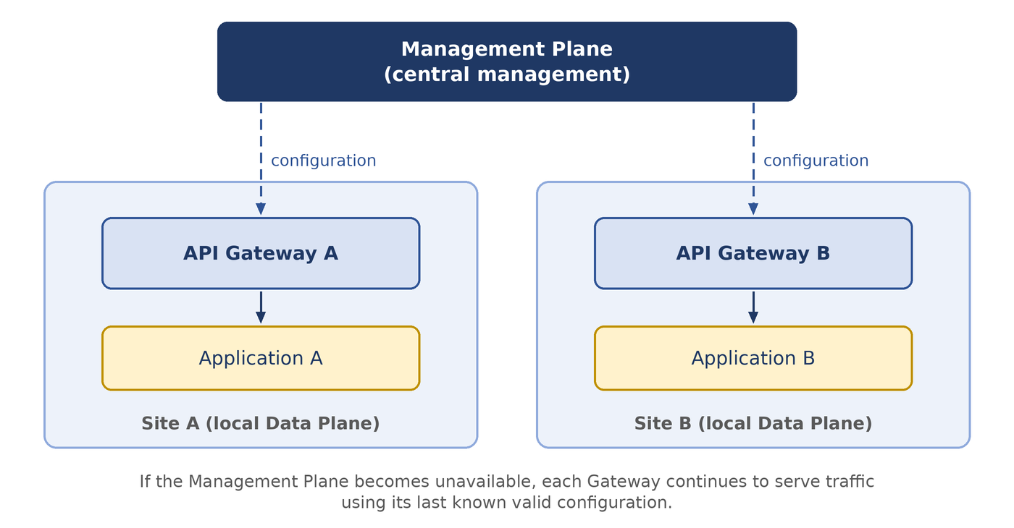
Figure 5 — Centralized management with distributed Data Planes

11 Governance and Exceptions

11.1 Governance model
Governance combines three mechanisms: mandatory guardrails, standards and guidelines. The overall principle is:
Enforce what can safely and consistently be enforced; document and guide the rest.

11.2 Mandatory guardrails
Requirements that are suited to technical enforcement should be implemented as mandatory Gateway guardrails. Examples are HTTPS at required boundaries, authentication, required logging, a maximum request size and mandatory organizational policies. Communication within the cluster, including between the Gateway and backend services, uses HTTP. No minimum TLS version and no maximum request size are defined by this document.

11.3 Standards
Standards define the organization's preferred and consistent way of operating APIs. Where it is practical, standards should be technically enforced.

11.4 Guidelines
Not every architectural or operational decision can or should be enforced by technology. Decisions that are not suited to technical enforcement remain guidelines. Examples are recommended caching, recommended timeout values, the recommended API versioning strategy and the recommended use of transformation.

11.5 Organizational governance
The preferred long-term model is for an organizational governance body to define API standards and policies, which the Infrastructure Team then implements as Gateway capabilities and guardrails. An organizational governance body has not yet been defined. Until it is, the Infrastructure Team can provide governance for the Gateway platform itself. This does not make the Infrastructure Team the owner of individual APIs.

11.6 Exceptions
The Platform should support a controlled exception mechanism. An exception should have a documented reason, an identified owner, approval from the Security Managers, a statement of the risks involved, and an expiration or review date where appropriate. Exceptions should not become an alternative to proper architecture.

12 Platform Boundaries

12.1 Boundary overview
The Gateway is one component of a wider security and infrastructure architecture. Table 6 summarizes the boundary between the Gateway and each adjacent component, and the sections that follow explain each boundary.
Table 6 — Boundaries between the Gateway and adjacent components
Adjacent component | The adjacent component is responsible for
WAF | - Attack signatures  - SQL injection detection  - Cross-site scripting detection  - Malicious payload detection  - Bot protection  - Other application security controls
Load Balancer | - Distribution between backend instances  - Backend pool management  - Infrastructure-level traffic distribution  - Instance-level availability
Identity Provider | - User authentication  - Client authentication  - Token issuance  - Identity lifecycle
Application | - Business authorization  - Business validation  - Business logic  - Data access control  - Business-level auditing

12.2 Gateway and WAF
The Gateway is not a WAF and must not attempt to become one. Protection against application-layer attacks, such as attack signatures, SQL injection and cross-site scripting detection, malicious payload detection and bot protection, belongs to the WAF. A WAF can be placed in front of the Gateway when the security architecture requires it.

12.3 Gateway and Load Balancer
The Gateway and the organization's Load Balancer can coexist, and the boundary between them should be clearly defined, as described in Section 5.3.

12.4 Gateway and Identity Provider
The Gateway does not need to be the organization's Identity Provider. The Identity Provider is responsible for user authentication, client authentication, token issuance and the identity lifecycle. The Gateway consumes identity, validates tokens, enforces API authorization and passes trusted identity information downstream.

12.5 Gateway and application
The Gateway provides infrastructure-level protection. The application remains responsible for business authorization, business validation, business logic, data access control and business-level auditing. In short, the Gateway asks whether a client is allowed to call an API, and the application asks whether that client is allowed to access a specific record.

13 Vendor Neutrality

13.1 Principle
The Gateway architecture should minimize unnecessary vendor lock-in. API contracts, the API lifecycle, the authentication and authorization models, the GitOps workflow, the governance model, observability requirements and the deployment model should remain conceptually independent of any specific product.

13.2 Vendor-specific capabilities
Vendor-specific capabilities can be used when they provide significant value, and they should then be identified as implementation-specific. The goal is not to guarantee zero migration effort. The goal is to ensure that:
The organization's API architecture and policies are not unnecessarily defined by the implementation details of a single Gateway product.

Appendix A — Capability Summary
Table 7 summarizes the status of each capability. Required means that the Platform provides the capability and applies it. Required capability means that the Platform provides the capability and the Application Team decides whether to enable it for a given API. Preferred identifies the preferred operating model. The remaining entries identify responsibilities that lie outside the Gateway.
Table 7 — Capability summary
Capability | Status | Described in
API routing | Required | Section 5.1
Version routing | Required | Section 5.2
Health checks | Required | Section 5.4
Timeouts | Required | Section 5.5
Automatic retry | Not recommended by default | Section 5.6
Authentication | Required | Section 4.1, 4.2, 4.3
Authorization | Required | Section 4.4
Rate limiting | Required capability | Section 5.7
Transformation | Required capability | Section 6.1
Caching | Required capability | Section 6.2
Schema validation | Required capability | Section 6.3
API documentation | Required | Section 7.1, 7.5
Developer Portal | Required | Section 7.5
Git integration | Required | Section 8.1
GitOps | Preferred operating model | Section 8.2
Audit logs | Required | Section 9.3
Runtime logs | Required | Section 9.1
Metrics | Required | Section 9.2
High availability | Required | Section 10.1
Distributed Data Plane | Required | Section 10.3
Centralized management | Preferred | Section 10.4
WAF | Separate component | Section 12.2
Load Balancer | Separate responsibility | Section 5.3, 12.3
Business logic | Application responsibility | Section 2.2, 12.5
Secrets storage | Separate secure system | Section 8.3
Vendor neutrality | Architectural principle | Chapter 13

Appendix B — Operating Model
Figure 6 summarizes the operating model. Application Teams operate their APIs through the Platform by defining them in Git. The Infrastructure Team owns the Platform, which combines central management with a distributed Data Plane and provides the capabilities described in this document. Organizational governance defines the standards that the Platform implements as guardrails.
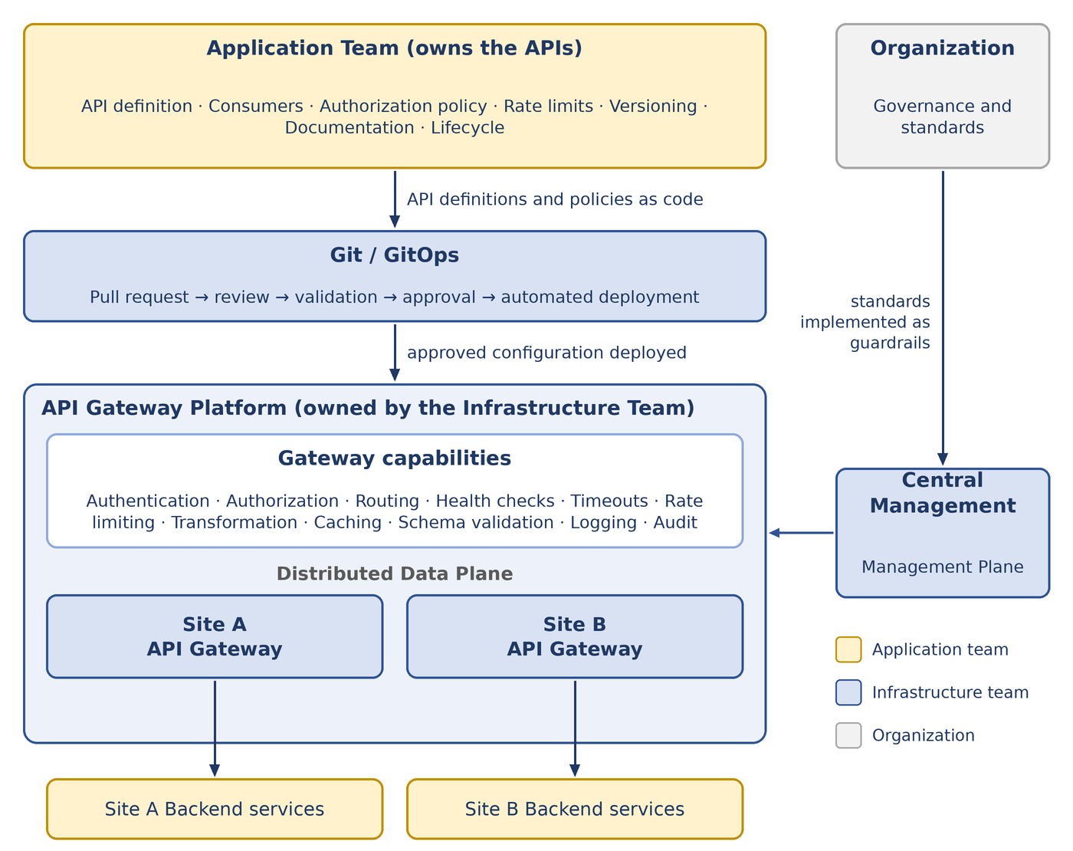
Figure 6 — API Gateway operating model

Appendix C — Open Issues
One item is not yet defined in this version of the document and is recorded here so that it is resolved deliberately rather than by default.
Governance body. The organizational governance body has not been defined, including its owner and mandate. Until it is, the Infrastructure Team provides interim governance for the Platform and the Security Managers approve exceptions. See Section 11.5 and Section 11.6.

