**PROJECT TITLE**

**REALPOLYAGENTWEAVE**

**THEME**  
XDC – RWA, PolyTrade, CIVIC and Goat ( Supply Chain / Trade Finance / Financial Cash Flow Portfolio optimization , Insitutional Defi )

**IDEA FOR SUBMISSION**  
RealPolyAgentWeave is a multi-agent MCP orchestration platform that transforms traditional trade documents into compliant, fractional ERC-6960 tokens using zero-knowledge proofs, enabling MSMEs to access the $60 trillion global supply chain finance market through deep business integrity verification and automated compliance workflows.

Blockchain adoption has been a challenge, for reasons of scalability and Privacy, and regulations but also user onboarding, and effectively representing the real world instruments effectively in the DLT digital world. We are addressing these gaps with agentic AI and DLT with REALPOLYAGENTWEAVE.

**PROJECT DESCRIPTION**

We are entering an era where blockchain technology is transitioning from speculative use cases to widespread institutional adoption. However, there are critical gaps that must be addressed to onboard a broader population—especially the unbanked and underbanked across the globe.

Through years of research, we’ve identified that the key adoption hurdles in blockchain-based real-world asset (RWA) platforms are:

* Regulatory and compliance complexities,
* Poor UI/UX,
* Lack of privacy-preserving mechanisms,
* Limited business mapping in real world processes , for lack of deep integrity

With the rise of AI technologies and multi-agent orchestration, new ways of solving these long-standing challenges are emerging. Our project addresses one such major challenge: **boosting blockchain adoption for tokenization use cases in supply chain finance, EXIM standards, and trade insurance**, particularly through deep, compliance-focused automation.

Most first-generation RWA platforms focus only on shallow representations of traditional paper documents. For example, even leading platforms like Cargo X manage the workflow of electronic bills of lading (eBLs) but do not capture **deep business integrity, verifiability, or operational compliance**. This limits both institutional trust and usability.

The reasons for this limitation are multifold—UI/UX bottlenecks, privacy risks, scalability challenges, and the inability to bridge enterprise systems with blockchain-native tools.

Highlights :

A deep integrity Supply chain Finance engine based on standards. – Multiple levels of compliance with very small proof sizes,

Agentic flows, where SMES can be at the same level playing field , where the MCP orchestrator brings high value compute to the SMEs desktop.

Driving g Deep Reverse supply chain with 6960 MAIN ID wrapping the basic 721.

Basic 721 – Minimal Integrity ( Like Cargo X ) – still does not have much depth in financial instruments of weighing .

But with additional layers of Proof of compliance ( Global, Local , EXIM ), Business Process modelling standards, Financial simulations and Proofs of liquidity ( Solvency / Reserves) etc drives,

Deep Reverse Supply Chain Tokenization as well as aggregation on classification of BLs for layers of financing for institutional flows for Institutional Defi.

Solution : A multi MCP Server Orchestrator between XDC , GOAT , PolyTrade and Civic

Very easy on-boarding for SMEs and Agentic loops .

Right level of granularity ( Not too small ) / Not too coarse with Supertools

**Why This Problem Is Critical?**

In the supply chain finance space, these gaps have prevented both traditional banks and new DeFi protocols from accessing a market that exceeds **$60 trillion** globally. The international corridor alone represents a **$2 trillion financing opportunity**.

* For financiers, the challenge is validation and risk.
* For sellers (especially MSMEs), it’s access to working capital and trusted liquidity.

**OUR SOLUTION: REALPOLYAGENTWEAVE**

**RealPolyAgentWeave** addresses these challenges by combining cutting-edge technology with multi-agent orchestration and a standards-first approach to compliance.

RealPolyAgentWeave is a **multi-agent MCP orchestration platform** designed to deliver:

* Deep integrity of financial instruments
* Data standardization and verifiable compliance
* Business process adherence
* Risk-managed, real-time payment flows
* Support for working capital optimization

It integrates **ZK-PRET** — a Zero-Knowledge Proof Engine for Tokenization — to **compose and validate multiple layers of business truth**. These proofs are **recursively composed** and cryptographically linked to tokenized trade assets, ensuring **real-time compliance**, **privacy**, and **cross-border interoperability**.

**Layered Proof Composition:**

* **Proof 1:** Valid Corporate Identity  
  *(via GLEIF vLEI / MCA / DGFT)*
* **Proof 2:** EXIM Trade Compliance  
  *(via MLETR / DCSA – Bill of Lading, export licenses, CBAM)*
* **Proof 3:** Financial Health and Tax Audit  
  *(via ITR-3 / GSTN audit trails)*
* **Proof 4:** Operational Process Adherence  
  *(via BPMN-modeled workflow validation)*
* **Proof 5+:** Risk Modeling & Contract Terms  
  *(via ACTUS-standardized cashflow and derivative logic)*

**ALL OF THESE BUNDLED IN TO REAL WORLD PROOF HIERARCHY IN TO 6960 / 3643 and SVP Instruments**

**Risk Tier Stratification (ACTUS + ZK-PRET):**

Assets are categorized based on the **depth of verified information and risk profile**:

* **Tier 1:** Fully compliant with certified audit, valid vLEI, and process verification
* **Tier 2:** KYC-compliant, limited financial audit, partial process coverage
* **Tier 3:** Minimal trust anchors, basic document-backed claims

This **on-chain stratification** enables **institutional financiers** to perform **risk-adjusted evaluations** on tokenized trade assets and assemble lending or insurance decisions accordingly.

The system effectively **bridges traditional compliance standards** — such as **ACTUS, GLEIF, DCSA, MLETR, and BPMN** — with **DeFi-native primitives** like:

* **ERC-721/6960-based composable and fractionalizable tokens**
* **Zero-knowledge recursive proofs**
* **On-chain registries and automated agents**

In doing so, RealPolyAgentWeave enables **regulated, efficient, and inclusive trade finance** — transforming real-world paper-based documents into programmable, trust-minimized assets on-chain.

**AGENTS ROLES AND ORCHAESTRATION MODELS**   
RealPolyAgentWeave uses a **Multi-Agent Control Plane (MCP)** comprising:

* **Identity Agent**: Verifies corporate identity (GLEIF vLEI, MCA, DGFT)
* **Compliance Agent**: Runs PRET proof generation using MLETR/DCSA/ACTUS standards
* **Orchestration Agent**: Sequences tokenization, proof bundling, and registry submission

In case of disputes or proof failures, a time-locked **Arbitration Agent** allows for multi-party voting, override mechanisms, and escalated governance — ensuring both decentralization and accountability.

**BUILT WITH**

* XDC network (Test net, Main net)
* Polytrade
* GOAT
* MCP
* CIVIC
* Hardhat

**WHAT MAKES US DIFFERENT**

* We go beyond basic tokenization. Our architecture transforms **paper or electronic trade documents** into ERC-721 NFTs and further fractionalizes them into ERC-6960 tokens for broader liquidity and compliance tagging.
* Each ERC-6960 token represents a **fractionalized claim** on a compliant trade document. It embeds:

1. **Hash-linked proof bundles** (from ZK-PRET)
2. **Metadata for compliance level, risk score, issuance time**
3. **Cross-chain registry pointer (e.g., IPFS) and MIT NANDA registry**  
   These tokens are readable by DeFi protocols and financiers for automated evaluation.

* Using **zero-knowledge proofs** and recursive compliance logic (ZK-PRET), we generate **verifiable business integrity** without compromising privacy.
* Our system **flattens the playing field**, allowing small MSMEs to participate at the same level as large enterprises in capital markets.
* The **agentic model** enables both fully autonomous behavior (auto-verification, orchestration) and human-in-the-loop control, where trust builds over time.

**STANDARDS TABLE :**

| **Standard** | **Purpose** | **Proof Type Enabled** |
| --- | --- | --- |
| ACTUS | Financial contract logic | Cashflow-based risk proofs |
| GLEIF | Legal identity (vLEI) | Corporate ID verification |
| DCSA | Bill of Lading standard | Maritime trade compliance |
| MLETR | Electronic trade record law | Legal doc validity & traceability |
| BPMN | Business process modeling | SLA adherence & workflow proofs |

**TECHNICAL ARCHITECTURE:**

**SNAPSHOTS**  
[Upload and reference relevant screenshots of your interface, outputs, proof logs, or dashboards]

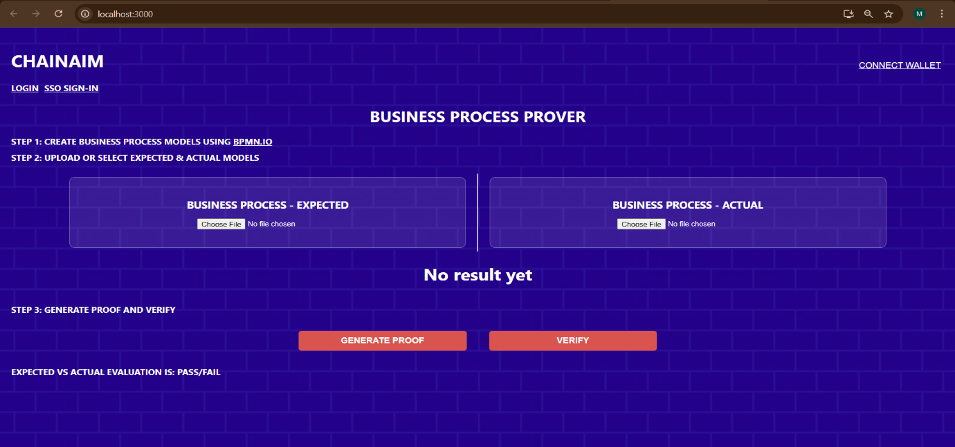

**VIDEO LINK**  
[Paste the link to your YouTube, Vimeo, or Youku demo video]

**PRESENTATION FILE**  
[Upload your presentation file — .pptx, .pdf, etc.]

**DEMO LINK**  
[Paste the working demo URL — GitHub Pages, Netlify, custom domain, etc.]

**PROJECT SOURCE (REPOSITORY LINK)**  
[Paste your GitHub or BitBucket public repo link]

<https://github.com/chainaimlabs/RealPolyAgentWeave>

<https://github.com/chainaimlabs/xdc-goat-mcp-server>

<https://github.com/chainaimlabs/civic-mcp-server>

https://github.com/chainaimlabs/ZK-PRET-TEST-V3

**SOURCE CODE FILE**  
[Upload a ZIP, PDF, or any other format of your complete source code. This is private to you and the judges.]