(Zkapp is deployed):

Verification hash: 3202944969948381086099017868469929146954020823899792905512493978409326518892

Two-level state transition

18 is the minimum age required for business registration, and that proof helps us to toggle the taxpayer state

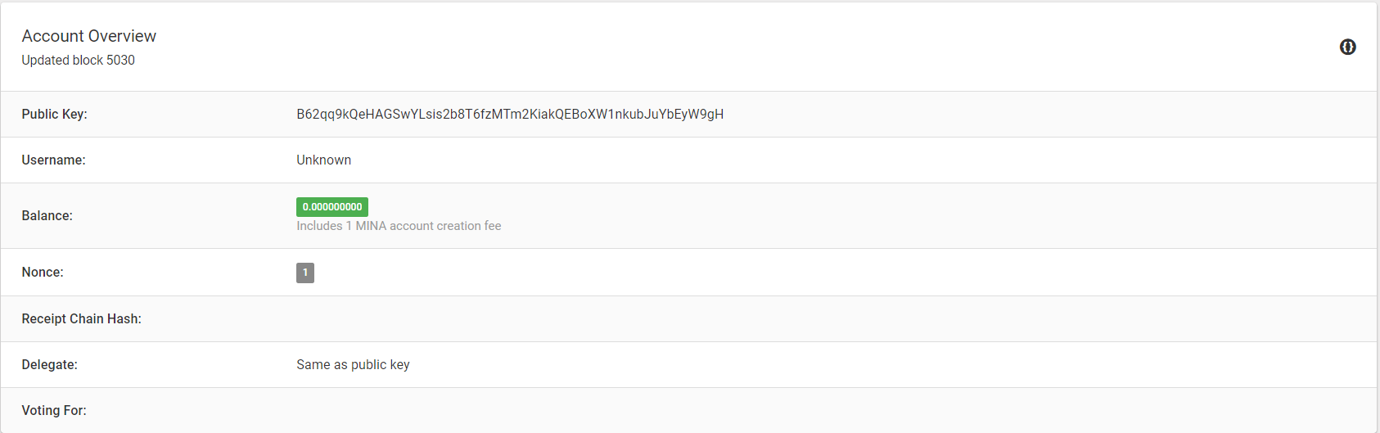

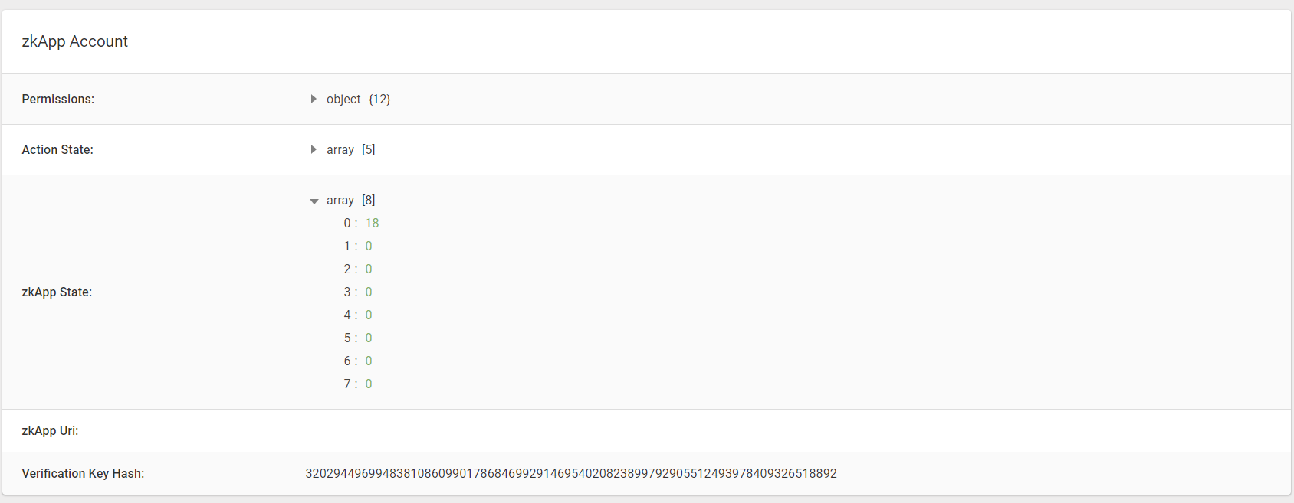

(A transaction has been established):

The age of the business owner is appropriate and hence the taxpayer state is toggled to one

