Before (zkapp is deployed):

18 -is the min age required to make state 1 toggle to state 1

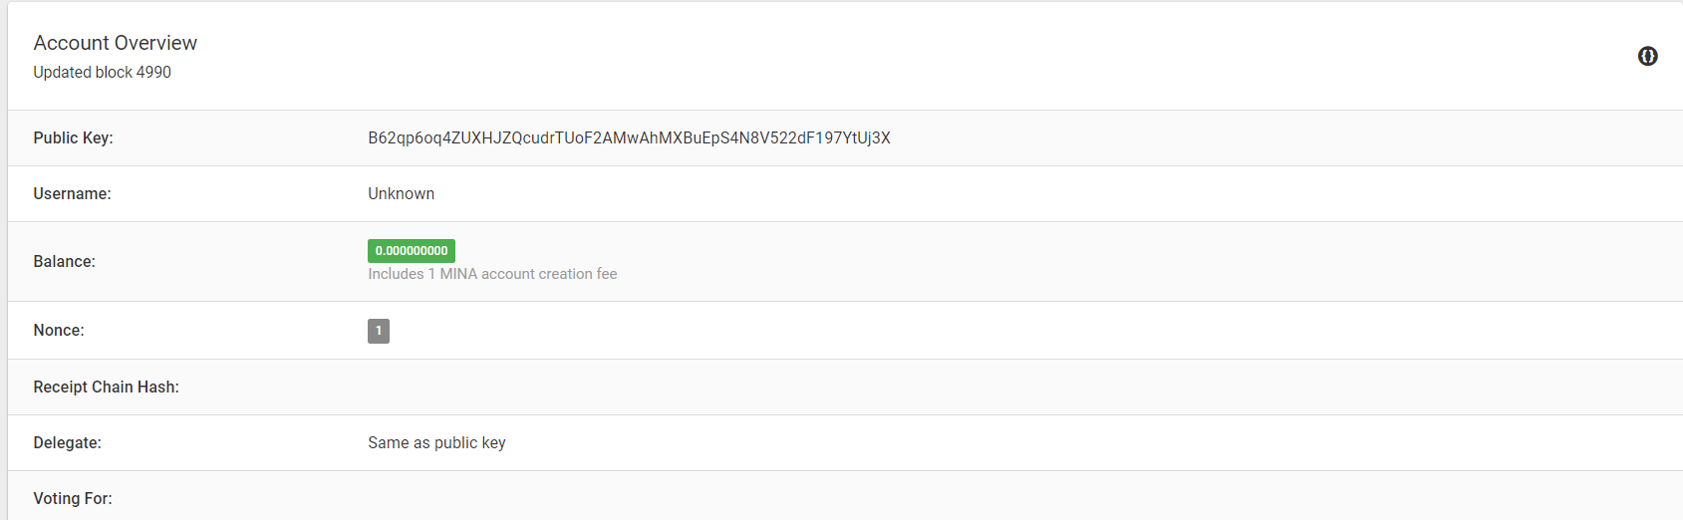

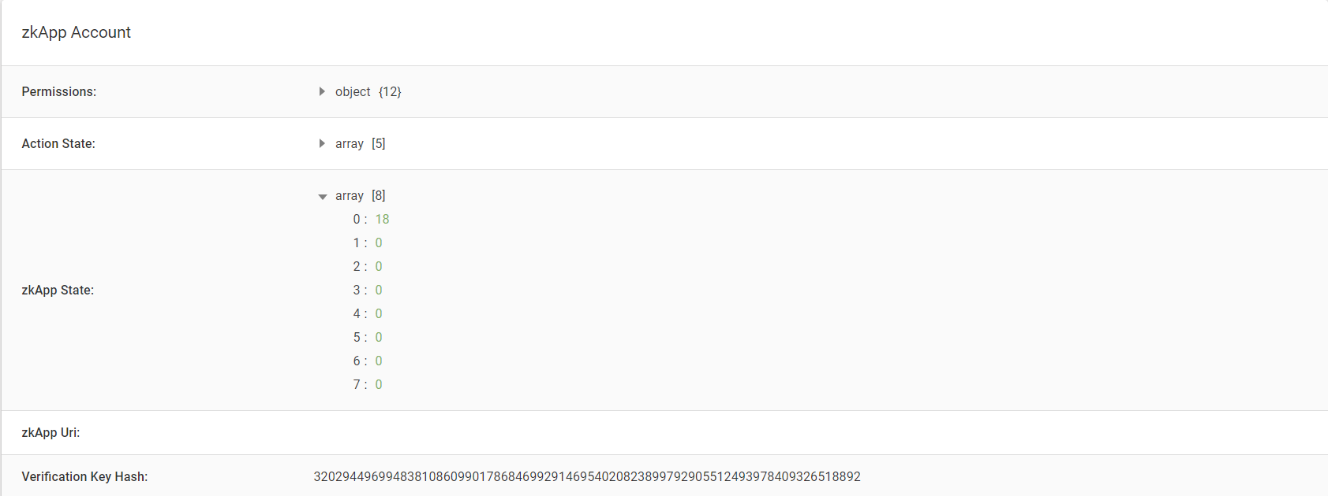

After (a transaction has been established):

The age is appropriate to establish a transaction and change the state to 1

