ZKPET – BUSINESS PROCESS PROVER

BPMN Circuit

**Legend**

a = Purchase Order

b = Booking

c = Invoice

d = Shipping Instruction

e = OI

F = Bill of Lading

G = Received

**Expected sequence of process :** a(cb|bc)d(ef|f)g

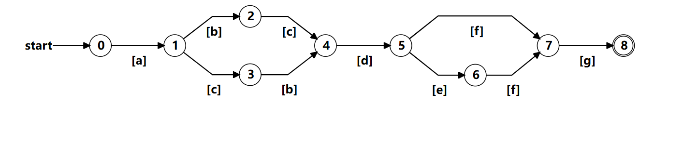

**Trace 1:** abcdefg (accepted)

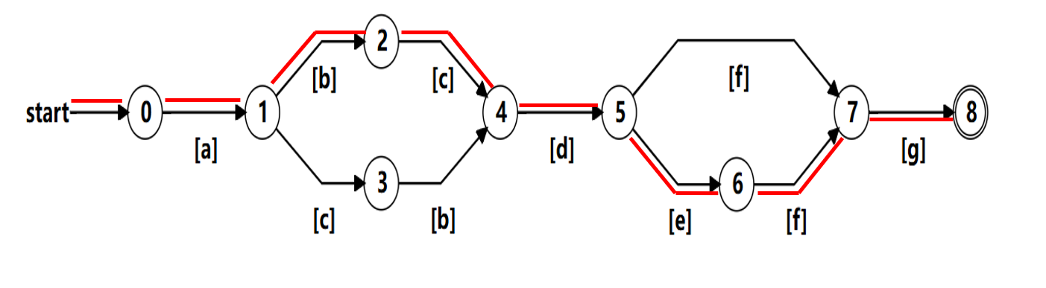

**Trace 2:** acbdfg (accepted)

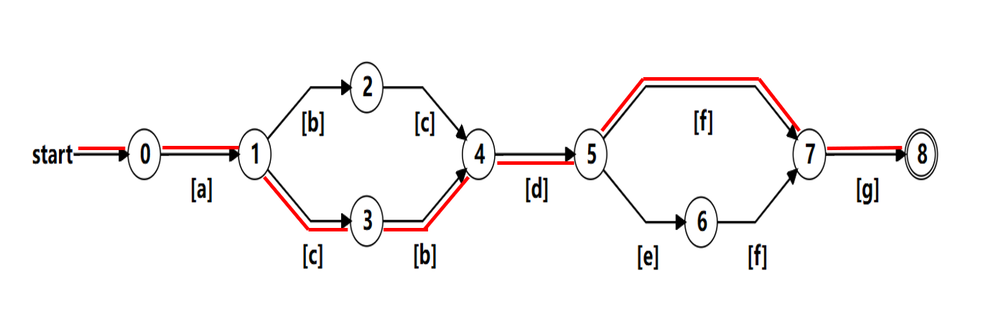

**Trace 3:** abfcdg (rejected)

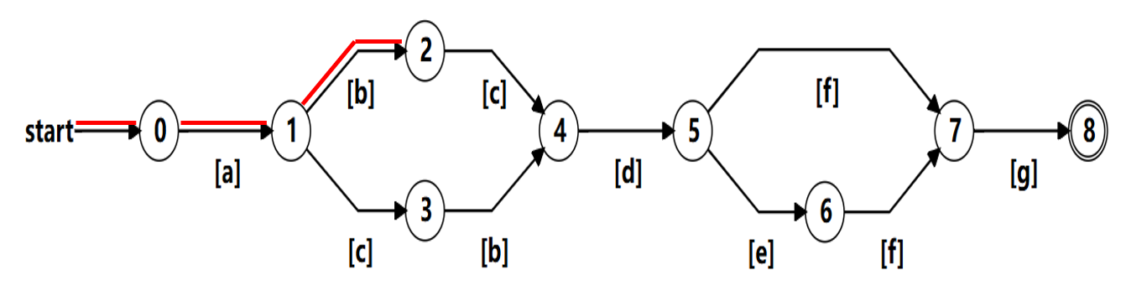

**Trace 4:** abcf (rejected)

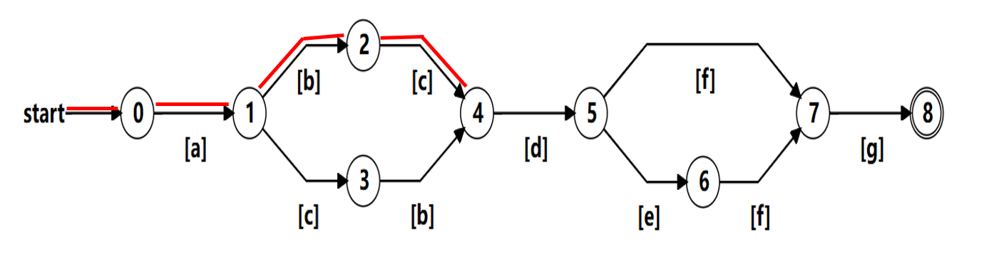

**Screenshot of verification code**

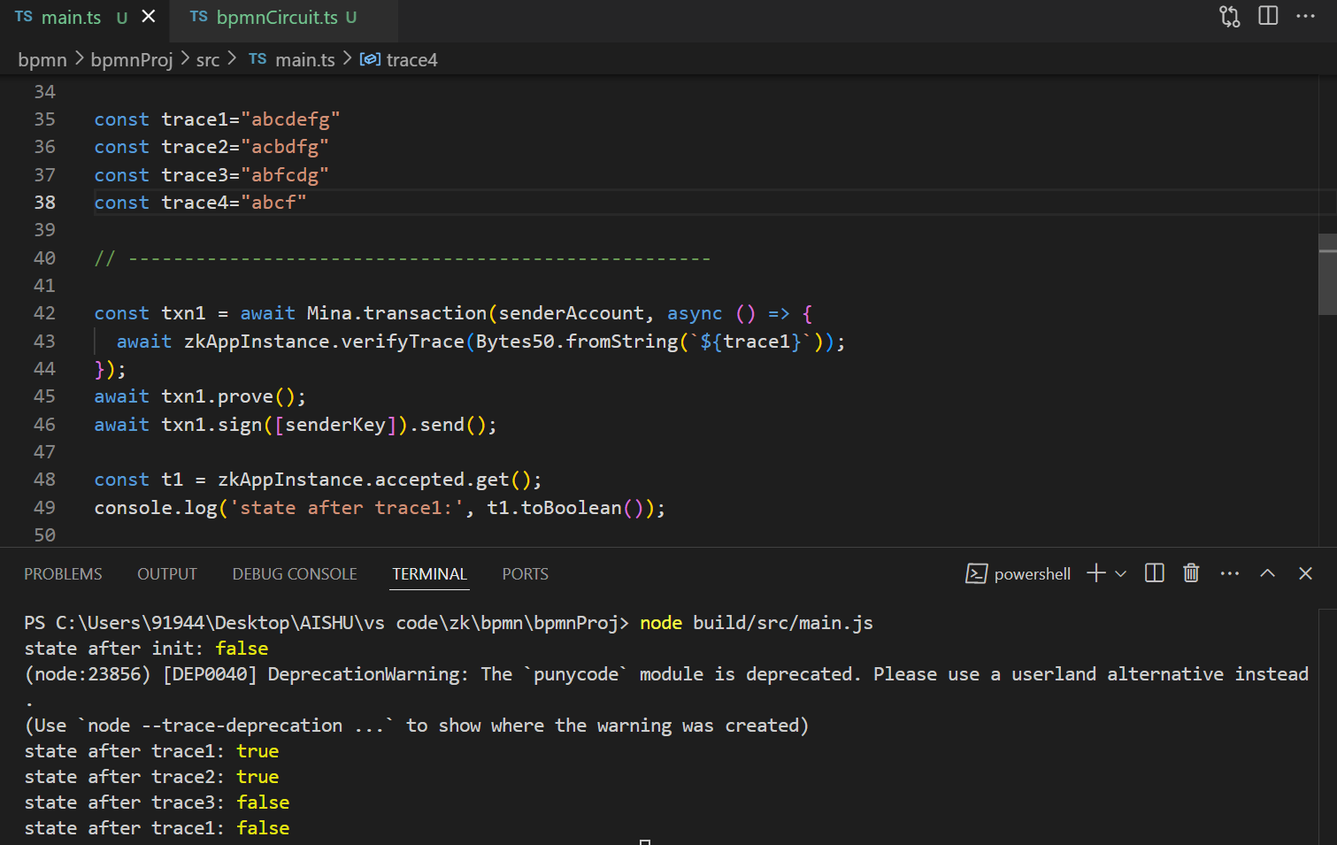

**Reference**

* link for generating circuit

<https://zkregex.com/min_dfa>

* link to check the circuit

<https://tool.zkregex.com/>

* online bpmn circuit designer

<https://bpmn.io/toolkit/bpmn-js/>

**XML File**<?xml version="1.0" encoding="UTF-8"?>

<definitions xmlns="http://www.omg.org/spec/BPMN/20100524/MODEL" xmlns:bpmndi="http://www.omg.org/spec/BPMN/20100524/DI" xmlns:omgdi="http://www.omg.org/spec/DD/20100524/DI" xmlns:omgdc="http://www.omg.org/spec/DD/20100524/DC" xmlns:xsi="http://www.w3.org/2001/XMLSchema-instance" id="sid-38422fae-e03e-43a3-bef4-bd33b32041b2" targetNamespace="http://bpmn.io/bpmn" exporter="bpmn-js (https://demo.bpmn.io)" exporterVersion="17.7.1">

<process id="Process_1" isExecutable="false">

<startEvent id="Event_1e6mvux" name="0">

<outgoing>Flow_1e1jt09</outgoing>

</startEvent>

<intermediateThrowEvent id="Event_0ckb2yy" name="1">

<incoming>Flow_1e1jt09</incoming>

<outgoing>Flow_1mcdovg</outgoing>

<outgoing>Flow_0xad9v9</outgoing>

</intermediateThrowEvent>

<sequenceFlow id="Flow_1e1jt09" name="a" sourceRef="Event_1e6mvux" targetRef="Event_0ckb2yy" />

<intermediateThrowEvent id="Event_0orj063" name="2">

<incoming>Flow_1mcdovg</incoming>

<outgoing>Flow_0uxr7s1</outgoing>

</intermediateThrowEvent>

<sequenceFlow id="Flow_1mcdovg" name="b" sourceRef="Event_0ckb2yy" targetRef="Event_0orj063" />

<intermediateThrowEvent id="Event_0s7vpsv" name="3">

<incoming>Flow_0xad9v9</incoming>

<outgoing>Flow_0q6gb9b</outgoing>

</intermediateThrowEvent>

<sequenceFlow id="Flow_0xad9v9" name="c" sourceRef="Event_0ckb2yy" targetRef="Event_0s7vpsv" />

<intermediateThrowEvent id="Event_09jlpil" name="4">

<incoming>Flow_0uxr7s1</incoming>

<incoming>Flow_0q6gb9b</incoming>

<outgoing>Flow_16doo4t</outgoing>

</intermediateThrowEvent>

<sequenceFlow id="Flow_0uxr7s1" name="c" sourceRef="Event_0orj063" targetRef="Event_09jlpil" />

<sequenceFlow id="Flow_0q6gb9b" name="b" sourceRef="Event_0s7vpsv" targetRef="Event_09jlpil" />

<intermediateThrowEvent id="Event_1ooatwj" name="5">

<incoming>Flow_16doo4t</incoming>

<outgoing>Flow_0u2xuqs</outgoing>

<outgoing>Flow_0wslkb9</outgoing>

</intermediateThrowEvent>

<sequenceFlow id="Flow_16doo4t" name="d" sourceRef="Event_09jlpil" targetRef="Event_1ooatwj" />

<intermediateThrowEvent id="Event_0zmkq57" name="6">

<incoming>Flow_0u2xuqs</incoming>

<outgoing>Flow_0564sbo</outgoing>

</intermediateThrowEvent>

<sequenceFlow id="Flow_0u2xuqs" name="e" sourceRef="Event_1ooatwj" targetRef="Event_0zmkq57" />

<intermediateThrowEvent id="Event_024ls17" name="7">

<incoming>Flow_0564sbo</incoming>

<incoming>Flow_0wslkb9</incoming>

<outgoing>Flow_01qx9za</outgoing>

</intermediateThrowEvent>

<sequenceFlow id="Flow_0564sbo" name="f" sourceRef="Event_0zmkq57" targetRef="Event_024ls17" />

<sequenceFlow id="Flow_0wslkb9" name="f" sourceRef="Event_1ooatwj" targetRef="Event_024ls17" />

<endEvent id="Event_0d8ci30" name="8">

<incoming>Flow_01qx9za</incoming>

</endEvent>

<sequenceFlow id="Flow_01qx9za" name="g" sourceRef="Event_024ls17" targetRef="Event_0d8ci30" />

<textAnnotation id="TextAnnotation_1bwv3je">

<text>start</text>

</textAnnotation>

<association id="Association_1x3xuqw" associationDirection="None" sourceRef="Event_1e6mvux" targetRef="TextAnnotation_1bwv3je" />

<textAnnotation id="TextAnnotation_1gqiu4d">

<text>end</text>

</textAnnotation>

<association id="Association_09y5cux" associationDirection="None" sourceRef="Event_0d8ci30" targetRef="TextAnnotation_1gqiu4d" />

</process>

<bpmndi:BPMNDiagram id="BpmnDiagram_1">

<bpmndi:BPMNPlane id="BpmnPlane_1" bpmnElement="Process_1">

<bpmndi:BPMNShape id="Event_1e6mvux_di" bpmnElement="Event_1e6mvux">

<omgdc:Bounds x="152" y="182" width="36" height="36" />

<bpmndi:BPMNLabel>

<omgdc:Bounds x="167" y="225" width="7" height="14" />

</bpmndi:BPMNLabel>

</bpmndi:BPMNShape>

<bpmndi:BPMNShape id="Event_0ckb2yy_di" bpmnElement="Event_0ckb2yy">

<omgdc:Bounds x="262" y="182" width="36" height="36" />

<bpmndi:BPMNLabel>

<omgdc:Bounds x="277" y="225" width="7" height="14" />

</bpmndi:BPMNLabel>

</bpmndi:BPMNShape>

<bpmndi:BPMNShape id="Event_024ls17_di" bpmnElement="Event_024ls17">

<omgdc:Bounds x="942" y="182" width="36" height="36" />

<bpmndi:BPMNLabel>

<omgdc:Bounds x="924.5" y="193" width="7" height="14" />

</bpmndi:BPMNLabel>

</bpmndi:BPMNShape>

<bpmndi:BPMNShape id="Event_0d8ci30_di" bpmnElement="Event_0d8ci30">

<omgdc:Bounds x="1062" y="182" width="36" height="36" />

<bpmndi:BPMNLabel>

<omgdc:Bounds x="1077" y="225" width="7" height="14" />

</bpmndi:BPMNLabel>

</bpmndi:BPMNShape>

<bpmndi:BPMNShape id="Event_0orj063_di" bpmnElement="Event_0orj063">

<omgdc:Bounds x="402" y="97" width="36" height="36" />

<bpmndi:BPMNLabel>

<omgdc:Bounds x="417" y="140" width="7" height="14" />

</bpmndi:BPMNLabel>

</bpmndi:BPMNShape>

<bpmndi:BPMNShape id="Event_0s7vpsv_di" bpmnElement="Event_0s7vpsv">

<omgdc:Bounds x="402" y="262" width="36" height="36" />

<bpmndi:BPMNLabel>

<omgdc:Bounds x="417" y="305" width="7" height="14" />

</bpmndi:BPMNLabel>

</bpmndi:BPMNShape>

<bpmndi:BPMNShape id="Event_09jlpil_di" bpmnElement="Event_09jlpil">

<omgdc:Bounds x="532" y="182" width="36" height="36" />

<bpmndi:BPMNLabel>

<omgdc:Bounds x="547" y="225" width="6" height="14" />

</bpmndi:BPMNLabel>

</bpmndi:BPMNShape>

<bpmndi:BPMNShape id="Event_1ooatwj_di" bpmnElement="Event_1ooatwj">

<omgdc:Bounds x="642" y="182" width="36" height="36" />

<bpmndi:BPMNLabel>

<omgdc:Bounds x="656.5" y="158" width="7" height="14" />

</bpmndi:BPMNLabel>

</bpmndi:BPMNShape>

<bpmndi:BPMNShape id="Event_0zmkq57_di" bpmnElement="Event_0zmkq57">

<omgdc:Bounds x="792" y="262" width="36" height="36" />

<bpmndi:BPMNLabel>

<omgdc:Bounds x="807" y="305" width="7" height="14" />

</bpmndi:BPMNLabel>

</bpmndi:BPMNShape>

<bpmndi:BPMNEdge id="Association_1x3xuqw_di" bpmnElement="Association_1x3xuqw">

<omgdi:waypoint x="180" y="185" />

<omgdi:waypoint x="230" y="110" />

</bpmndi:BPMNEdge>

<bpmndi:BPMNEdge id="Association_09y5cux_di" bpmnElement="Association_09y5cux">

<omgdi:waypoint x="1091" y="186" />

<omgdi:waypoint x="1138" y="130" />

</bpmndi:BPMNEdge>

<bpmndi:BPMNEdge id="Flow_1e1jt09_di" bpmnElement="Flow_1e1jt09">

<omgdi:waypoint x="188" y="200" />

<omgdi:waypoint x="262" y="200" />

<bpmndi:BPMNLabel>

<omgdc:Bounds x="222" y="182" width="7" height="14" />

</bpmndi:BPMNLabel>

</bpmndi:BPMNEdge>

<bpmndi:BPMNEdge id="Flow_1mcdovg_di" bpmnElement="Flow_1mcdovg">

<omgdi:waypoint x="292" y="187" />

<omgdi:waypoint x="360" y="115" />

<omgdi:waypoint x="402" y="115" />

<bpmndi:BPMNLabel>

<omgdc:Bounds x="332" y="158" width="7" height="14" />

</bpmndi:BPMNLabel>

</bpmndi:BPMNEdge>

<bpmndi:BPMNEdge id="Flow_0xad9v9_di" bpmnElement="Flow_0xad9v9">

<omgdi:waypoint x="293" y="213" />

<omgdi:waypoint x="360" y="280" />

<omgdi:waypoint x="402" y="280" />

<bpmndi:BPMNLabel>

<omgdc:Bounds x="338" y="232" width="7" height="14" />

</bpmndi:BPMNLabel>

</bpmndi:BPMNEdge>

<bpmndi:BPMNEdge id="Flow_0uxr7s1_di" bpmnElement="Flow_0uxr7s1">

<omgdi:waypoint x="438" y="115" />

<omgdi:waypoint x="470" y="115" />

<omgdi:waypoint x="538" y="187" />

<bpmndi:BPMNLabel>

<omgdc:Bounds x="513" y="136" width="7" height="14" />

</bpmndi:BPMNLabel>

</bpmndi:BPMNEdge>

<bpmndi:BPMNEdge id="Flow_0q6gb9b_di" bpmnElement="Flow_0q6gb9b">

<omgdi:waypoint x="438" y="280" />

<omgdi:waypoint x="470" y="280" />

<omgdi:waypoint x="537" y="213" />

<bpmndi:BPMNLabel>

<omgdc:Bounds x="508" y="255" width="7" height="14" />

</bpmndi:BPMNLabel>

</bpmndi:BPMNEdge>

<bpmndi:BPMNEdge id="Flow_16doo4t_di" bpmnElement="Flow_16doo4t">

<omgdi:waypoint x="568" y="200" />

<omgdi:waypoint x="642" y="200" />

<bpmndi:BPMNLabel>

<omgdc:Bounds x="603" y="182" width="7" height="14" />

</bpmndi:BPMNLabel>

</bpmndi:BPMNEdge>

<bpmndi:BPMNEdge id="Flow_0u2xuqs_di" bpmnElement="Flow_0u2xuqs">

<omgdi:waypoint x="671" y="214" />

<omgdi:waypoint x="720" y="280" />

<omgdi:waypoint x="792" y="280" />

<bpmndi:BPMNLabel>

<omgdc:Bounds x="692" y="229" width="7" height="14" />

</bpmndi:BPMNLabel>

</bpmndi:BPMNEdge>

<bpmndi:BPMNEdge id="Flow_0564sbo_di" bpmnElement="Flow_0564sbo">

<omgdi:waypoint x="828" y="280" />

<omgdi:waypoint x="880" y="280" />

<omgdi:waypoint x="947" y="213" />

<bpmndi:BPMNLabel>

<omgdc:Bounds x="852" y="262" width="4" height="14" />

</bpmndi:BPMNLabel>

</bpmndi:BPMNEdge>

<bpmndi:BPMNEdge id="Flow_0wslkb9_di" bpmnElement="Flow_0wslkb9">

<omgdi:waypoint x="672" y="187" />

<omgdi:waypoint x="730" y="120" />

<omgdi:waypoint x="870" y="120" />

<omgdi:waypoint x="947" y="188" />

<bpmndi:BPMNLabel>

<omgdc:Bounds x="798" y="102" width="4" height="14" />

</bpmndi:BPMNLabel>

</bpmndi:BPMNEdge>

<bpmndi:BPMNEdge id="Flow_01qx9za_di" bpmnElement="Flow_01qx9za">

<omgdi:waypoint x="978" y="200" />

<omgdi:waypoint x="1062" y="200" />

<bpmndi:BPMNLabel>

<omgdc:Bounds x="1017" y="182" width="7" height="14" />

</bpmndi:BPMNLabel>

</bpmndi:BPMNEdge>

<bpmndi:BPMNShape id="TextAnnotation_1bwv3je_di" bpmnElement="TextAnnotation_1bwv3je">

<omgdc:Bounds x="190" y="80" width="99.99999237060547" height="29.999998092651367" />

<bpmndi:BPMNLabel />

</bpmndi:BPMNShape>

<bpmndi:BPMNShape id="TextAnnotation_1gqiu4d_di" bpmnElement="TextAnnotation_1gqiu4d">

<omgdc:Bounds x="1100" y="100" width="99.99999237060547" height="29.999998092651367" />

<bpmndi:BPMNLabel />

</bpmndi:BPMNShape>

</bpmndi:BPMNPlane>

</bpmndi:BPMNDiagram>

</definitions>