n_estimators = 1200

max_depth = 8

pre:

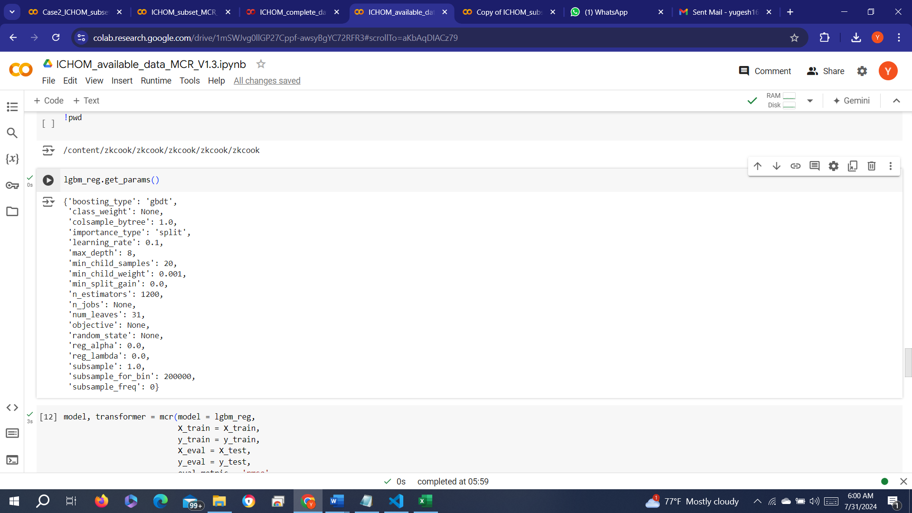

Post:

n_estimators: 150

max_depth: 4

