Beginning Bitcoin - Getting Started with Mobile Wallets
Author | josh
Date | 2019-06-17 20:57:21

Overview
For someone that's completely new to the concept of digital money, all the information out there can get a tad overwhelming. Fortunately, getting a practical start in using cryptocurrencies is actually fairly trivial with modern mobile wallets!
Installing a proper wallet is the first step in a safe and successful journey into the crypto space. We want a wallet that makes it easy to send and receive funds (has a nice user interface) and where you control your own funds (by owning the private keys). Both of these wallets allow you full control over your own funds - there is no institution like an exchange holding your money for you like a bank. It's yours, like digital cash! In order to securely back up your money, each wallet generates a 12-24 word "seed" that you need to write down somewhere in the event you lose your phone or something of that nature.
In this tutorial, we'll learn to install two easy to use and secure multi-asset wallets developed by Bitcoin.com and Coinomi. Both of these allow the user to send and receive multiple cryptocurrencies, so it's easy for a beginner to dabble in a few currencies that interest them.

Wallet Install Walkthroughs

The Bitcoin.com Wallet
The first wallet we'll take a look at is the Bitcoin.com wallet. This application is available on Android and iOS, as well as desktop platforms. I find it easy to use on a mobile phone for portable payments. This wallet supports both Bitcoin Cash (BCH) and Bitcoin Core (BTC). It's also compatible with a payment protocol known as BIP70 used by the popular payment processor Bitpay, so it's easy to buy things with this wallet through retailers like Newegg and service providers like AT&T.
Let's walk through how to set up this wallet so you can start sending and receiving funds securely.
- First, install the application on your phone through the Google Play store or the App Store.
- Open up the application - you'll see a screen that says "Creating wallet" while your initial seed is generated
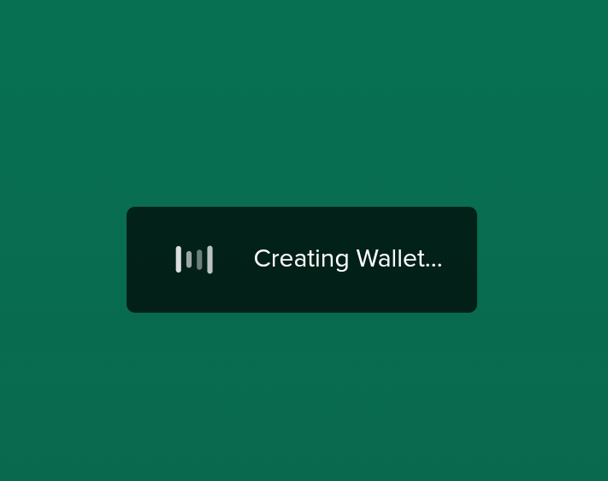
- Next, you'll see a screen telling you that your wallets are ready to go! Tap on either your BCH or BTC wallet - it doesn't matter which as both will share the same backup phrase.
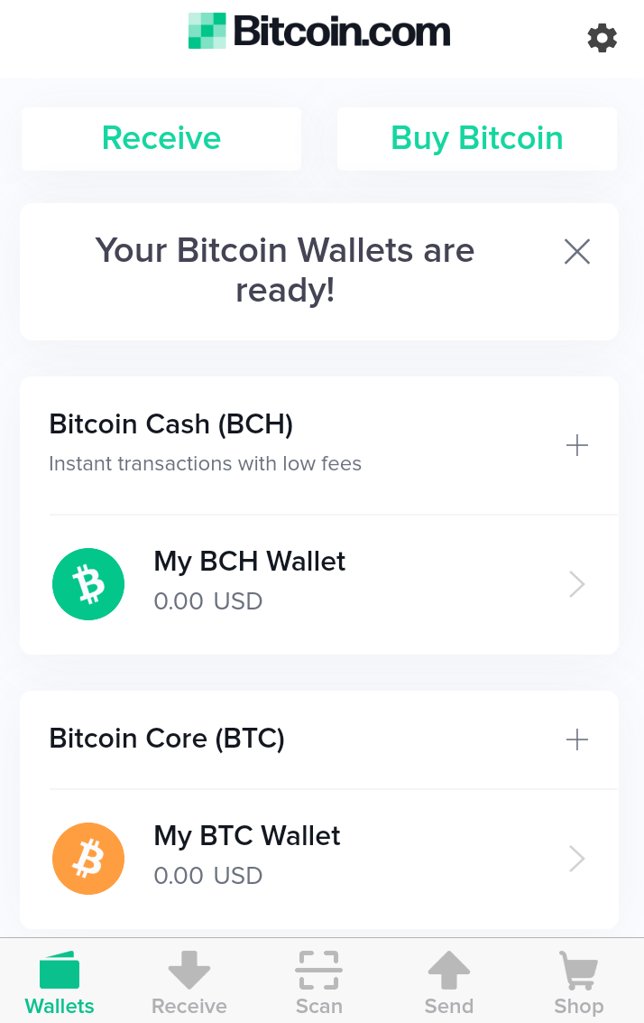
- When you open up your wallet, go to the settings (the cog icon at the top) and click on the "backup" option.
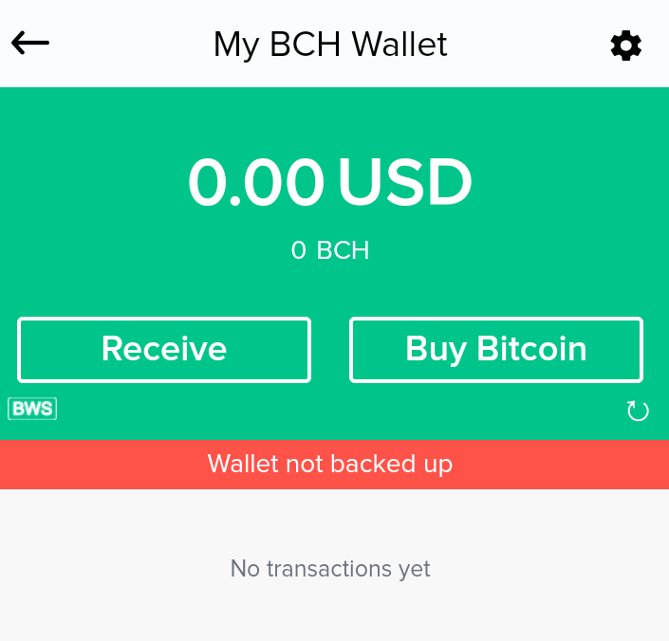 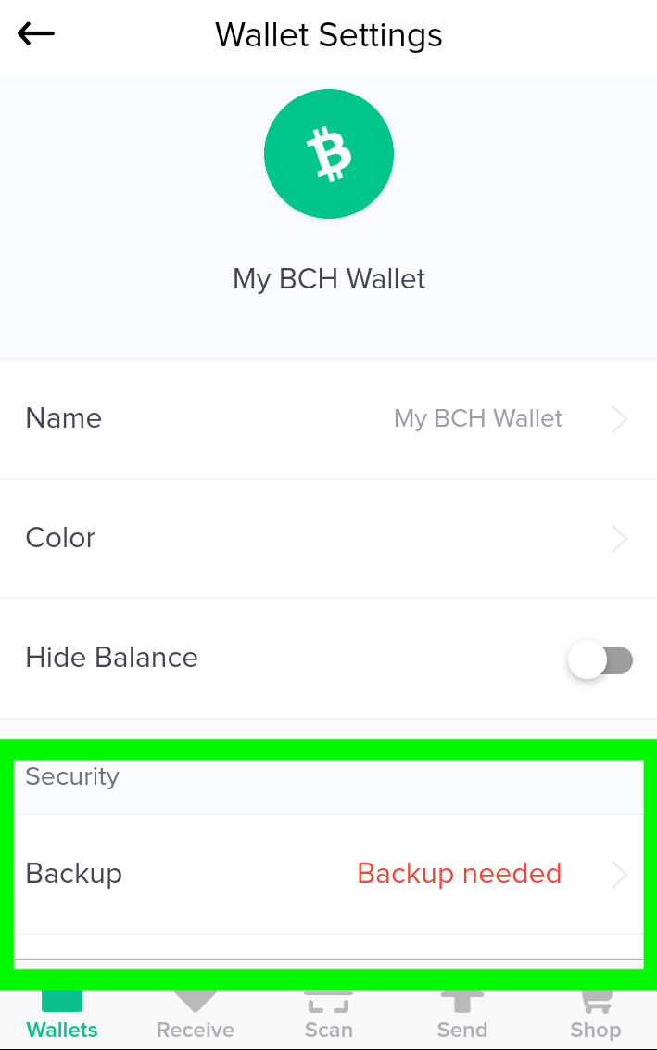
- Next, write down the backup phrase shown on the screen and store it somewhere safe. This phrase is absolutely secret and should never be shared with anyone. It's used to generate all of the keys that unlock your money for spending. Also, don't use or write down the phrase shown in this tutorial. Anyone can see it, so anyone could spend money sent to this example wallet.
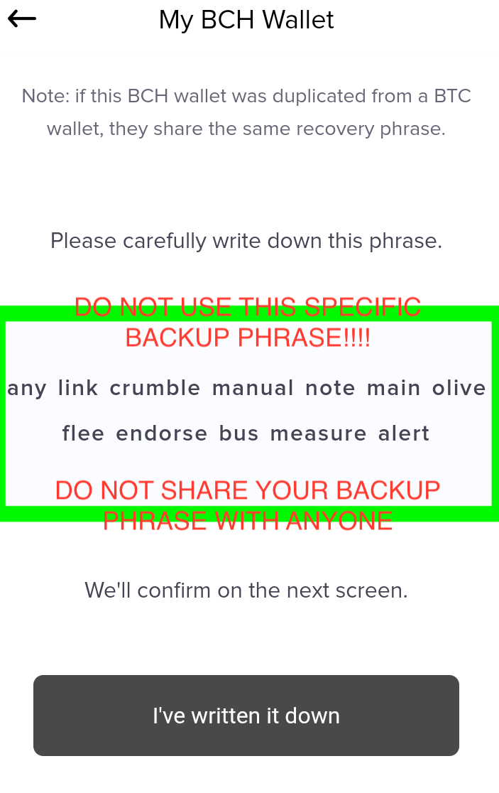
- Now verify it on the next screen, and your wallet is ready to use!
- To receive BCH or BTC from someone, or send it to your wallet from an exchange, click on "receive" and one of your addresses will be shown in text and QR code format. This address is public (used to send you money) and can be given away freely. Just don't use the example one shown here, because it belongs to the (not so) secret backup phrase shown above.
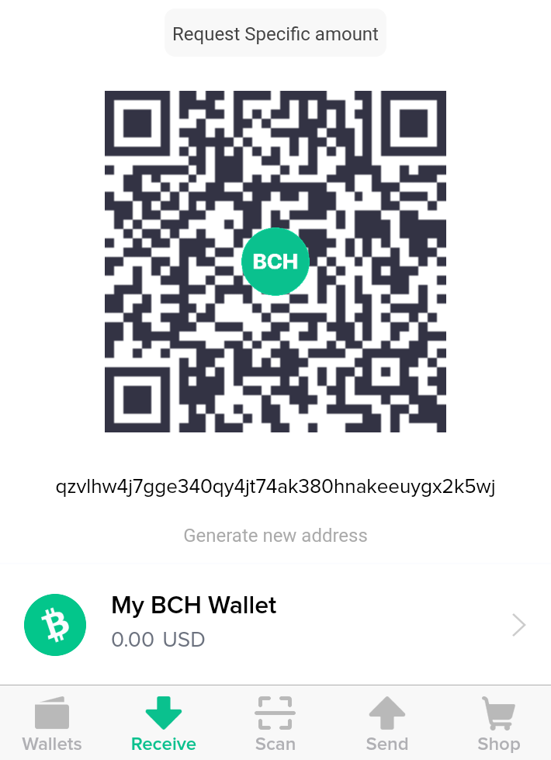

The Coinomi Wallet
The Coinomi wallet is another easy to use and secure mobile wallet for Android or iOS. This wallet is built with security in mind according to the Coinomi website, and supports hundreds of cryptocurrencies including Bitcoin, Bitcoin Cash, Litecoin, and Ethereum.
- Just like with the Bitcoin.com wallet, start by actually installing the application via the Google Play store or the App Store.
- When you first open up the app, it will ask you if you'd like to create or restore a wallet. We'll select "create" here.
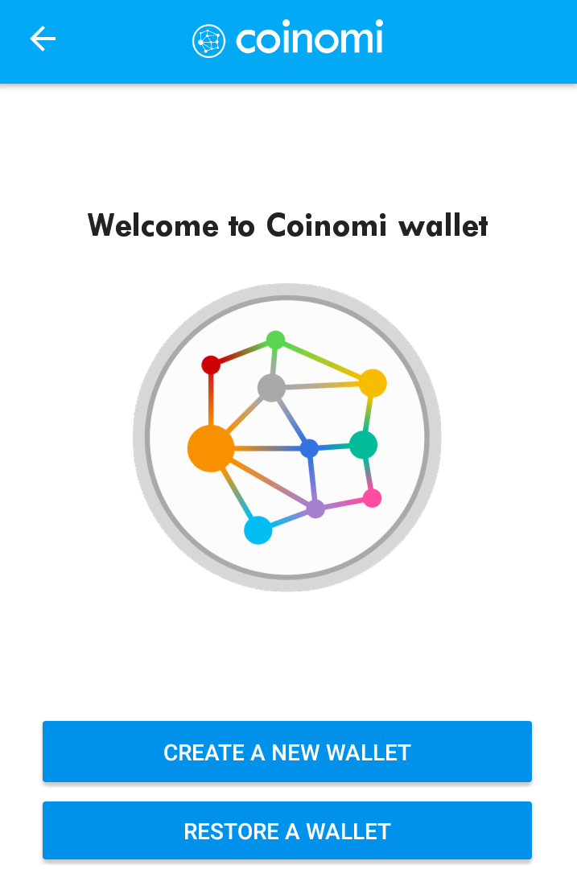
- Next, the wallet will generate and display a 24 word "seed" phrase that allows you to easily back up your wallet. Write this down and store it somewhere safe. Again, do not share this with anyone. It's the secret key that's used to unlock all of your funds when you want to spend them. And again, don't use the specific phrase shown below. Anyone that's read this tutorial could steal your money if you did!
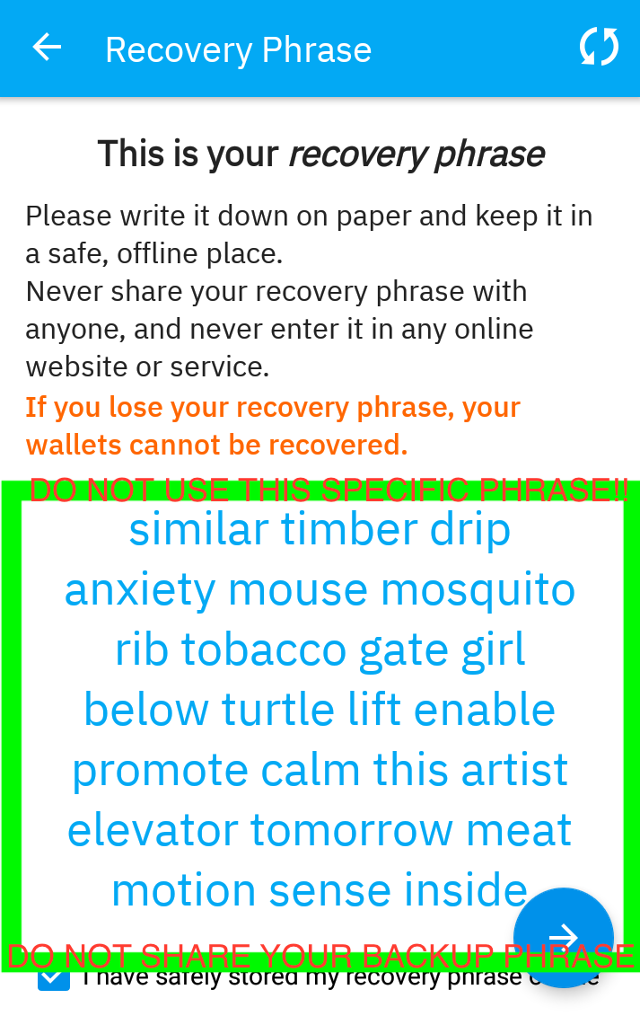
- Next, select the currencies you want to use. You can add and remove currencies any time, and all of them will use the same backup phrase you wrote down in the last step to generate keys and addresses. One backup, many wallets!
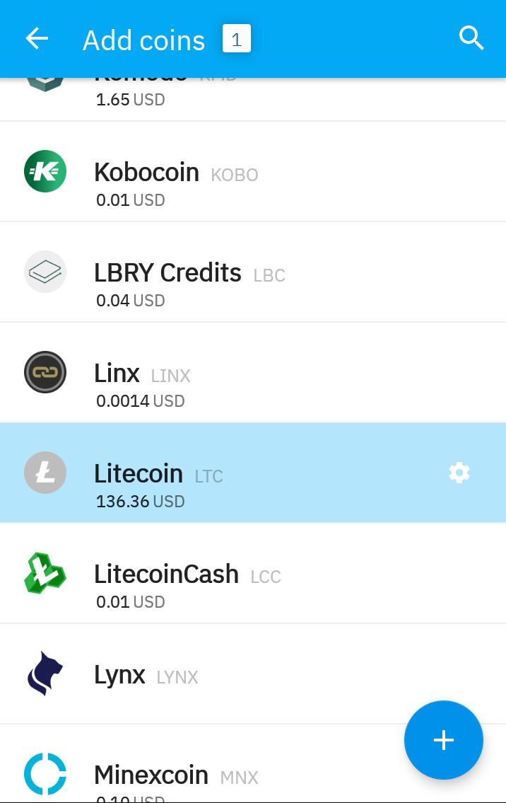
- Now you can open up the wallet created for any currency you'd like to use, and your address will be shown in text and QR format. There's a couple of different address formats these days - usually "compatibility" is a good bet if you're not sure. Again, don't send any funds to the address shown here.
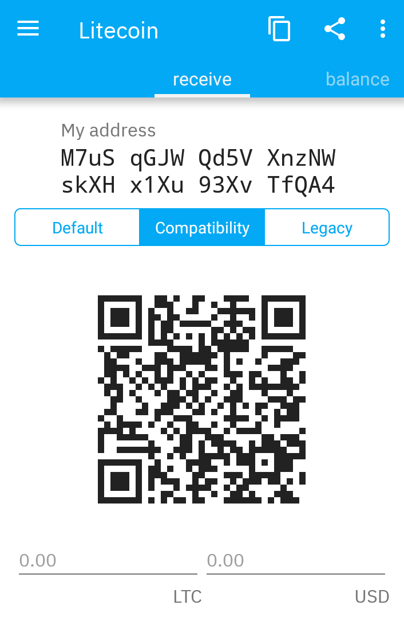

Getting Started with Crypto - It's That Easy!
Using either of these mobile wallets is a great way to get started using cryptocurrencies like Bitcoin, Bitcoin Cash, Litecoin, and Ethereum. These mobile wallets are available on the most popular mobile platforms, and can be installed by simply visiting the right app store.
Setup is easy and secure, as both wallets use BIP39 mnemonics to generate your addresses. All you have to do is write down this phrase in a safe place and your wallet can always be restored if you have a problem. More importantly, the funds you send to these wallets are truly yours; they're not held by an exchange.
And as we've seen here, these wallets are pretty easy to use! Just a few set up steps and you're ready to send and receive magic internet money yourself.

