Common Bitcoin & Crypto SCAMS (And How to Avoid Them)
Author | josh
Date | 2020-07-20 10:30:54

Overview
Unfortunately, with all new technology comes those that will take advantage of it in a negative way. The crypto world has brought us some amazing new technology and positive use cases. But it has also brought out those thieves and scammers that will take advantage of others for their own gain. Let's discuss some of the most common crypto scams and how to avoid falling victim to them.

The Three Most Common Scams

The Crypto "Doubling" Scam
The crypto "doubling" or crypto giveaway scam has become ubiquitous, and recently took center stage with a hack targeting major celebrities on Twitter. The crypto doubling scam is simple but insidious! These fraudulent giveaways will use YouTube or Twitter to pose as a popular figure in the crypto space, and say that due to some event they are doing a generous airdrop of Bitcoin or another currency.
The scam asks you to send BTC to an address, and claims that they will then send double that amount back to you. How generous? Well, no. Crypto transactions are irreversible by design. So once they receive your Bitcoin, they will simply take it and run. There's nothing you can do to get it back.
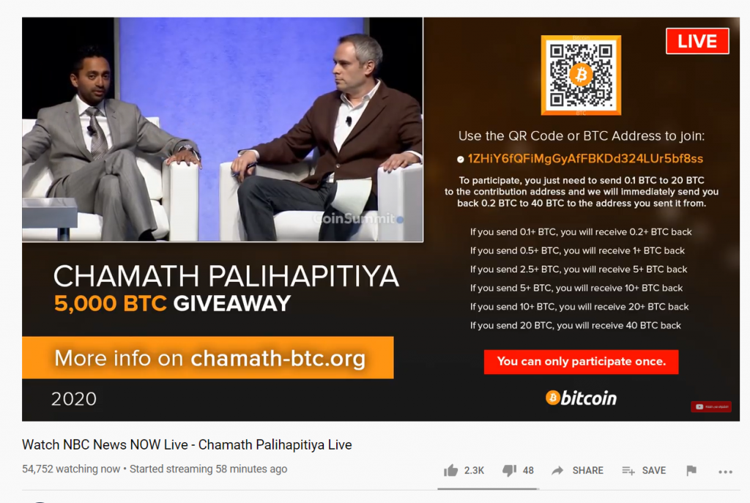
A Fake Bitcoin Giveaway Scam
Avoiding this scam is simple. NEVER, EVER, EVER send someone crypto with the promise of receiving more back. No one is going to do this. If someone truly wants to give you crypto for free, all they will need is your public address. You never need to send crypto for someone to "verify" your address or anything of that nature. Run away, and keep your precious Bitcoin.

The Crypto "Recovery" Scam
In a previous tutorial, I went more in depth on this particular type of common scam I see on YouTube. In these, the scammers use hundreds of fake YouTube accounts to comment on videos and claim that some "genius hacker" helped them recovery lost coins or generate more for free.
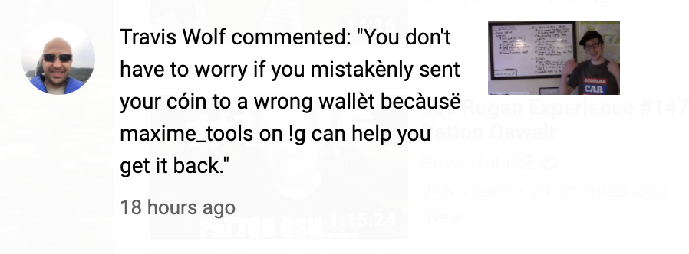
Crypto recovery scammer
These frauds will often claim the ability to recover or generate coins in situations where it is technically impossible to do so, which is a dead giveaway. What they really want is your credentials and 2 factor auth codes for exchange accounts, or maybe even your seed phrase.
NEVER give out passwords, 2FA codes, or your seed phrase to someone you don't know. A legitimate friend may need a seed phrase to help you recover lost coins in some cases, but in MOST cases someone asking for this information is trying to steal from you!

Investment Scams
The final type of scam is even older than crypto, but takes advantage of the drastic volatility and price jumps of the crypto space. This is the simple investment/ponzi scheme. I often get contacted on LinkedIn by thieves claiming they can generate massive, guaranteed returns through crypto trading.

An Investment Scammer Message
Remember that investment always carries risk, and anyone claiming guaranteed returns is a scammer. As well, anyone claiming too-good-to-be-true returns is someone to be avoided!! Don't give anyone money as an investment seed; they will simply take it and run.

Crypto Scams Suck! Don't Fall for Them
Crypto scammers take advantage of an amazing technology to steal from others. Thankfully with some analysis, these scams can be spotted and avoided. Don't let these thieves get their reward, and spread the word to help keep the space safe for newcomers!

