What's Up with My Transaction? - Lost Bitcoin Recovery Flow Chart
Author | josh
Date | 2020-11-11 15:07:20
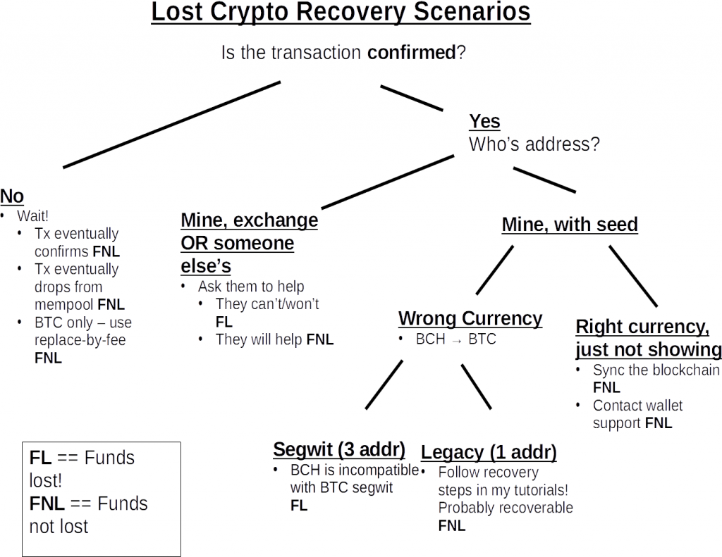
Remember:
* Crypto transactions are irreversible by design. Always double, triple check the receiving address before sending
* Be wary of scammers claiming they can recover lost coins. This is often not technically possible as I've outlined above, and they will use your information to steal from you. No one doing business through instagram, whatsapp, etc. and spamming comments is legitimate
If you think you've got a chance to recover your funds, these tutorials may help:
Recovering BCH sent to BTC Address Video
Article version of the above tutorial
What Happens When You Send BCH to BTC Video
Article version of the above tutorial

