Beginning Bitcoin - Sending Funds From Your Wallet
Author | josh
Date | 2019-09-07 19:01:13

Overview
Getting started with Bitcoin isn't as intimidating as it would seem. In another tutorial, we discussed how to get started with a mobile wallet, using Bitcoin.com's app or the Coinomi wallet. We learned how to install the wallet, safely back up our funds using the seed phrase, and get an address for loading up funds.
But the real use of Bitcoin isn't simply funding a wallet and watching the price bounce up and down. Cryptocurrencies are currencies after all, so they can be spent! Sending Bitcoin is fairly straightforward, but it's a bit of a different mechanism than using a credit card online. Let's learn how to send funds to someone else using the Bitcoin.com mobile wallet, and learn about what makes these transactions different that traditional online payments.

Creating Cryptocurrency Transactions

Sending funds with the Bitcoin.com wallet
Let's donate a dollar to our friends at Eat BCH using the Bitcoin.com wallet. To do this, first open up the wallet with some funds in it, and click on the Send button. You'll see this screen with options to enter a Bitcoin Cash address manually (or copy/paste), or to scan a QR code. I find that scanning a QR code is often the easiest way to get an address, and Eat BCH has one on the website.
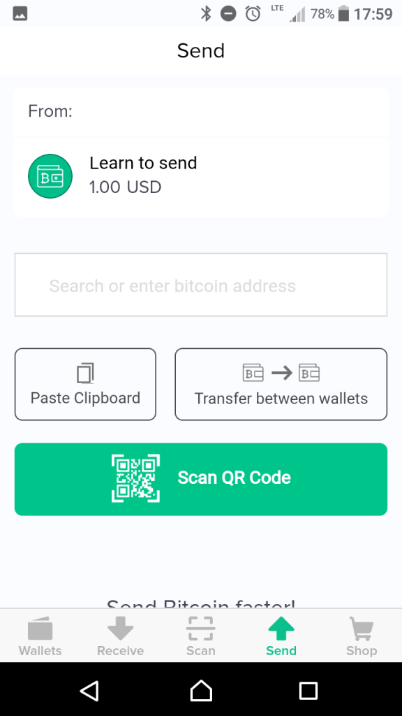
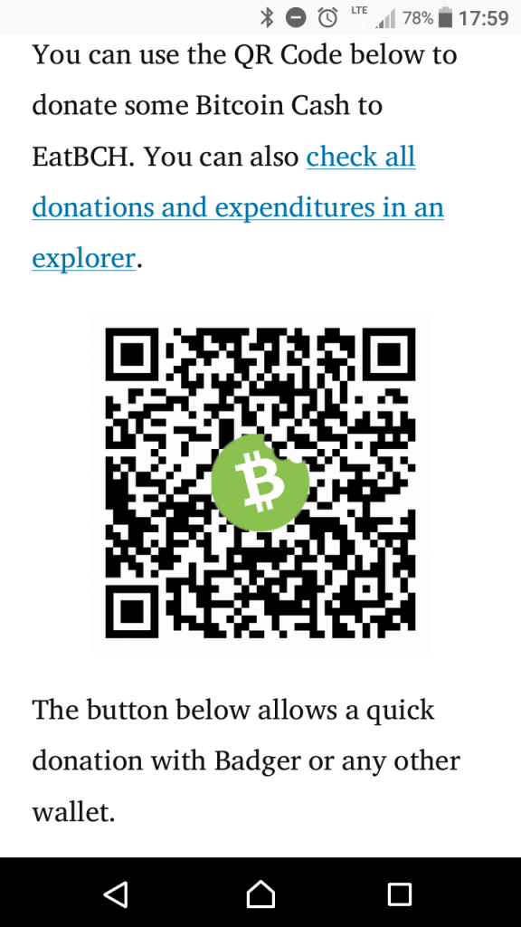
It's always a good idea to double check the address that actually ends up in the transaction preview. Make sure you didn't accidentally copy/paste an incorrect address, or scan the wrong QR code. It happens, and there's also malware out there that has fudged copy/pasted addresses.
Just take a second to make sure you have the destination you actually want. There are no do-overs with cryptocurrency transactions - once they are sent there is no reversal!
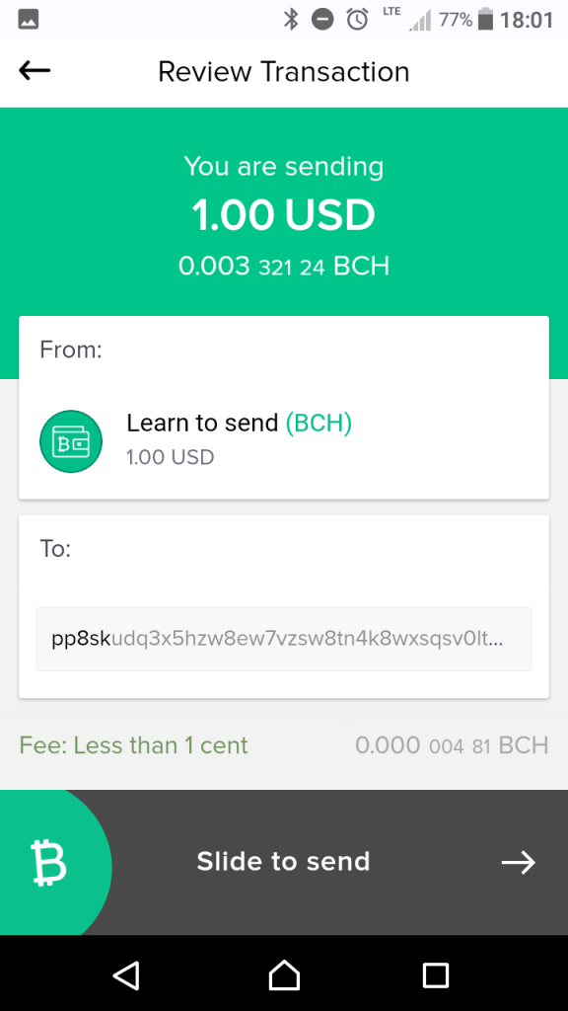
Once everything is verified, slide the Bitcoin logo at the bottom to send. Your transaction will be created, and is on it's way.
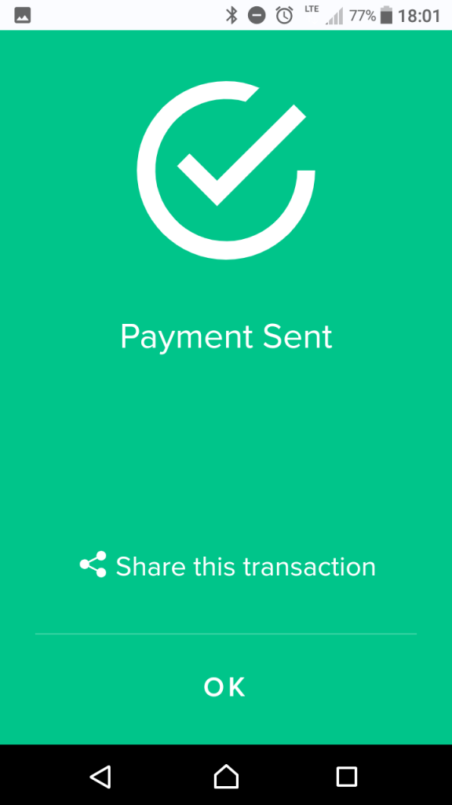

Bitcoin vs. Traditional Online Payments
It's simple to create Bitcoin, Ethereum, and other cryptocurrency transactions with a nice wallet user interface. But these transactions work a bit different than traditional monetary transfers, and it's good to understand how they work at a high level.
The major difference between a cryptocurrency transaction and a traditional credit card/debit card payment is the mechanism. Traditional credit card payments are pull transactions. You give a merchant your credit card information, which is private information you are entrusting to them. They use that number to request funds be pulled from your account, via the Visa/Mastercard/etc. network.
Bitcoin transactions are push transactions. Instead of giving away private information, the merchant has to give you their public address that you push funds to in a transaction. You're in charge of the sending, and no private information is every exchanged.
The true beauty of this system is the increased security you get with this model! You can publish a Bitcoin transaction on a billboard and everything is safe. Try putting your credit card number in a public space and see how long it takes to have major problems!

Bitcoin Transactions - Simple and Secure!
All you need to send money is a wallet with a network connection, some cryptocurrency of your choice, and a recipient address. With a modern mobile wallet, this process is a simple as scanning a QR code and hitting send. Thanks to Bitcoin's security model, you don't have to trust an intermediary like a payment company to process the transaction - it's entirely peer-to-peer. And even more novel and important, there's no need for anyone to reveal private numbers.
If you haven't already, try sending your first transaction! Grab some Bitcoin or Bitcoin Cash, or maybe some Litecoin. Use a few dollars to introduce a friend to cryptocurrency, buy something fun, or donate to a good cause. Adoption is important, and it's easy!

