Recovering BCH (Sent to BTC Address)
Author | josh
Date | 2019-12-23 21:00:01

Overview
Many of the viewers of my tutorial on what happens when you send BCH to a BTC address have asked for more specific help on how to recover funds in this scenario. Fortunately, not all is lost if this happens - it just depends on the context. For non-custodial wallets (where the user controls the private key), it's fairly straightforward to recover the lost BCH and send it back to a wallet the user would like to use. It is important to note, however, that this only works with these non-custodial wallets. If a user sends funds to a custodial wallet (like CashApp or an exchange), they'll have to get in touch with that exchange's customer service for help.

BCH Fund Recovery

What Actually Happens...
If a user sends BCH to a "BTC" address, the funds never really leave the Bitcoin Cash blockchain. The confusion happens because BCH and BTC legacy addresses are backward compatible - so when the user creates the BCH transaction with the BTC wallet address as the receiver, the transaction is totally valid and is sent.
But, the BTC and BCH addresses also share the same private key. Therefore, if the user has access to the BTC wallet's recovery phrase (or the private key directly), they can import/sweep that key into a BCH wallet to get the funds back.

An Example Scenario, With Recovery Steps
For this tutorial, I "accidentally" sent some Bitcoin Cash to a Bitcoin address provided by a blockchain.info wallet. The funds do not show up in my BTC balance, because I actually did this on the BCH chain.
Looking at a block explorer, we can see the mistaken address for this transaction. In legacy format (BCH/BTC backward compatible), we see the address is `1Ka4YZ19kq87yXUAPXMt9KZLd2eap1pT4Y`
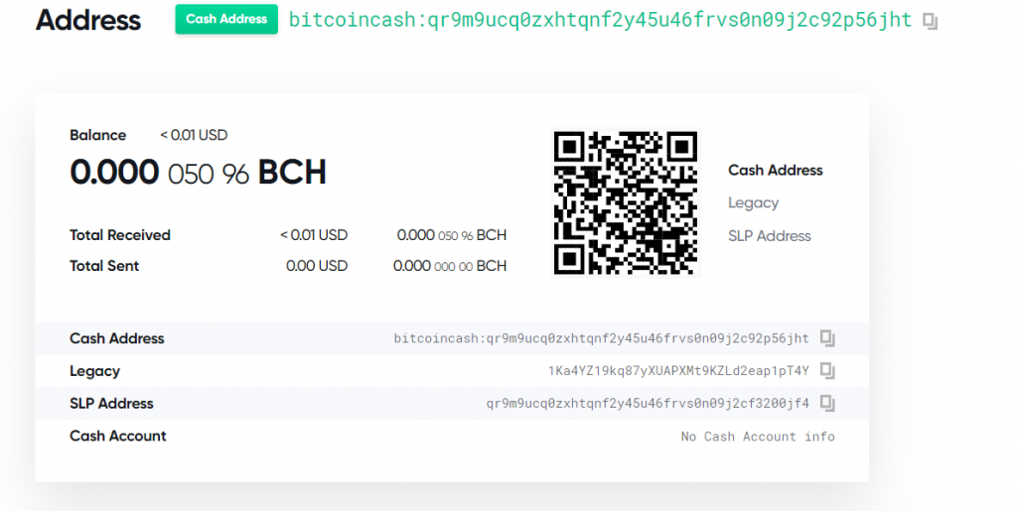
Now what we need to do is to get the associated private key for this address. In this case, blockchain.info provides a mnemonic seed phrase used to generate all the wallet's private keys and associated addresses. Therefore, if we get this seed phrase we can extract the specific key for this address and import it into another wallet we control. The seed phrase for our test wallet here is:
water pulse panel anchor impulse brown effort cake open drastic bright aerobic
It's important that you don't reuse this seed phrase for any of your own wallets - anyone who's seen this tutorial could steal your money!
Now what we can do is import this seed phrase into a mnemonic tool. I'm a big fan of Ian Coleman's Bip39 Mnemonic Code tool. An important note - if you're doing this with real funds, download the webpage and run the tool when your PC is offline. Ian's tool is trusted in the community, but it's best practice to never but private information like seed phrases into online tools - your funds could be stolen by a nefarious website.
When the seed is put in the tool, the derived addresses and keys will be shown in a table like this:
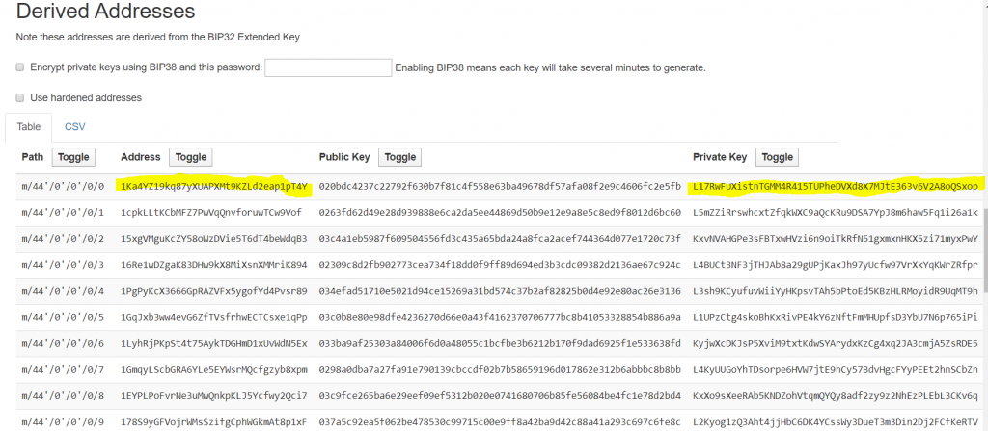
Search for the address you mistakenly sent the funds to. If you've used your wallet a lot, you may have to generate more child addresses. Also, if you don't see the address here, don't panic - play around with some derivation settings. Different wallets use different paths and that sort of thing, but in this case our wallet used the defaults.
Now you need to copy the Wallet Import Format private key shown next to the address - this will allow you to unlock the funds. What we'll do here is import or sweep the address into a BCH wallet we control to recover the funds. Note the distinction - an import keeps the funds in the same address. If you add this to a wallet with an existing backup phrase, the imported address will not be protected by that backup phrase. Sweeping is better - this will create a new transaction that sends the recovered funds to a new address controlled by the wallet's phrase.
Your funds are back! For this sample recover, I imported the funds into an Electron Cash wallet on desktop.
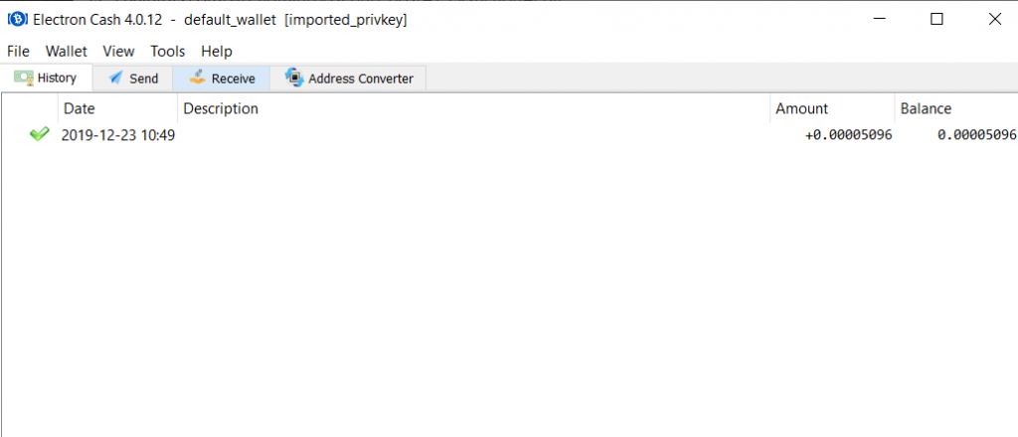

Fund Recovery - It's All About Keys
The most critical step in recovering lost funds is understanding that whoever controls the private keys owns the lost funds. If you've sent your funds off to an exchange or app like CashApp, you'll need help from them because you don't control the keys. But if you accidentally sent funds to an address provided by your own BTC wallet, you can follow these steps to get your BCH back into your normal BCH wallet. It's a matter of getting the key for the mistaken address into a BCH wallet that recognizes the funds on the blockchain.
I hope this helps! It can be scary to lose funds in the cryptocurrency space, where things are a lot more final than in the world of banking. Ultimately though, cryptocurrency gives us more control over our own money and that's a great thing.
Oh and as a little easter egg for my viewers - I left the BCH for this tutorial in the sample address. If you want it, it's yours :) First recovered, first served.

