Part 4, Chapter 5

Investment Scams
Investment scams, in my experience, tend to result in some of the biggest losses in the cryptocurrency space. These scams are also the most likely to hit those that aren’t initially interested in Bitcoin or other technologies but are instead driven by the possibility of financial gains. Investment scams, as the name might suggest, are built on the fraudulent promise of returns if the victim is willing to send coins to the scammer as investment principal.

Often, these scams originate from cold contact on popular social media platforms. I’ve seen Instagram, LinkedIn, Twitter, and Bluesky used for investment scams with a fair amount of regularity. Wasting the time of these scammers often provides valuable information on how the scams actually play out. First, the attacker establishes a rapport with you, asking simple questions about where you’re from, what you do for work, and what your hobbies are. They usually quickly move to the topic of “making passive income” by investing in cryptocurrency.

Examples of Investment Scams
The sophistication and length of these scams, sometimes called pig butchering scams, can vary. In some cases, a lone scammer impersonates a high-profile crypto celebrity and gives a deposit address to you via the chat. I’ve encountered several scammers pretending to be Andreas M. Antonopoulos or Roger Ver. This approach can lend some legitimacy to the scam, given that these figures are well-known experts in the cryptocurrency space.

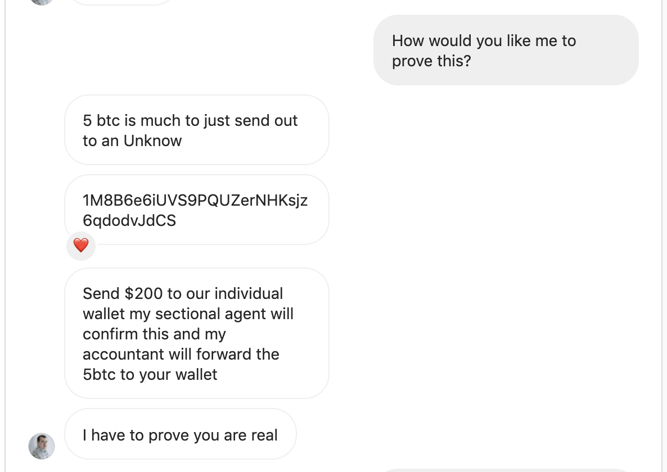An Andreas impersonator asking for coins directly

In most cases, the scammer lures you to a fake but very convincing “investment platform.” These websites, although showing signs of fraud to the trained eye, tend to look quite real. Within the site, you’re prompted to set up an account and make your first deposit into the trading platform. This is where the theft takes place. You’re not actually sending coins to a trading platform at all, you’re simply sending into the wallet of the scammer. Once those coins are sent, there’s no way to reverse the transaction to get your money back.

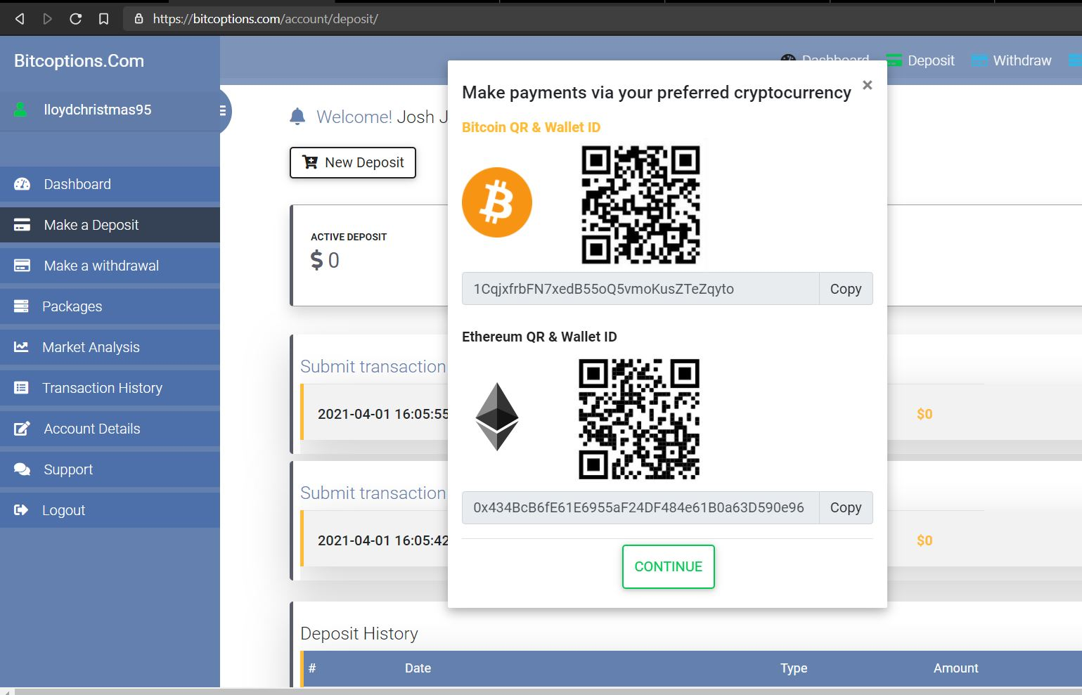A legitimate, modern looking fake trading website

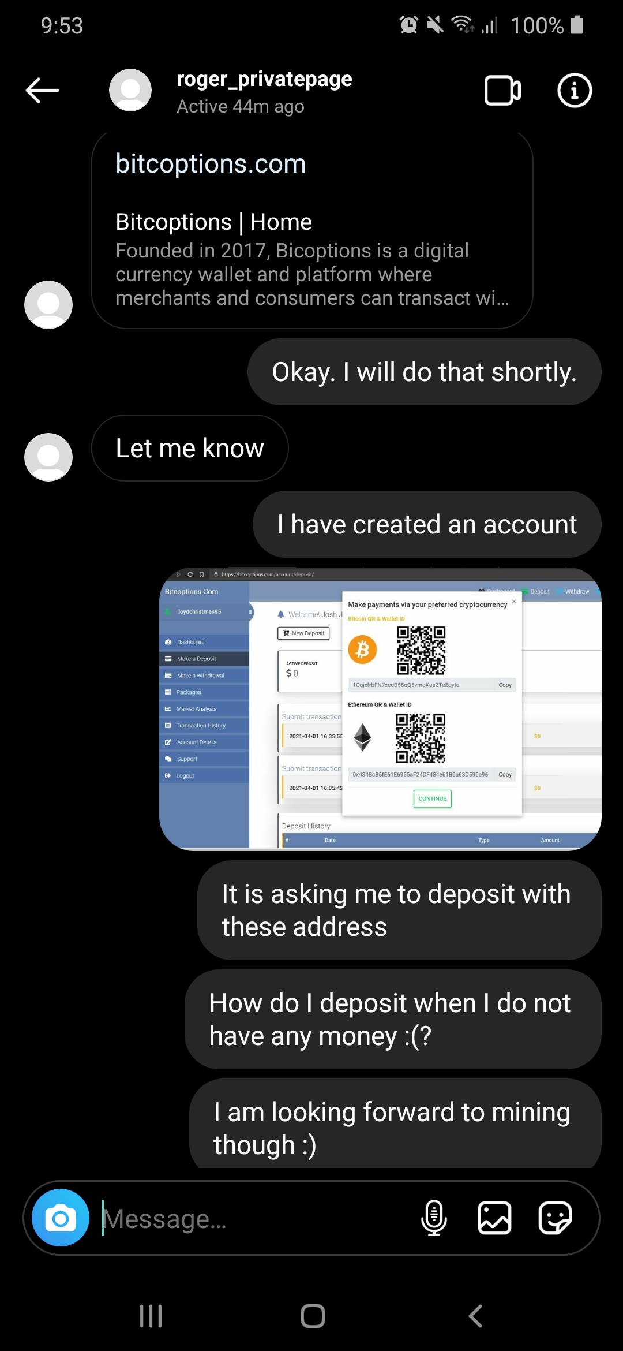A Roger impersonator sending me to a fake trading website

These scams don’t often stop at the first deposit, however. If the scammers know they’ve got you, they will try and extract as much money as possible from you before you catch on. Scammers will typically show “trading gains” via the fake website, making you think that the investment is paying off. One thing you’ll never be able to do, however, is withdraw. The scammers will make up several excuses as to why you cannot get money back out of the platform; most often this reason is fake “taxes.” The attacker will claim that you must pay taxes (in cryptocurrency, of course) before you can withdraw. This is nothing more than a final attempt to extract value from you before you realize that this is a scam.

Mitigation Steps
Investment scams are often difficult to mitigate, because they are multifaceted and tend to offer enticing rewards. What’s worse is that overall, the rise of prices in the last ten years lends some legitimacy to the idea of “quick money” in crypto. However, there are several mitigation tactics we can use to avoid these scams in various stages.
First, be wary of cold-contact messages that immediately lead to talking about investments, especially if those investments are cryptocurrency related. The reality is that crypto is highly speculative at this time, and price fluctuations tend to keep legitimate financial planners away. Regardless, most legitimate investment professionals don’t go right into recommending particular websites – they would instead schedule a call or an office visit. As well, be aware of impersonation – scammers often pretend to be a high-profile or high-net-worth crypto professional to gain your trust. But how likely is it that someone with a large following would contact you out-of-the-blue? Not very!

Cold contact messages discussing "passive income" are often a red flag
Next, take the time to evaluate a supposed investment website or business with a careful eye. Pig butchering scammers go to great lengths to make it appear that they are running a real business, but careful scrutiny can show why these websites and businesses are fraudulent. If you’re technically savvy, using a whois tool can reveal how long a website has been available – a fake investment platform claiming to be 5 years old may have been registered for only a month, a clear red flag. As well, learn to spot fake business registrations or reviews. Scammers have even used pay-for-PR firms to publish news articles on their behalf, making it look as though this business has rave reviews.
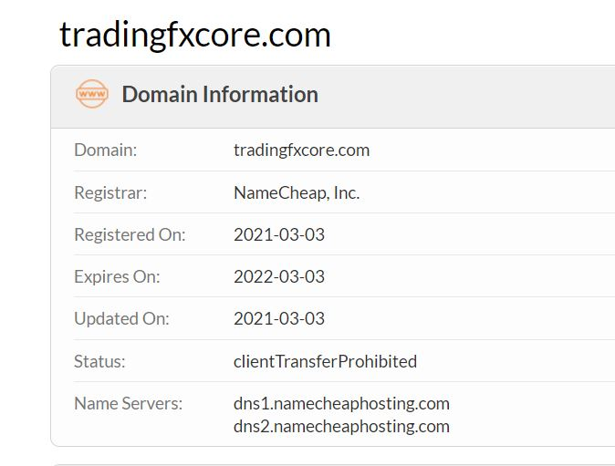A whois tool showing a recently registered fake trading platform
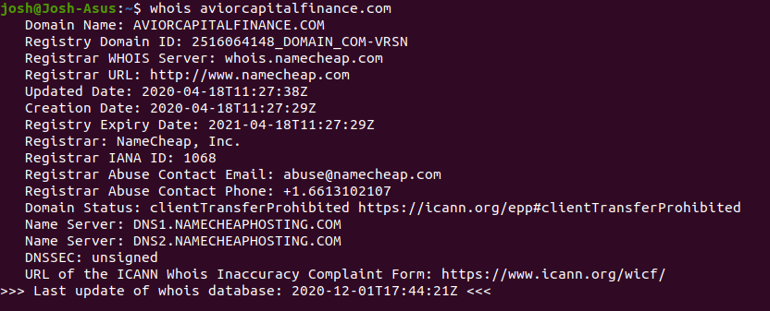A command-line whois record of another fraudulent trading site
Finally, take the time to evaluate if the offered rewards are too-good-to-be-true. These websites often claim outlandish returns, sometimes 50-100% of your investment in a single day. No legitimate investment vehicle offers that type of return. In fact, many of these returns would have you earn more bitcoin than are in existence within a week or two of reinvesting your gains. Doing so would be completely impossible, making the fraudulent claims scary yet comical.
Too-good-to-be-true rates of return listed on a fake crypto investment website

