Part 4, Chapter 6

Blackmail Scams
A typical blackmail scam starts something like this: you receive an email claiming that you have a “pending payment.” This alone can grab your attention if you’re not expecting it. But the scam quickly gets much worse – the scammer claims that they have gained total access to your device with malware! The scammer asserts control of your email, your webcam, your microphone, your files, and your contacts. And the scammer will leak embarrassing information about you to those contacts – unless you pay them in bitcoin.
This type of social engineering scam employs fear, a powerful tactic for exploiting people for money. Threats that take on a legal and social nature are remarkably effective when used for theft, and hackers employ several convincing tactics to make you feel like the threat is legitimate.

Examples of Blackmail Scams
The scammers often use an interesting trick to make you believe you’ve been compromised – they send the email from “your email.” That is, they put your own email address in the “from” field of the email. If your email is x@y.com, the email states it is from x@y.com. This doesn’t actually mean that this email was sent from your own mailbox – it just looks like it.
The scammers then get into the core of the scam – the threat and the demand for payment. Usually, the scammers claim to have used their malware to capture an embarrassing video of you, which they threaten to share with all of your friends, family, and coworkers.
The scammers demand payment in cryptocurrency – usually Bitcoin as it is the most popular and well known digital currency. The scammer claims that if you send payment to their Bitcoin address, they will delete the video and leave you alone.
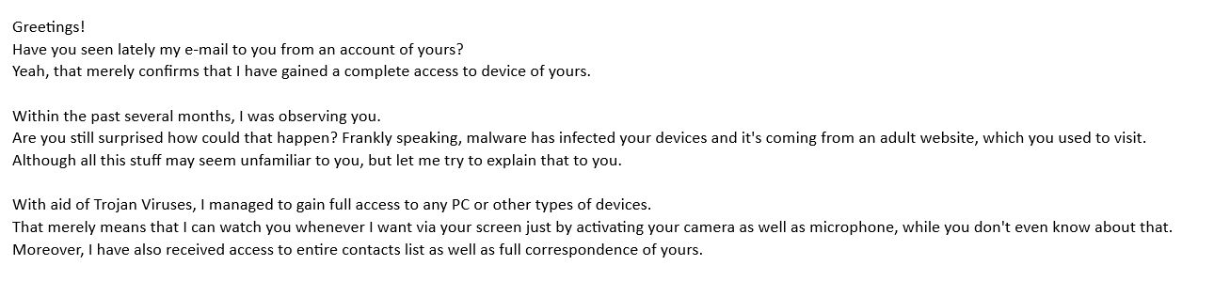A blackmail email specifically noting that it "came from your own email"
These scams can add further layers of threatening information to the emails, such as passwords leaked in previous data breaches. For example, perhaps you had a weak password “hunter2” for a website that suffered a breach. When the attackers cracked your password from that breach, it became publicly available in password dumps circulated around by malicious actors. Many people reuse passwords across websites and other services, and so there’s a likelihood you’re using that same password for your email account. You see your email password within the blackmail message, and believe your email has been compromised, even if it hasn’t.
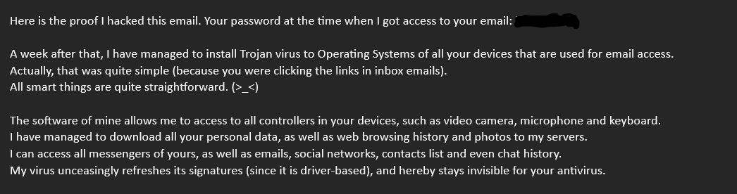A blackmail message with a password from a previous data breach
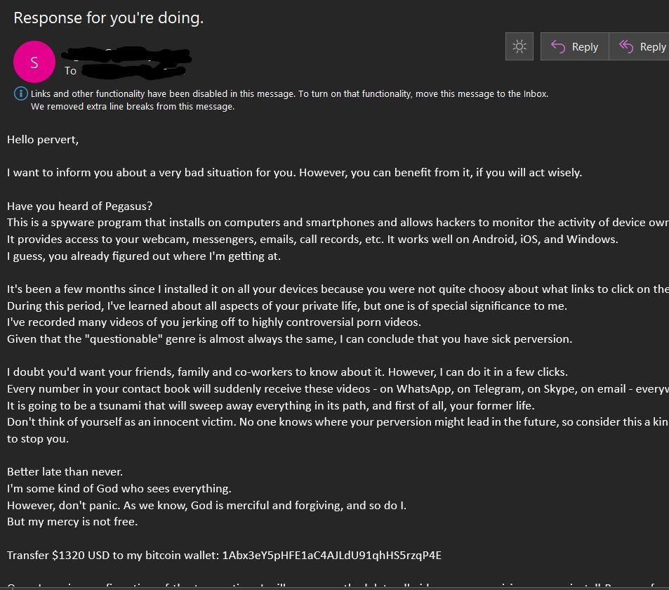A blackmail message with threats and a Bitcoin address

Mitigation Steps
With the email “from” trick and leaked passwords, these blackmail messages can be pretty threatening. In this case, it is important to both slow down and evaluate the threat. It’s pretty unlikely that this attacker actually has full access to your computer. Modern operating systems and antivirus software are pretty good, and malware proliferation doesn’t usually happen through most of the legitimate websites you visit. This is not a foolproof assumption, as this type of spyware does exist. It just isn't that likely that you've acquired it on your system through normal use. Second, you may not do the embarrassing thing that the hacker is threatening you with in the first place.

Even if an attacker did have full access to your PC, your browsing habits, and your contacts, they probably aren’t going to threaten you and ask for a relative pittance in Bitcoin. It would be easier, more efficient, and more discreet to just steal your passwords for bank accounts, cryptocurrency exchanges, or wallets and then steal everything they can that way. Why bother asking you? In this case, they’re asking because they don’t actually have any access to your system at all. They just sent an email (which anyone can do) hoping you’ll panic and send them an irreversible form of payment.

Since scammers don’t actually have anything damaging to you, they simply send you an email with a threat. Remember, anyone can send an email to anyone. And anyone can set the “from” field of an email to anything they want. Scammers rely on fear and time pressure, both of which are classic social engineering tactics. They hope you’ll be scared enough to send them cryptocurrency, which is an irreversible form of payment. However, you don’t have to send them anything! They don’t truly have access to your email, your device, or any private information about you. It’s all a trick using simple mass email tools and social engineering.

