Part 4, Chapter 7

Recovery Scams
All of the scams we’ve discussed so far cover the wide variety of ways an attacker may try to steal cryptocurrency from you – such as investment scams, fake wallets, fraudulent services, malicious airdrops, and blackmail. All result in a loss of cryptocurrency, whether through gaining access to your wallet keys, signing a wallet-draining contract, or directly transacting with a scammer who tricked you via social engineering. The last type of scam we’ll discuss is one that can occur after you have already been victimized by one of these other attacks. This is the fake recovery scam.

After a loss, many users are desperate to try and recover some of their stolen funds. It hurts to lose money, and the fact that the loss occurred due to social engineering could make them feel embarrassed, unintelligent, and desperate to repair the loss. Even though the smartest folks can fall victim to a scam, sophisticated attackers use embarrassment and desperation to their advantage to steal from you again – this time by convincing you to use a fake recovery service. In nearly all cases, it’s not technically possible to recover lost or stolen coins due to the nature of cryptocurrency transactions. Yet, attackers will convince you that they have some special “hacking knowledge” to get your money back, and in the process, steal even more money.

Examples of Recovery Scams
Recovery scammers can advertise their fraudulent services in a myriad of ways, but social media is a useful tool for reaching a wide audience of potential targets. If you’ve ever mentioned keywords like “crypto,” “bitcoin,” “wallet,” or “recovery” in a comment, you may have seen bot replies advertising the services of a professional “hacker.”
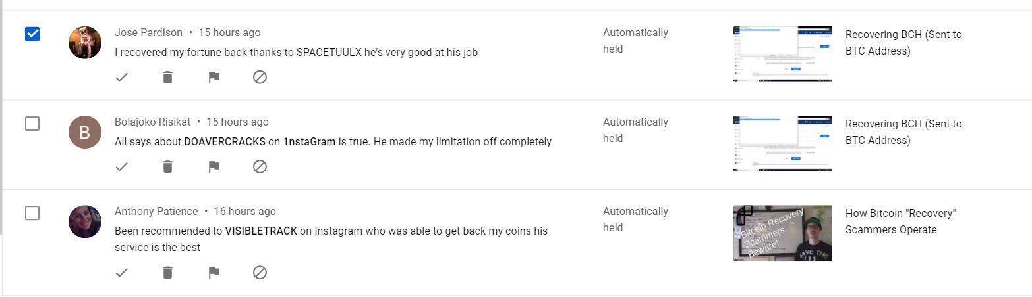Bot comments advertising fake recovery services
These fake services tend to operate on common social media platforms such as Instagram, where targets are readily available and it’s easy to create new accounts once the old ones are reported or deleted. Similar to other scams, attackers sometimes use impersonation – pretending to be a respected figure in the crypto community. I’ve even seen myself impersonated in my own comment section, which is both jarring and hilarious.
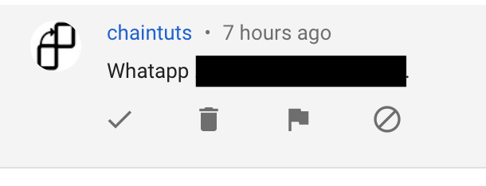A chaintuts impersonator luring potential victims to WhatsApp
Once a recovery scammer has made contact, they can attempt to steal from you in several ways. The first, simplest, and perhaps easiest way is to convince you that they are legitimate and to ask you to pay upfront for services. For example, they may say that their upfront deposit for recovery is $150 in Bitcoin. Once you pay, they can take that money and run, with no way for you to conduct a chargeback.
But once you’re on the hook, the scammers want to extract as much as possible from you. So, they will usually trick you into giving up access to other wallets or exchange accounts in order to empty them out. In one interaction with a recovery scammer, I was asked to provide 2FA codes for a Coinbase account. These codes could be used to conduct a password reset and steal my account without me giving up my password. By using clever technical language, a scammer may convince you this is safe since you don’t have to give a password. Most people are aware that giving a password to someone else is risky. But 2FA codes in the hands of an attacker can be just as dangerous.
Attackers are also likely to ask for a seed phrase if a self-custody wallet was involved in the initial loss. Seed phrases grant access to all of the coins and tokens in a wallet, and so the scammer wants them as an easy means to clean out your account. Seed phrases or individual private keys are a high value target that should never be shared with anyone, let alone a stranger.
Recognizing this part of the scam can actually be difficult, as there are some very rare cases where a seed phrase can be used to recover misplaced coins in your own wallets – for example, if you sent Bitcoin Cash or another Bitcoin fork to a Bitcoin address in your own self-custody wallet. In those cases though, a legitimate helper would likely guide you through those steps yourself, rather than asking for the seed. In my consulting experience, I guide users through their own recoveries as this is the most secure avenue for handling these cases.
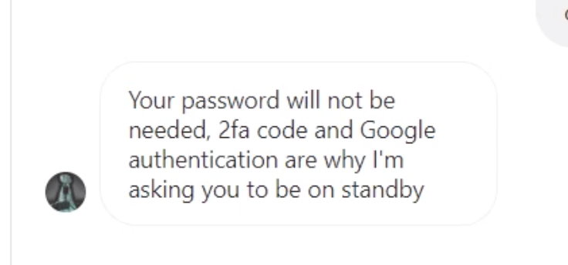A recovery scammer asking for Coinbase 2FA codes
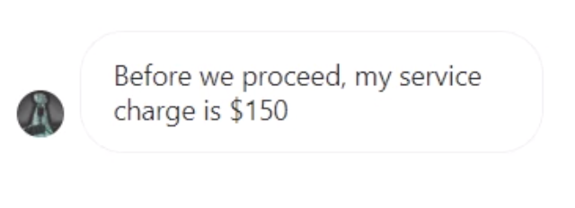The same scammer requesting an upfront payment in Bitcoin

Case Study
A chaintuts viewer on YouTube commented on a video in the midst of a recovery scam. The fraudulent hacker asked them to use CashApp, a custodial service for Bitcoin. The attacker tried to trick them into enabling on-chain transactions, a feature that would allow the scammer to send any of the user’s available balance to their own Bitcoin wallet. I replied to this comment advising the user not to do this, to immediately cut off contact with the scammer, and to change any relevant password and 2FA settings immediately. Thankfully, this user reported that they stopped before the attacker was able to send out coins, but it was a close call.
Lessons Learned:
The attacker was so adamant about enabling on-chain transactions because this would allow them to send themselves coins in an irreversible way. Once a transaction was sent on the Bitcoin blockchain, the attacker would have full access to the coins with no chargeback mechanism available to the user. It’s possible that a CashApp-to-CashApp user transaction – which actually occurs in a centralized database rather than on the blockchain – could be reversed – but certainly not a real Bitcoin transaction.
Never allow anyone access to your accounts, even if they claim it’s for recovery purposes. Someone with access to your exchange accounts could change settings, clean out your accounts, or set you up for future compromise.
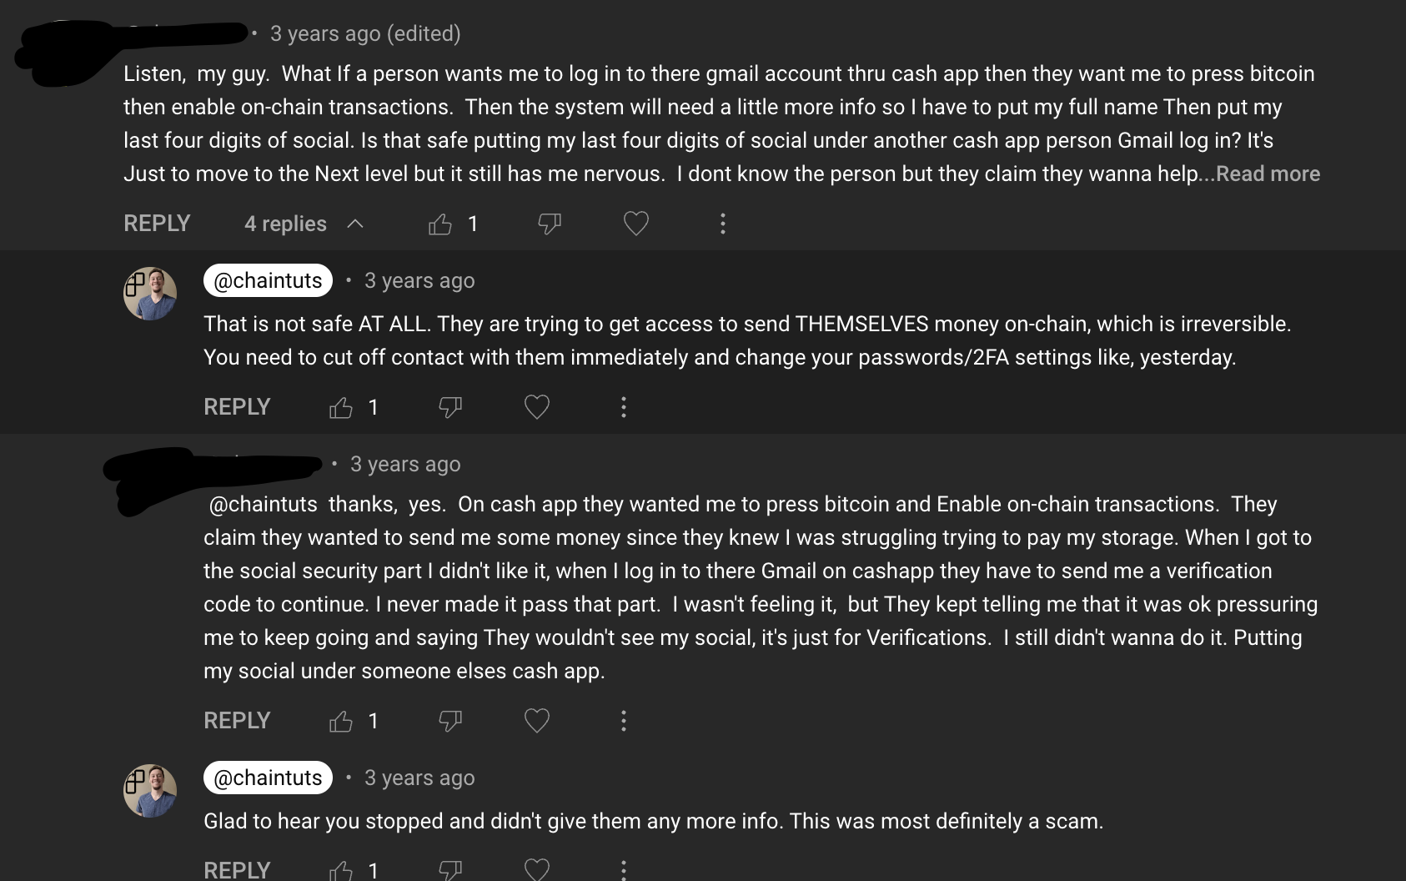A chaintuts viewer almost caught in a recovery scam, asking for Bitcoin via CashApp

