CURICULUM VITAE (CV)

**Detail Personal**

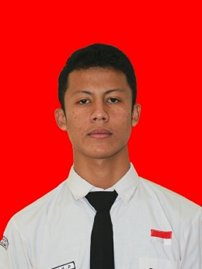Nama : Chairil Rafi Purnama

Tempat Tanggal Lahir : Bandung 13 Juli 1996

Jenis Kelamin : Male

Alamat : Jalan parakan Asri Dalam no 58

Status : Belum Menikah

Number Telephone : 08985722049

Email : [chairilrafi11@gmail.com](mailto:chairilrafi11@gmail.com)

**Edukasi**

|  |  |  |
| --- | --- | --- |
| Periode | Sekolah/Universitas | Major |
| 2013 | Lulus SDN Prakarsa 1 Bandung | - |
| 2016 | lulus SMPN 45 Bandung | - |
| 2018- | SMKN 4 Bandung | Software Engginering |

**Other Skill**

* Microsoft Office
* Internet Literacy
* Android Studio (Prefer)
* HTML, PHP, JAVA , C++, C
* Active English with TOIC , score : **480**

**Working Experience**

* 1 October – 31 December 2018 PKL di CV INSAN BROABBAND NETWOTK

**Project**

* Shafood (Aplikasi Berbagi Makanan) |Mobile Android
* Lembaga Quran Mengaji (Tarq) |Mobile Android
* ShaMind (Forum) |Mobile Android