portfolio.performance.api Prompts
AI Agent: Claude Haiku 4.5 and GPT 5 mini
Consider you are an Forward Deployable Engineer Level 1 and generate code based on below instruction and not production ready level

Epic Name: Portfolio Daily Return Summary API

Business Context: A portfolio performance platform for retail investors and workplace accounts needs a service that calculates a daily return summary for a portfolio using start value, end value, net cash flow and benchmark movement. Advisors and internal operations teams want a fast way to validate whether the portfolio return on a given valuation date is within expected tolerance.

What you are building: A backend-fist API that accepts a valuation request and returns daily return %, benchmark return %, excess return % and a status decision of VALID, REVIWE_REQUIRED or INVALID_INPUT

participant instructions:

1.Build one working backend endpoint using spring Data JPA with MSsql server as db: POST /api/performance/daily-return

2.Reject as INVALID_INPUT if begin market value is less than 0 or end market value is less than 0.

3.Reject as INVALID_INPUT if currency is missing.

4.calculate portfolio return using ((endValue-beginValue-netCashFlow)/beginValue)*100 when beginValue is greater than 0.

5.Reject as INVALID_INPUT if beginValue is equal to 0 and endValue is not equal to 0.

6.set REVIWE_REQUIRED if absolute difference between portfolio return and benchmark return is greater than 5%.

7.set REVIWE_REQUIRED if absolute net cash flow is greater than 20% of begin market value.

8.set VALID otherwise.

9.Use database as mssql server and generate test data if required.

API Sample Request:

{

"portfolioId":"PF-1001",

"validationDate":"2026-06-14",

"beginMarketValue":1000000,

"endMarketValue":1035000,

"netCashFlow":10000,

"benchmarkReturnPct":1.8,

"currency":"USD",

"requwatedBy":"advisor01"

}

API Sample Response:

{

"portfolioId":"PF-1001",

"validationDate":"2026-06-14",

"portfolioReturnPct":2.5,

"benchmarkReturnPct":1.8,

"excessReturnPct":0.7,

"status":"VALID",

"reasons":[],

"processedAt":"2026-06-14T10:30:00Z"

}

Minimum Technical expectation:

1.Layered or equivalent backend structure (controller/service/repository or similar)

2.Input validation and defensive handling of bad requests

3.Simple performance calculation service with deterministic test cases

4.At least 3 meaningful automated tests covering valid, review and invalid scenarios

5.Simple README covering approach, assumptions and how to run

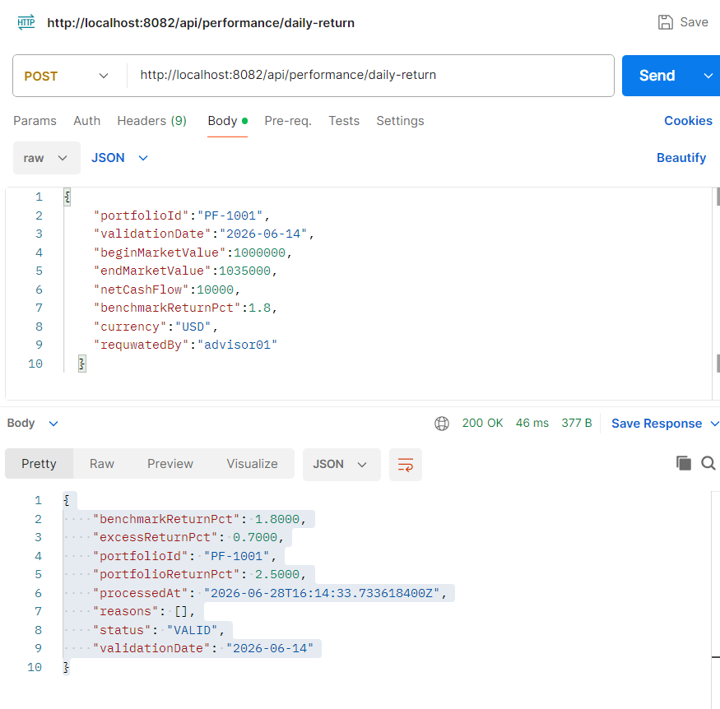
Request CURL command
curl --location 'http://localhost:8082/api/performance/daily-return' \
--header 'Content-Type: application/json' \
--data '{
"portfolioId":"PF-1001",
"validationDate":"2026-06-14",
"beginMarketValue":1000000,
"endMarketValue":1035000,
"netCashFlow":10000,
"benchmarkReturnPct":1.8,
"currency":"USD",
"requwatedBy":"advisor01"
}'

Response
{
"benchmarkReturnPct": 1.8000,
"excessReturnPct": 0.7000,
"portfolioId": "PF-1001",
"portfolioReturnPct": 2.5000,
"processedAt": "2026-06-28T16:14:33.733618400Z",
"reasons": [],
"status": "VALID",
"validationDate": "2026-06-14"
}

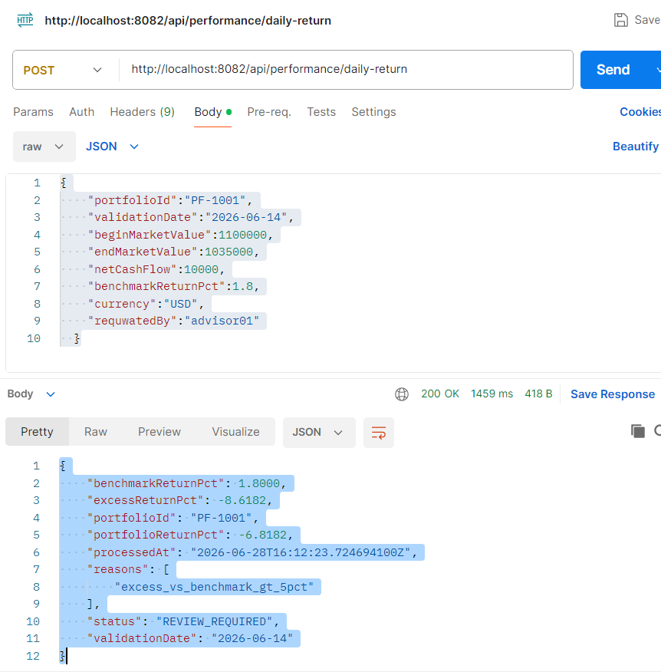
Request CURL command
curl --location 'http://localhost:8082/api/performance/daily-return' \
--header 'Content-Type: application/json' \
--data '{
"portfolioId":"PF-1001",
"validationDate":"2026-06-14",
"beginMarketValue":1100000,
"endMarketValue":1035000,
"netCashFlow":10000,
"benchmarkReturnPct":1.8,
"currency":"USD",
"requwatedBy":"advisor01"
}'
Response
{
"benchmarkReturnPct": 1.8000,
"excessReturnPct": -8.6182,
"portfolioId": "PF-1001",
"portfolioReturnPct": -6.8182,
"processedAt": "2026-06-28T16:12:23.724694100Z",
"reasons": [
"excess_vs_benchmark_gt_5pct"
],
"status": "REVIEW_REQUIRED",
"validationDate": "2026-06-14"
}

