CAS GLOBAL TEACHING MATERIALS INNOVATION CHALLENGE
Instructor Guide
AI-Augmented Catastrophe Claims Management
The Gulf Crest Insurance Company Case
For instructor use. The primary reference document for teaching this 6-hour module.
Gulf Crest Insurance Company, Hurricane Marisol, and all figures are fictional.

Contents
Chapter 1: Introduction 3
Chapter 2: Module Overview 5
Chapter 3: Learning Objectives 7
Chapter 4: Industry Background 9
Chapter 5: Teaching Plan 16
Chapter 6: Assessment 21
Chapter 7: Teaching Notes 23

Chapter 1: Introduction

1.1 Purpose of the Module
This module teaches students to apply actuarial methods and machine learning together on a single, realistic problem: how a property and casualty (P&C) insurer responds to a major hurricane. Rather than treating actuarial science and data science as separate subjects, the module walks students through one continuous decision-making process, from raw claims data to a written recommendation for company leadership, using the same fictional event (Hurricane Marisol) and the same fictional insurer (Gulf Crest Insurance Company) throughout.
The module is built around eight Jupyter notebooks, a Power BI dashboard, and a Student Workbook, and is designed to be completed inside a single 6-hour classroom block (see Chapter 2 for the session breakdown).

1.2 Target Audience
- Undergraduate or graduate students in actuarial science, risk management, or a related quantitative program.
- Students who have completed an introductory statistics course and have some exposure to Python or a similar programming language; no prior insurance industry experience is assumed.
- Instructors looking for a single, self-contained module that bridges the CAS syllabus (Predictive Analytics, Reserving) with applied data science, without requiring a full-semester course.

1.3 Prerequisites
- Basic Python: variables, functions, and familiarity with pandas DataFrames (loading a CSV, filtering rows, computing summary statistics).
- Basic statistics: mean, median, standard deviation, and an intuitive understanding of a probability distribution.
- No prior actuarial coursework is required. Every actuarial concept used in the module (loss ratio, reserving, catastrophe thresholds) is introduced from first principles in the Student Workbook and in Chapter 4 of this guide.

1.4 Teaching Philosophy
The module follows one guiding principle: keep it simple. Every technique used in the core build is chosen because it is both teachable and completable inside a 6-hour classroom module by a student without a specialized machine learning or actuarial background. Where a more advanced technique exists (for example, Mack's stochastic reserving model, or a graph neural network for fraud detection), it is mentioned only as an optional stretch note for advanced students, never as a requirement.
Research and industry benchmarks inform the module's realism (fraud rates, claim severity distributions, catastrophe thresholds), but they are not turned into a checklist of techniques to cram in. The result is a module that stays approachable for a student new to both fields, while still reflecting how a real actuarial team would actually reason through a catastrophe response.
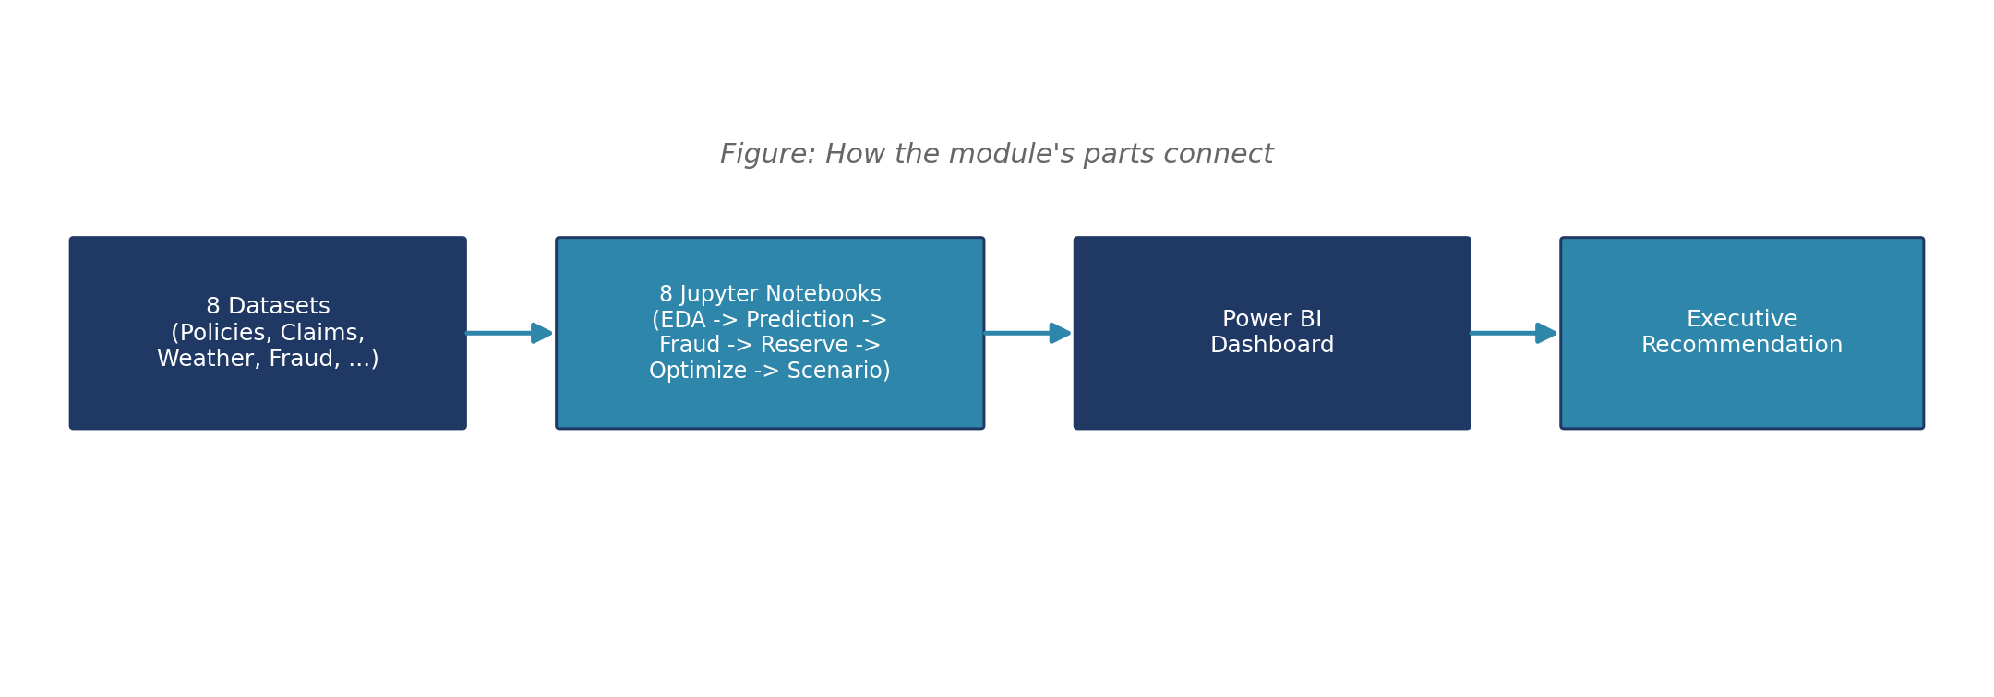

1.5 Why a Single Continuous Scenario
Many teaching materials cover actuarial and data science methods as a series of unrelated exercises, one dataset per technique. This module deliberately does the opposite: every notebook works from the same eight datasets, describing the same fictional company and the same fictional catastrophe, so a student's understanding compounds across the day rather than resetting with each new topic.
This has two practical benefits for teaching. First, a figure introduced early (for example, Zone Z2's high wind and surge readings in Notebook 1) pays off later (the same zone's elevated claim rate in Notebook 2, and its outsized share of the reserve estimate in Notebook 5), which rewards students for paying attention throughout rather than only within a single notebook. Second, it mirrors how an actual actuarial team works: nobody at a real insurer analyzes claim severity in isolation from fraud risk, reserving, or resource allocation. They are all facets of the same underlying claims population, considered together.

1.6 What Students Will Produce
By the end of the 6-hour module, each student will have: completed written and multiple-choice responses in the Student Workbook covering all eight notebooks; run and interpreted eight Jupyter notebooks producing real model outputs (not toy examples); reviewed a Power BI dashboard summarizing those same findings for a non-technical audience; and read a full executive recommendation memo modeling the kind of communication expected of a working actuary. The Assessment Package (Deliverable 7), completed after the 6-hour module, then asks students to apply the same skills independently to a country and event of their own choosing.

Chapter 2: Module Overview

2.1 Duration
The module is designed to run in 6 hours of classroom time, split across six sessions (see Chapter 5 for the full teaching plan). It can be delivered in a single extended session, across two half-day blocks, or spread across a week of shorter class meetings, depending on the instructor's schedule.
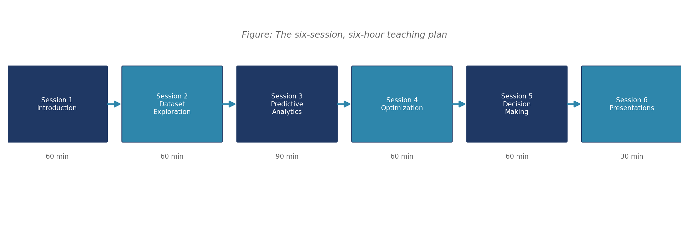

2.2 Number of Sessions
Session | Focus | Suggested duration
Session 1 | Introduction | 60 minutes
Session 2 | Dataset Exploration | 60 minutes
Session 3 | Predictive Analytics | 90 minutes
Session 4 | Optimization | 60 minutes
Session 5 | Decision Making | 60 minutes
Session 6 | Presentations | 30 minutes

2.3 Software Required
- Python 3.9 or later, with pandas, numpy, scikit-learn, and matplotlib installed (a requirements file is included with the notebooks).
- Jupyter Notebook or JupyterLab, or an equivalent notebook environment (Google Colab works without local installation).
- Power BI Desktop (free) to open the companion dashboard file, or a web browser to view the interactive HTML dashboard alternative provided alongside it.
- A spreadsheet program (Excel, Google Sheets, or similar) to open the two datasets provided in Excel format for instructors who prefer not to open a CSV directly.

2.4 Learning Approach
The module uses a guided-discovery approach. Each notebook poses a business question before showing any code (for example, “how much will these claims ultimately cost?”), then walks through the analysis needed to answer it, with discussion questions embedded at each step. The Student Workbook mirrors this structure with worked examples, multiple-choice checks, and short written questions so students can consolidate what each notebook covered before moving to the next one.
Instructors are encouraged to pause between notebooks for the discussion questions listed in Chapter 7 (Teaching Notes) rather than treating the notebooks as a code-along exercise to complete silently.

2.5 How This Module Fits Around the Assessment Package
The 6-hour module and the Assessment Package (Deliverable 7) are related but separately timed. The six sessions in this chapter cover the in-class content; the Assessment Package's five components (Individual Quiz, Group Assignment, Coding Assignment, Presentation, and Reflection) are typically assigned as follow-up work due over the following one to two weeks, since the Group Assignment in particular requires students to research a real country and event outside of class time. Session 6 (Presentations) is reserved for an in-class wrap-up and a preview of that follow-up work, not for grading the Assessment Package's own presentation component.

2.6 Delivery Formats
The module has been designed to work in three common delivery formats without modification to its content:
- Single full-day block: all six sessions delivered back-to-back in one 6-hour sitting, with a short break after Session 3.
- Two half-day blocks: Sessions 1-3 on the first day, Sessions 4-6 on the second, which naturally splits the module at the boundary between data exploration/modeling and optimization/decision-making.
- Weekly short sessions: each of the six sessions delivered as its own 60-90 minute class meeting across a two- to three-week span, which gives students more time between sessions to complete the corresponding Workbook activities as homework.

Chapter 3: Learning Objectives
By the end of this module, students will be able to:
- Understand Property and Casualty insurance: explain what a policy, premium, claim, and total insured value are, and describe how an insurer's financial statements respond to a catastrophe.
- Analyse insurance data: identify missing data patterns, distinguish missing-at-random from missing-for-a-reason, and describe a right-skewed severity distribution and why it matters for modeling.
- Estimate claim severity: fit and compare a Gamma GLM and a gradient boosting model, and explain the trade-off between predictive accuracy and interpretability.
- Estimate reserves: build a claims development triangle, and apply both Chain Ladder and Bornhuetter-Ferguson, explaining why the choice between them matters immediately after a new catastrophe.
- Identify fraudulent claims: recognize why accuracy is a misleading metric under class imbalance, and apply class weighting, SMOTE, and Isolation Forest as three different responses to that imbalance.
- Optimize claim handling: design and evaluate a claims triage rule that balances efficiency against fairness under a limited daily processing capacity.
- Make actuarial decisions: run a sensitivity analysis across a model's key assumptions and judge whether a conclusion is stable enough to act on.
- Communicate recommendations: write a concise, evidence-based recommendation memo for a non-technical executive audience, in the style produced in Notebook 8.
Key definition: Alignment with the CAS syllabus
These objectives map directly to CAS Exam content on ratemaking, reserving, and predictive analytics: Gamma GLMs and gradient boosting (Predictive Analytics), Chain Ladder and Bornhuetter-Ferguson (Basic Ratemaking and Reserving), and classification under class imbalance (Predictive Analytics). The module is not a replacement for exam preparation, but it gives students a single worked case where these methods are applied together on one dataset rather than in isolation.

3.1 Objective-to-Notebook Mapping
Instructors assessing which objectives a given student has met can use this table to trace each objective back to the notebook(s) and workbook activity where it is taught and practiced.
Objective | Primary notebook(s) | Workbook activity
Understand P&C insurance | 1 | Activity 1
Analyse insurance data | 2 | Activity 2
Estimate claim severity | 3 | Activity 3
Identify fraudulent claims | 4 | Activity 4
Estimate reserves | 5 | Activity 5
Optimize claim handling | 6 | Activity 6
Make actuarial decisions | 7 | Activity 7
Communicate recommendations | 8 | Activity 8
Because each objective maps to exactly one notebook and one workbook activity, a student's Workbook completion record doubles as a rough check on which objectives still need reinforcement before the Assessment Package is due.

Chapter 4: Industry Background
This chapter gives instructors enough industry context to teach the module confidently, even without a background in insurance. Each section is written to be read aloud or paraphrased directly to students during Session 1.

4.1 Property Insurance
Property insurance pays a policyholder for damage to a covered building or its contents, in exchange for a premium. Gulf Crest's book of business (see Chapter 4 of the Student Workbook, Part A) is split between homeowners insurance (residential property) and commercial property insurance (business-owned buildings and contents). Every policy carries a total insured value (TIV), the maximum an insurer could owe if the property were a total loss, and records rating factors such as construction type and geographic zone that affect how much damage a given event is likely to cause.
Formula: Loss ratio
Loss ratio = Incurred losses / Earned premium.
It measures how much of every premium dollar collected is being paid back out in claims. A loss ratio below 100% means an insurer is collecting more in premium than it pays out in losses (before accounting for expenses); a loss ratio above 100% means the opposite.
Gulf Crest's dashboard reports a loss ratio of 65.7% across the full claims history shown, but this figure moves sharply upward the quarter Hurricane Marisol lands, since incurred losses jump from about $8.6 million to $44.5 million while premium keeps growing at its normal, steady pace.

Two other figures worth introducing here, since students will see them throughout the module: gross written premium (GWP), the total premium an insurer books before any reinsurance cessions or other deductions, and earned premium, the portion of written premium that corresponds to coverage already provided (a one-year policy earns its premium gradually over the year, not all at once when it is written).

4.2 Motor Insurance
Motor (auto) insurance is not part of Gulf Crest's book of business and is not modeled anywhere in this module, but it is worth a one-sentence contrast for students: unlike property claims, most motor claims settle quickly and involve a well-understood, standardized damage assessment process, which is why catastrophe reserving (Section 4.4 below) is a much smaller concern for a motor-only insurer than it is for a coastal property insurer like Gulf Crest.

4.3 The Claims Process
A claim moves through a predictable sequence of stages from the moment a policyholder reports a loss to the moment it is finally paid or denied. Understanding this sequence explains why, 30 days after Hurricane Marisol, most catastrophe claims in the dataset are still open.
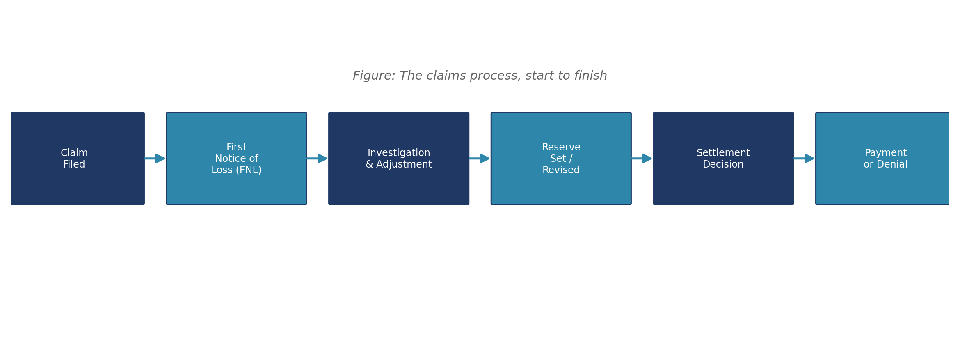
- Claim filed: the policyholder notifies Gulf Crest that a covered loss has occurred.
- First notice of loss (FNL): the claim is logged into Gulf Crest's system and assigned a claim identifier.
- Investigating and adjusting . The adjuster examines the damage, verifies coverage and estimates the cost of repairing or replacing the loss.
- Reserve established or adjusted: Gulf Crest establishes (reserves) an estimated dollar amount to cover the eventual payout, and adjusts it as more information is obtained.
- Settlement decision: Gulf Crest arrives at an agreed-upon final payout amount with the policyholder or denies the claim if it is not covered.
- Paid or denied: the claim is closed by issuing a payment or documenting a denial.
A severe catastrophe like Hurricane Marisol generates far more claims than routine operations, which slows every stage of this process. This is why, at the 30-day mark used throughout the module, most catastrophe claims are still in the investigation or reserve stages rather than closed.
Worked example: Reading the claims process into the numbers
Gulf Crest recorded 2,883 total claims after Hurricane Marisol, of which 2,021 are catastrophe claims and 862 are routine, non-storm claims (Notebook 1).
Of the 2,021 catastrophe claims, the large majority remain Open 30 days after landfall (2,035 of 2,883 claims company-wide are Open), because most have not yet completed the investigation and adjustment stage described above.
Only 904 of 2,883 claims have a formal reserve review on record at all (Notebook 5), and for Hurricane Marisol specifically, only 43 of 2,021 claims have completed that stage. This single fact, more than any other, explains why the reserving methods in Section 4.4 below behave so differently for Marisol than for Gulf Crest's routine book.
Ask students: if only 43 of 2,021 Marisol claims have been reviewed, what does that imply about how much confidence to place in any reserve estimate based only on claims paid so far? This sets up the Chain Ladder failure mode covered next.

4.4 Reserving
A reserve is money an insurer sets aside today to pay for a claim that has not yet fully settled. Reserving well matters because an insurer's reported financial health depends directly on getting this estimate right: reserving too little understates the company's true liabilities, and reserving too much ties up capital unnecessarily.
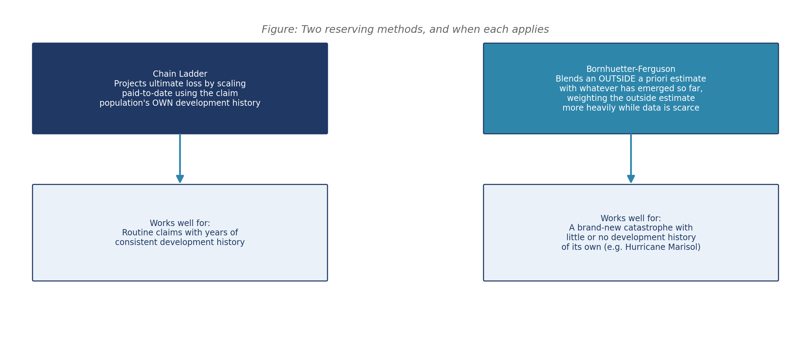
Key definition: Development triangle
A table that tracks how a group of claims from the same origin period (for example, a quarter) has paid out over successive development periods since. Older origin periods have had time to reach later development ages, filling in more of the triangle, while the most recent origin periods have only reached their earliest development ages, leaving the triangle's later columns empty. This shape is exactly why the table is called a triangle rather than a rectangle.

Chain Ladder projects a claim population's ultimate cost by scaling up what has been paid so far, using a development pattern learned from that same population's own claims history. It works well for routine claims with years of consistent development behind them, but fails immediately after a brand-new catastrophe, since there is no relevant development history yet for that catastrophe's own claims. Bornhuetter-Ferguson solves this by blending an outside, a priori estimate (often a bottom-up adjuster estimate) with whatever has emerged so far, weighting the outside estimate more heavily while data is scarce. Notebook 5 works through both methods on Gulf Crest's own data and shows exactly why naively applying Chain Ladder to Hurricane Marisol badly understates the true reserve need.
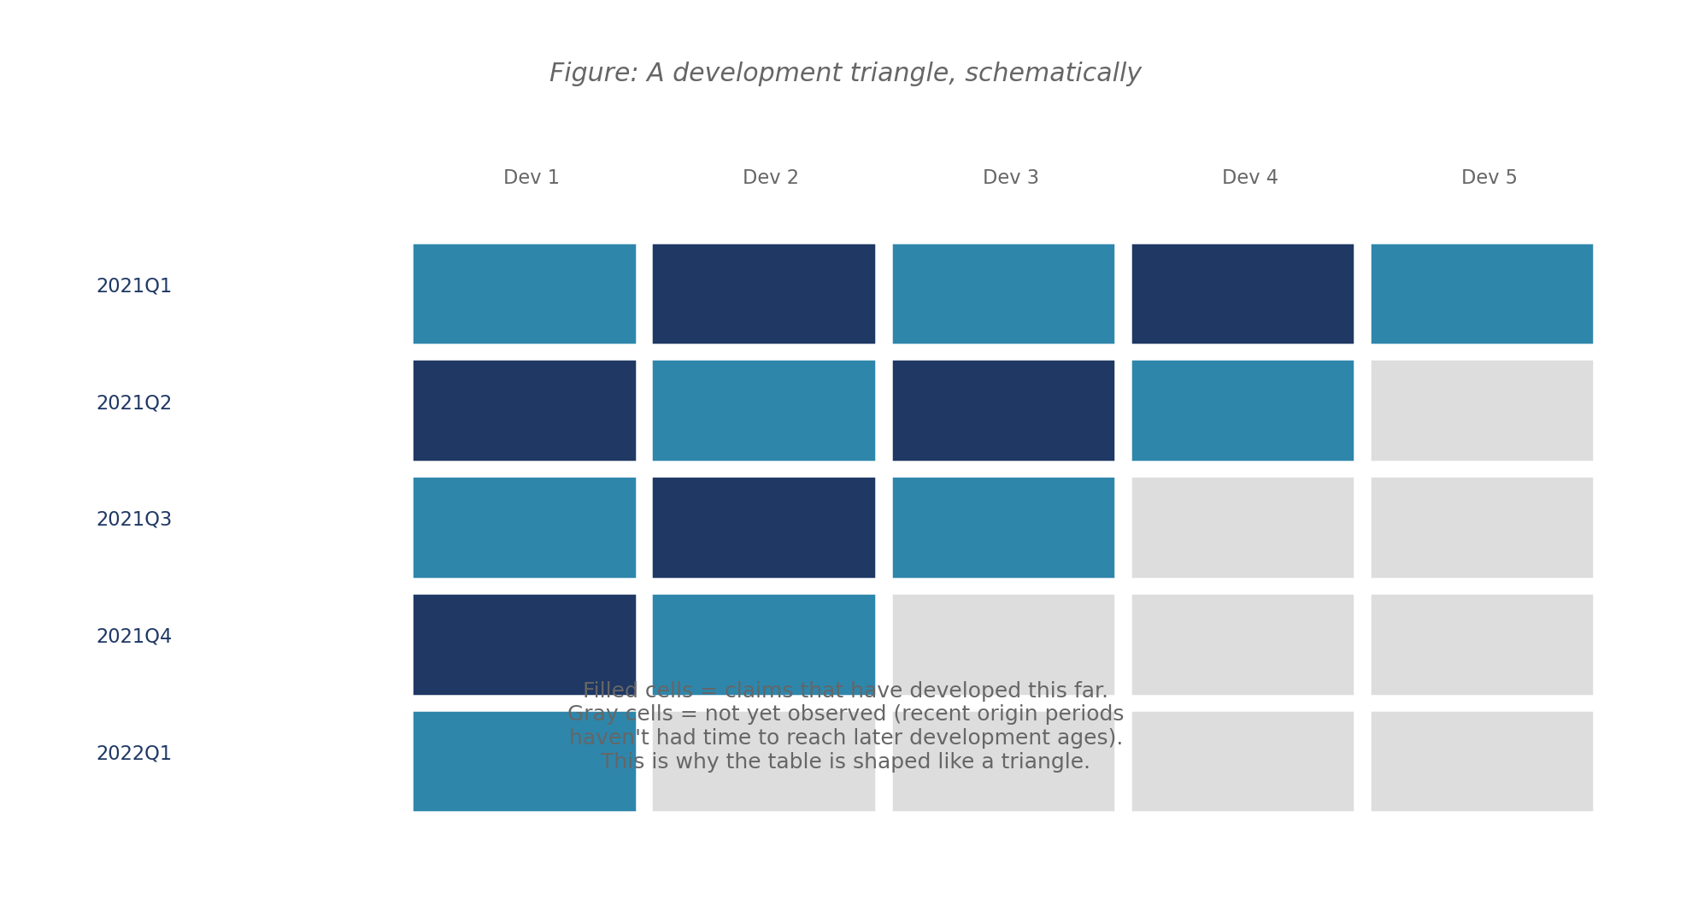
Formula: Chain Ladder
Ultimate estimate = Paid to date x Cumulative development factor (CDF) to ultimate.
The CDF comes from age-to-age factors computed from the triangle's own historical pattern: how much, on average, claims at one development age still grow by the time they reach the next age.

Worked example: Why naive Chain Ladder fails for Hurricane Marisol
Gulf Crest's routine claims have a cumulative development factor (CDF) of 1.2165 at development age 1, meaning routine claims paid at age 1 still grow by about 21.65% on their way to their ultimate value.
Hurricane Marisol's 43 reviewed claims have paid $38,371.64 so far. Applying the routine CDF of 1.2165 to that figure gives a naive Chain Ladder ultimate of just $46,678.84.
Compare that to the adjusters' own bottom-up estimate for the full Marisol claim population: $167,999,241.68. The naive Chain Ladder estimate is off by roughly three orders of magnitude.
Why does it fail so badly? Because the 1.2165 factor describes how routine claims (which pay out quickly, with a short tail) develop, not how large catastrophe claims (which pay out slowly, over months, with a long tail) develop. Applying one population's development pattern to a completely different population produces a meaningless result, however mechanically correct the arithmetic is.

Formula: Bornhuetter-Ferguson
Ultimate estimate = Paid to date + (1 - Percent paid so far) x Prior expected ultimate.
The 'prior expected ultimate' is the outside, a priori estimate (here, the adjusters' bottom-up figure); the 'percent paid so far' is a judgment-based assumption about how mature the claims are.

Worked example: The Bornhuetter-Ferguson calculation for Hurricane Marisol
Prior expected ultimate (adjusters' bottom-up estimate): $167,999,241.68.
Paid to date across the 43 reviewed claims: $38,371.64.
Assumed percent paid so far: 5% (a judgment-based assumption, since Marisol has no development history of its own to estimate this from directly).
Ultimate estimate = $38,371.64 + (1 - 0.05) x $167,999,241.68 = $159,637,651.24.
Reserve needed = Ultimate estimate - Paid to date = $159,637,651.24 - $38,371.64 = $159,599,279.60.
Notice how little the small amount actually paid so far moves the final answer: at this early stage, the BF estimate is still driven almost entirely by the outside prior, exactly as the method is designed to behave.

4.5 Catastrophe Events
An event is generally treated as a declared catastrophe once its aggregate insured losses cross an industry-recognized threshold; the real-world PCS/Verisk convention uses $25 million or more in a single event. This module uses a simplified $1 million threshold to keep the concept easy to teach, while preserving the same underlying idea: past this point, an event is large enough that it needs to be tracked, reserved for, and reported on separately from routine, day-to-day claims activity.
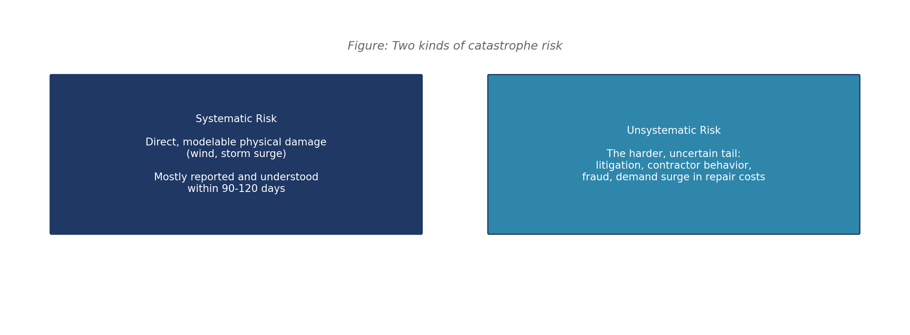
The systematic-versus-unsystematic risk framing (Chapter 4, Student Workbook Part B) is a useful teaching device here: the direct physical damage from wind and storm surge is systematic (correlated across many policies at once, and relatively fast to assess), while fraud, litigation, and repair-cost inflation are unsystematic (claim-specific, slower to resolve, and harder to predict). This is exactly why a catastrophe is harder to reserve for than routine claims: a much larger share of its ultimate cost sits in the harder-to-predict unsystematic tail.

4.6 Pricing
Pricing (ratemaking) is not directly modeled in this module's notebooks, but it is worth explaining to students how the module's findings would eventually feed into it. An insurer's premium for a given policy is built from its expected claim frequency and severity, loaded for expenses and a profit margin, and adjusted for the policy's own rating factors (construction type, zone, coverage type). A severity model like the GLM built in Notebook 3 is exactly the kind of model an actuary would use to inform a future rate filing, which is part of why Notebook 3 emphasizes the GLM's interpretability: a rate filing needs to be explained and defended to a regulator, factor by factor.
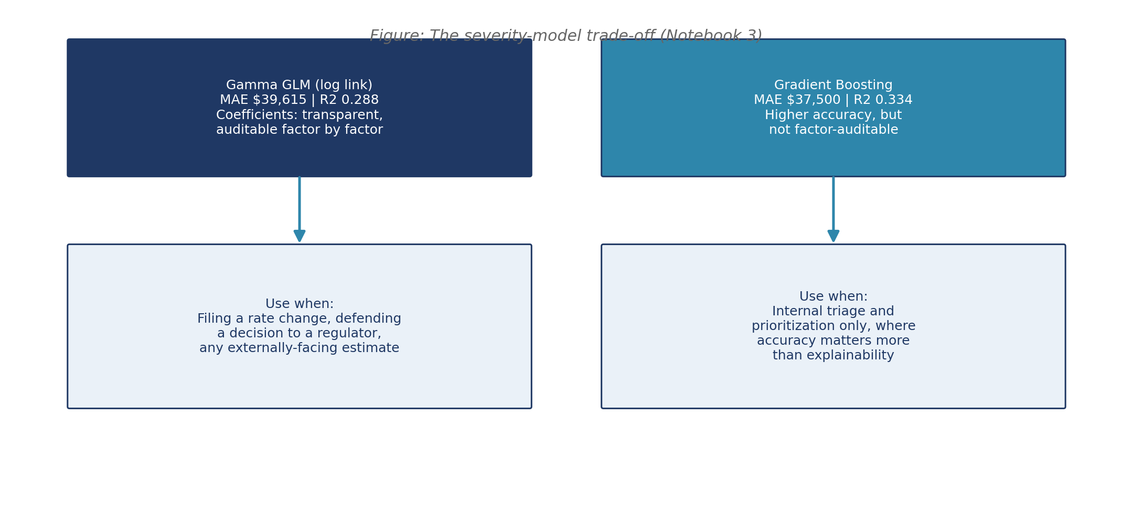

Why a Gamma GLM, specifically
Claim severity is strictly positive (a claim cannot cost a negative amount) and right-skewed (most claims are modest, a few are very large). Ordinary linear regression assumes normally distributed errors and can predict impossible negative severities; a Gamma distribution with a log link matches both the positivity and the skew, which is why it is the standard starting point on the CAS syllabus for severity modeling, and why Notebook 3 uses it rather than plain linear regression.
Gradient boosting makes no such distributional assumption; it instead learns nonlinear splits and interactions directly from the data, which is part of why it scores modestly higher on both MAE and R-squared in Notebook 3 (see Figure above), at the cost of not being expressible as a small set of auditable coefficients.

4.7 Claims Analytics: Fraud Detection and Triage
Two further techniques recur throughout the module and are worth introducing here alongside the more traditional actuarial content above, since they draw on the same claims data.

Fraud detection under class imbalance
Only 15% of investigated Gulf Crest claims are confirmed fraud. A model that predicts “not fraud” for every single claim scores 85% accuracy while catching zero actual fraud cases, which is why Notebook 4 shifts to precision, recall, and F1 as soon as this imbalance becomes apparent.
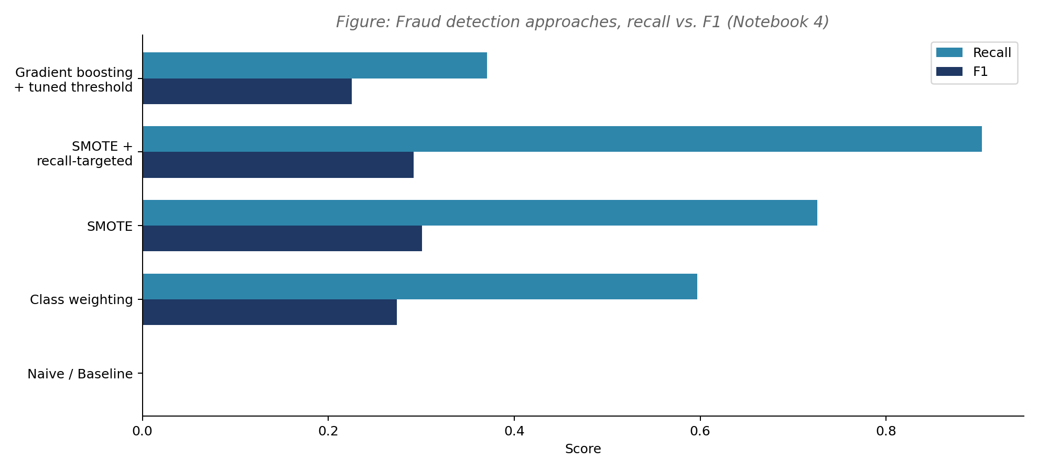
Key definition: Precision, recall, and F1
Precision: of the claims flagged as fraud, what share actually are fraud. Recall: of the claims that actually are fraud, what share the model successfully flags. F1: the harmonic mean of precision and recall, a single number that balances both.
Class weighting and SMOTE are two different ways of correcting a classifier's training process so it stops defaulting to the majority class; Isolation Forest instead flags anomalies without needing any fraud labels at all, which matters because 43% of Gulf Crest's claims have not yet been formally investigated.

Claims triage as a scoring-and-ranking problem
With more open claims than adjusters can process in a day, Gulf Crest needs a rule for what gets worked first. Notebook 6 builds a simple, transparent priority score rather than a full operations-research optimization model, deliberately keeping the technique inside what a student can build and explain in one class session.
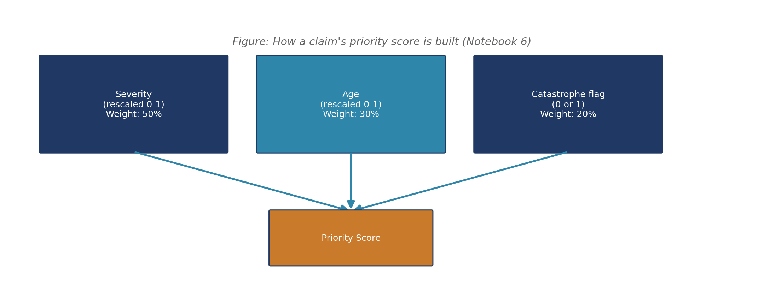
The weights (severity 50%, age 30%, catastrophe flag 20%) are a stated judgment call, not something derived from data. This is worth discussing explicitly with students: no historical dataset reveals the objectively correct trade-off between these three factors, so stating the weights plainly is more honest, and easier for management to review and adjust, than disguising an equally subjective choice as if it were data-driven.

4.8 Reinsurance
Reinsurance is insurance for insurers: Gulf Crest can transfer part of its own risk to a reinsurer in exchange for a share of its premium, reducing how much it would have to pay out of its own capital after an event like Hurricane Marisol.
Structure | How it works
Excess-of-loss | The reinsurer pays losses above a set retention (a per-claim or per-event threshold); Gulf Crest keeps everything below that line.
Quota share | The reinsurer takes a fixed proportional share of every policy's premium and every loss, regardless of size.
Reinsurance recoveries are explicitly out of scope for this module's reserve estimates (see Notebook 8's Limitations section): the $159.6 million Bornhuetter-Ferguson estimate produced in Notebook 5 is Gulf Crest's gross exposure before any reinsurance recovery, not its final net cost. This distinction is worth emphasizing to students, since it is also the subject of one of the harder quiz questions in the Assessment Package.

4.9 Glossary of Key Terms
A quick-reference list of every term used across the module's notebooks, workbook, and assessment, in the order a student is likely to encounter them. Cross-reference the section above for a fuller explanation of any term marked with a section number.
Term | Definition
Policy | A contract in which a customer pays premium in exchange for the insurer promising to pay covered losses.
Claim | A request for payment filed by a policyholder after a covered loss occurs.
Premium / Gross Written Premium (GWP) | The amount a policyholder pays for coverage; GWP is the total booked before reinsurance cessions (Section 4.1).
Earned premium | The portion of written premium corresponding to coverage already provided as of the reporting date.
Total insured value (TIV) | The maximum an insurer could owe if a covered property were a total loss (Section 4.1).
Incurred losses | The total cost of claims attributed to a reporting period, whether paid or still reserved.
Loss adjustment expenses (LAE) | The cost of investigating and settling claims, separate from the claims payments themselves.
Policyholder surplus | Assets minus liabilities; an insurer's capital cushion (Section 4.1).
Loss ratio | Incurred losses divided by earned premium; a measure of how much of every premium dollar is paid back out in claims (Section 4.1).
Catastrophe (declared) | An event whose aggregate insured losses cross an industry-recognized threshold (Section 4.5).
Systematic risk | Direct, modelable physical damage from an event, correlated across many policies at once (Section 4.5).
Unsystematic risk | The harder, claim-specific tail: litigation, fraud, contractor behavior, repair-cost inflation (Section 4.5).
Reserve | Money an insurer sets aside today to pay for a claim that has not yet fully settled (Section 4.4).
Development triangle | A table tracking how claims from the same origin period have paid out over successive development periods (Section 4.4).
Chain Ladder | A reserving method that scales paid-to-date using a development pattern from the claim population's own history (Section 4.4).
Bornhuetter-Ferguson | A reserving method that blends an outside a priori estimate with whatever has emerged so far (Section 4.4).
Gamma GLM | A generalized linear model with a Gamma distribution and log link, well suited to strictly positive, right-skewed data like claim severity (Section 4.6).
Gradient boosting | A tree-based machine learning method that often predicts more accurately than a GLM but is harder to interpret (Section 4.6).
Precision | Of the claims flagged as fraud, the share that actually are fraud (Section 4.7).
Recall | Of the claims that actually are fraud, the share the model successfully flags (Section 4.7).
F1 score | The harmonic mean of precision and recall, balancing both in a single number (Section 4.7).
Class imbalance | A dataset where one outcome (here, fraud) is much rarer than the other, which can make plain accuracy misleading (Section 4.7).
SMOTE | Synthetic Minority Oversampling Technique: a method that generates synthetic minority-class examples to correct class imbalance during training.
Isolation Forest | An unsupervised anomaly-detection method that needs no fraud labels at all (Section 4.7).
Priority score | A transparent, weighted score used to rank claims for triage under limited adjuster capacity (Section 4.7).
Excess-of-loss reinsurance | A reinsurance structure that pays losses above a set retention threshold (Section 4.8).
Quota share reinsurance | A reinsurance structure that takes a fixed proportional share of every policy's premium and losses (Section 4.8).

Chapter 5: Teaching Plan
This chapter gives a session-by-session run sheet for the 6-hour module. Each session lists its goal, the material covered, suggested pacing, and a pointer to the relevant Teaching Notes in Chapter 7.

Session 1: Introduction (60 minutes)
Segment | Minutes | Content
Scenario framing | 15 | Introduce Gulf Crest Insurance Company and Hurricane Marisol (Student Workbook Parts A and B). Explain the systematic vs. unsystematic risk framing.
Notebook 1 walkthrough | 25 | Load and preview all 8 datasets together as a class. Confirm students can answer the four Workbook Activity 1 questions.
Learning objectives and roadmap | 10 | Present Chapter 3's learning objectives and the 8-notebook roadmap (Figure, Chapter 1) so students see where the day is headed.
Setup check | 10 | Confirm every student's Python environment, Jupyter, and Power BI (or the HTML dashboard alternative) are working before Session 2 begins.

Session 2: Dataset Exploration (60 minutes)
Segment | Minutes | Content
Notebook 2 (EDA) walkthrough | 35 | Missing data patterns, severity distribution (right-skewed), claims by cause and geography, first look at fraud labels.
Workbook Activity 2 | 20 | Students complete the Part B/C exploratory questions individually or in pairs.
Discussion | 5 | Why does Marsh Point (Zone Z2) show both the highest wind/surge and the highest claim rate? What does that confirm about the dataset's realism?

Session 3: Predictive Analytics (90 minutes)
Segment | Minutes | Content
Notebook 3 (Severity Prediction) | 30 | Gamma GLM vs. gradient boosting; MAE and R-squared comparison; the accuracy-versus-interpretability trade-off.
Notebook 4 (Fraud Detection) | 40 | Class imbalance; why accuracy is misleading (85% accuracy, 0% recall); class weighting, SMOTE, recall-targeted thresholds, Isolation Forest.
Workbook Activity 3-4 | 20 | Students record their own notebook figures and answer the accompanying MCQ and written questions.

Session 4: Optimization (60 minutes)
Segment | Minutes | Content
Notebook 5 (Reserve Estimation) | 25 | Development triangle; why naive Chain Ladder badly understates Marisol's ultimate cost; Bornhuetter-Ferguson as the fix.
Notebook 6 (Claims Triage Optimization) | 25 | Priority scoring vs. FIFO; the fairness trade-off; the hybrid rule.
Workbook Activity 5-6 | 10 | Students complete the reserving and triage questions.
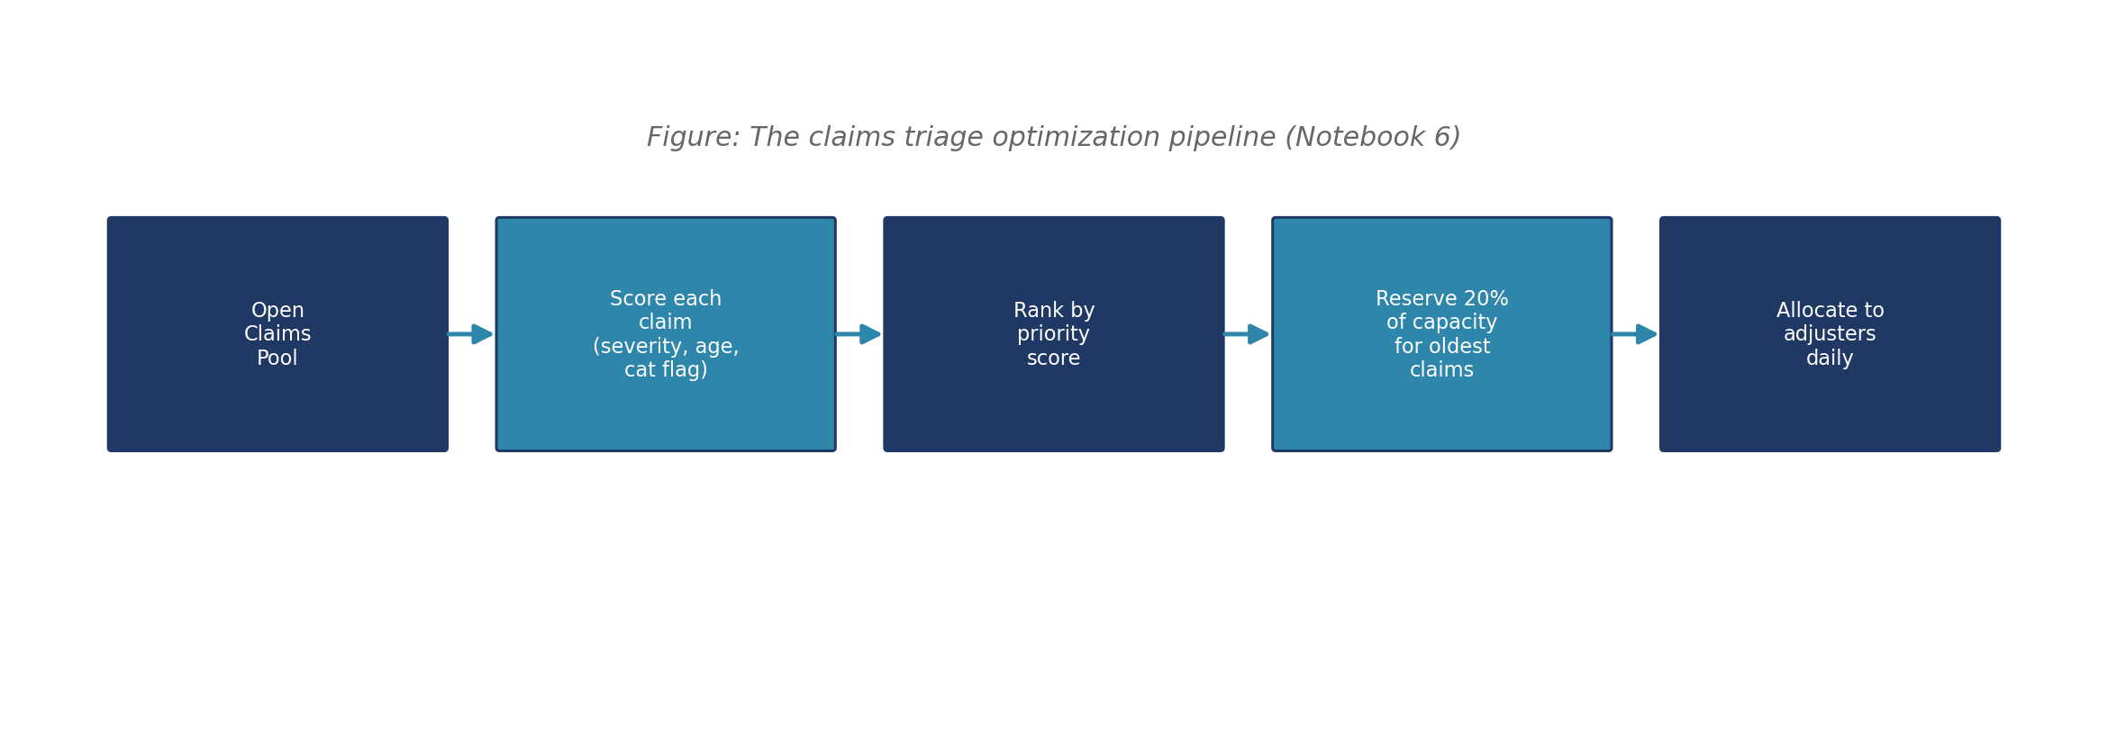

Session 5: Decision Making (60 minutes)
Segment | Minutes | Content
Notebook 7 (Scenario Analysis) | 25 | Sensitivity checks on the percent-paid assumption, adjuster capacity, and the fraud recall target; why none of the earlier findings are fragile.
Notebook 8 (Final Recommendation) | 20 | Reading and discussing the executive memo; what makes a recommendation memo effective for a non-technical audience.
Workbook Activity 7-8 and HOTS questions | 15 | Students complete the remaining workbook questions, including the Higher-Order Thinking questions.
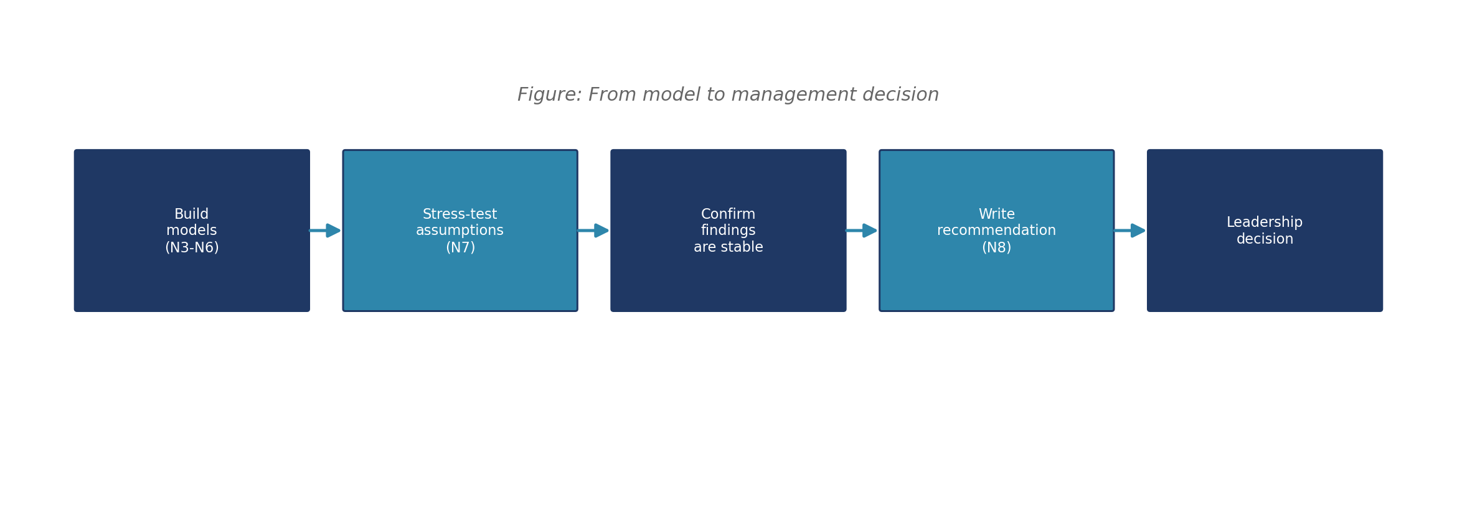

Session 6: Presentations (30 minutes)
Reserved for wrap-up rather than the Assessment Package's own Group Presentation (which is graded separately and typically scheduled after the 6-hour module, once students have had time to research their chosen country and event). Use this session for a short instructor-led recap of the four Notebook 8 findings, a live look at the Power BI dashboard, and a preview of the Assessment Package components due in the following days.

Before Session 1: Checklist for Preparation
- Make sure each student has Python 3.9+ with pandas, numpy, scikit-learn and matplotlib installed or a working Google Colab account as a backup.
- Distribute the Student Workbook and the eight dataset CSVs (or confirm students can access the shared 04_Datasets folder) at least one day before Session 1.
- Open the Power BI dashboard file (or the companion interactive HTML dashboard) once yourself before class to confirm it renders correctly on the classroom projector or screen-share setup.
- Print or digitally distribute this Instructor Guide's Chapter 4 (Industry Background) as optional pre-reading for students without any insurance background.

Materials Needed Per Session
Session | Materials
1 | Student Workbook Parts A-B, 8 dataset CSVs, Notebook 1
2 | Notebook 2, Student Workbook Part C
3 | Notebooks 3-4, Student Workbook Part D (Activities 3-4)
4 | Notebooks 5-6, Student Workbook Part D (Activities 5-6)
5 | Notebooks 7-8, Student Workbook Part D (Activities 7-8 and HOTS questions)
6 | Power BI dashboard (or HTML alternative), Assessment Package overview handout

Pacing notes
- The 90-minute Session 3 is the module's most content-dense block. If running the module across multiple shorter class meetings, this is the best place to split into two sessions rather than shortening the content.
- Sessions 4 and 5 assume Sessions 2 and 3 finished on schedule; if a class runs behind, the Notebook 7 sensitivity analysis (Session 5) is the most compressible section, since its three checks can be demonstrated live rather than run individually by every student.
- See Chapter 7 (Teaching Notes) for the discussion questions, common student mistakes, and extension activities tied to each session above.

Sample Opening Script (Session 1)
New instructors sometimes find it easier to start from a script rather than a bullet list. The following is a suggested opening for Session 1, written to be read aloud or closely paraphrased; adapt the specific phrasing to your own classroom style.
Worked example: Suggested Session 1 opening (5 minutes)
“Today we're going to spend six hours as the actuarial team for a fictional insurance company called Gulf Crest. Thirty days ago, a Category 4 hurricane called Marisol made landfall along Gulf Crest's coastline, and thousands of claims have come in. Nobody knows yet exactly how much this is going to cost the company, which claims might be fraudulent, or how to prioritize the adjusters we have. That's our job today.”
“Everything you'll see, the company, the storm, every number in these datasets, is fictional. But it's built to behave the way real insurance data behaves, using publicly documented industry patterns, so the skills you build today transfer directly to a real claims department.”
“We'll move through eight short notebooks over the day, each one answering one specific business question. By the end, you'll have written the same kind of executive recommendation memo a real actuarial analyst would hand to their VP. Let's start by opening Notebook 1 and seeing what data we actually have to work with.”

This kind of scripted framing is optional, but instructors delivering the module for the first time have found it useful for setting the right tone before diving into code: this is a business problem with a narrative, not a sequence of disconnected coding exercises.

Instructor Self-Check Before Moving to the Next Chapter
- Can you explain, without notes, why Chain Ladder fails immediately after a new catastrophe? (Chapter 4, Section 4.4)
- Can you explain why 85% accuracy with 0% recall is a bad outcome for a fraud classifier? (Chapter 4, Section 4.7)
- Do you know where to find the exact answer key for the 20-question Individual Quiz? (Solution Manual, Deliverable 9, Section 4)
- If a student's notebook produces a materially different number than the ones in this guide (not just a rounding difference), do you know the most likely cause to check first? (a changed random seed, a modified dataset, or a skipped preprocessing step, in that order of likelihood)

Chapter 6: Assessment
This chapter summarizes how the module is graded. Full detail, including the printed quiz, the assignment briefs, and the complete rubric text, is in the Assessment Package (Deliverable 7); the answer key for the quiz and grading notes for the open-ended components are in the Solution Manual (Deliverable 9). This chapter gives instructors the high-level shape of grading without needing to open either document.

6.1 Rubrics
The Assessment Package is scored out of 50 marks using a holistic rubric: each component is weighted by how much independent judgment, real-world ambiguity, and cumulative module knowledge it demands, not simply by how long it takes to complete.
Component | Marks | What it tests
Individual Quiz | 10 | Foundational understanding of insurance concepts and the module's techniques, tested without notes.
Group Assignment | 15 | Ability to apply the module's approach to a real country, a real catastrophic event, and genuinely public data.
Coding Assignment | 15 | Ability to build a new synthetic dataset and apply the module's modeling techniques to it without a prebuilt notebook.
Presentation | 5 | Quality of the research plan prepared to support the Group Assignment.
Reflection | 5 | Depth and honesty of a short spoken reflection on what the module taught the student.
The Group and Coding assignments carry the most weight because they ask students to apply the module's techniques to a genuinely new, unscaffolded situation, which is the clearest evidence of real understanding as opposed to following a worked example.

6.2 Expected Outcomes
- Every student should be able to explain, in plain language, why Chain Ladder fails immediately after a new catastrophe and why Bornhuetter-Ferguson is the appropriate fix.
- Every student should be able to explain why accuracy is a misleading metric for a fraud classifier and name at least one technique (class weighting, SMOTE, or Isolation Forest) used to address that.
- Strong students (top band) will connect the module's four Notebook 8 findings into a coherent argument for a specific action Gulf Crest's leadership should take, rather than restating each finding in isolation.
- Strong students completing the Group Assignment will produce a simplified model grounded in real data for their chosen country and event, with a clear, mathematically supported recommendation, not just a narrative description of the event.

6.3 Marking Scheme
Marking follows the rubric bands defined in the Assessment Package's Appendix: each component is scored against explicit criteria for full marks, partial credit, and minimal credit, rather than a single pass/fail cutoff. For the Individual Quiz, each of the 20 questions is worth 0.5 marks (10 marks total), machine-gradable against the answer key in the Solution Manual. For the open-ended components (Group Assignment, Coding Assignment, Presentation, Reflection), instructors should use the detailed criteria in the Assessment Package's rubric rather than a simple correct/incorrect check, since these components are deliberately open-ended.
Total marks (of 50) | Suggested letter grade band
45-50 | A: excellent, evidence-based, technically sound throughout
38-44 | B: solid understanding, minor gaps in execution or justification
30-37 | C: foundational understanding present, execution inconsistent
Below 30 | Below passing: revisit core concepts before reassessment
These bands are a suggested starting point only; instructors should calibrate them against their own institution's grading policy.

6.4 Rubric Detail by Component
This section reproduces the grading emphasis for each component in more detail than the weighting table above, so instructors can grade without needing to have the full Assessment Package open.

Individual Quiz (10 marks)
Machine-gradable against the Solution Manual's answer key. No partial credit within a question; each of the 20 questions is worth 0.5 marks. Because the quiz spans easy, medium, and hard difficulty tiers, a useful diagnostic beyond the raw score is which tier a student's incorrect answers cluster in: errors concentrated in the hard tier suggest a student who has the mechanics but not yet the judgment to apply them to an ambiguous situation, which the Group and Coding assignments will test further.

Group Assignment (15 marks)
Graded on four dimensions: quality and relevance of the chosen country and event (is genuinely public data available?), depth of the data collection itself (not just a narrative description of the event), soundness of the simplified model built from that data, and whether the final recommendation is mathematically supported rather than asserted. A group that picks a well-documented event but produces only a narrative summary, with no model or calculation of its own, should not receive full marks even if the writing is polished.

Coding Assignment (15 marks)
Graded on whether the synthetic dataset is built to the stated specification (10,000 policies, 3,000 claims, a 5.7-magnitude neighboring-city earthquake causing a month-long local power outage), whether the student applies at least one modeling technique from the core module (severity prediction, fraud detection, reserving, or triage optimization) to their own new dataset, and whether the student's code runs without a prebuilt notebook to lean on. Partial credit applies for a dataset built to specification even if the modeling step is incomplete, since dataset construction is itself a meaningful skill being assessed.

Presentation (5 marks)
Graded as a research plan, not a rehearsal of the Group Assignment's findings: does it identify the right topics to research, cite genuinely usable sources, and propose specific AI-assisted research prompts and a workable research plan template, in line with the guide provided in the Assessment Package's Section 4.

Reflection (5 marks)
Graded on depth and specificity rather than polish: a reflection that names one specific idea from the module and explains concretely how it changed the student's thinking should outscore a reflection that offers only general praise for the module without engaging any particular concept.

Chapter 7: Teaching Notes
This chapter collects discussion questions, expected solutions, common student mistakes, and optional extension activities, organized by notebook. It is meant to be read alongside the notebooks themselves during class preparation, and pairs with the detailed model answers in the Solution Manual (Deliverable 9).

7.1 Expected Solutions
The complete, notebook-by-notebook solutions, including every real executed output, chart, and discussion answer, are in the Solution Manual (Deliverable 9), Section 1. This section gives the headline figures for all eight notebooks, so instructors can check a student's work at a glance without opening that document.

Notebook 1: Introduction
- 2,883 total claims: 2,021 catastrophe (Hurricane Marisol) versus 862 routine, non-storm claims.
- Zone Z2 (Marsh Point) recorded the highest peak wind (138 mph) and highest storm surge (13.5 ft) of the six zones.
- Most catastrophe claims are still Open 30 days post-landfall, since property damage of this scale takes longer than a month to fully investigate and settle.

Notebook 2: Exploratory Data Analysis
- Missing cause_of_loss values cluster around the most recent reported dates: missing for a reason (not yet classified), not a data error.
- Claim severity is right-skewed: the mean sits noticeably above the median, and a log-scale histogram makes the underlying pattern legible.
- The wind-speed-versus-claim-rate chart confirms the geographic pattern from Notebook 1: zones with higher peak wind show higher claim rates.
- Fraud labels: 57.4% of claims investigated so far; a 15% fraud rate within that investigated subset.

Notebook 3: Severity Prediction
- Gamma GLM (log link): MAE $39,615, R-squared 0.288. Gradient boosting: MAE $37,500, R-squared 0.334.
- Gradient boosting scores modestly better on both metrics, but the GLM's coefficients are transparent and auditable factor by factor; gradient boosting's prediction cannot be unpacked the same way.

Notebook 4: Fraud Detection
- Naive / uncorrected baseline: 85% accuracy, 0% recall on fraud, the module's central lesson about class imbalance.
- Class weighting: 52.7% accuracy, 59.7% recall, F1 0.274. SMOTE: 49.5% accuracy, 72.6% recall, F1 0.301 (the best F1 of any approach tried).
- SMOTE with a recall-targeted threshold (0.359): pushes recall to 90.3%, at a further cost to precision and overall accuracy (34.5%).
- Gradient boosting with a tuned threshold (0.05): 61.8% accuracy, the highest of the corrected approaches, but does not beat SMOTE on F1 or recall.
- Isolation Forest (no labels needed): flags 433 of 2,883 claims (15.0%) as anomalous, useful for the 43% of claims not yet formally investigated.

Notebook 5: Reserve Estimation
- Naive Chain Ladder (routine pattern misapplied to Marisol): ultimate estimate of just $46,678.84.
- Bornhuetter-Ferguson: ultimate estimate of $159,637,651.24; reserve needed $159,599,279.60 (see the full worked calculation in Chapter 4, Section 4.4).

Notebook 6: Claims Triage Optimization
- Priority scoring: dollar-weighted average 4.35 days to close, versus 11.22 days under FIFO and 10.34 under random ordering.
- Pure priority scoring resolves the largest 10% of claims in 1.60 days on average, but makes the smallest 10% wait 18.62 days.
- The hybrid rule (20% of capacity reserved for the oldest claims) recovers most of that fairness (13.58 days for the smallest 10%) at almost no cost to the overall efficiency gained (4.77 days dollar-weighted average).

Notebook 7: Scenario and Sensitivity Analysis
- Reserve sensitivity: the Bornhuetter-Ferguson ultimate ranges from $142,837,727 (15% assumed percent paid) to $164,677,628 (2% assumed percent paid), about a 7% swing around the $159.6 million base case.
- Triage capacity sensitivity: days to clear the backlog fall smoothly from 41 (at 50 claims/day) to 14 (at 150 claims/day), with no hidden breakpoint.
- Fraud recall-target sensitivity: F1 peaks at a 70% recall target (0.294); Gulf Crest's chosen 80% target scores 0.292, confirming it as a deliberate, near-optimal choice.

Notebook 8: Final Recommendation
- A written executive memo (no code output) synthesizing Notebooks 3 through 7 into four findings and a summary recommendation list; the full text is reproduced in the Solution Manual, Section 1.
- The memo also states its own limitations explicitly: syllabus methods were used deliberately over more advanced techniques, the reserve estimate rests on a single scalar assumption rather than a full confidence interval, and reinsurance recoveries were out of scope.

7.2 Discussion Ideas

Session 1-2
- Ask students to name one thing in the dataset that surprised them before revealing the geographic wind/claim-rate confirmation in Notebook 2. This primes them to notice the pattern themselves rather than being told it.
- Ask why a missing cause_of_loss value is not automatically a data-quality problem. Good answers should distinguish missing-at-random from missing-for-a-reason.

Session 3
- Pose this before revealing the GLM-versus-gradient-boosting comparison: if gradient boosting is more accurate, why would any actuary ever use the GLM instead? Aim to surface the interpretability-versus-accuracy trade-off from the students themselves.
- Ask students to explain, in their own words, why 85% accuracy with 0% recall is a worse outcome than a lower-accuracy model that actually catches some fraud. This is the single most important conceptual point in Notebook 4.

Session 4
- Ask students to predict what Chain Ladder will estimate for Hurricane Marisol's ultimate cost before running the notebook cell. Most will not predict the answer is absurdly low, which makes the reveal more memorable.
- Ask which claims should be prioritized first under limited adjuster capacity, and why, before showing the priority-scoring formula. This surfaces the severity-versus-fairness tension the notebook then formalizes.

Session 5
- Ask students what would have to be true for the Bornhuetter-Ferguson estimate to be considered fragile, then show the Notebook 7 sensitivity range (a 7% swing across a wide range of assumptions) as the answer.
- Ask students to critique a draft one-paragraph recommendation memo (write a deliberately weak one, missing a specific action or a supporting number) before showing them Notebook 8's actual memo, to build an appreciation for what makes a recommendation actionable.
- Ask students whether a gross reserve estimate (before reinsurance) should be expected to match the company's net, single-quarter incurred losses figure, and why not. This question also appears in the Assessment Package's Individual Quiz (question 20) and is worth surfacing in discussion before students encounter it there.

7.3 Common Mistakes
- Treating gradient boosting's higher accuracy as an unqualified reason to prefer it over the GLM, without considering the audience the prediction is for (a regulator or a rate filing needs interpretability, not just accuracy).
- Reporting the naive Chain Ladder estimate for Hurricane Marisol without flagging that it is a known-bad estimate produced specifically to illustrate the method's failure mode, not a genuine reserve recommendation.
- Treating a model's F1 score in isolation, without connecting it back to what a false negative (a missed fraud case) or false positive (an unnecessary investigation) actually costs Gulf Crest in practice.
- In the Group Assignment, choosing a country or event with too little genuinely public data available, which leaves students unable to build even a simplified model. Steer students toward events with documented insurance-industry loss estimates before they commit to a topic.
- Confusing a gross reserve estimate (before reinsurance) with a net, company-wide incurred-losses figure from the financial statements; these describe different scopes and are not expected to reconcile (see Chapter 4, Section 4.8, and Assessment Quiz question 20).
- Presenting the 80% fraud recall target as if it were the mathematically optimal choice, when Notebook 7 shows F1 actually peaks closer to a 70% target; the 80% target is a deliberate, defensible business choice to favor catching fraud, not the point of maximum overall balance, and students should be able to hold both facts at once.
- In the Coding Assignment, building a synthetic dataset that does not actually reflect the stated earthquake-and-outage scenario (for example, claims that look identical to Gulf Crest's hurricane claims with only the labels changed), which defeats the purpose of the assignment: applying the module's techniques to a meaningfully different kind of catastrophe.

7.4 Extension Activities
- Have advanced students re-fit the Notebook 3 severity models after removing the rarest cause-of-loss categories (Sinkhole, Lightning Strike) and discuss how the GLM's coefficients change.
- Have advanced students research Mack's stochastic reserving model or ODP bootstrapping (both mentioned as out-of-scope stretch topics in the module's technical design) and present, in one slide, what those methods would add on top of the Chain Ladder and Bornhuetter-Ferguson estimates already computed.
- Have advanced students extend Notebook 7's scenario analysis with a fourth sensitivity check of their own choosing (for example, how the fraud model's performance changes if the labeled fraud rate itself were different), and discuss whether their new finding is as stable as the three already in the notebook.
- For classes with reinsurance coverage elsewhere in the curriculum, have students estimate how much of the $159.6 million Bornhuetter-Ferguson ultimate a hypothetical excess-of-loss treaty (for example, a $10 million retention) would leave with Gulf Crest net of recovery.

7.5 Frequently Asked Questions

“Why does my notebook give slightly different numbers than the ones in this guide?”
Small differences (a few decimal places in a model score, a slightly different SMOTE resample) are normal and expected: random train/test splits and solver initialization vary slightly from run to run unless a random seed is fixed identically. The figures in this guide and the Solution Manual come from one specific reference run; a student's own run should be close in magnitude and direction, not identical to the decimal.

“How much partial credit should I give if a student's reasoning is right but their number is wrong?”
For workbook and quiz questions where the exact figure is fixed by the case data itself (the $1 million catastrophe threshold, the 59% coastal policy share), a wrong number generally reflects a misread of the data and should lose some credit. For questions marked “run-dependent” in the Solution Manual, grade the reasoning and method, not the exact figure, since small run-to-run variation is expected there.

“A student asks why we don't just always use the most accurate model. How do I answer that?”
Point back to Notebook 3 (severity) and Notebook 4 (fraud): in both cases, the most accurate model on a narrow metric is not automatically the right business choice. A GLM's transparency matters for anything filed externally; a fraud model's accuracy is actively misleading under class imbalance. The consistent theme across the module is that the right model depends on the purpose of the estimate, not on a single leaderboard metric.

“Can students use a different programming language or tool than the one in the notebooks?”
Yes, for the Coding Assignment (Assessment Package, Deliverable 7) specifically, provided the core techniques (a severity or classification model, and at least one actuarial method from the module) are still demonstrated. The core module's own eight notebooks should be run as provided, since the Student Workbook and Solution Manual are keyed to their specific structure and output.

7.6 Document Map
This module produces several documents. The table below tells an instructor which one to open for a given need, so this guide does not need to duplicate content that already lives elsewhere in the package.
Need | Document
Teach the 6-hour module session by session | This Instructor Guide (Chapters 1-7)
Give students exercises and worked examples | Student Workbook
Check a student's Workbook answers | Student Workbook Solution Manual
Check a student's notebook, dashboard, or quiz answers | Notebooks, Dashboard and Quiz Solution Manual
Assign summative, graded work after the module | Assessment Package
Present the module's content to a class or reviewers | PowerPoint Presentation
Run the underlying analysis yourself | The 8 Jupyter notebooks and their datasets
Show the findings to a non-technical audience | Power BI dashboard
Keeping these documents separate, rather than combining answer keys into student-facing files, is a deliberate design choice for this module: it lets instructors distribute the Student Workbook and Assessment Package to students without exposing solutions, while keeping every answer key available in one predictable place.

7.7 Quick Reference Card
A single-page summary of the module's most frequently cited figures, for instructors who want one place to check a number during class without searching this guide or the Solution Manual.
Figure | Value
Total policies / total claims | 5,000 policies / 2,883 claims
Catastrophe vs. routine claims | 2,021 vs. 862
Total insured value | ~$2.42 billion
Catastrophe threshold used in this module | $1 million in aggregate insured losses
Severity model: GLM MAE / R-squared | $39,615 / 0.288
Severity model: gradient boosting MAE / R-squared | $37,500 / 0.334
Fraud rate (investigated claims) | 15.0%
Best fraud F1 achieved (SMOTE) | 0.301
Naive Chain Ladder ultimate (Marisol) | $46,679 (known-bad estimate)
Bornhuetter-Ferguson ultimate (Marisol) | $159,637,651
Priority scoring vs. FIFO (dollar-weighted avg. days) | 4.35 vs. 11.22
Reserve sensitivity range (Notebook 7) | $142.8M to $164.7M
Assessment Package total marks | 50

