HDS 5310: Analytics and Statistical Programming
Project title: Exploring Anxiety Levels in Peptic Ulcer Disease Patients: An Analysis using R Studio
Date: 05/08/2023
Team members:
Ranjith Nathi
Priyanka Vemulapalli
Keerthi Vallabhaneni
Vanitha Ajmeera
Chaitali Gopal Chaudhari

Research Question: What is the level of anxiety in Peptic ulcer patients and in which age group and gender are most affected and what are the conditions leading to this co-existing disease including the causes, type of ulcer, and overweight?
Background:
Peptic ulcer disease (PUD) is ulcerations and erosions in the stomach and duodenum.^{[1]} There are two types of peptic ulcers namely gastric ulcer and duodenal ulcer. Emotional stress and psychological factors are frequently identified as important contributors to PUD. Several studies suggested that psychological stress may play a role in the onset and course of PUD. Studies have also shown that subjects with anxiety, personality, and panic disorders are more likely to have had PUD. However, the relationship between psychological problems and PUD is still controversial.^{[2]} Peptic ulcer disease (PUD) affects four million people worldwide annually and has an estimated lifetime prevalence of 5−10% in the general population.
The connection between anxiety and peptic ulcer disease is an important area for study because it has implications for both the prevention and treatment of these conditions. Peptic ulcer disease is a common gastrointestinal disorder that affects millions of people worldwide, and anxiety is a common mental health disorder that significantly affects the community. ^{[5]} Even though a link between these two conditions has been suggested in previous research, there is still much to learn about the underlying mechanisms that cause anxiety and peptic ulcer disease.^{[12]} Because it can help healthcare workers more effectively identify and manage these conditions in their patients, understanding the connection between anxiety and peptic ulcer disease is important. For example, if peptic ulcer disease is found to be associated with anxiety, medical providers may advise anxious patients to undergo routine gastrointestinal screenings or be given preventive medicine. On the other hand, if peptic ulcer disease is found to be a factor in nervousness, medical professionals might focus on treating the underlying digestive disorder to enhance the patient's mental health. ^{[2]} Overall, by providing an improved understanding of their causes and effective treatments, research into the connection between anxiety and peptic ulcer disease has the potential to enhance the quality of life for people who experience these conditions.
In 2019, the global prevalence of PUD was approximately 8.09 [95% UI 6.79–9.58] million, representing a 25.82% increase from 1990. The age-standardized prevalence rate was 99.40 (83.86–117.55) per 100,000 population in 2019, representing a decrease of 143.37 (120.54–170.25) per 100,000 population from 1990. The point prevalence of peptic ulcer was 4.72% and the lifetime prevalence was 11.22% in India.^{[3]} The duodenal to gastric ulcer ratio was 17.1:1. Duodenal and gastric ulcer were common in men. The prevalence of peptic ulcer increased with age, with a peak prevalence of 28.8% in the 5th decade of life. Studies that have explored the relationship between mental disorders and peptic ulcer have several limitations.^{[20]}
First, epidemiologic studies to date have relied exclusively on self-report diagnosis of ulcer, which is subject to report bias. Second, timeframes have been unclear when comparing mental disorders and ulcer.^{[6]} It was hypothesized that life stress would be a predictor of documented incident ulcer, that the association between stress and ulcer would be attributable in part to health risk behaviors and in part to confounding by low socioeconomic status, and that psychological stress and H pylori would be additive, independent ulcer risk factors.^{[9]} Few studies have evaluated the bidirectional relation between depression and peptic ulcer disease.
Peptic ulcers have been associated with psychological stress, schizophrenia and anxiety10,11,12. Peptic ulcer patients showed higher odds for anxiety disorders (adjusted odds ratio [AOR] = 4.41, 95% CI = 1.82–10.61) and stress (AOR = 1.11, 95% CI = 1.01–1.23)10,12. In addition, peptic ulcer patients had 1.47 times higher odds for depression (95% CI = 1.19–1.82)9.^{[4]} Inflammation and the disease burdens of pain, poor quality of life, and stress in peptic ulcer patients were presumed to contribute to the elevated risk of depression in peptic ulcer patients.
Anxiety causes peptic ulcer disease and has been the subject of numerous studies in the past. This research identified a significant connection between anxiety and the onset of peptic ulcer disease. While other studies examined the effect of psychological factors, such as depression and anxiety, on the probability to develop ulcers, some of these studies concentrated on the role of stress hormones, such as cortisol, in the development of ulcers. ^{[11]}
This project is different from other studies as we mainly focused on the assessment of anxiety levels and how anxiety levels could increase the risk of peptic ulcer disease. The dependent variable for this study is the Hamilton Anxiety Score and some independent variables like age, sex, BMI, cause, economic status, and type of ulcer. The above-mentioned variables were not taken in other studies.
We plan to use data collected from the patient’s medical records, laboratory data values, and direct communication with patients and caretakers along with physician opinions. This data was collected from Sandeep Reddy gastro clinic outpatient department, India in 2021-2022. 238 individuals were interviewed, and the data was collected.
Variable Description:
Dependent Variable:
HMA Score: The Hamilton anxiety scale is the dependent variable used in our project.
HMA.score_cat: Categorized as mild, moderate, severe, and very severe.
Independent Variables:
Age, gender, socio-economic status, level of education, smoking status, alcohol consumption, diet, family history, type of ulcer, are our independent variables. These factors were considered because they might have an impact on people with peptic ulcer anxiety levels. For example, studies indicate that younger patients might be more anxious than older patients, these people may experience greater stress if their family has a history of peptic ulcers or anxiety disorders.[8,9,10] In previous studies, they didn’t report anything regarding education status, family history, and type of ulcers which are associated with greater risk of developing anxiety, we need to provide some information on these variables in this project.
Age: This is the age of the subject, categorized as 15-30, 31-50 and 51-75.
Sex: Categorized as male and female.
Area: A value of 1 represents urban and a value of 2 represents rural.
Education status: This represents the educational status of the subject (1= less than high school, 2=high school, 3=college).
Regular exercise: A value of 1 represents yes and a value of 2 represents no.
Type_of_ulcer: 1 represents gastric ulcer, 2 represents duodenal ulcer and 3 represents both.
Cause: 1 represents H. pylori, 2 represents NSAIDS use and 3 represents stress, and 4 alcohol and 5 irregular food intakes.
Monthly_income: 1 represents income of 0 to 15000INR, 2 represents income of 150001 to 30000INR and 3 represents income of 30001 to 100000INR.
A frequently used and validated technique for measuring patient anxiety is the Hamilton Anxiety Scale. Researchers can accurately measure the degree of anxiety in peptic ulcer patients using this scale and contrast these levels with those of healthy people or patients with other medical disorders. This comparison can aid in the identification of peptic ulcer patient risk factors for anxiety and guide the creation of focused therapies.^{[15]} Many people around the world are afflicted by the prevalent medical illness known as peptic ulcers. These patients' quality of life may be negatively impacted by an increase in anxiety because anxiety may worsen ulcer symptoms and potentially stimulate the growth of new ulcers. To be able to create more successful therapies, healthcare professionals can benefit from an understanding of the prevalence and severity of anxiety in peptic ulcer patients.
Many studies were done previously to find the relationship between ulcers and anxiety. Especially, our study measures the anxiety levels of patients who had peptic ulcer disease by using the Hamilton Anxiety scale, so we must improve patient quality of life by assessing the standardizing of treatment conditions and increasing the awareness of the relationship between anxiety and peptic ulcer disease.

METHODOLOGY:
Descriptive statistics:
To begin with, descriptive statistics, load the data using a function read_excel(). After loading the data, compute descriptive statistics for each variable using R functions such as summary() to obtain summary statistics such as minimum, maximum, median, quartiles, and so on. The mean() and sd() functions are also used to compute the variables' mean and standard deviation. To make a table, utilize the table () function to summarize data into different categories or groupings. The packages "dplyr" and "tidyr" are used to aggregate, summarize, filter, and refactor data. After calculating descriptive statistics and producing a table, use the "knitr" package to create a table.
To obtain descriptive statistics for all the variables, we are going to use CreateTableOne() from the tableone package. Get percentages and frequencies for categorical variables like sex, marital status, income, BMI, and level of education and cause. For continuous variables such as HMA score and age we often look at mean or SD values, whereas in other circumstances we look at median or IQR values. CreateTableOne() assigns table statistics based on the data.
Data Visualization:
The choice of data visualization techniques for a given dataset depends on the type of variable. When dealing with continuous variables like HMA score and age histograms and density plots are commonly used to display the distribution of the data. Scatter plots can also be used to identify trends, correlations, and outliers.
For categorical variables like sex, marital status, income, education level, BMI and cause and type of ulcer bar charts and pie charts are often used to display the frequency or proportion of each category. Bar charts can be used to compare the relative sizes of different categories.
Statistical tests:
- We used the chi-squared test to check the statistical relationship between two categorical variables.
- Chi-squared Test – Assumptions:
- Variables: The variables being analyzed must be categorical, which means they can be divided into distinct groups or categories.
- Independence: The observations must be independent. This means that the values in one category cannot be influenced by the values in another category.
- Sample size: The sample size must be sufficiently large.
- Expected values: The expected values must be at least 5 in at least 80% of the groups. This ensures that the distribution of the data follows the chi-squared distribution.
- Null Hypothesis Significance Testing (NHST) for statistical significance.
- If Assumptions are not met, we use Fisher's exact test (Expected values).
- Next step we use Standardized Residuals to Understand Which Groups Contributed to Significant Relationships. If Standardized residuals that are higher than 1.96 or lower than –1.96 indicate that the observed value in that group was much higher or lower than the expected value.
- Calculating and Interpreting Effect Sizes to know the Strength of a Significant Chi-squared using Cramer”s V.
We used Two-Way Analysis of Variance (ANOVA) to know the relationship in between 2 or more variables.
- Choosing and Using Post-hoc Tests
- Tukey’s honestly significant difference: modified t-test was used.
- Testing ANOVA Assumptions:
- Testing Normality
- We used the Shapiro-Wilk test.
- Homogeneity of Variances Assumption
- We used Levene’s Test
- Alternatives When Two-Way ANOVA Assumptions Fail
▪ We used the Friedman test.
Model:
We used a logistic regression model. (Logistic regression is a statistical method used for predicting the probability of a binary outcome (i.e., a variable that can take one of two possible values).
- To know the model fit, model significance, and odds ratios we used odds.n.ends.
- Compute and interpret odds ratios and model significance and specificity.
- Model Assumptions:
- ASSUMPTION 1: Independence of observations
- ASSUMPTION 2: No multicollinearity
- ASSUMPTION 3: Linearity
- We used the vif() function from the car package functions for checking multicollinearity.
- For Linearity – the common method is to plot the predicted values of the logit (i.e., the natural logarithm of the odds) against each predictor variable.
Results and Discussion:
From Table 1:
There were 238 participants in total. The study had 73.1% female participants and majority lived in rural areas i.e., 52.9%. The participants were between the ages of 31-50 or 51-75, with only 25.2% between the age of 15-30. Almost 44% of participants had college degrees, 12.6% with a high school diploma, and 43.7% with less than a high school education. Majority of the participants (52.9%) maintained a healthy weight while 20.2%, 21.8%, and 5% were categorized as underweight, overweight, and obese respectively. Only 29.4% participants reported engaging in regular exercise. 63.9% participants reported a monthly income of 0 to 15000INR. Majority of participants consumed non vegetarian diets i.e., 95%. While 38.7% consumed spicy food. The diagnosis of most participants was gastric ulcer with 55.5% while 30.3% were diagnosed with duodenal ulcers and 14.3% were diagnosed with both. Only 1.7% reported a positive family history of peptic ulcer disease. The most common cause of peptic ulcer disease was reportedly irregular food intake followed by stress, NSAID use, and H. Pylori infection. 80.7% of the participants were non-smokers. Based on their HMA score, most participants had mild (57.1%) or moderate (33.6%) cases of peptic ulcer disease while only a smaller percentage had severe (8.4%) or very severe (0.8%) cases.
The above table showed a descriptive analysis of all variables by using the Tableone function.
Table 2: shows the comparison of all variables to the HMA score:
The table 2 shows that most patients in all four HMA score categories were females (ranging from 62.5% to 80.0%). The highest percentage of patients in the age category of 51-75 were in the severe and very severe HMA score categories (70.0% and 100.0%, respectively). Many patients in all four HMA score categories lived in rural areas (ranging from 50.0% to 60.0%). Most patients in all four HMA score categories did not exercise regularly (ranging from 62.5% to 76.5%). In terms of BMI, the highest percentage of patients in the severe and very severe HMA score categories were overweight (30.0% and 100.0%, respectively) or obese (10.0% and 0.0%, respectively). Most patients in all four HMA score categories had a monthly income of $0 to $15,000 (ranging from 58.8% to 70.0%). Most patients in all four HMA score categories consumed non-vegetarian diets (ranging from 92.5% to 100.0%). In terms of the type of ulcer, most patients in all four HMA score categories had gastric ulcers (ranging from 50.0% to 60.0%). The highest percentage of patients in the mild, moderate, and severe HMA score categories had PUD caused by NSAIDs use (20.0%, 25.0%, and 10.0%, respectively). Only patients in the mild and moderate HMA score categories had PUD caused by H. pylori (8.8% and 20.0%, respectively). Overall, the table suggests that the severity of the HMA score is associated with certain demographic and clinical characteristics of patients with PUD, such as age, sex, low income, BMI, diet, and the cause of PUD.
Data Visualizations:
The bar graph of the HMA score which is our dependent variable, depicted its right skew as shown in figure1. Bar graphs of age, income, and type of ulcer which are our independent variables is depicted as shown in Figure 2,3,4.
Figure 1: Bar graph of HMA score.
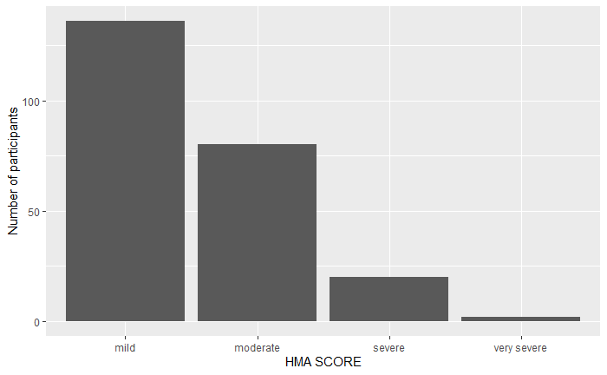
According to the above graph, we can interpret that lot of participants have mild to moderate HMA scores. Very less participants have very severe HMA scores.
Figure 2: Bar graph of age
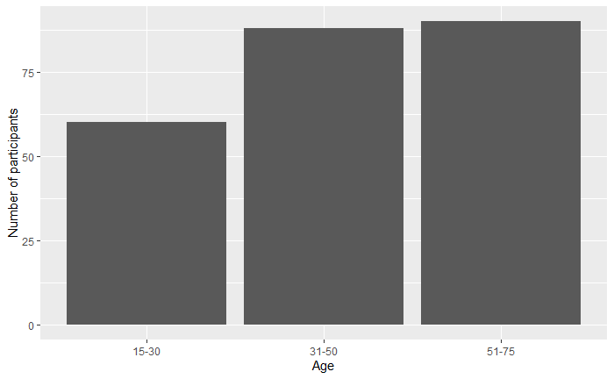
The above graph shows that more participants are of the age between 51-57 and fewer participants are of age between 15-30.
Figure 3: Bar graph of income.
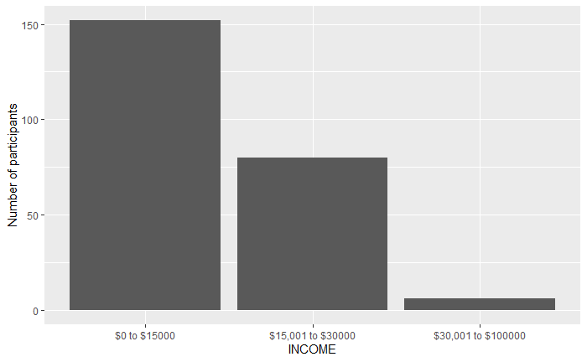
From the above graph, we can see that many people have income ranges between $0 to $15000 and very few people are of high income.

Figure 4: Bar graph of type of ulcer.
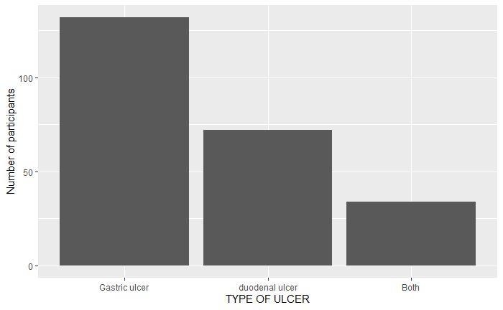
The above graph states that many participants have Gastric ulcer. There are very less participants who have both ulcers means Gastric and duodenal ulcer.
In the following bar graph our dependent variable, which is HMA score and marital status, an independent variable is depicted.
Figure 5: Bar graph of HMA score and marital status.

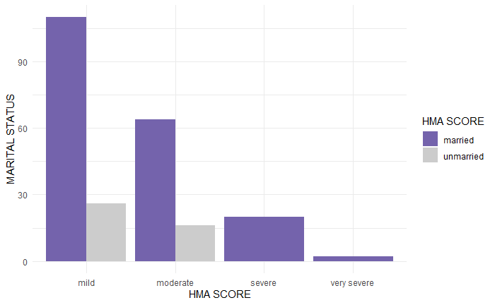

From the above bar graph, one can state that more married people have Mild HMA Score, and very less married people have Very severe HMA score. More Unmarried people have mild HMA score and None of the unmarried people have very severe HMA score.
We have plotted a scatter plot of HMA score by type of ulcer. It shows that gastric ulcers have a greater number of mild HMA score and very severe HMA score. Duodenal ulcer and both type of ulcer has Moderate number of HMA score.
Figure 6: Scatter plot of HMA score and type of ulcer.

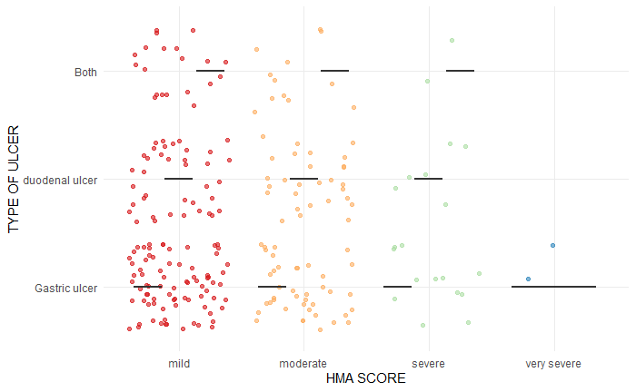

The below graph shown HMA score by age. This density graph tells us that age group between 15-30, 31-50 and 51-75 have more number of mild HMA score. As There are a greater number of participants in the age group 51-75, we can say that Mild HMA Score is also more in that age group.
Figure 7: Graph showing HMA score by age:

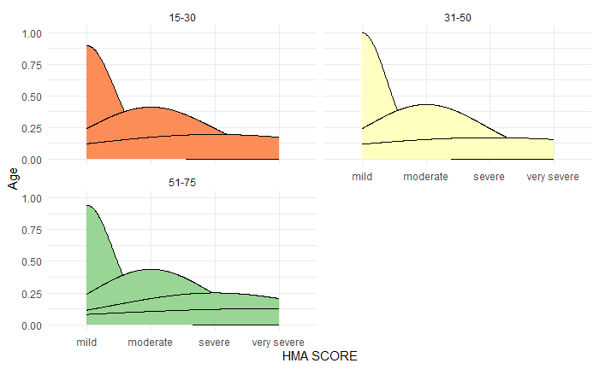
Data Management:
Some variables needed recoding and they were transformed into factor types. They were renamed with the following names and categories: Age (15-30, 31-50, 51-75), Sex (male, female), Area ( rural, urban), Marital status (married, unmarried, unknown), Education status (less than high school, high school, college), Regular exercise (yes, no), Weight (underweight, healthy weight, overweight, obesity), Monthly income (0-15000INR, 15001-30000INR, 30001-100000INR), Family history (yes, no), Diet (vegetarian, non-vegetarian), Spicy food (yes, no), Type of ulcer (gastric ulcer, duodenal ulcer, both), Cause (H.pylori, NSAIDS use, stress, alcohol, irregular food intake), Smoking ( light, heavy, no), HMA score ( mild, moderate, severe, very severe).
Statistical Tests:
We have performed the Chi-squared test:
Reasons for the selected variables mentioned in the literature review.
HMA score and type of ulcer: To investigate the nature of the association between the HMA score and the type of ulcer, a chi-square test was performed. The test statistic calculated is X-squared = 3.3375, with degrees of freedom (df) = 6, and a corresponding p-value of 0.7655. The p-value is greater than the significance level of 0.05, which indicates that there is no evidence to reject the null hypothesis that there is no association between the two variables. In other words, there is no statistically significant association between "HMA score" and "type of ulcer".
HMA score and sex: The test statistic (X-squared) is 13.249, with 3 degrees of freedom (df) and a p-value of 0.004129. Since the p-value is less than the commonly used alpha level of 0.05, we can reject the null hypothesis that there is no association between the two variables. This suggests that there is a statistically significant association between the HMA score category and sex in relation to the incidence of peptic ulcers. When the expected frequencies in one or more cells are less than 5, it is recommended to use an alternative test, such as Fisher's exact test, which is more appropriate for analysing small sample sizes or low expected frequencies. These results obtained from Fisher's exact test suggest that there is a statistically significant association between the two categorical variables, "HMA.score_cat" and "sex", with a p-value of 0.004601. The alternative hypothesis for Fisher's exact test is two-sided, which means that it tests whether there is any association between the two variables, regardless of the direction. This contrasts with the chi-squared test, which is one-sided and tests whether there is a positive or negative association between the variables. Comparing these results to the previous chi-squared test with a p-value of 0.004129, both tests provide strong evidence against the null hypothesis of no association between the two variables. However, Fisher's exact test may be more appropriate when the sample size is small or when the expected frequencies in one or more cells are less than 5, as it does not rely on the same assumptions as the chi-squared test. Therefore, based on these results, we can conclude that there is a statistically significant association between the HMA score category and sex in relation to the incidence of peptic ulcers.
HMA score and age: These results obtained from Pearson's chi-squared test suggest that there is a statistically significant association between the two categorical variables, "HMA score" and "age" with a p-value of 0.01716. The chi-squared test indicates the strength and direction of the association between two categorical variables. In this case, the test statistic X-squared is 15.43, which indicates a moderate to strong association between the two variables. The degree of freedom (df) is 6. The results obtained from Fisher's exact test for the association between "HMA score" and "age" suggest that there is a statistically significant association between the two categorical variables, with a p-value of 0.01448. When comparing these results to the previous Pearson's chi-squared test with a p-value of 0.01716, both tests provide evidence against the null hypothesis of no association between the two variables. However, Fisher's exact test may be more appropriate when the sample size is small or when the expected frequencies in one or more cells are less than 5, as it does not rely on the same assumptions as the chi-squared test. Overall, both tests suggest a statistically significant association between HMA score and age.
HMA score and BMI: The test statistic calculated is X-squared = 25.07, with degrees of freedom (df) = 9, and a corresponding p-value of 0.002895. The p-value is less than the significance level of 0.05, which indicates that there is evidence to reject the null hypothesis that there is no association between the two variables. In other words, there is a statistically significant association between "HMA score" and "BMI". To further investigate the nature of the association, additional analyses such as post-hoc tests or regression analyses may be necessary.
HMA score and cause: The test statistic calculated is X-squared = 36.568, with degrees of freedom (df) = 12, and a corresponding p-value of 0.0002624. The p-value is less than the significance level of 0.05, which indicates that there is evidence to reject the null hypothesis that there is no association between the two variables. In other words, there is a statistically significant association between "HMA score" and "cause".
Looking at the standardized residuals, For the "H Pylori" column, the moderate category has a higher frequency than expected, while the severe category has a lower frequency than expected. For the "NSAIDS use" column, the moderate category has a lower frequency than expected, while the severe category has a higher frequency than expected. For the "Stress" column, the severe category has a higher frequency than expected. For the "Alcohol" column, there are no significant differences between the observed and expected frequencies. For the "Irregular food intake" column, the mild category has a higher frequency than expected, while the very severe category has a lower frequency than expected.
Cramér’s V for HMA score and sex - the effect size is between small and medium ( 0.2359371)
Cramér’s V for HMA score and age - the effect size is between small and medium(0.1800467)
Cramér’s V for HMA score and cause - the effect size is between small and medium (0.2263085)
Cramér’s V for HMA score and BMI - the effect size is between small and medium (0.1873806)
The assumptions met for the chi-squared test is-
Assumption 1: Variables are categorical.
Assumption 2: unmet, which is the expected values are five or higher in at least 80% of proofs. This is because, for a very small sample, the approximation is not great. So, fisher’s exact test is applied, and it showed statistical significance.
Assumption 3: met i.e., all observations are independent.
We have conducted a two-way ANOVA test:
HMA score by age and sex: Tukey’s HSD is done as a post hoc test for two-way ANOVA.
For the factor "age", there are three pairwise comparisons:
Age 31-50 vs. 15-30, the estimated mean difference is -0.862 with a 95% confidence interval (CI) ranging from -2.92 to 1.20, and the p-value for the comparison is 0.585, which is not statistically significant. For age 51-75 vs. 15-30, the estimated mean difference is 2.056 with a 95% CI ranging from 0.0074 to 4.104, and the p-value for the comparison is 0.049, which is statistically significant at the 0.05 level. For age 51-75 vs. 31-50, the estimated mean difference is 2.918 with a 95% CI ranging from 1.08 to 4.76, and the p-value for the comparison is 0.001, which is statistically significant at the 0.05 level.
For the factor "sex", there is one comparison:
Male vs. Female: The estimated mean difference is -2.168 with a 95% CI ranging from -3.67 to -0.67, and the p-value for the comparison is 0.005, which is statistically significant at the 0.05 level.
For the interaction between "age" and "sex", there are twelve pairwise comparisons:
- 31-50 Female vs. 15-30 Female: The estimated mean difference is 1.750 with a 95% CI ranging from -3.27 to 6.77, and the p-value for the comparison is 0.917, which is not statistically significant.
- 51-75 Female vs. 15-30 Female: The estimated mean difference is 1.107 with a 95% CI ranging from -3.58 to 5.80, and the p-value for the comparison is 0.984, which is not statistically significant.
- 15-30 Male vs. 15-30 Female: The estimated mean difference is -1.614 with a 95% CI ranging from -5.98 to 2.76, and the p-value for the comparison is 0.896, which is not statistically significant.
- 31-50 Male vs. 15-30 Female: The estimated mean difference is -3.162 with a 95% CI ranging from -7.32 to 0.998, and the p-value for the comparison is 0.249, which is not statistically significant.
- 51-75 Male vs. 15-30 Female: The estimated mean difference is 0.766 with a 95% CI ranging from -3.43 to 4.96, and the p-value for the comparison is 0.995, which is not statistically significant.
- 51-75 Female vs. 31-50 Female: The estimated mean difference is -0.643 with a 95% CI ranging from -5.03 to 3.74, and the p-value for the comparison is 0.998, which is not statistically significant.
- 15-30 Male vs. 31-50 Female: The estimated mean difference is -3.364 with a 95% CI ranging from -7.40 to 0.674, and the p-value for the comparison is 0.163, which is not statistically significant.
To test the normality of residuals Shapiro-Wilk test was done which failed the normality assumption. So, graphing the residuals was done to confirm which showed that residuals were not normally distributed. Instead, they seemed bimodal, with some large residuals at the lower end and some at the upper end of the range.
Figure 8: Residual plot
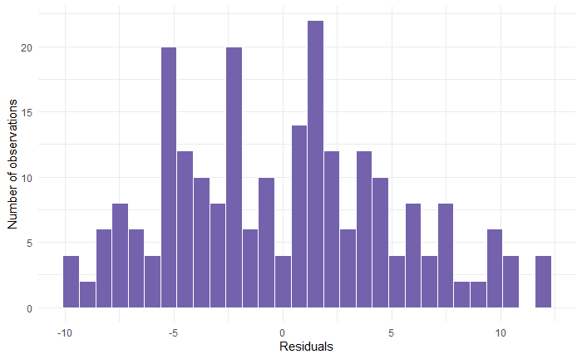
To test the homogeneity of variances assumption, levene’s test was performed. The results were statistically significant, so the null hypothesis was rejected. The equal variances assumption was not met. The two-way ANOVA had failed its assumptions.
So, the Friedman test is performed. There was a statistically significant interaction between age and sex on the mean percent of HMA score [F (2, 232) = 3.396; p < .05]. The table shows that the main effects of both age and sex are statistically significant, as indicated by the low p-values (p < 0.05). This suggests that both age and sex are important factors that contribute to the variation in the outcome variable. Additionally, the interaction between age and sex is also significant (p = 0.035188), indicating that the effect of age on the outcome variable may differ depending on the sex of the individual, and vice versa. Specifically, this result suggests that the effect of age on the outcome variable may be stronger or weaker in males compared to females, or vice versa.
The residual term represents unexplained variation that cannot be attributed to any of the factors included in the model. The residual mean sum of squares is relatively large compared to the other factors, which suggests that there may be other important factors that were not included in the model. Overall, this ANOVA suggests that both age and sex, as well as their interaction, are important factors in explaining the variation in the outcome variable.
Table 3: Table showing residuals of age and sex.
Df Sum Sq Mean Sq F value Pr(>F)
age 2 396 197.82 7.289 0.000851 ***
sex 1 221 221.32 8.154 0.004685 **
age:sex 2 184 92.16 3.396 0.035188 *
Residuals 232 6297 27.14
Signif. codes: 0 ‘***’ 0.001 ‘**’ 0.01 ‘*’ 0.05 ‘.’ 0.1 ‘ ’ 1
HMA score by cause and overweight:
There was a statistically significant interaction between cause and overweight on the mean percent of HMA score [F(8, 222) = 2.200; p < .05]. The main effect of cause appears to be statistically significant (p = 0.00265), indicating that it explains a significant amount of the variation in the outcome. Similarly, the main effect of being overweight is also statistically significant (p = 0.00209). The interaction between cause and overweight also appears to be statistically significant (p = 0.02845), suggesting that the combined effect of these two factors is not simply additive, but instead interacts in some way to influence the outcome.
Tukey’s HSD is done as a post hoc test. To test normality assumptions Shapiro-Wilk test is done. The null hypothesis for the Shapiro-Wilk test is that the distribution is normal. By accepting this null hypothesis with a p-value >0.01, the assumption met. So, this test shows that the residuals met the normality assumption.
For homogeneity assumptions, Levene’s test is done. The results were statistically significant, so the null hypothesis was rejected. The equal variances assumption was not met. The two-way ANOVA met the normality assumption. There was a statistically significant interaction between cause and overweight on mean percent of HMA score.
[F(8, 222) = 2.200; p < .05]. The main effect of cause appears to be statistically significant (p = 0.00265), indicating that it explains a significant amount of the variation in the outcome. Similarly, the main effect of overweight is also statistically significant (p = 0.00209). The interaction between cause and overweight also appears to be statistically significant (p = 0.02845), suggesting that the combined effect of these two factors is not simply additive, but instead interacts in some way to influence the outcome.
Table 4: Table showing residuals of cause and overweight.
Df Sum Sq Mean Sq F value Pr(>F)
cause 4 440 109.93 4.206 0.00265 **
over_weight 3 396 132.11 5.055 0.00209 **
cause:over_weight 8 460 57.49 2.200 0.02845 *
Residuals 222 5802 26.13
---
Signif. codes: 0 ‘***’ 0.001 ‘**’ 0.01 ‘*’ 0.05 ‘.’ 0.1 ‘ ’ 1

Final Model:
We ran a logistic regression model that included age, sex, ABMI, cause, and HMA score. Overall, these results suggest that "age cat", "sex", "BMI", and "cause" may be associated with HMA score, with the highest level of the score being associated with older age, female gender, and cause of irregular food intake and healthy weight and overweight. This is a logistic regression model (specified using the glm function in R) with the dependent variable HMA score cat and the independent variables age, sex, cause, and BMI. The purpose of the model is to investigate the relationship between these independent variables and the probability of having a Hamilton score for Anxiety (HMA) among patients with peptic ulcers. The model output shows the estimates of the coefficients for each independent variable, along with their standard errors, z-values, and p-values. A coefficient estimate represents the expected change in the log odds of having a high HMA score for a one-unit increase in the corresponding independent variable, holding all other variables constant. The intercept term is statistically significant (p = 0.00899), indicating that the probability of having a high HMA score is significantly different from zero when all the independent variables are equal to zero. The age variables (age categories) are not statistically significant (p > 0.05), indicating that there is no evidence of a significant association between the age category and the probability of having a high HMA score. The sex variable is statistically significant (p = 0.04573), indicating that females are less likely to have a high HMA score than males, holding all other variables constant. The cause variables (cause of peptic ulcer) are not all statistically significant, with only the cause of irregular food intake approaching significance (p = 0.07152). The BMI variables (BMI categories) are statistically significant, indicating that being in the healthy weight category is associated with a lower probability of having a high HMA score, holding all other variables constant. The null deviance represents the deviance of the null model (i.e., a model with only an intercept term), while the residual deviance represents the deviance of the fitted model. The difference between the null and residual deviances (22.39) indicates that the fitted model explains some of the variability in the data. Overall, the model suggests that sex and BMI categories are associated with the probability of having a high HMA score among patients with peptic ulcers. However, the other independent variables (age categories and cause of peptic ulcer) do not appear to be significantly associated with the outcome. Logistic regression model significance: the result of a chi-squared test for the overall significance of the logistic regression model. The chi-squared value is 22.394 with 10 degrees of freedom and a p-value of 0.013, which suggests that the model is statistically significant. In this case, the model has a sensitivity of 0.4902 (i.e., it correctly identifies 49.02% of actual positive cases) and a specificity of 0.7867 (i.e., it correctly identifies 78.67% of actual negative cases). The odds ratio was computed for age, and sex, cause by the HMA score but no statistically significant results.
Assumptions Report:
Assumption 1: Independence of observations.
The Observations are independent, and this assumption is met.
Assumption 2: No multicollinearity
None of the values in the right-hand column were greater than 2.5, so this assumption is met.
Table 5: In Assumption 2 multicollinearity is not shown.
GVIF Df GVIF^(1/(2*Df))
age_cat 1.284162 2 1.064523
sex 1.037716 1 1.018683
cause 1.369562 4 1.040094
BMI 1.162404 3 1.025399

Assumption 3: Linearity is seen.
Figure 9: Loess curve to check linearity assumption.

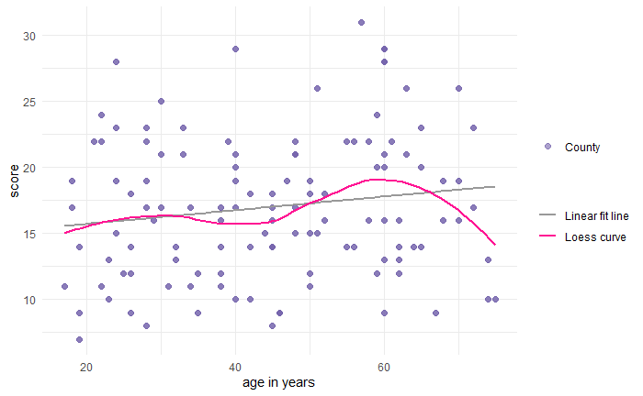

The Loess curve stays close enough to the linear fit line, the linearity assumption is met. The Loess curve stays close enough to the linear fit line, it suggests that the relationship between the variables is approximately linear, which would satisfy the linearity assumption for linear regression. However, it's still possible for the relationship between the variables to deviate from linearity in some parts of the data.
CONCLUSION:
Overall, these results suggest that "age", "sex", "BMI", "cause" may be associated with HMA score, with the highest level of score being associated with older age, female gender, and cause of irregular food intake and healthy weight and overweight. The interaction between cause and over_weight also appears to be statistically significant (p = 0.02845), suggesting that the combined effect of these two factors is not simply additive, but instead interacts in some way to influence the outcome. The interaction between age and sex is also significant (p = 0.035188), indicating that the effect of age on the outcome variable may differ depending on the sex of the individual, and vice versa. Specifically, this result suggests that the effect of age on the outcome variable may be stronger or weaker in males compared to females, or vice versa. The residual term represents unexplained variation that cannot be attributed to any of the factors included in the model. The residual mean sum of squares is relatively large compared to the other factors, which suggests that there may be other important factors that were not included in the model. Overall, this ANOVA suggests that both age and sex, as well as their interaction, are important factors in explaining the variation in the outcome variable. The present study gives insight of relationship between Anxiety and PUD. Majority of the PUD patients reported anxiety symptoms. Apart from H. Pylori infection and NSAIDs use, other reasons for developing PUD are irregular food intake and psychological stress further increases PUD incidence, prevalence and show impact on ulcer healing. The results of this study will guide physicians to treat the patients better in the future by carefully assessing each variable.
References:
- Alexandru G, Kuo B. Neuromodulatory process of the brain-gut axis. Neuromodulation technology at the neural interface, 2008; 11(4): 249-259.
- Doi: 10.1111/j.1525-1403.2008.00172.x
- Lee YB, Yu J et al., The association between peptic ulcer diseases and mental health problems: A population-based study: a STROBE compliant article. Medicine (Baltimore). 2017 Aug;96(34). Doi: 10.1097/MD.0000000000007828
- Mario F, Goni E. Gastric acid secretion: changes during a century. Best Pract Res Clin Gastroenterol 2014; 28:953–65. Doi: 10.1016/j.bpg.2014.10.006
- Nardone G, Compare D. The psyche and gastric functions. Dig Dis 2014; 32:206–12.
Doi: 10.1159/000357851
- Nimish V. Peptic ulcer disease: epidemiology, etiology, and pathogenesis. Hindawi, 2020.
- Panigrahi M et al., Clinical Profile and Risk factors of Peptic ulcer disease in coastal eastern India. JMSCR, 2018; vol. 6 (7): 615-620. Doi: 10.18535/jmscr/v6i7.108
- Renee D, Nicholas J, et al., A link between physician-diagnosed ulcer and anxiety disorders among adults. Annals of epidemiology, 23 (2013): 189-192.
- Doi: 10.1016/j.annepidem.2013.01.003
- Adil J. Abdul S, Kasim O. Hussein et al., Generalized anxiety disorder in peptic ulcer patients. Annals of tropic medicine and public health, 2020; vol. 23 (16).
- Doi: 10.36295/asro.2020.231610
- Levenstein S et al., Psychological stress increases the risk for peptic ulcer, regardless of Helicobacter pylori infection or use of nonsteroidal anti-inflammatory drugs. Clin Gastroenterol Hepatol. 2015 Mar; vol. 13(3):498-506. Doi: 10.1016/j.cgh.2014.07.052
- Jagpal K et al., A study of psychiatric morbidity in patients of peptic ulcer diseases. Chron of Young Scientists, 2012; Vol. 3 (1): 29-37. Doi: 10.4103/2229-5186.94310
- Hasnath S. Prevalence of PUD among the patients with abdominal pain attending the department of medicine in Dhaka medical college hospital. Journal of dental and medical sciences, 2014; vol. 13 (1): 5-20. Doi: 10.9790/0853-13190520
- Overmier J, Murison R. Restoring psychology’s role in peptic ulcer. Appl Psychol Health Well Being 2013; 5:5–27. Doi: 10.1111/j.1758-0854.2012.01076.x
- Albaqawi et al., Profile of peptic ulcer disease and its risk factors in Arar, Northern Saudi Arabia. Electro Physic, 2017; 9. 5740-5745. Doi: 10.19082/5740
- Jeung H, Lee, et al., Obesity and Risk of Peptic Ulcer Disease: A Large-Scale Health Check-Up Cohort Study. Nutrients, 2019; vol. 11 (6): 1288. Doi: 10.3390/nu11061288
- Hamilton M.The assessment of anxiety states by rating. Br J Med Psychol 1959; 32:50–55.
Abbasi-Kangevari M, Ahmadi N, Fattahi N, Rezaei N, Malekpour MR, Ghamari SH, Moghaddam SS, Azadnajafabad S, Esfahani Z, Kolahi AA, Roshani S, Rezazadeh-Khadem S, Gorgani F, Naleini SN, Naderimagham S, Larijani B, Farzadfar F. Quality of care of peptic ulcer disease worldwide: A systematic analysis for the global burden of disease study 1990-2019. PLoS One. 2022 Aug 1;17(8):e0271284. doi: 10.1371/journal.pone.0271284. PMID: 35913985; PMCID: PMC9342757.https://www.ncbi.nlm.nih.gov/pmc/articles/PMC9342757/
- Xie, X., Ren, K., Zhou, Z. et al. The global, regional, and national burden of peptic ulcer disease from 1990 to 2019: a population-based study. BMC Gastroenterol 22, 58 (2022). https://doi.org/10.1186/s12876-022-02130-2
- Khuroo MS, Mahajan R, Zargar SA, Javid G, Munshi S. Prevalence of peptic ulcer in India: an endoscopic and epidemiological study in urban Kashmir. Gut. 1989 Jul;30(7):930-4. doi: 10.1136/gut.30.7.930. PMID: 2788113; PMCID: PMC1434311.
https://www.ncbi.nlm.nih.gov/pmc/articles/PMC1434311/

Appendix:
Table 1: Table showing descriptive statistics of all variables.
Overall
n 238
age (%)
15-30 60 (25.2)
31-50 88 (37.0)
51-75 90 (37.8)
sex = FEMALE (%) 174 (73.1)
area = rural (%) 126 (52.9)
marital status = unmarried (%) 42 (17.6)
education status (%)
less than high school 104 (43.7)
high school 30 (12.6)
college 104 (43.7)
regular exercise = No (%) 168 (70.6)
BMI (%)
underweight 48 (20.2)
healthy weight 126 (52.9)
overweight 52 (21.8)
obesity 12 ( 5.0)
monthly income (%)
$0 to $15000 152 (63.9)
$15,001 to $30000 80 (33.6)
$30,001 to $100000 6 ( 2.5)
type of ulcer (%)
Gastric ulcer 132 (55.5)
duodenal ulcer 72 (30.3)
Both 34 (14.3)
cause (%)
H Pylori 30 (12.6)
NSAIDS use 53 (22.3)
Stress 55 (23.1)
Alcohol 5 ( 2.1)
Irregular food intake 95 (39.9)
HMA.score_cat (%)
mild 136 (57.1)
moderate 80 (33.6)
severe 20 ( 8.4)
very severe 2 ( 0.8)

Table 2: Showing the comparison of all variables to the HMA score.
Stratified by HMA.score_cat
mild moderate severe very severe
n 136 80 20 2
age (%)
15-30 34 ( 25.0) 22 ( 27.5) 4 ( 20.0) 0 ( 0.0)
31-50 58 ( 42.6) 28 ( 35.0) 2 ( 10.0) 0 ( 0.0)
51-75 44 ( 32.4) 30 ( 37.5) 14 ( 70.0) 2 (100.0)
sex = FEMALE (%) 108 ( 79.4) 50 ( 62.5) 16 ( 80.0) 0 ( 0.0)
area = rural (%) 68 ( 50.0) 46 ( 57.5) 12 ( 60.0) 0 ( 0.0)
education status (%)
less than high school 46 ( 33.8) 42 ( 52.5) 14 ( 70.0) 2 (100.0)
high school 24 ( 17.6) 6 ( 7.5) 0 ( 0.0) 0 ( 0.0)
College 66 ( 48.5) 32 ( 40.0) 6 ( 30.0) 0 ( 0.0)
BMI (%)
Underweight 18 ( 13.2) 22 ( 27.5) 8 ( 40.0) 0 ( 0.0)
healthy weight 82 ( 60.3) 40 ( 50.0) 4 ( 20.0) 0 ( 0.0)
overweight 28 ( 20.6) 16 ( 20.0) 6 ( 30.0) 2 (100.0)
obesity 8 ( 5.9) 2 ( 2.5) 2 ( 10.0) 0 ( 0.0)
monthly income (%)
$0 to $15000 80 ( 58.8) 56 ( 70.0) 14 ( 70.0) 2 (100.0)
$15,001 to $30000 52 ( 38.2) 22 ( 27.5) 6 ( 30.0) 0 ( 0.0)
$30,001 to $100000 4 ( 2.9) 2 ( 2.5) 0 ( 0.0) 0 ( 0.0)
type of ulcer (%)
Gastric ulcer 78 ( 57.4) 40 ( 50.0) 12 ( 60.0) 2 (100.0)
duodenal ulcer 38 ( 27.9) 28 ( 35.0) 6 ( 30.0) 0 ( 0.0)
Both 20 ( 14.7) 12 ( 15.0) 2 ( 10.0) 0 ( 0.0)
cause (%)
H Pylori 12 ( 8.8) 16 ( 20.0) 2 ( 10.0) 0 ( 0.0)
NSAIDS use 30 ( 22.1) 10 ( 12.5) 11 ( 55.0) 2 (100.0)
Stress 31 ( 22.8) 17 ( 21.2) 7 ( 35.0) 0 ( 0.0)
Alcohol 4 ( 2.9) 1 ( 1.2) 0 ( 0.0) 0 ( 0.0)
Irregular food intake 59 ( 43.4) 36 ( 45.0) 0 ( 0.0) 0 ( 0.0)
HMA.score_cat (%)
mild 136 (100.0) 0 ( 0.0) 0 ( 0.0) 0 ( 0.0)
moderate 0 ( 0.0) 80 (100.0) 0 ( 0.0) 0 ( 0.0)
severe 0 ( 0.0) 0 ( 0.0) 20 (100.0) 0 ( 0.0)
very severe 0 ( 0.0) 0 ( 0.0) 0 ( 0.0) 2 (100.0)

Figure 1: Bar graph of HMA score.

Figure 2: Bar graph of age
Figure 3: Bar graph of income.
Figure 4: Bar graph of type of ulcer.
Figure 5: Bar graph of HMA score and marital status.

Figure 6: Scatter plot of HMA score and type of ulcer.

Figure 7: Graph showing HMA score by age:

Figure 8: Residual plot

Table 3: Table showing residuals of age and sex.
Df Sum Sq Mean Sq F value Pr(>F)
age 2 396 197.82 7.289 0.000851 ***
sex 1 221 221.32 8.154 0.004685 **
age:sex 2 184 92.16 3.396 0.035188 *
Residuals 232 6297 27.14
Signif. codes: 0 ‘***’ 0.001 ‘**’ 0.01 ‘*’ 0.05 ‘.’ 0.1 ‘ ’ 1

Table 4: Table showing residuals of cause and overweight.
Df Sum Sq Mean Sq F value Pr(>F)
cause 4 440 109.93 4.206 0.00265 **
over_weight 3 396 132.11 5.055 0.00209 **
cause:over_weight 8 460 57.49 2.200 0.02845 *
Residuals 222 5802 26.13
---
Signif. codes: 0 ‘***’ 0.001 ‘**’ 0.01 ‘*’ 0.05 ‘.’ 0.1 ‘ ’ 1

Table 5: In Assumption 2 multicollinearity is not shown.
GVIF Df GVIF^(1/(2*Df))
age_cat 1.284162 2 1.064523
sex 1.037716 1 1.018683
cause 1.369562 4 1.040094
BMI 1.162404 3 1.025399

Figure 9: Loess curve to check linearity assumption.

