# 2 LITERATURE REVIEW

Development in the technology has led to a more comfortable lifestyle but still there are many general problems which are not yet been solved. Problems involving municipal related issues and crimes are increasing at a higher rate. There are many app which let people aware about Social Concepts. Citizen can submit complaints to higher authorities like an elected representative at municipal assembly, a co- operator. But people don't readily come forward for reporting these issues due to the fear of revealing oneself.

#### Existing systems: -

#### NDMC 311(NEW DELHI MUNICIPAL COUNCIL)

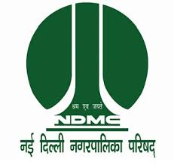

Released on : - 30-oct-2018

Published by : - New Delhi Municiple Council

NDMC resolves to intensify its efforts in providing better civic services to the citizens and a multitude of visiting patrons from all over the country and overseas. Other objectives before NDMC are to improve quality of life provide social and community welfare amenities with public, private participation- with special emphasis on promotion of art & culture, environmental improvement, cleaning & greening campaigns to serve as a show window of "A Model Well-Planned Metropolitan City"

Features:

1. Raise Complaints regarding Municipal Issues.
2. Pay Bills for Civic amenities like Water, Electricity & File Property Tax and Estate Tax.
3. Find Nearby Places according to the location.
4. Register in OPD of Nearby Hospitals.
5. 24X7 Helpline for emergencies like Fire, Ambulance, Police etc.

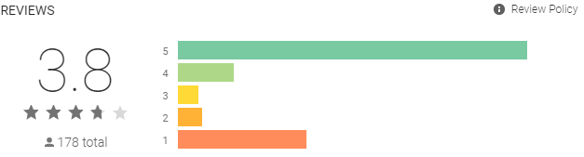

* CITIZEN



Released on : - 03-Mar-2017

Published by : - Andrew Frame

**Citizen** is a safety network and [mobile application](https://en.wikipedia.org/wiki/Mobile_app) designed to open the 911 and emergency response systems of cities, providing crime and safety alerts, real-time incident updates, and live user-generated video streams. Originally titled *Vigilante*,the app rebranded as Citizen, launching first in New York City in early 2017 and then the San Francisco Bay Area later the same year.

* Real-time Safety Alerts: Location-based notifications help you avoid potentially dangerous situations.
* Live Breaking Video: Watch live video of an incident unfold from different angles or broadcast live from the scene.
* Keep Your Community Safe: Report incidents right when they happen to protect the people around you.

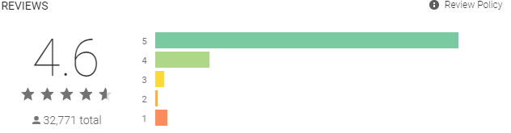

* **MyBMC 24x7**



Released on : - 06-nov-2019

Published by : - Brihanmumbai Municipal Corporation

MyBMC 24x7 will help the citizens to lodge their complaints, payment of water bills, payment property tax, renewal of licenses from anywhere at any time and accordingly

make their life stress free and hassle-free.

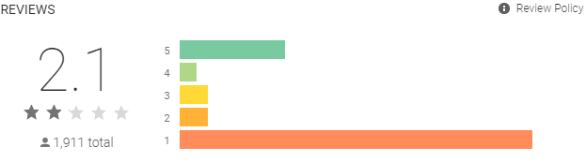

* Swachhata-MoHUA

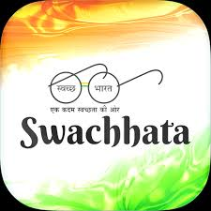

Released on : - 04-jan-2020

Published by : - NDA Government (Launched by PM .Narendra Modi)

The app enables a citizen to post a civic-related issue (eg; a garbage dump) which is then forwarded to the city corporation concerned and thereafter assigned to the sanitary inspector of the particular ward. The app will capture the location while the picture is being taken. Just type in the landmark of the complaint location. The complaint will then be assigned to the concerned sanitary inspector/engineer.

Take a picture of the Civic-related issue using your smart phone, and post it in one of the following categories.

1. Garbage dump.
2. Dustbins not cleaned.
3. Dead animals.
4. Public toilet(s) blockage.

