**QUESTION 1:**

**Create an int array with 5 values and print only odd values.**

class Odd

{

public static void main(String args[])

{

int a[]={1,2,3,4,5,6};

System.out.println("Odd numbers:");

for(int i=0;i<a.length;i++)

{

if(a[i]%2!=0)

{

System.out.println(a[i]);

}

}

}

}

**Output:**

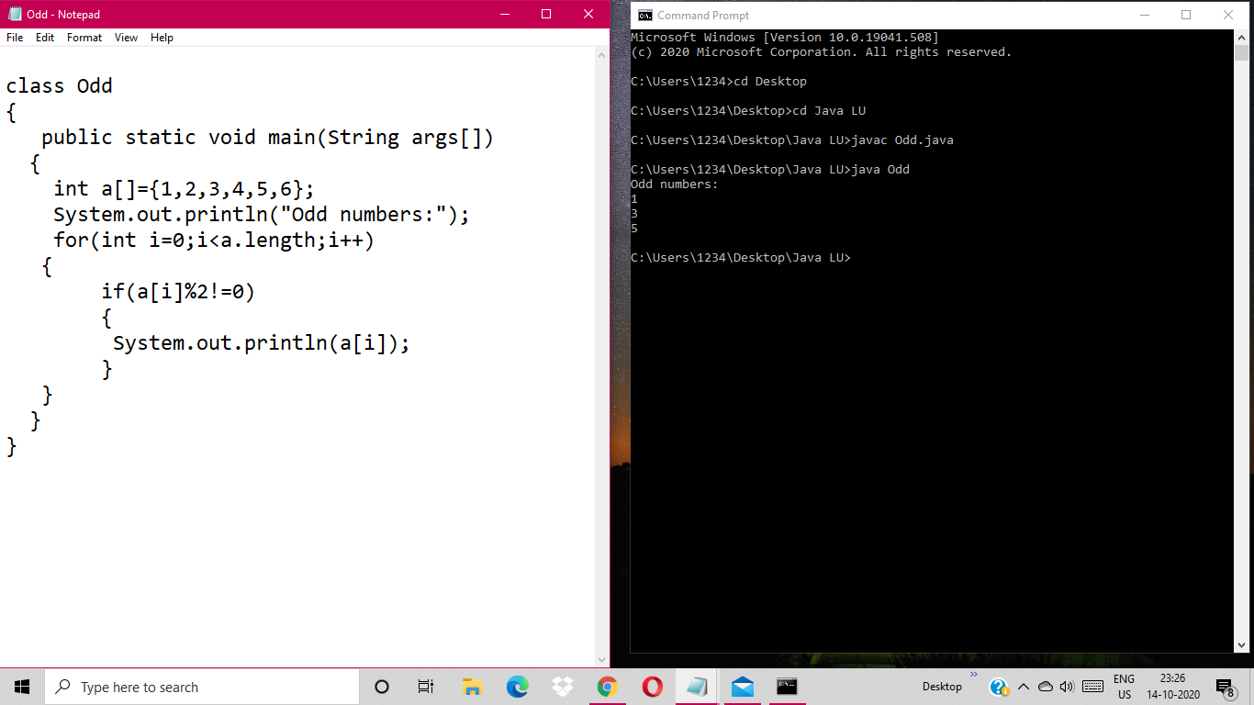

**QUESTION 2:**

**Create an int array of size 5, take all the values from the user, add all the values and print the sum.**

import java.util.Scanner;

class SumofUser

{

public static void main(String args[])

{

int[] ArrNo =new int[5];

int i;

int sum=0;

Scanner s=new Scanner(System.in);

for(i=0;i<5;i++)

{

System.out.println("Enter " +(i+1)+ " value:");

ArrNo[i]=s.nextInt();

}

for(i=0;i<ArrNo.length;i++)

{

sum=sum+ArrNo[i];

}

System.out.println("Sum of the values taken from user is:"+sum);

}

}

**Output:** 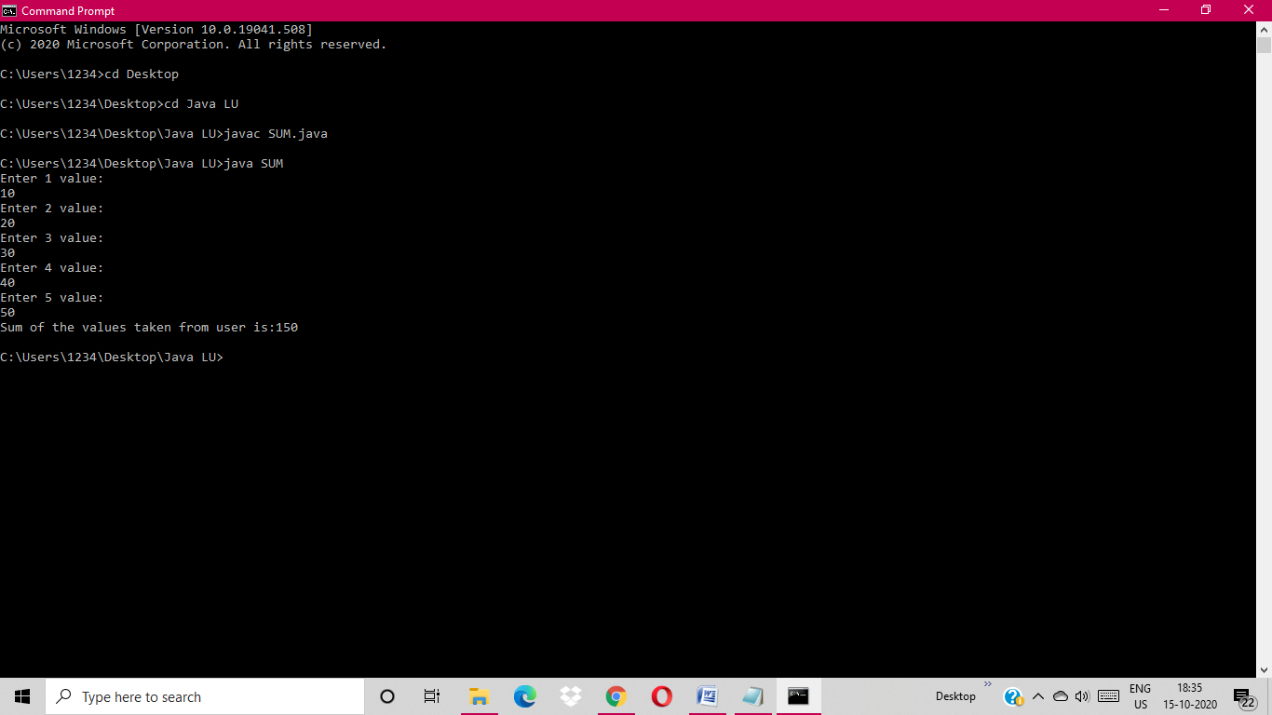

**QUESTION 3:**

**Create a class avenger with properties (name,age,power,weapon,planet) and with**

**functions-getDetails() and displayDetails(). Create 5 objects as an array in the main method and call.**

public class Avenger

{

String name,weapon,power,planet;

int age;

public void getDetails()

{

Scanner sc=new Scanner(System.in);

System.out.println("\n Enter the Name:");

name=sc.nextLine();

System.out.println("\n Enter the Weapon:");

weapon=sc.nextLine();

System.out.println("\n Enter the Power:");

power=sc.nextLine();

System.out.println("\n Enter the Planet:");

planet=sc.nextLine();

System.out.println("\n Enter the Age:");

age=sc.nextInt();

}

public void displayDetails()

{

System.out.println("\n Name is:"+name);

System.out.println("\n Weapon is:"+weapon);

System.out.println("\n Power is:"+power);

System.out.println("\n Planet is:"+planet);

System.out.println("\n Age is:"+age);

}

public static void main(String args[])

{

Avenger av[] = new Avenger[5];

for(int i=0; i<5; i++)

{

av[i] = new Avenger();

av[i].getDetails();

}

System.out.println("**** Data Entered as below ****");

for(int i=0; i<5; i++)

{

av[i].displayDetails();

}

}

}

**Output:**

