**Question 1:**

/* Create a parent class for different employees with common details name, age, salary,

designation, and methods to get details and display details.

*/

**package** emp;

**import** java.util.Scanner;

**class** EmployeeDetails {

**public** String name;

**public** **int** age;

**public** **double** salary;

Scanner sc=**new** Scanner(System.***in***);

**public** **void** getDetails()

{

System.***out***.println("Enter the Name:");

name=sc.nextLine();

System.***out***.println("Enter the Age:");

age=sc.nextInt();

System.***out***.println("Enter the Salary:");

salary=sc.nextDouble();

}

**public** **void** display()

{

System.***out***.println("Name is :"+name);

System.***out***.println("Age is :"+age);

System.***out***.println("Salary is :"+salary);

}

}

**package** emp;

**class** Employee1 **extends** EmployeeDetails

{

**public** **void** show()

{

System.***out***.println("Details of Employee 1 are: ");

}

}

**package** emp;

**class** Employee2 **extends** EmployeeDetails

{

**public** **void** show1()

{

System.***out***.println("Details of Employee 2 are: ");

}

}

**package** emp;

**public** **class** Main {

**public** **static** **void** main(String[] args) {

// **TODO** Auto-generated method stub

Employee1 e1=**new** Employee1();

Employee2 e2=**new** Employee2();

e1.getDetails();

e1.display();

e2.getDetails();

e2.display();

}

}

**Output:**

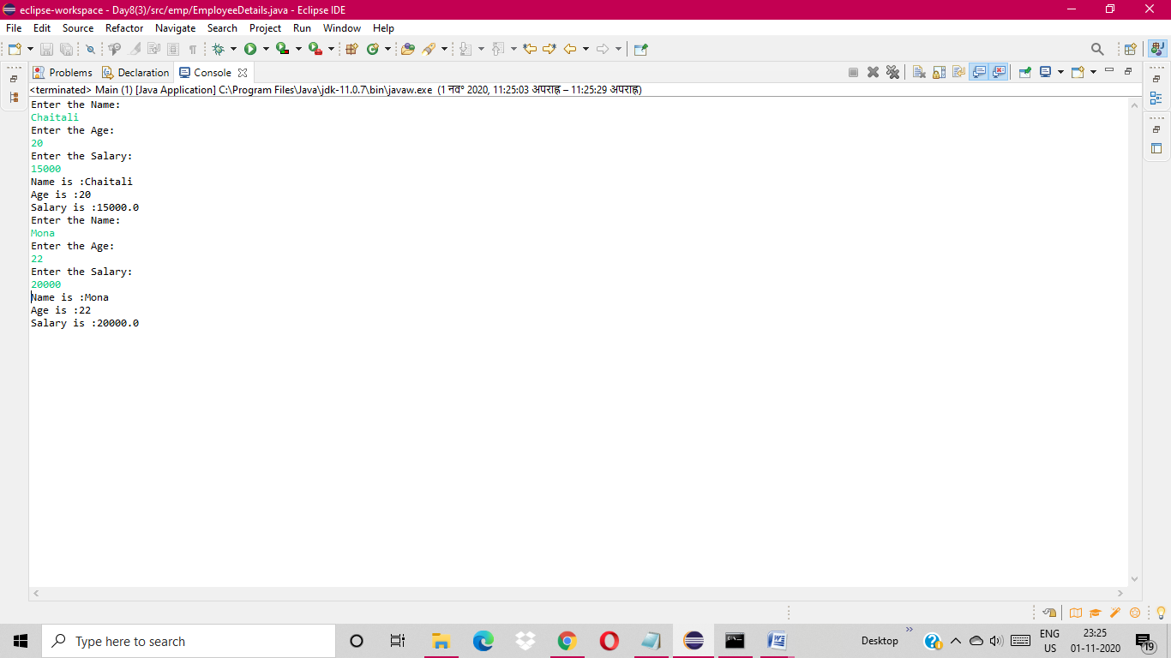

**Question 2:**

/*Create three child classes one for the doctor,

one for an engineer,

and one for pilots and include

their different operations in respective classes.

*/

import java.io.FileReader;

import java.io.IOException;

import java.io.StringWriter;

import java.util.ArrayList;

import java.util.Iterator;

import java.util.List;

class Children

{

public Children()

{

System.out.println("Class Children ");

}

public void Operationtype()

{

System.out.println("Operation type: ");

}

class Doctor extends Children

{

public Doctor()

{

System.out.println("Class Doctor");

}

public void work()

{

System.out.println("Work Done :");

System.out.println(" \t The job of a doctor is to diagnose and treat illness and injury. Doctors examine patients and arrive upon diagnosis, perform surgeries, prescribe medications, educate patients and their family members, check patients' records and keep an eye on their recovery.");

}

}

public class Engineer extends Doctor

{

public Engineer()

{

System.out.println("Class Engineer");

}

public void work()

{

System.out.println("Work Done :");

System.out.println(" \t What They Do. Engineers apply the principles of science and mathematics to develop economical solutions to technical problems. Their work is the link between scientific discoveries and the commercial applications that meet societal and consumer needs. Many engineers develop new products.");

}

}

public class Pilot extends Engineer

{

public Pilot()

{

System.out.println("Class Pilot");

}

public void work()

{

System.out.println("Work Done :");

System.out.println(" \t The Pilot's responsibilities include transporting passengers and cargo, determining the safest routes, analyzing flight plans and weather conditions, calculating fuel, and inspecting operation systems and navigation equipment.");

}

}

public static void main(String args[])

{

Pilot obj = new Pilot();

obj.Operationtype();

obj.work();

// obj.speed();

}

}

**Question 3:**

/*In the main method create an array of objects for three of them get the details and print for all the

objects */

**class** Car{

**public** **int** power;

**public** **int** serial_no;

**public** **void** setData(**int** c, **int** d){

power=c;

serial_no= d;

}

**public** **void** display()

{

System.***out***.println("Power is: "+power);

System.***out***.println("Serial no is: "+serial_no);

}

}

**public** **class** ArrayOfObjects {

**public** **static** **void** main(String[] args) {

// **TODO** Auto-generated method stub

Car[] c = **new** Car[3];

c[0] = **new** Car();

c[1] = **new** Car();

c[2] = **new** Car();

c[0].setData(800,111);

c[1].setData(900,222);

c[2].setData(650,123);

//display the employee object data

System.***out***.println("Car Object 1:");

c[0].display();

System.***out***.println("Car Object 2:");

c[1].display();

System.***out***.println("Car Object 3:");

c[2].display();

}

}

**Output:**

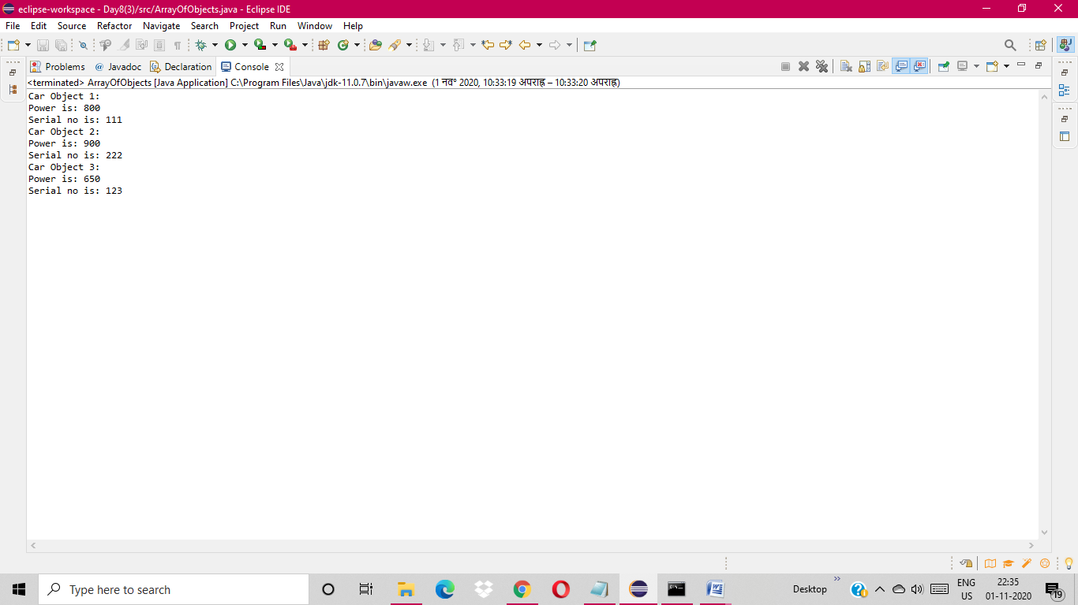

**Question 4:**

**package** emp2;

**import** java.io.FileReader;

**import** java.io.IOException;

**import** java.io.StringWriter;

**import** java.util.ArrayList;

**import** java.util.Iterator;

**import** java.util.List;

**public** **class** Main

{

**public** **static** **void** main(String args[])

{

//create array of employee object

Employee[] obj = **new** Employee[3] ;

//create & initialize actual employee objects using constructor

obj[0] = **new** Employee(10,"Nilesh");

obj[1] = **new** Employee(20,"Akash");

obj[2] = **new** Employee(30,"Akshay");

//display the employee object data

System.***out***.println("Employee Object 1:");

obj[0].showData();

System.***out***.println("Employee Object 2:");

obj[1].showData();

System.***out***.println("Employee Object 3:");

obj[2].showData();

}

}

**package** emp2;

**class** Employee

{

**int** empId;

String name;

//Employee class constructor

Employee(**int** eid, String n)

{

empId = eid;

name = n;

}

**public** **void** showData(){

System.***out***.print("EmpId = "+empId + " " + " Employee Name = "+name);

System.***out***.println();

}

}

**Output:**

