Docker-Based Web Application Deployment on Cloud Virtual Machine

Goal
Deploy a Docker-based web application on a cloud virtual machine and make it accessible via the internet.

Step 1: Launch Cloud Virtual Machine
Create a virtual machine (AWS EC2 or Google Cloud).
Select OS: Ubuntu or Amazon Linux.
Allow HTTP traffic (Port 80) in the firewall/security group.
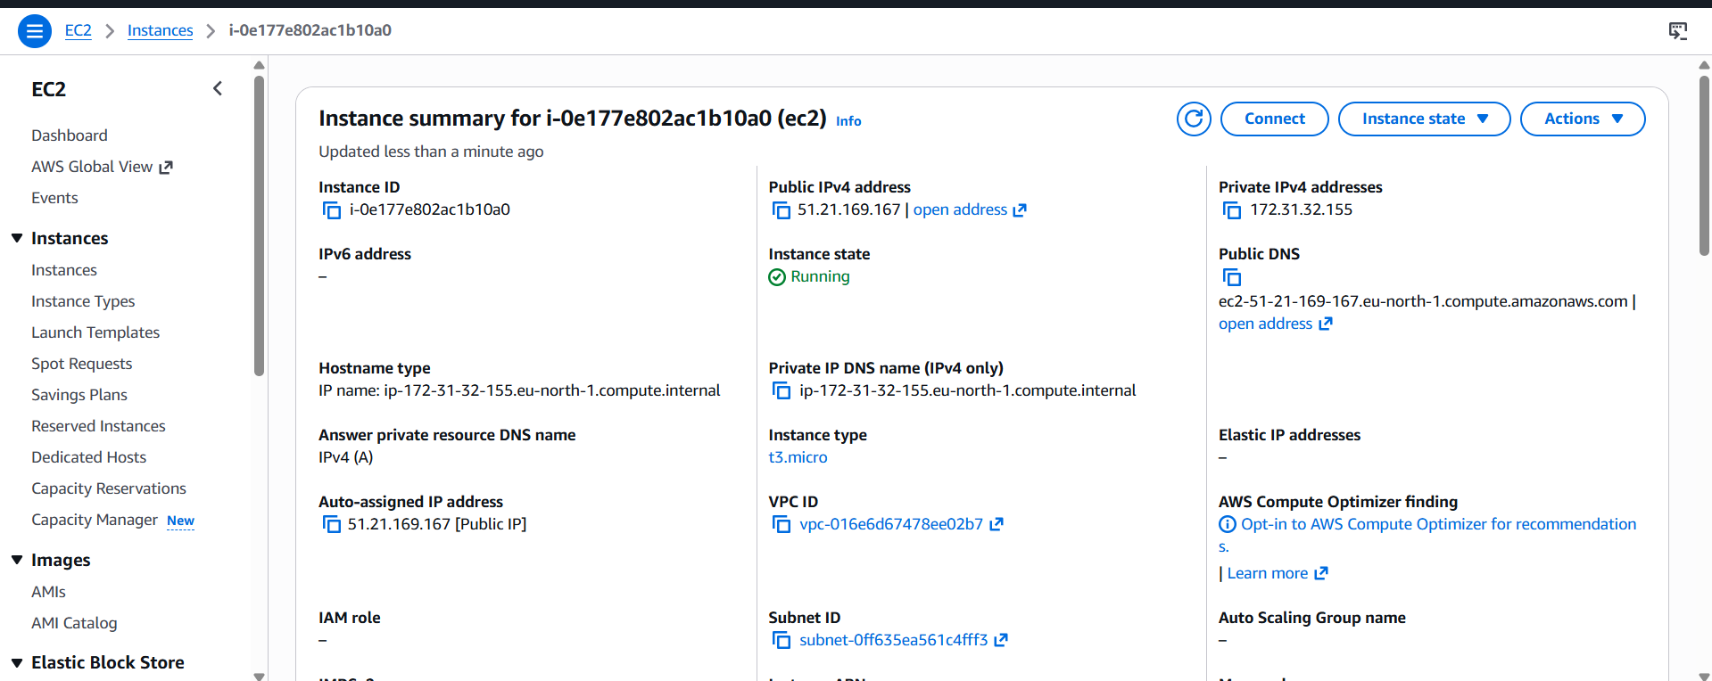.

Step 2: Connect to Virtual Machine
Connect using SSH command:
ssh -i key.pem ubuntu@< 51.21.169.167> (Ubuntu)
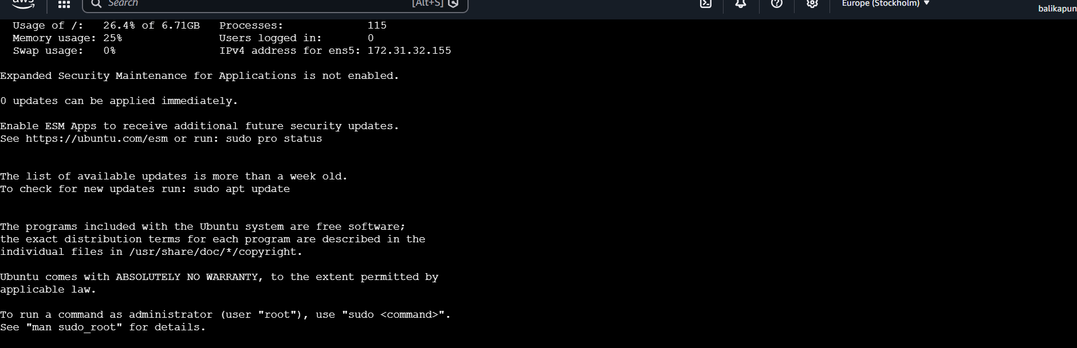

Step 3: Install Docker
For Ubuntu:
sudo apt update
sudo apt install docker.io -y
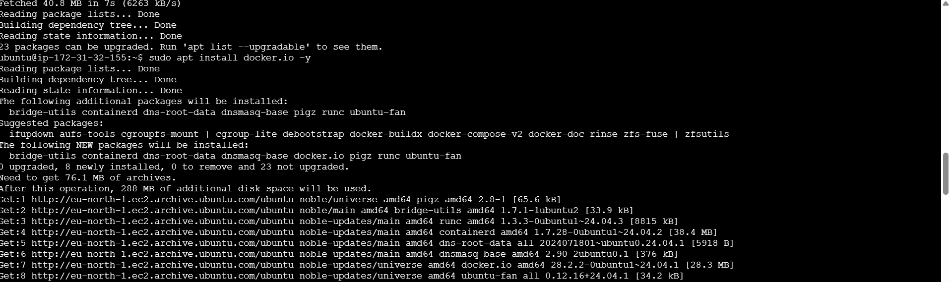

Step 4: Start Docker Service
sudo systemctl start docker
sudo systemctl enable docker
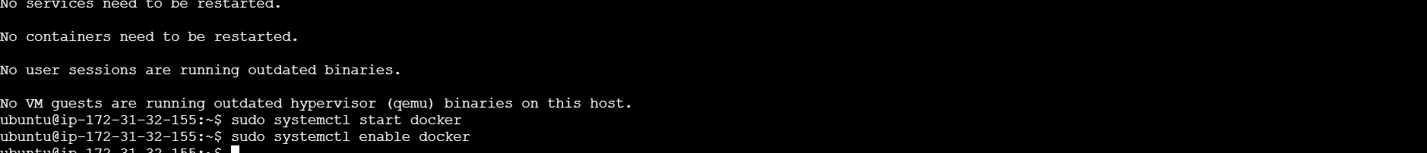

Step 5: Run Docker Container (nginx)
sudo docker run -d -p 80:80 nginx
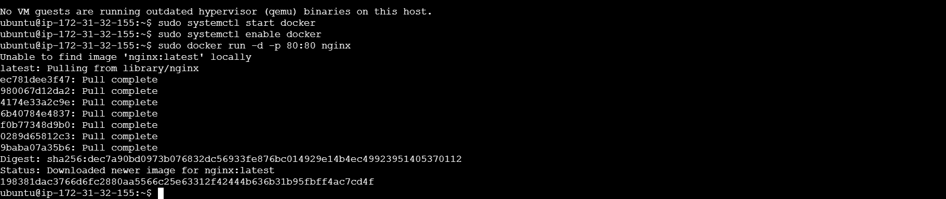

Step 6: Verify Running Container
sudo docker ps

Step 7: Access Web Application
Open a web browser and enter:
http:// 51.21.169.167
