Static Website Hosting using AWS S3

Goal
Host a static website using AWS S3 and make it publicly accessible.
Requirements
- Create bucket + enable static hosting
- Upload HTML/CSS/JS files
- Set public permissions / bucket policy
- Access website through public URL

Implementation Steps

1. Create S3 Bucket
Created a bucket named "chaitali2004" in region eu-north-1 and disabled block public access.
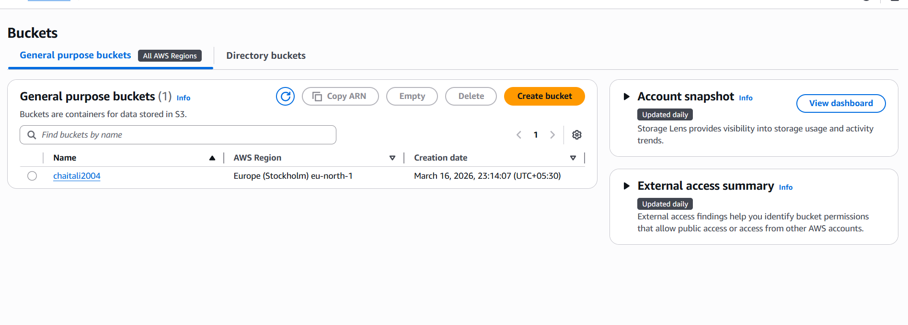

2. Enable Static Website Hosting
Enabled static website hosting and set index document as index.html.
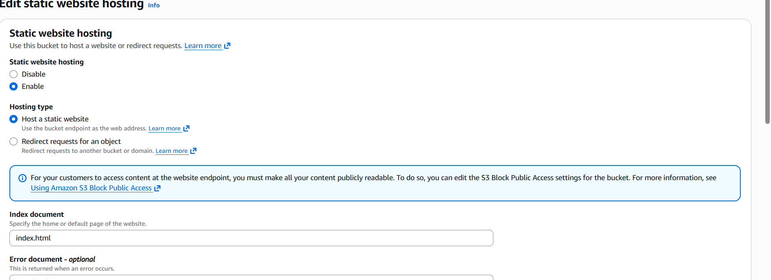

3. Upload Files
Uploaded index.html, style.css, and script.js directly into the bucket root.
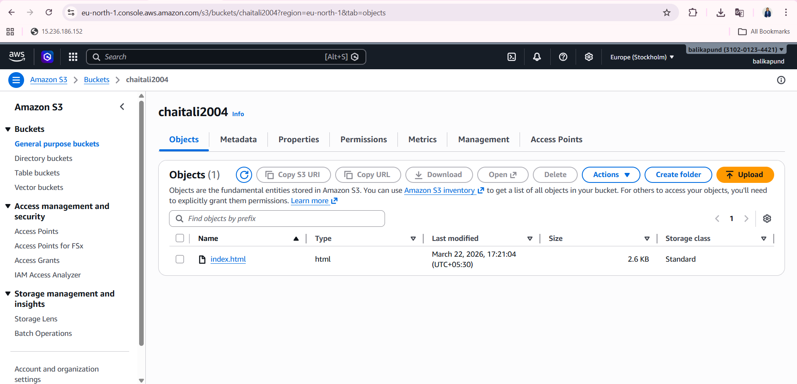
4. Bucket Policy
Added bucket policy to allow public read access.
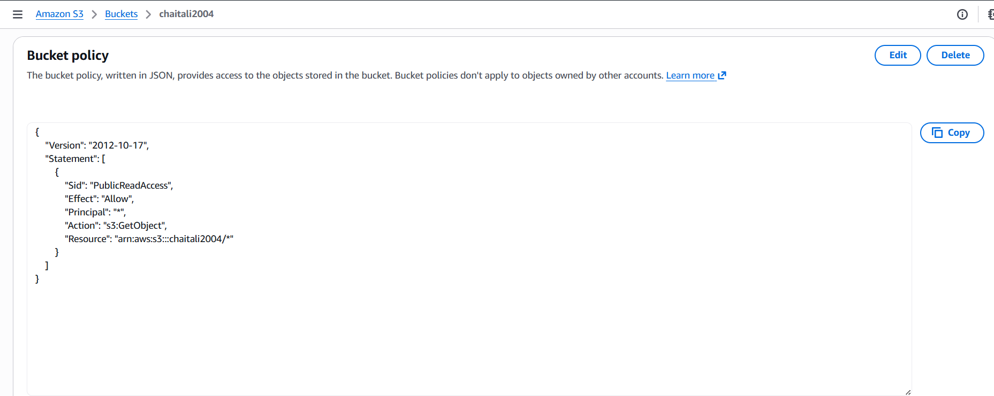

5. Access Website
Opened the website using the S3 endpoint URL.
http://chaitali2004.s3-website-eu-north-1.amazonaws.com
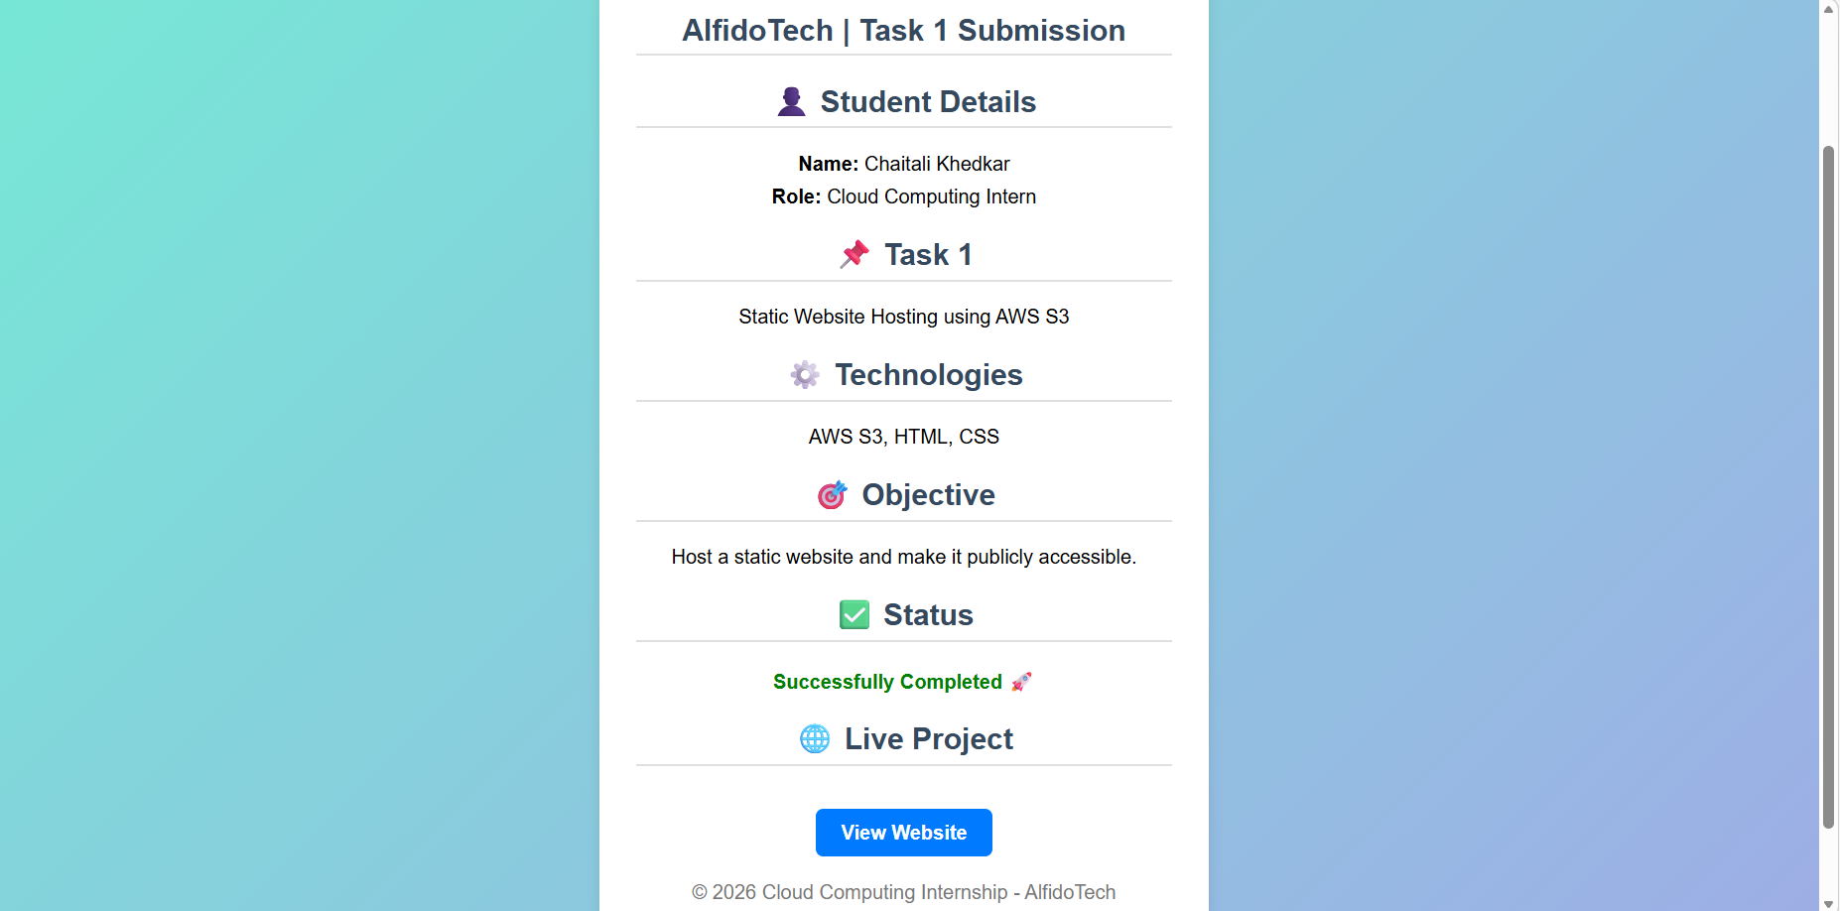
Conclusion
Successfully hosted a static website using AWS S3 and made it publicly accessible.

