Serverless Function Deployment Report (AWS Lambda + API Gateway)

Objective
Create and deploy a serverless function that returns JSON output and expose it via a public API endpoint.

Step 1: Create Lambda Function
Go to AWS Console → Lambda → Create Function
- Choose runtime (Node.js or Python)
- Create function
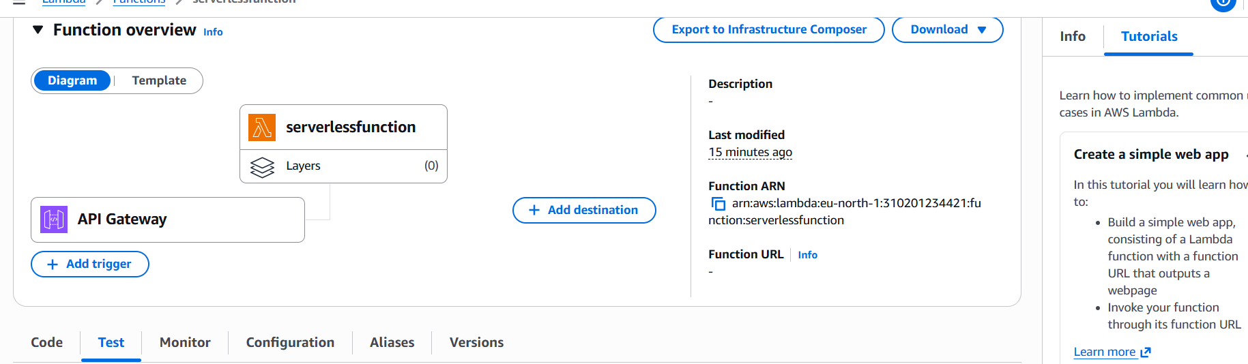

Step 2: Add Function Code
Paste the function code and click Deploy.
Example (python 3.14):
import json
def lambda_handler(event, context):
return {
'statusCode': 200,
'body': json.dumps({
'message': 'Hello from Serverless Function 🚀',
'status': 'success'
})
}
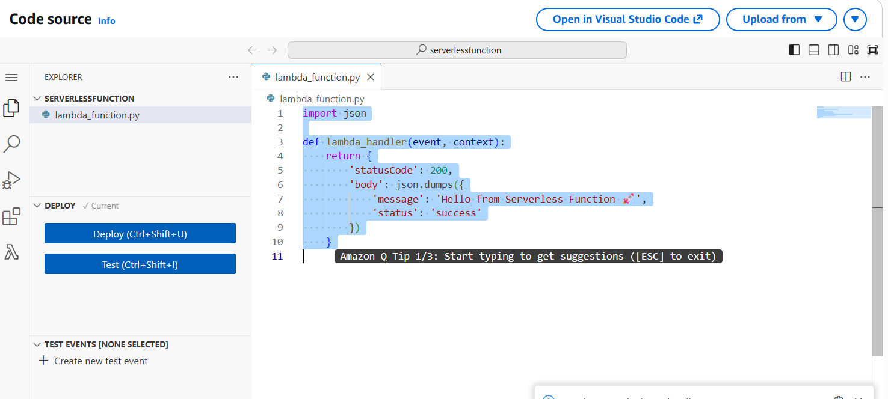

Step 3: Test Function
Click Test → Create test event → Run function.
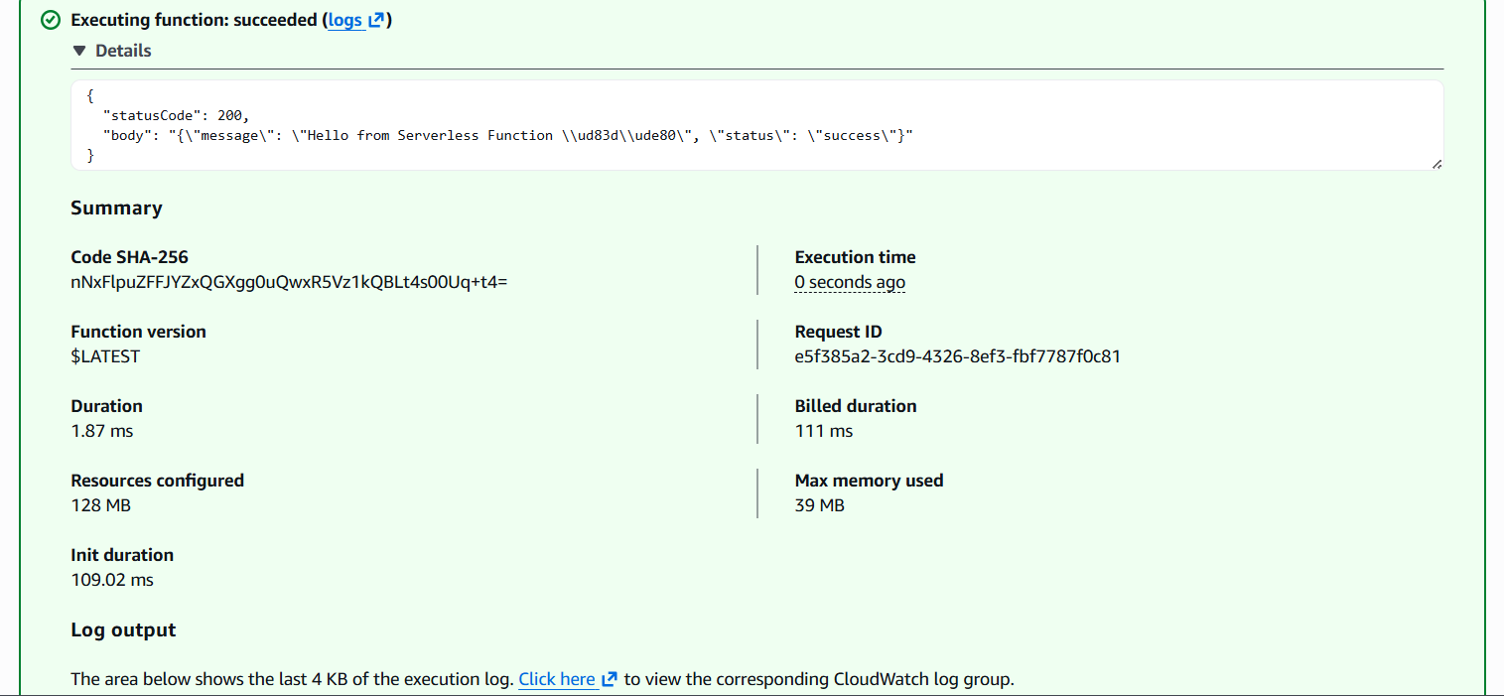

Step 4: Create API Gateway
Go to API Gateway → Create API → HTTP API
- Add integration with Lambda
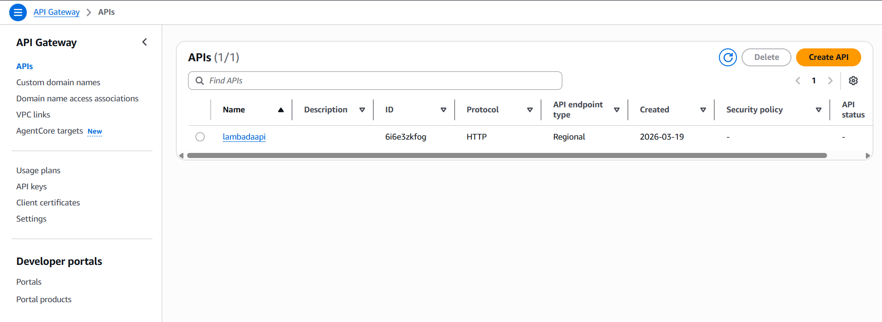

Step 5: Create Route and Integration
Add route:
GET /
Attach Lambda integration.
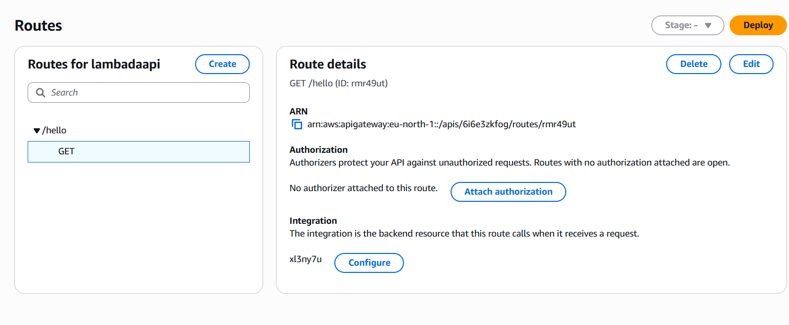

Step 6: Deploy API
Deploy API and create stage (e.g., default).
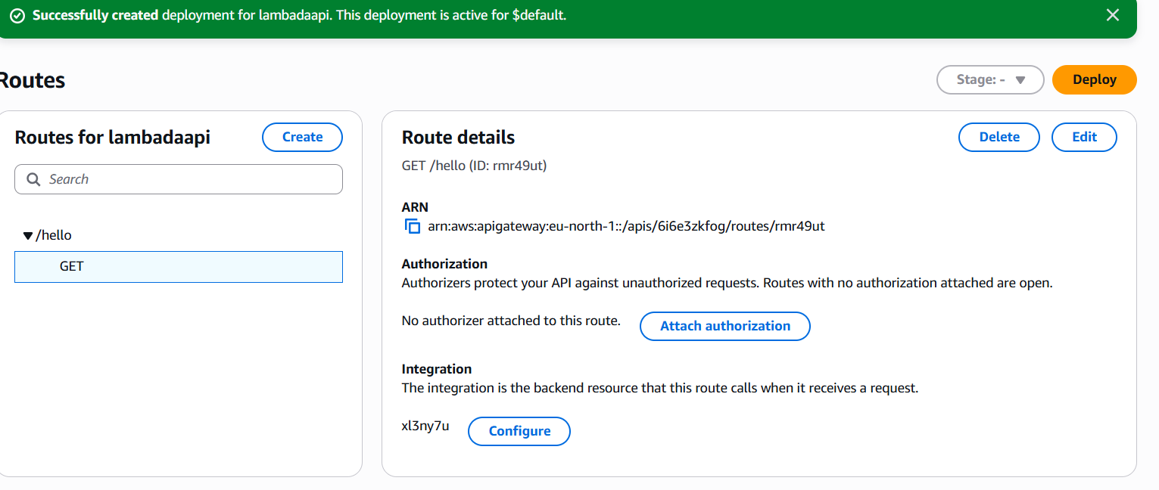

Step 7: Get Endpoint URL
Go to Stages → Copy Invoke URL.
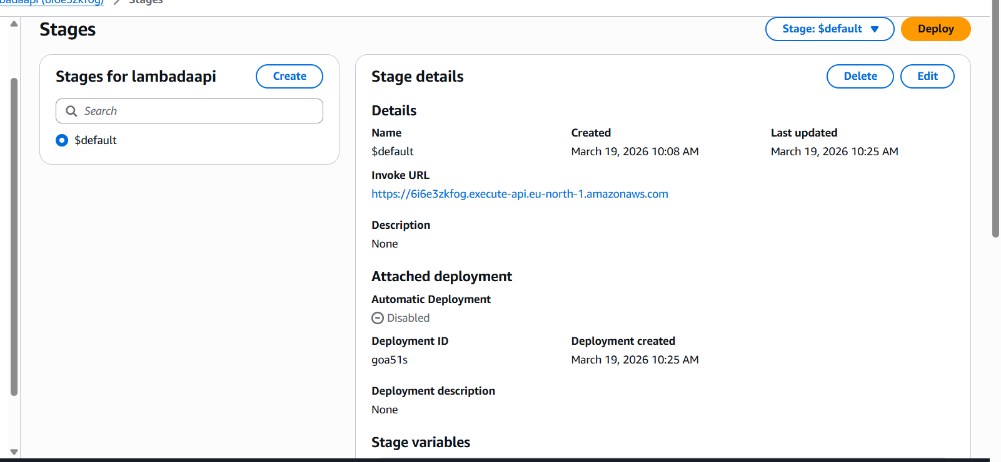

Step 8: Test in Browser
Open the endpoint URL in browser.
