Cloud VM Web Server Setup (AWS EC2 / Google Compute Engine)

Objective
Launch a VM instance (Ubuntu), configure firewall, install Apache/Nginx, and display a custom web page.

Step 1: Create VM Instance
AWS EC2:
- Go to AWS Console → EC2 → Launch Instance
- Select Ubuntu 22.04
- Choose t2.micro
- Enable HTTP traffic
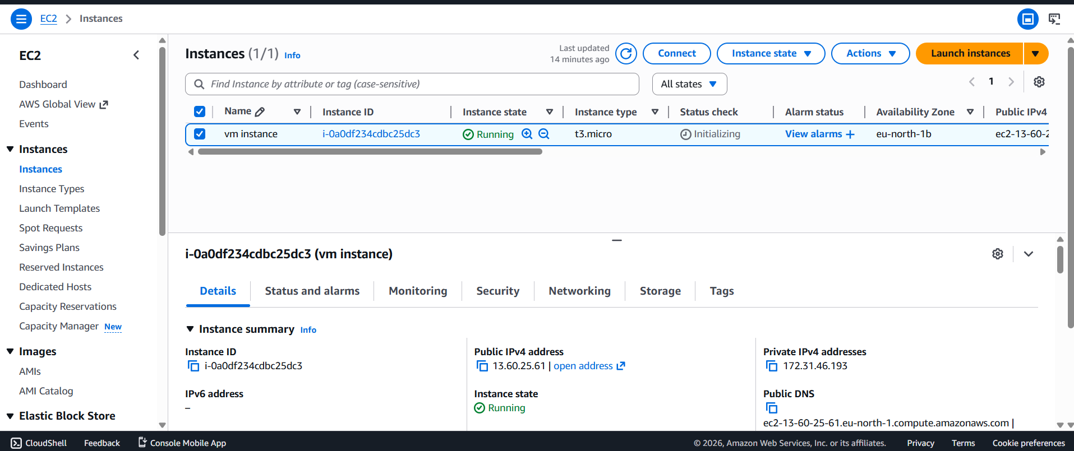

Step 2: Configure Firewall (Port 80)
AWS:
- Go to Security Groups
- Add inbound rule: HTTP (Port 80)
[Add Screenshot: Security group inbound rules]

Step 3: Connect to VM
AWS:
ssh -i key.pem ubuntu@<public-ip>
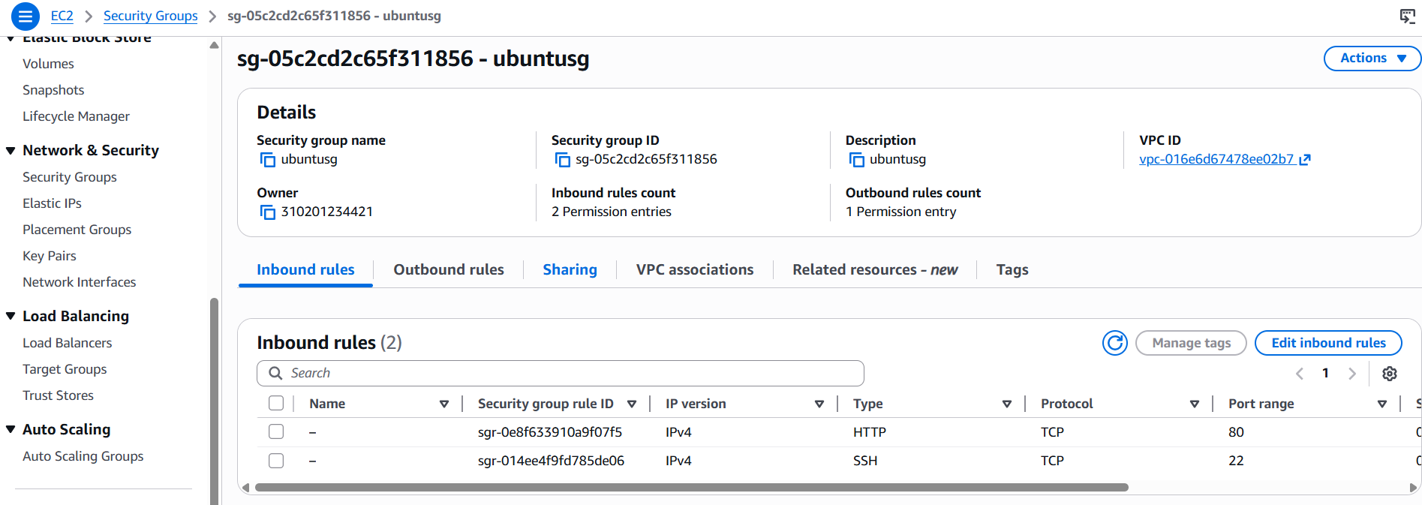

Step 4: Install Web Server
Apache:
sudo apt update
sudo apt install apache2 -y
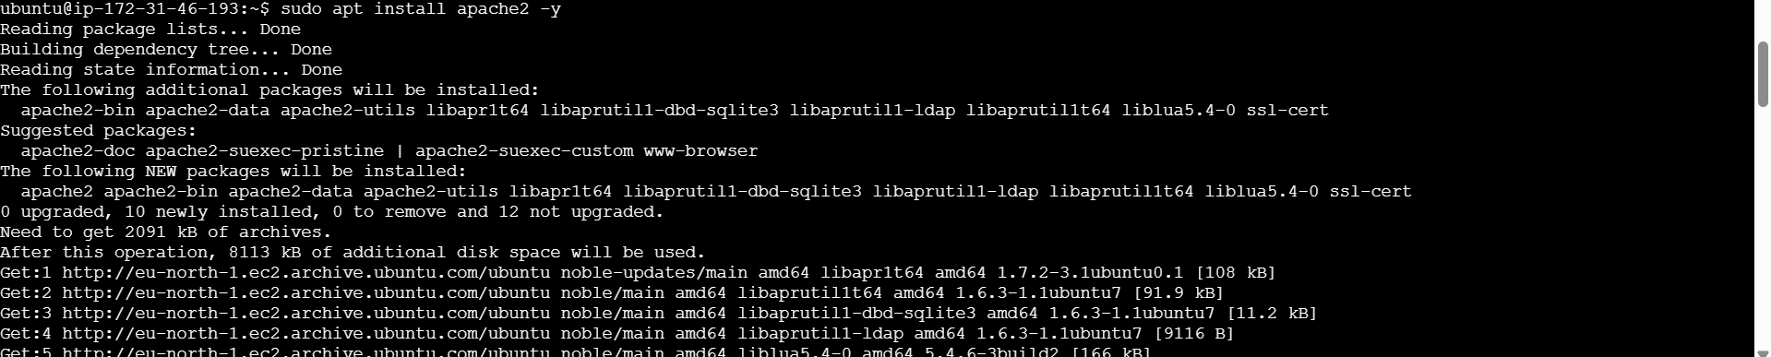

Step 5: Create Custom Web Page
sudo nano /var/www/html/index.html
Add:
Hello from Cloud VM
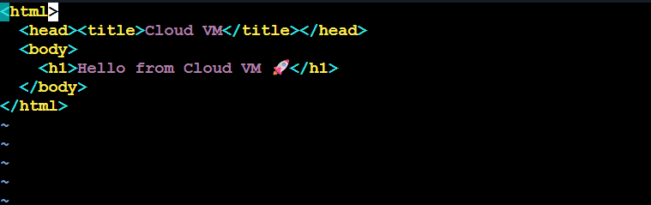

Step 6: Access Website
Open browser: http://<public-ip>
