In last week’s assignment my results were not informative. The alpha value was 1 and Inc. was 0.000. For this week’s assignment I used more variables than that I used in previous week. I included release year, genre and days of weeks with the previously existing variables which showed improvement in my results. So, accordingly I tried different re-binning options which is as follows:

* I tried using both the searches, i.e. “all models” and “loopless” search. The results were as follows: ‘IV:BuPr:GrPr’ was selected as the best dBIC model in “all model” search with 61.68 % and ‘IV:BuGrPr’ was selected as the best model as dBIC in “loopless” with 66.56%.
* I used width as 5 instead of 3 and level as 10 instead of 7, and occam produced best model with width of 4 and level 2.
* I even tried using both dAIC and dBIC, but the results were same during Search of “Sort By”. I even tried using “Information” option but still the results were same.
* Occam showed me ‘IV:BuGrPr’ as the best model by dBIC with information 66.56%. That means budget and gross income were the independent variables used by the occam to predict dependent variable, i.e. Profit.

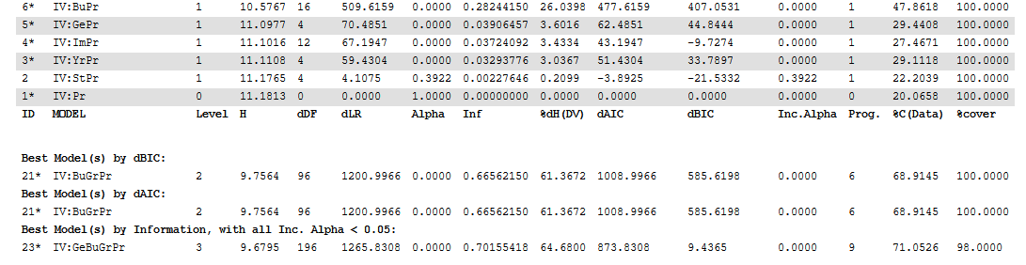

* I even tried neutral model. Comparitively model is very complex. Occam shows 'IV:GeYrStBuGrPr' as the best dAIC model. Here, inf is 78.86% and coverage is the same 100%

My dataset is about the movie. Here, I am trying to predict the profit of the movie on the basis of the independent variables, i.e. budget, overseas profit percent, release year, day of week. Occam showed ‘IV:BuGrPr’ as the best dBIC model. Then, I did “do fit” on the same model. Here, my variables are as follows:

Bu: Budget of the movie

Gr: Gross Income

Pr: Profit

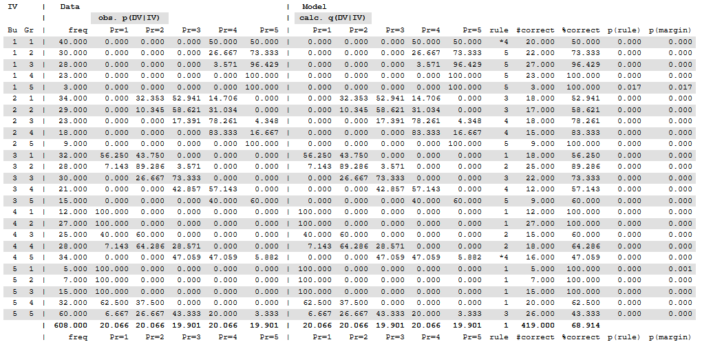

Here, profit, i.e. Pr=4 is the most predicted on the basis of my independent variables, i.e. budget and gross income. It is actually selected twice in this model. Firstly, it shows 50% of accuracy and is 68% correct. Secondly, it showed 47.059% of accuracy and is 68% correct. Also, the prediction and data shows the same bin. When I observed my IVs, budget is increasing over the period of time, but I see some variations in gross income, which is not increasing in proportion with the increase in budget. I am looking for some reasoning here, for what could be the reasons for the variations here.