**ASSIGNMENT24.2**

**Problem Statement**

**Q1 Fetch date and temperature from teperature_data where zip code is greater than 300000 and less than 399999.**

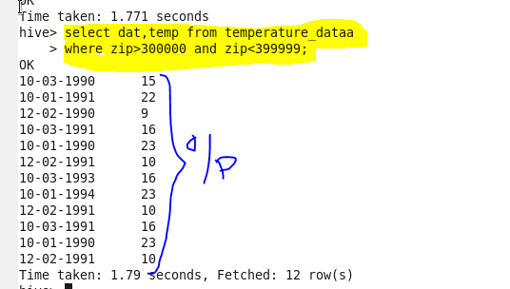

**Q2 Calculate maximum temperature corresponding to every year from temperature_data table.**

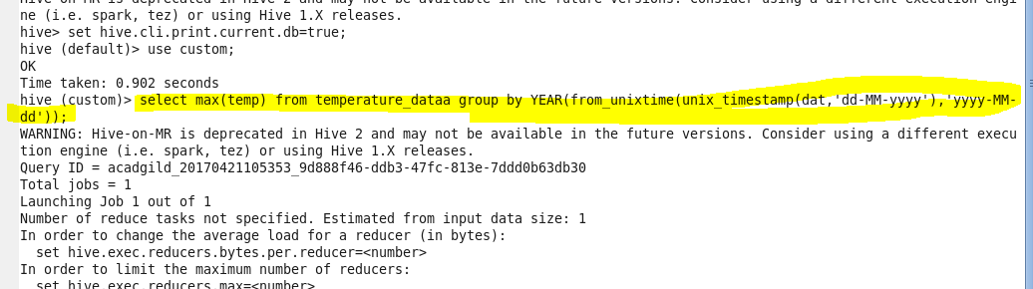

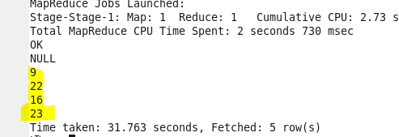

**Q3 Calculate maximum temperature from temperature_data table corresponding to those years which have at least 2 entries in the table.**

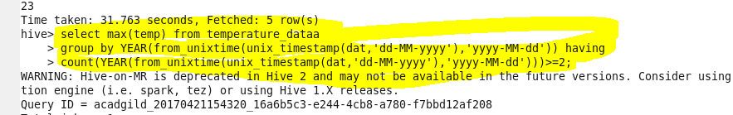



**Q4 Create a view on the top of last query, name it temperature_data_vw.**

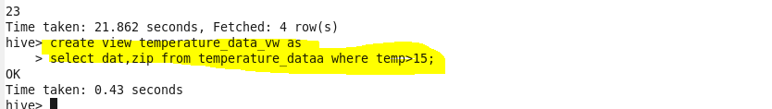

**Q5 Export contents from temperature_data_vw to a file in local file system, such that each file is '|' delimited.**

