**To Load the data from Local**

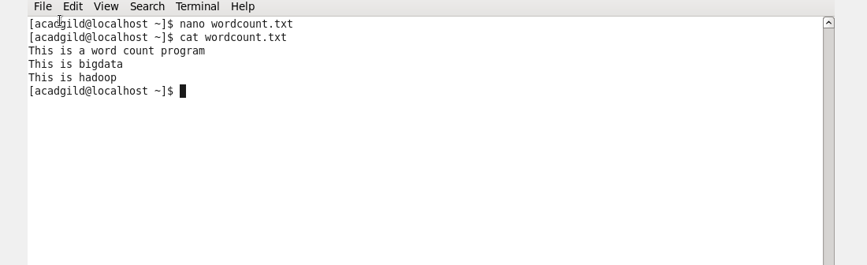

**Loading**

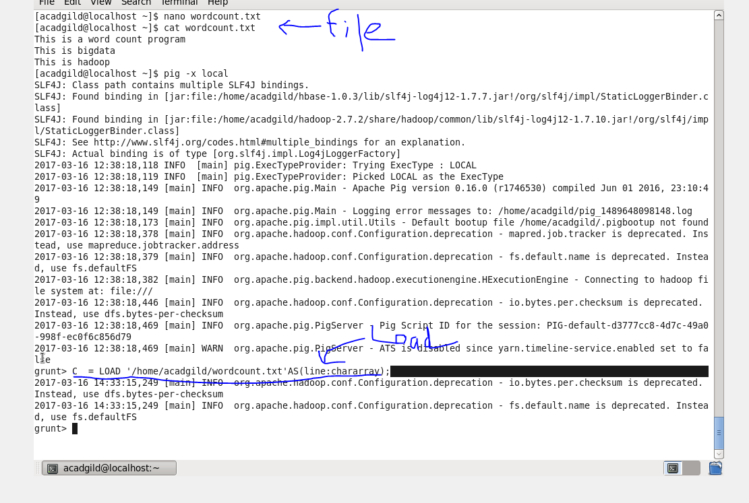

**Main program lines , generating word count**

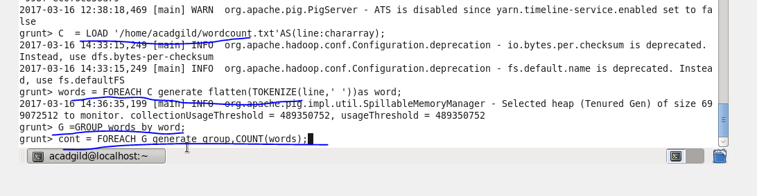

**Output**

