**Assignment10.6**

**Problem statement:**

**In this assignment you need to write the pig scripts for the given problem statements.**

**INPUT:**

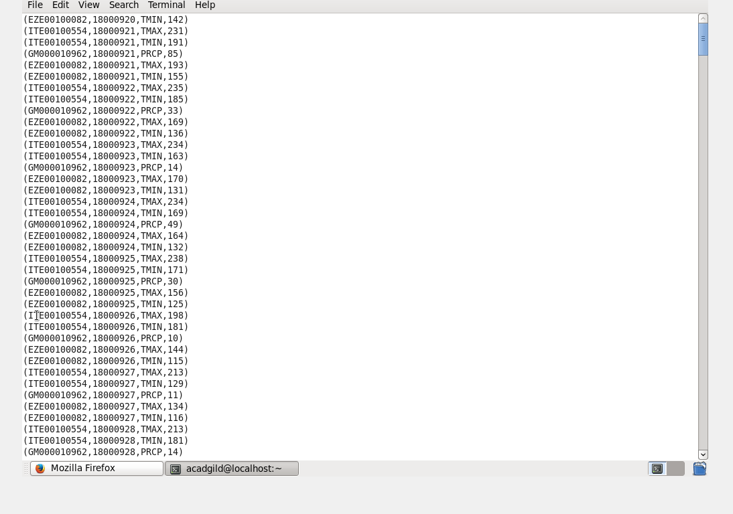

1. **Write a pig script to find the minimum temperature observed in a given weather station in a particular year.**

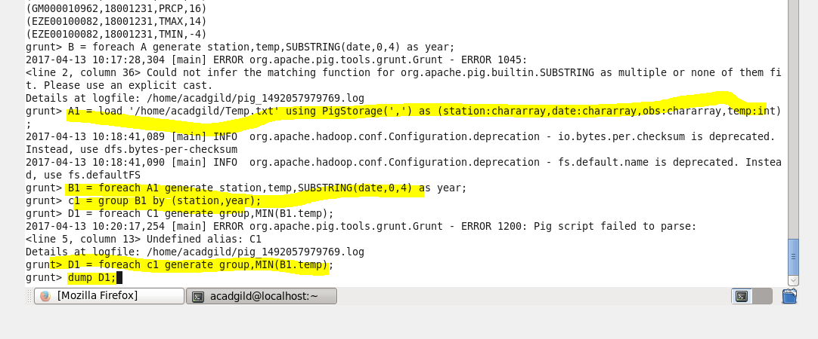

**Op:**

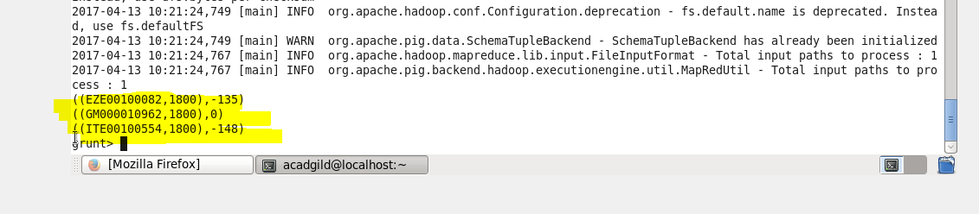

**2. Write a pig script to find the maximum temperature observed in a given weather station in a particular year.**

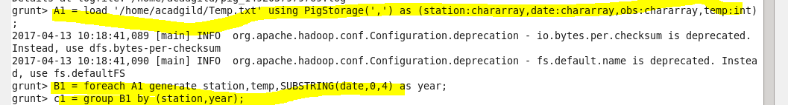



**OP:**

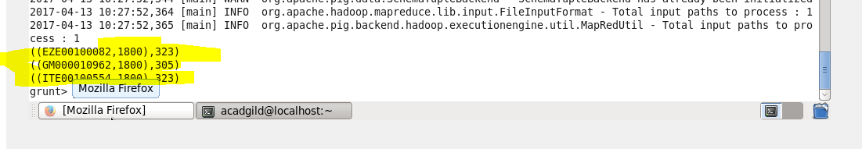

**3. Write a pig script to find the number of readings given by each weather station according to the dataset.**

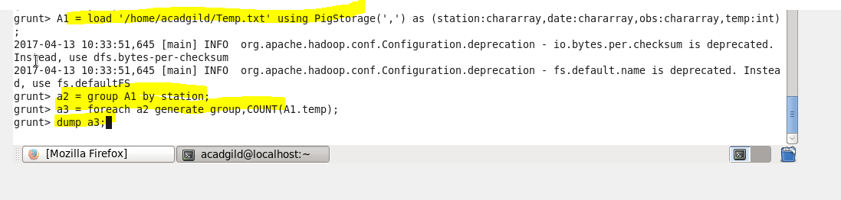

**OP:**

