Q.Create two datasets employee and department of file type text where the columns are delimited by tab ( ‘\t’ ), and use these datasets to perform below Join operations :

- SELF JOIN
Ans.a)Load the employee.txt file in pig in a particular container called emp,
Load same employee.txt in pig in an another container called emp2,
And perform self join.
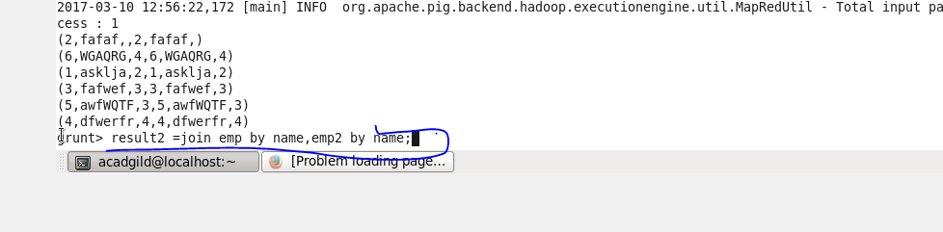
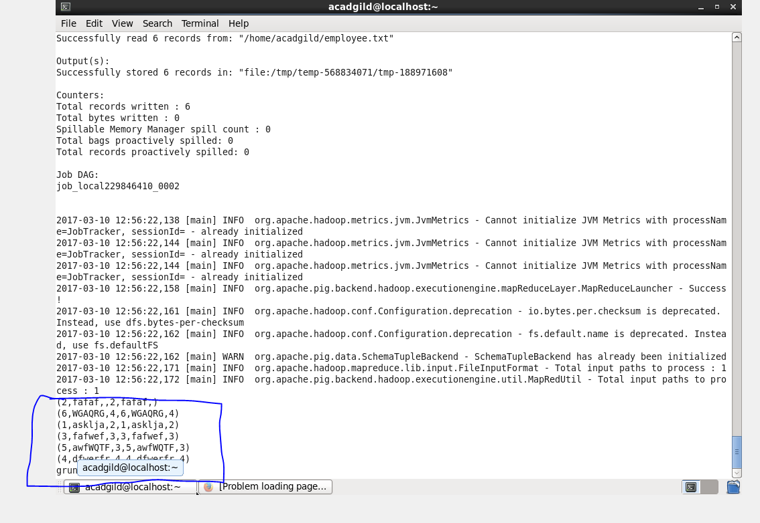

2.Inner join.
a)Load employee.txt in emp and department.txt in dept and perform inner join.
Loading………..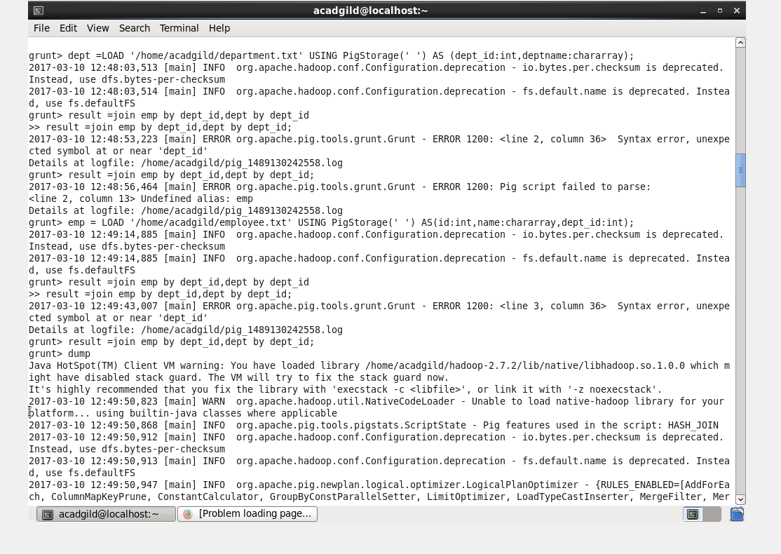

Result of join………
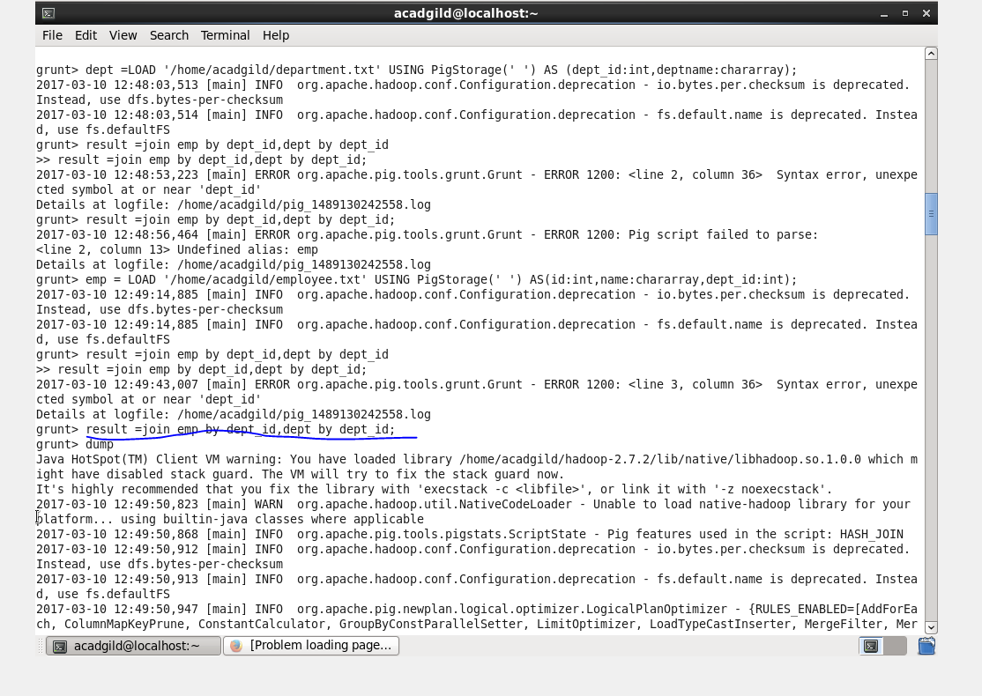
Output…………
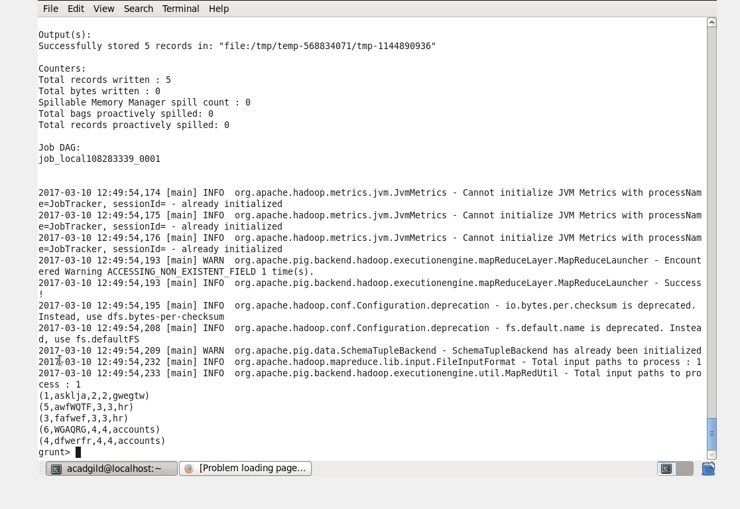

3.LEFT OUTER JOIN
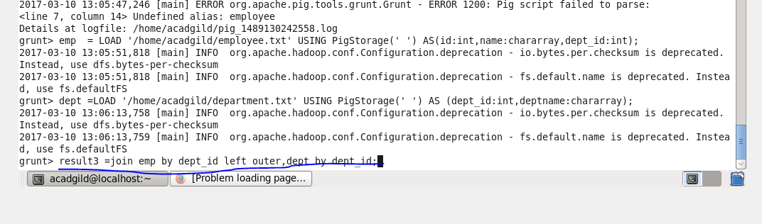

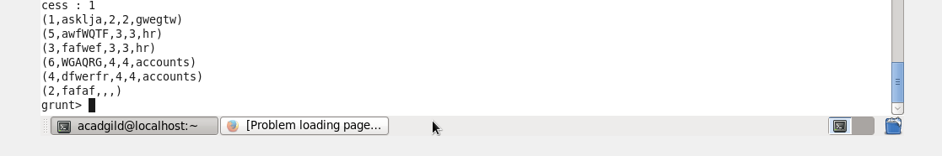

4.RIGHT OUTER JOIN
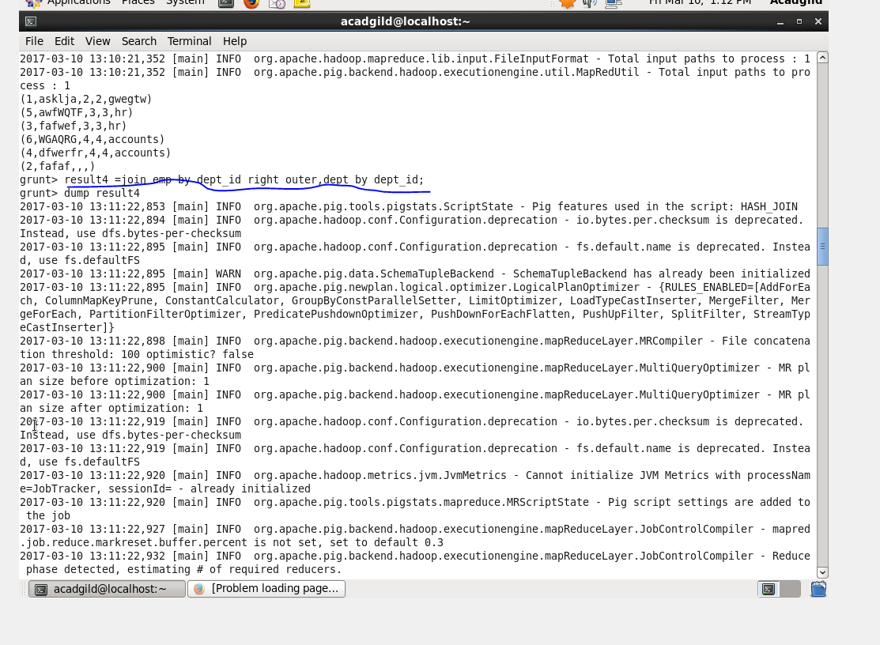

5.full outer join
