**Load**

To load the data either from local filesystem or Hadoop filesystem.

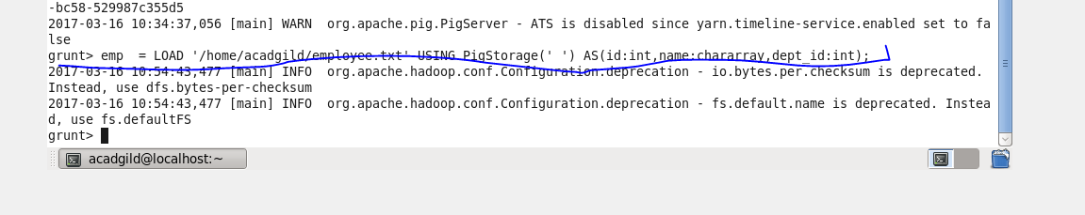

### Limit

Used to limit the number of outputs to the desired number.

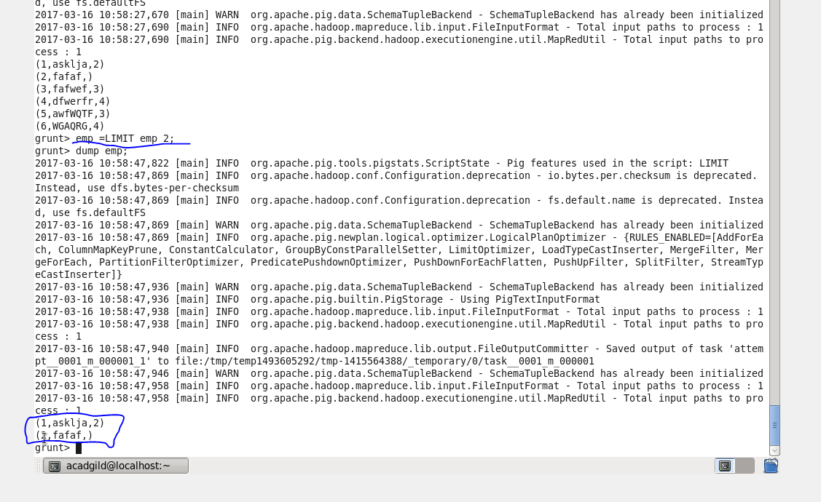

### Order

Sorts a relation based on single or multiple fields.

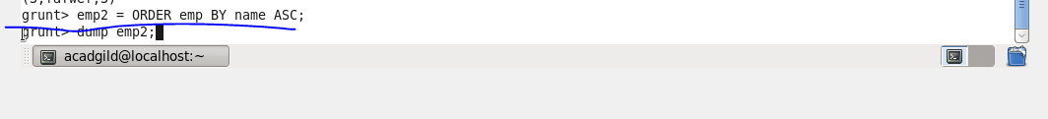

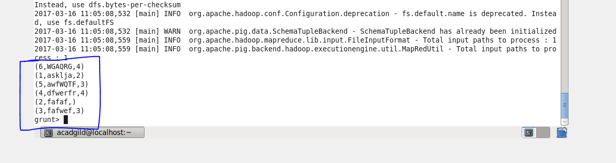

### Group

Groups the data based on one or multiple fields. It groups together tuples that have the same group key (key field). The key field will be a tuple if the group key has more than one field, otherwise it will be the same type as that of the group key.

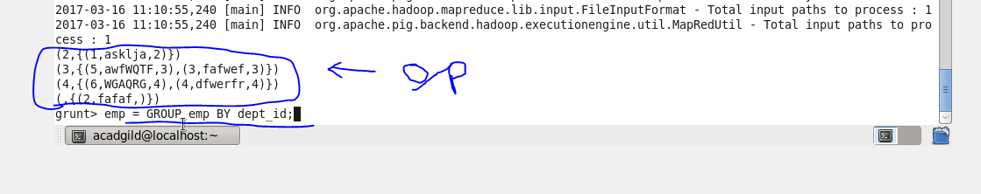

### Foreach

It generates data transformations based on desired columns of data.

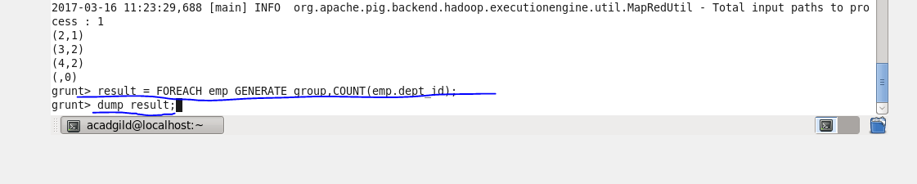

### Filter

Filters a relation based on certain condition

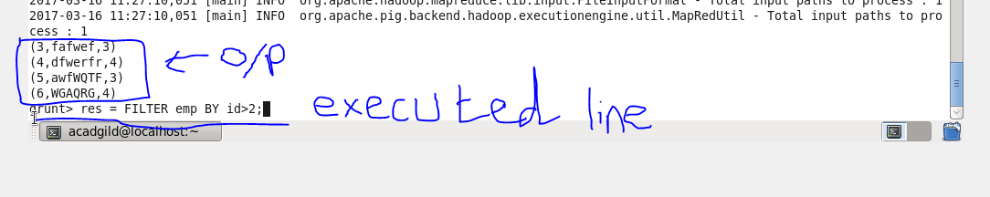

### Store

Stores and saves the data into a filesystem.

