**Assignment 28.3**

* Creating table

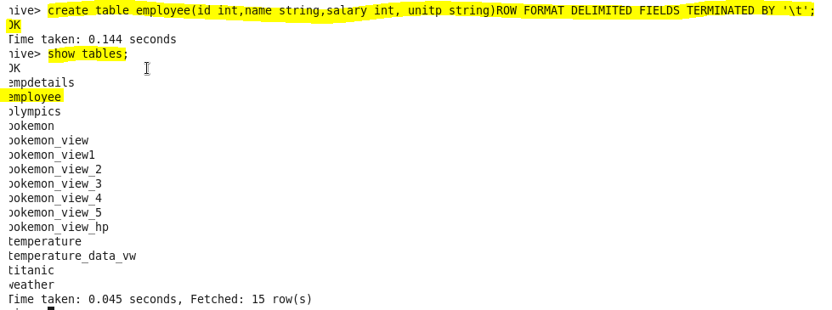

* Loading data into the table

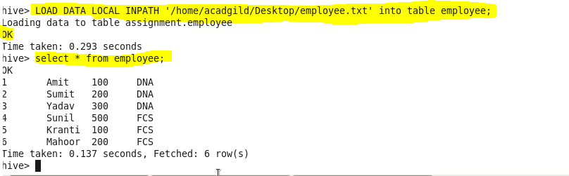

* Then, according to question finding list of employees who receive a salary less than 100, compared to their immediate employee with higher salary in the same unit using lag and partition keywords.

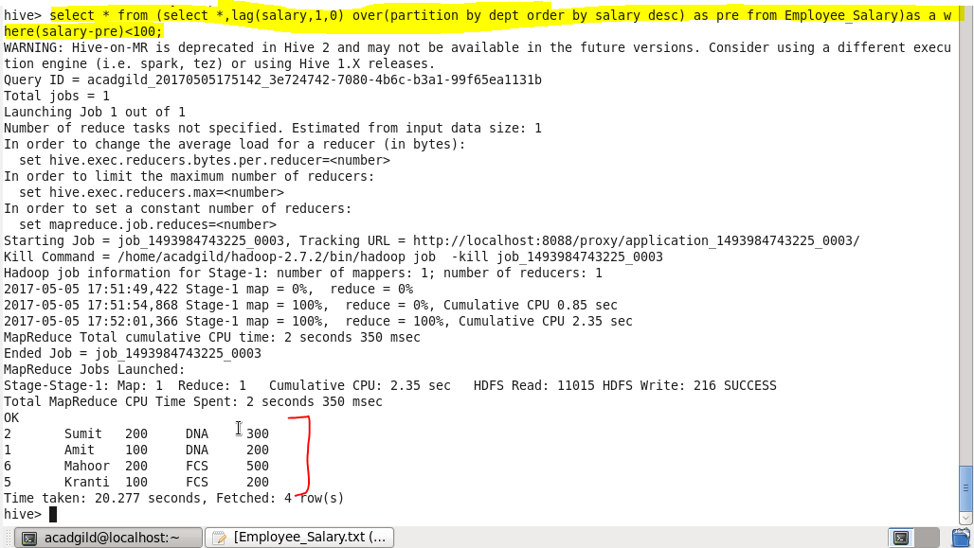

**● List of all employees who draw higher salary than the average salary of that department.**

* In this particular problem we will check for the employees whose salary is greater than average salary of that department using avg function for that we will select name from a subquery I that we will select name,salary and average salary from the same table and will filter by salary should greater than average salary.

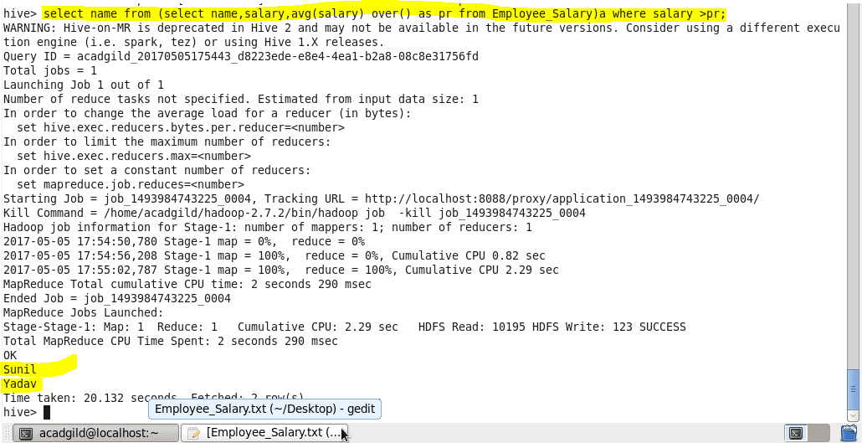

**Problem Statement: Link: olympic_data.csv Store the above dataset into the following file formats.**

**● SEQUENCEFILE**

* Creating table in **sequencefile format**
* Describing the contents of it
* Loading dataset into file
* Displaying all the data using ‘select’ keyword.

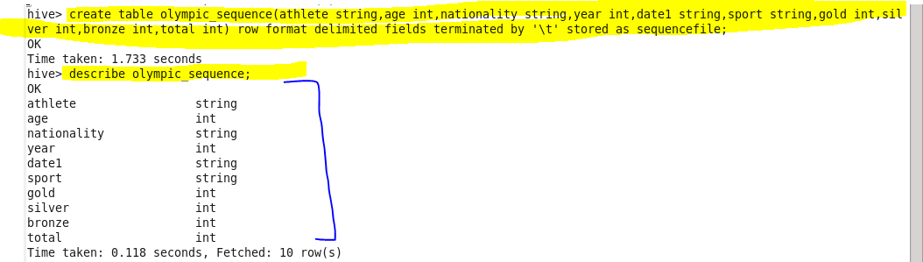

**Insert data :**

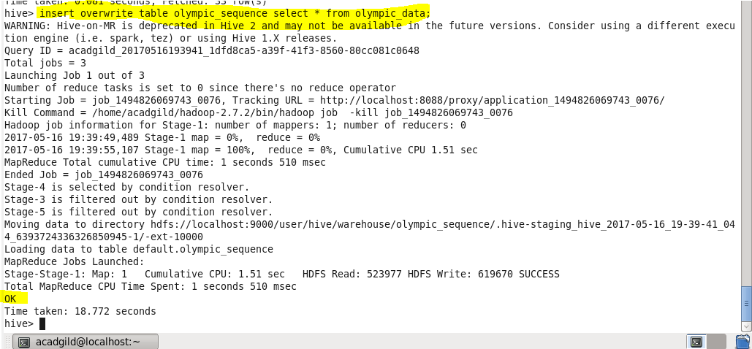

Showing result :

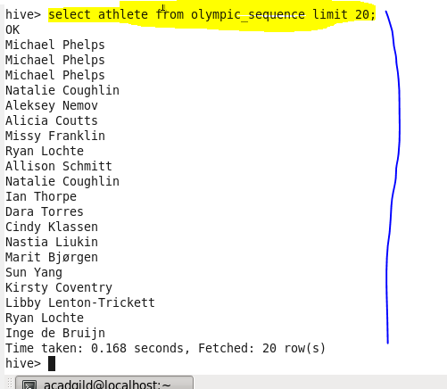

**● RCFILE**

* Creating table in rcfile format.
* Describing the contents of it.
* Inserting the data into created table.
* Displaying all the data using ‘select’ keyword.

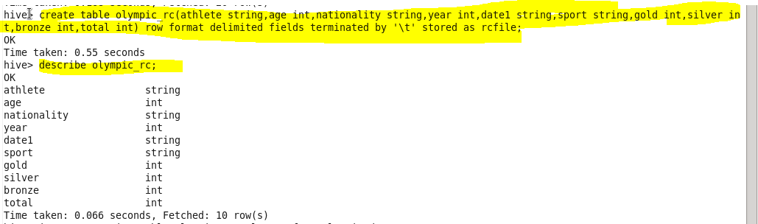

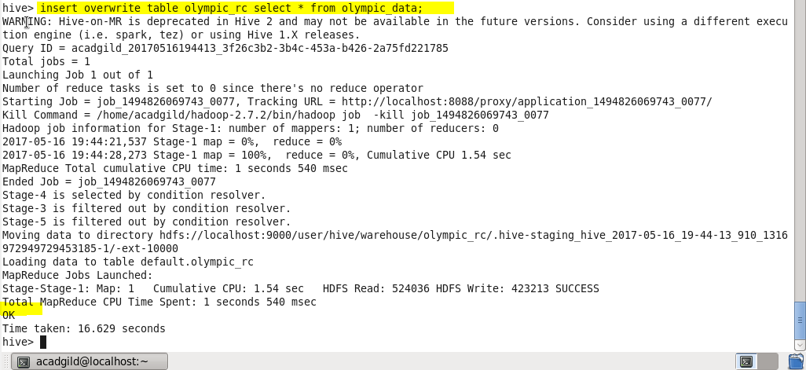

**Showing result**

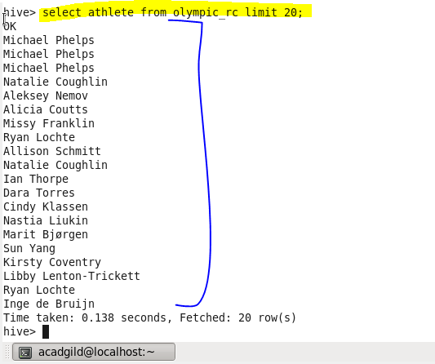

**● ORC FILE**

* Creating table in orcfile format.
* Inserting the data into created table.
* Displaying all the data using ‘select’ keyword.



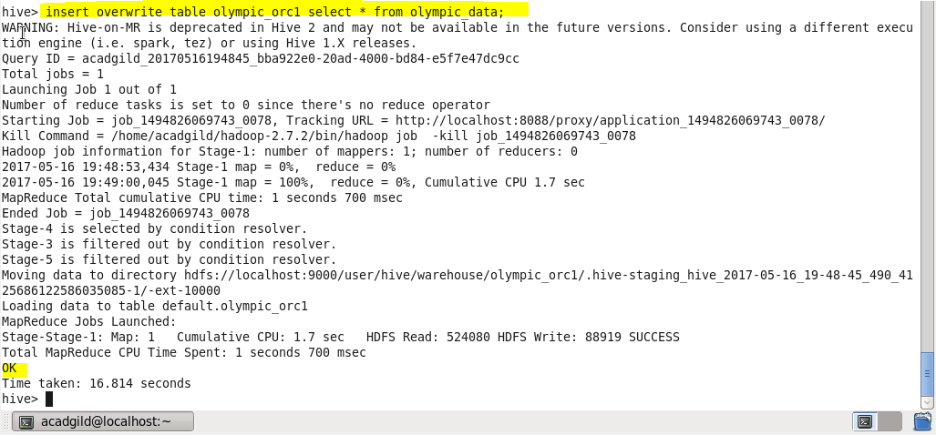

**Showing result:**

