**Problem Statement:**

**We have loaded “petro_data.txt” to perform few pig operation to retrieve the result depending on particular problem statement.**

**Write the Pig codes to analyze the petroleum data set.**

**Input file:**

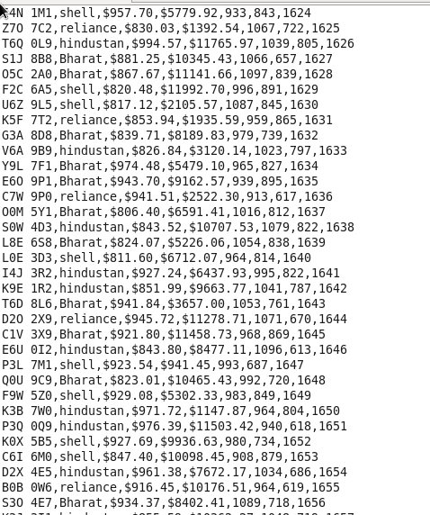

**1. What is the total amount of petrol in volume sold by every distributor?**

**Program:**

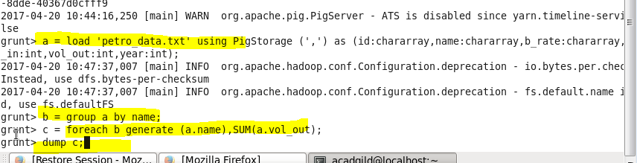

**Result:**

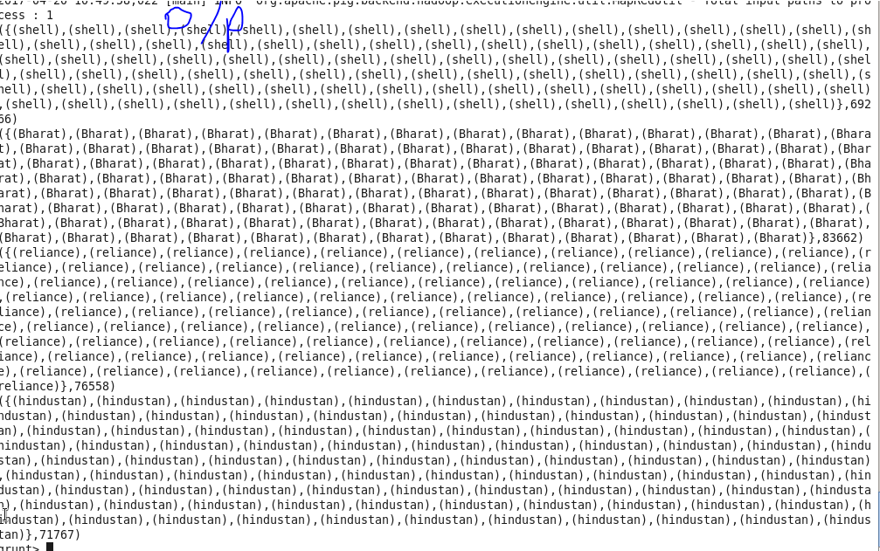

**2. Which are the top 10 distributors ID's for selling petrol? Also display the amount of petrol sold in volume**

**Program:**

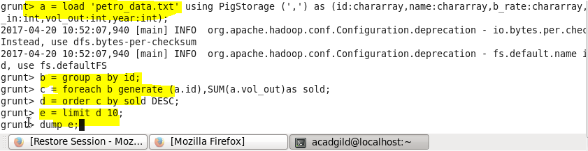

**Result:**

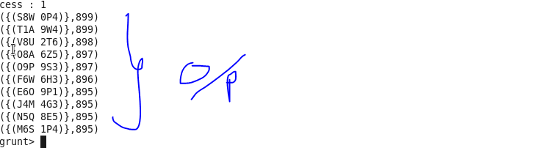

**3. List 10 years where consumption of petrol is more with the distributer id who sold it.**

**Program:**

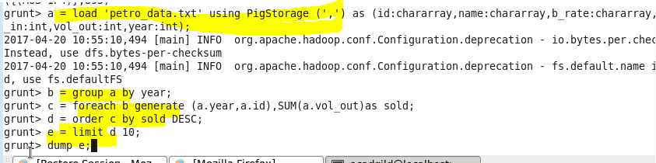

**Result:**

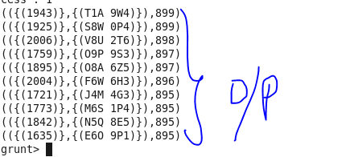

**4. Find the distributer name who sold petrol in least amount.**

**Program:**

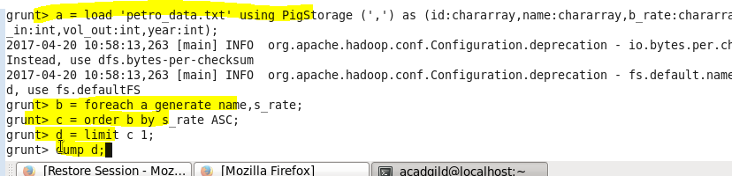

**Result:**

