Problem Statement

Write the Pig codes to analyze the Student data set.

https://github.com/prateekATacadgild/mAPrEDuce/blob/master/studentDS

Data Dictionary 1. Name : chararray

2. Col.Undertaken : chararray

3. Dob : chararray

4. Stream : chararray

5. Grade : float

6. State : chararray

7. City : chararray

Input file:

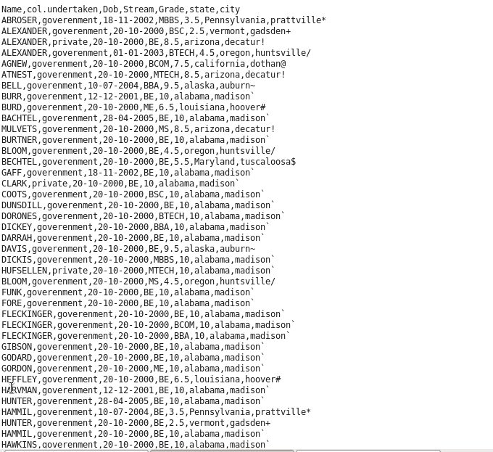

1. Find the number of students who scored less than 5(50%).

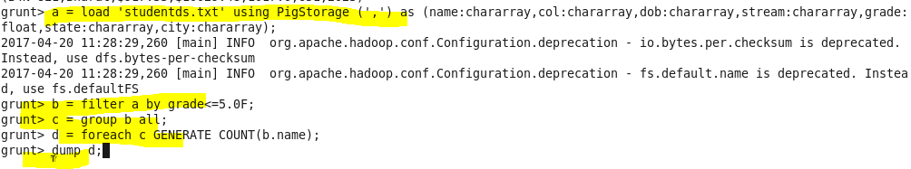

Result:



2. List the name of students who are from Alaska.

Program:

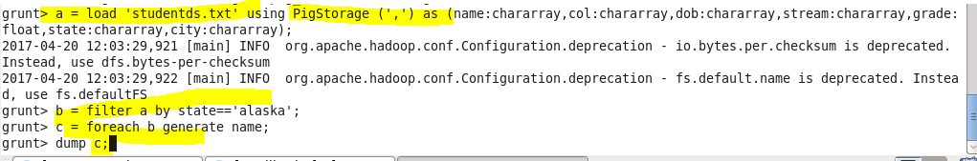

Result:

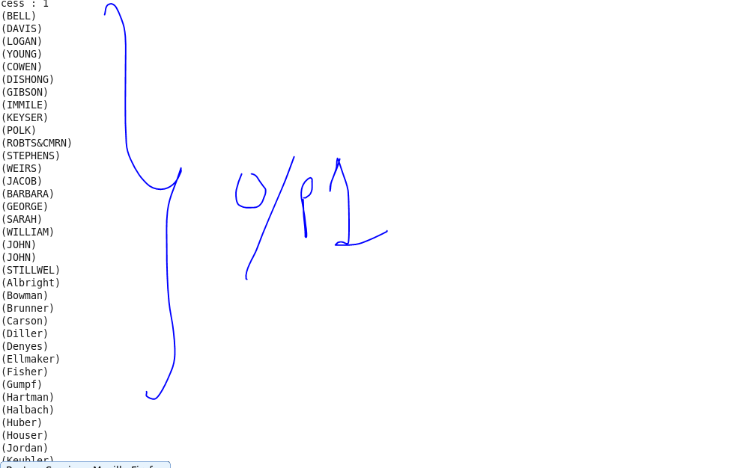

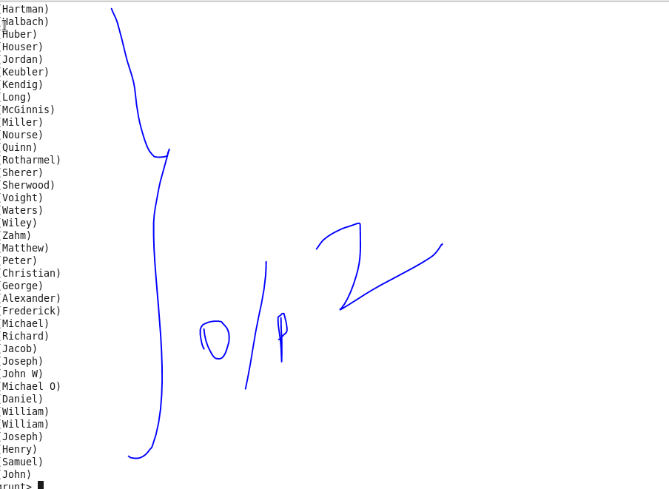

3. How many government colleges are there in Alabama?

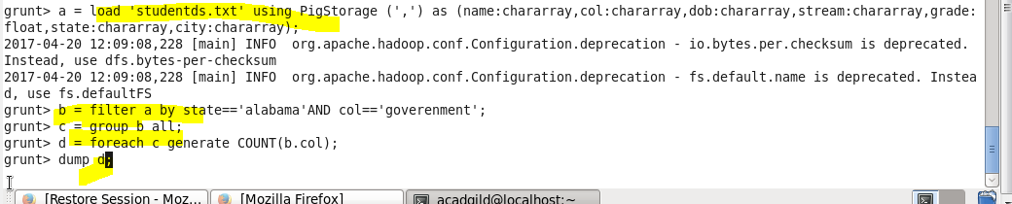

Result:

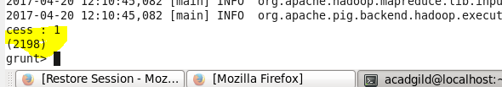

4. List the name of students who are from Oregon and persuing BE.

Program:

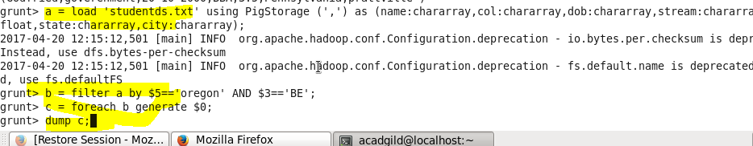

Result:

