**ASSIGNMENT16.5**

**Write a map reduce program to join the below given two datasets using map side join.**

**Driver**

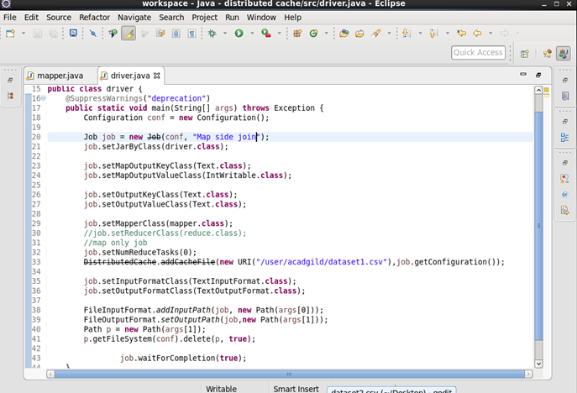

**Mapper**

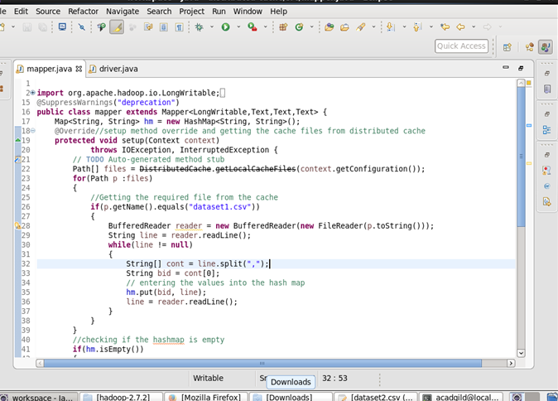

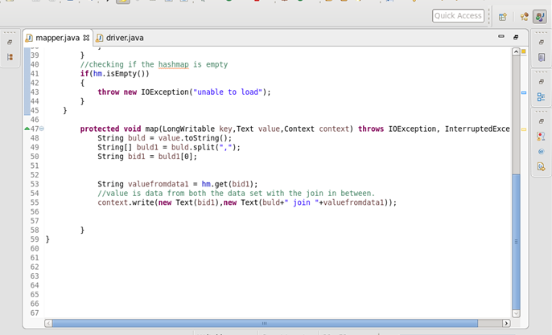

**Output**

