ASSIGNMENT19.1

Convert Avro File to JSon type File using Hive.

Avro is one of the preferred data serialization systems because of its language neutrality. Due to lack of language portability in Hadoop writable classes , avro becomes a natural choice because of its ability to handle multiple data formats which can be further processed by multiple languages.

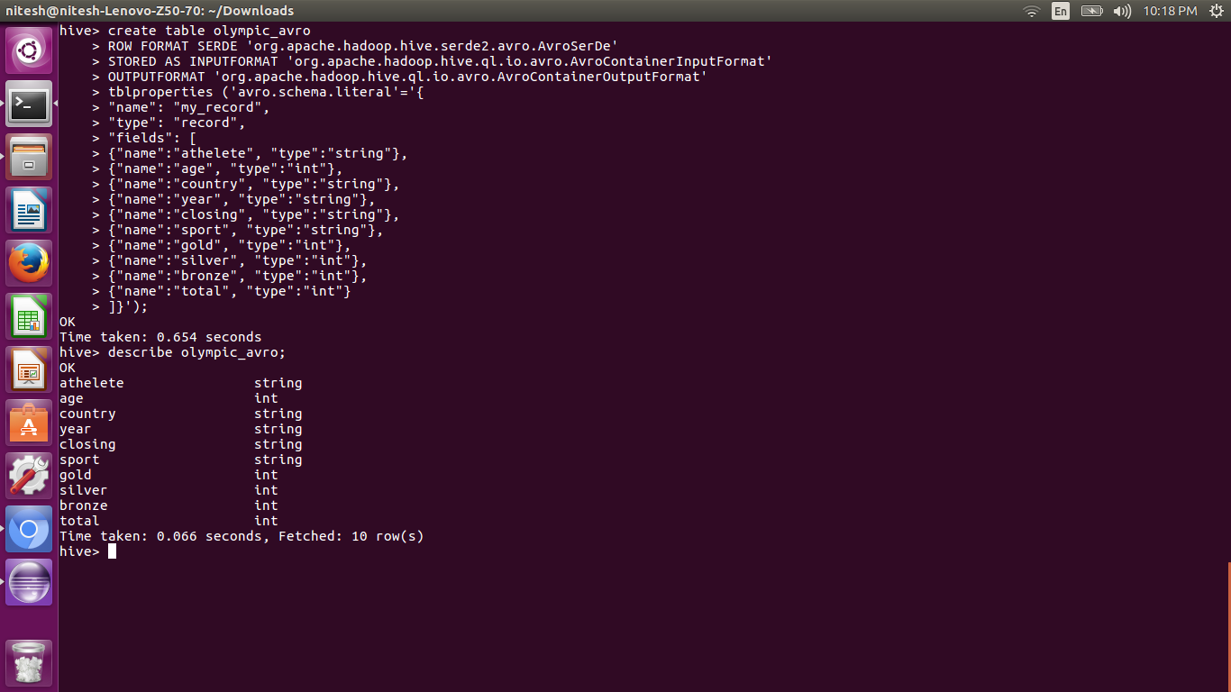

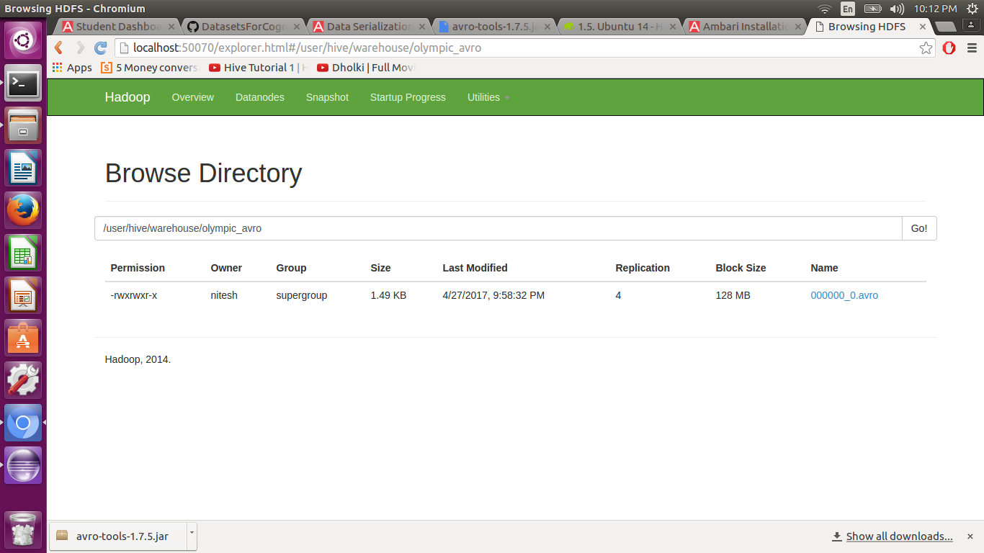

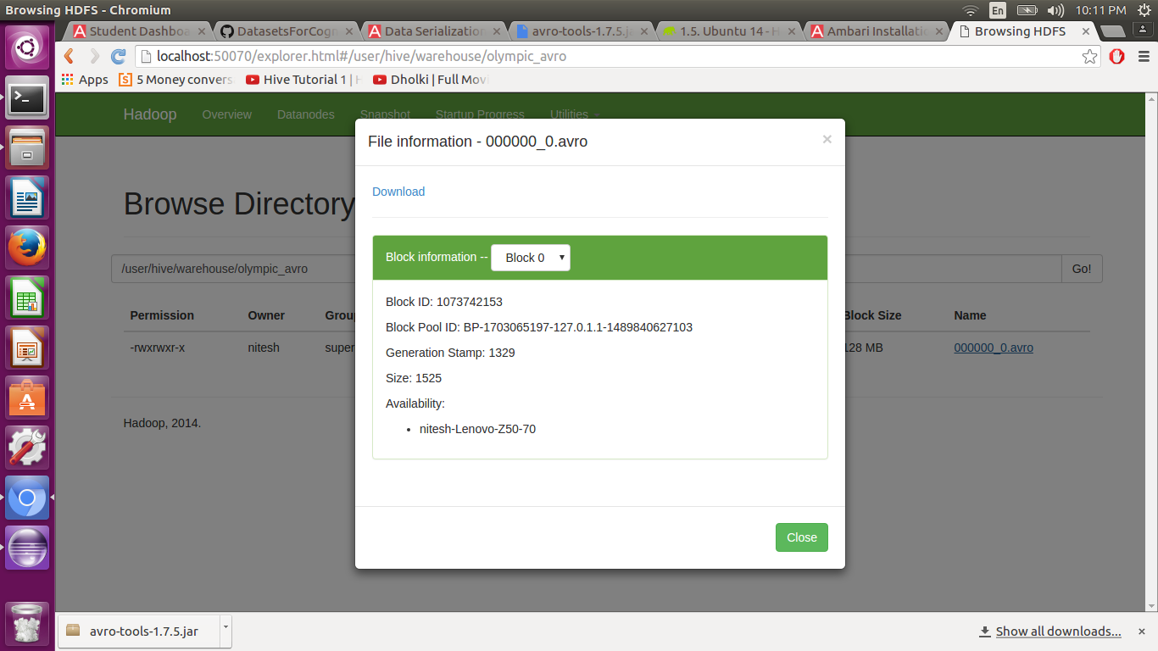

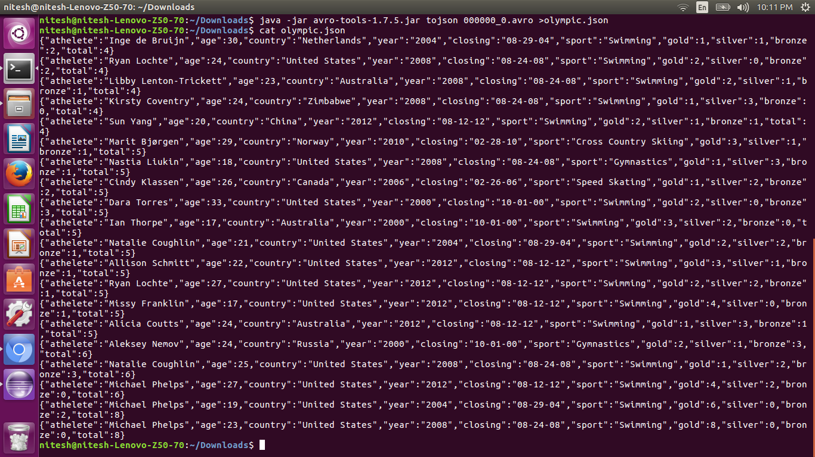

a file with name ‘olympic.json’ will be created with the json schema of the Avro file. To see the contents of this json cat Olympic. json’.

This will show the content of the created file in the json format from the avro file. For this we needed a jar avro-tools-1.7.5.jar.